1.Open your own laptop or desktop (or use an online PC hardware simulator if you don't have access to a real system) and identify the GPU model installed. Write down the GPU's brand, model number, and whether it is integrated or dedicated.
I checked the settings of my laptop to identify the GPU details.
- Laptop Brand: HP
- Laptop Model: HP EliteBook x360 1030 G4
- GPU Brand: Intel
- GPU Model: Intel UHD Graphics 620
- Type of GPU: Integrated GPU
2.Take a clear photo or screenshot of the cooling system (fan, heatsink, or liquid cooling setup) inside your PC or from a PC hardware simulator. Label the main cooling components and briefly describe their function.

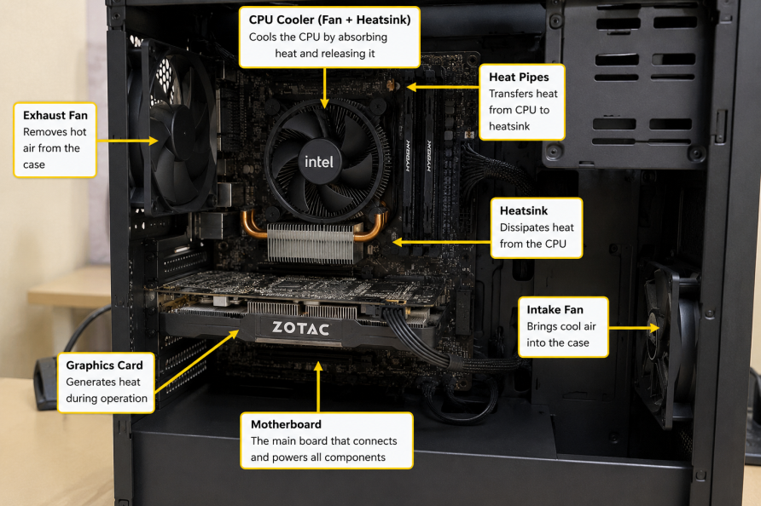

3.Create a comparison table listing at least 3 differences between air cooling and liquid cooling systems for GPUs, including factors like cost, efficiency, and maintenance.

Factors | Air Cooling | Liquid Cooling
Cost | Air cooling is cheaper and more affordable. | Liquid cooling is more expensive.
Cooling Efficiency | Provides good cooling for normal use and moderate gaming. | Provides better cooling for heavy gaming and high-performance tasks.
Maintenance | Requires very little maintenance, mainly cleaning dust from the fans. | Needs more maintenance and regular checking of the cooling system.
Noise Level | Fans can become noisy at high speeds. | Usually quieter because it uses liquid to transfer heat efficiently.
Installation | Easy to install and replace. | More complex to install compared to air cooling.

4.Imagine you are building a gaming PC for streaming IPL matches and playing graphics-heavy games. Choose between air cooling and liquid cooling for your GPU, and justify your choice in 3-4 sentences based on your research.

• If I were building a gaming PC for streaming IPL matches and playing graphics-heavy games, I would choose liquid cooling for my GPU.

• Liquid cooling provides better cooling performance and keeps the GPU temperature low even during long gaming and streaming sessions.

• It is also quieter than air cooling, which makes the overall experience more comfortable.

• Although liquid cooling is more expensive and requires more maintenance, I think it is the best choice because it offers better efficiency, stable performance, and helps prevent overheating during heavy use.

