1.Create a comparison table listing the main differences between DDR3, DDR4, and DDR5 RAM, including speed, voltage, and typical use cases.

Feature | DDR3 | DDR4 | DDR5
Speed (Data Rate) | DDR3 has a slower speed (800–2133 MT/s). | DDR4 has a medium speed (1600–3200 MT/s). | DDR5 has a very fast speed (4800–8400+ MT/s).
Voltage (Power) | It uses higher voltage (1.5V). | It uses lower voltage (1.2V). | It uses the lowest and most efficient voltage (1.1V).
Max Stick Capacity | Supports up to 16 GB per stick. | Supports up to 64 GB per stick. | Supports up to 128 GB or more per stick.
Power Management | Power management is controlled by the motherboard. | Power management is controlled by the motherboard. | Power management is handled on the RAM stick itself (PMIC).
Error Correction | No built-in error correction. | No built-in error correction. | Includes On-Die ECC for internal error correction.
Released Year | Released in 2007 (Older Generation). | Released in 2014 (Mainstream Generation). | Released in 2020 (Latest Generation).

2.Open your laptop or desktop (with power disconnected), locate the RAM slots, and take a clear photo of the installed RAM module. Reinstall the RAM module and verify that your system boots up successfully.<br><br><em><strong>Hint:</strong> Refer to your device manual or a trusted YouTube guide if unsure about RAM removal and installation steps.</em>
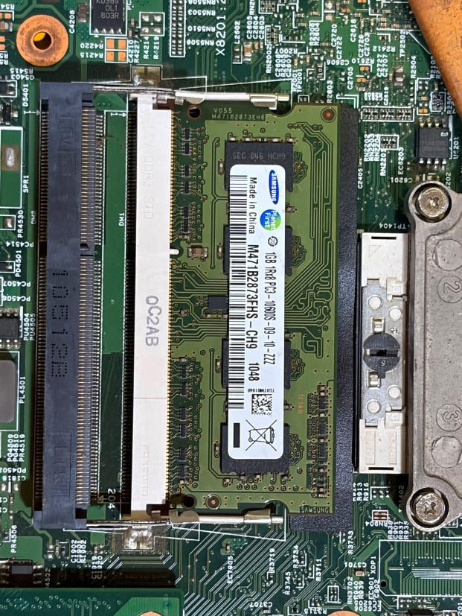
RAM Module Removal and Reinstallation
I powered off my laptop and disconnected the charger before opening the back panel. After locating the RAM slot, I carefully removed the installed RAM module and took a photo of it. The RAM installed in my laptop is a Samsung 1GB DDR3 PC3-10600S SO-DIMM module.
Steps Performed:
- Shut down the laptop and disconnected the power source.
- Opened the laptop back cover.
- Located the RAM slot on the motherboard.
- Released the side clips and carefully removed the RAM module.
- Took a clear photo of the RAM module.
- Reinserted the RAM module at an angle and pressed it down until the clips locked into place.
- Reassembled the laptop and powered it on.

3.List three key differences between HDD, SSD, and NVMe storage types, and for each, name one app or use case (from apps you use daily) that would benefit most from that storage type.

Three Key Differences Between HDD, SSD, and NVMe

Feature | HDD | SSD | NVMe SSD
Speed | Slow | Fast | Very Fast
Storage Technology | Mechanical disk | Flash memory | Flash memory with PCIe connection
Price | Cheapest | Moderate | Most expensive

Use Cases:
- HDD (Hard Disk Drive)
  - HDD is good for storing large amounts of data at a low cost.
  - Example: I would use an HDD to store my photos, videos, movies, and college files.
- SSD (Solid State Drive)
  - SSD is much faster than HDD and helps applications open quickly.
  - Example: Apps like Instagram and Google Chrome load faster and run more smoothly on an SSD.
- NVMe SSD
  - NVMe SSD is the fastest storage type and is ideal for high-performance tasks.
  - Example: Gaming applications, video editing software, and large file transfers benefit the most from NVMe SSD storage.

4.Remove the storage drive (HDD or SSD) from your system, take a photo of the connector type (SATA, M.2, or NVMe), and reinstall the drive. Confirm that your device recognizes the storage after reassembly.<br><br><em><strong>Constraint:</strong> Only perform this task if you have access to a device you are allowed to open. If not, find and share a YouTube video link showing the process for your laptop/PC model.</em>

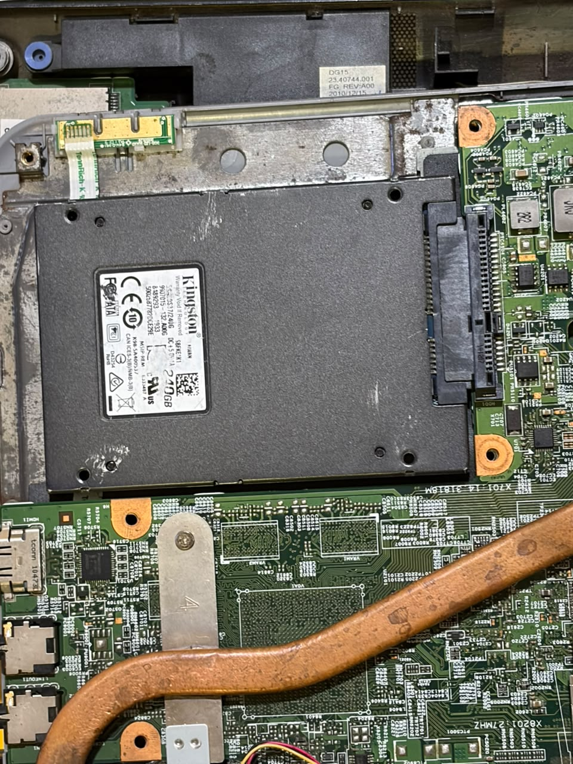

I opened my laptop and located the storage drive. I found that my laptop uses a Kingston 240GB SSD. After removing the back cover, I checked the connector type and observed that it is a SATA SSD connected through a SATA interface.
Steps Performed:
- Shut down the laptop and disconnected the charger.
- Opened the back panel carefully.
- Located the Kingston 240GB SSD.
- Observed the SATA connector attached to the SSD.
- Reinstalled the SSD securely in its original position.
- Closed the back panel and powered on the laptop.
- Checked File Explorer to confirm that the SSD was detected.

