1.Draw a labeled diagram of an ATX motherboard and mark at least 8 different slots and ports (such as RAM slots, PCIe slots, SATA ports, USB headers, CPU socket, power connector, etc.).

->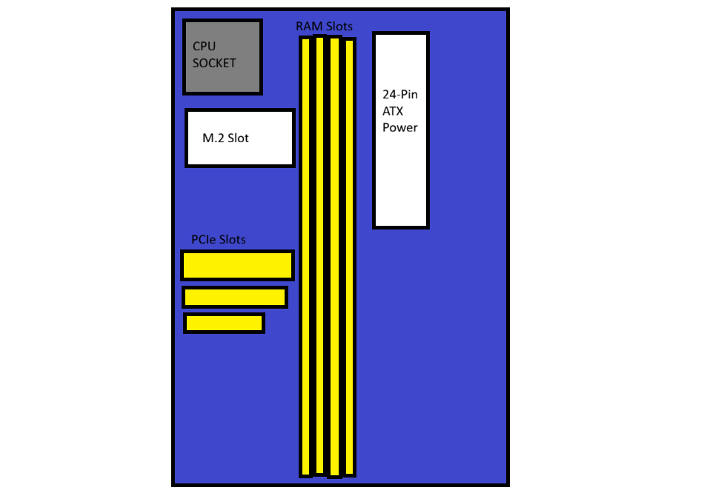

2.Research and list 3 popular CPU socket types (for example: LGA1151, AM4, LGA1200) and name one compatible CPU model for each.

-> A CPU socket is the slot on the motherboard that holds the processor. It connects the CPU to the rest of the computer. Different processors require different socket types. Here are three popular CPU sockets and one compatible processor for each:
- Socket AM4
  - Brand: AMD
  - Details: This is one of AMD's most successful sockets. It supports many generations of Ryzen processors and uses a Pin Grid Array (PGA) design.
  - Compatible CPU: AMD Ryzen 5 3600
- Socket LGA 1200
  - Brand: Intel
  - Details: Intel introduced this Land Grid Array (LGA) socket for its 10th and 11th generation desktop processors to handle better power delivery.
  - Compatible CPU: Intel Core i5-10400
- Socket LGA 1700
  - Brand: Intel
  - Details: This is a newer, larger socket built to support Intel's 12th, 13th, and 14th generation processors, which feature a hybrid architecture.
  - Compatible CPU: Intel Core i5-12400F

3.Explain in your own words the primary functions of the CPU and the chipset on a motherboard, and describe how they work together when you open a music app like Spotify.

-> 1. Primary Functions of the CPU and the Chipset
- CPU (Central Processing Unit):
  - To me, the CPU is the "Brain" of my computer.
  - Its main job is to think, calculate, and execute all the commands that I give to my system.
  - Whenever I run a program, the CPU is the one processing the background data and making sure things run smoothly.
- Chipset:
  - I see the chipset as the "Traffic Controller" or the bridge on my motherboard.
  - My CPU cannot talk to every single hardware component directly, so the chipset manages the communication.
  - It controls the data flowing between my CPU, RAM, storage drives, and external devices like my mouse or headphones.

2. How They Work Together When I Open Spotify
When I decide to listen to music and open Spotify, my CPU and chipset work together as a team through these steps:
- My Input: First, I use my mouse to double-click the Spotify icon. My mouse sends this click signal to the chipset, which immediately forwards it to the CPU so it knows I want to open the app.

- Finding the Files: My CPU understands my command and tells the chipset to go find Spotify's setup files inside my storage drive (SSD/HDD).

- Loading to Memory: The chipset locates the Spotify files in my storage and moves them over to my RAM (system memory) so my CPU can read them much faster.

- Launching the App: Now, my CPU processes the code from the RAM, and suddenly the Spotify screen pops up on my monitor.

- Playing the Music: Finally, when I click play on my favorite song, my CPU quickly decodes the digital music file. The chipset then takes this processed audio data and routes it directly to my headphones or speakers so I can hear the music.

4.Find a clear photo of a real motherboard (from the internet or your own device), and identify at least 5 different ports or slots by circling them and labeling each one.

