1.Draw a diagram of a bus topology and label all key components, then write one real-world example where this topology might be used.
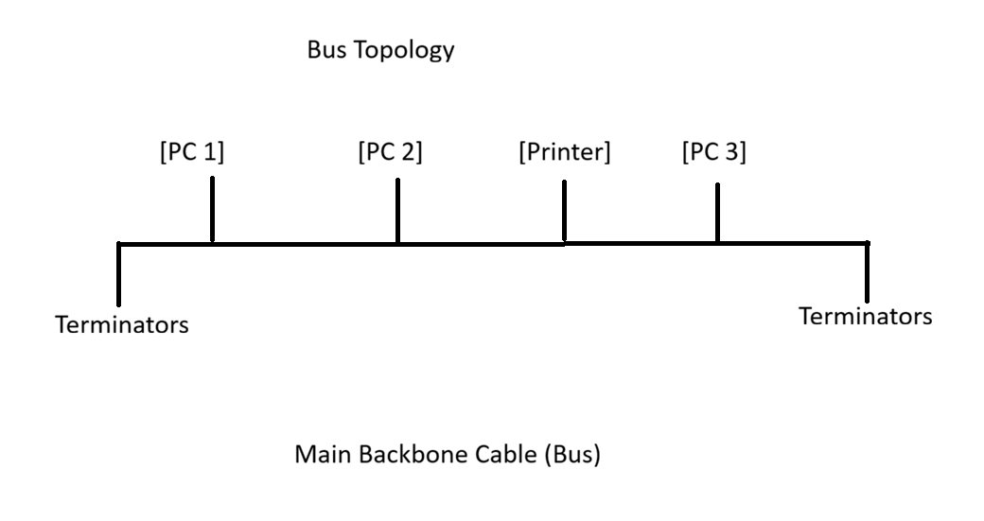
2.In Cisco Packet Tracer, create a simple star topology with one switch and four PCs connected to it; name each PC after a popular app (e.g., WhatsApp, Zomato, Spotify, Flipkart) and take a screenshot of your topology.
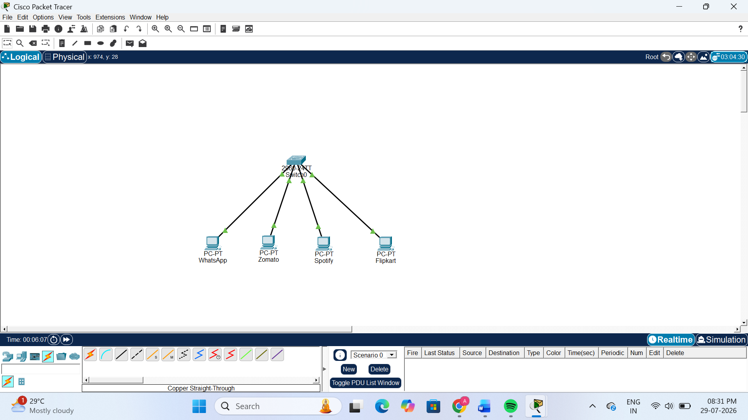
3.Draw a ring topology diagram and explain in 2-3 sentences how data travels between devices in this setup.<br><br><em><strong>Hint:</strong> Use arrows to show the direction of data flow.</em>
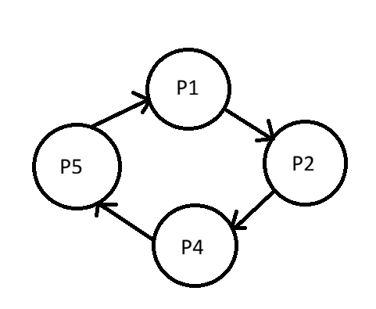
In a Ring Topology, each device is connected to two neighbouring devices, forming a closed loop. Data travels in one direction from one device to the next until it reaches the destination. If one connection fails, communication in the ring may stop.
4.Compare mesh and star topologies by listing 2 advantages and 2 disadvantages of each in a table format.
Topology | Advantages (2) | Disadvantages (2)
Mesh Topology | 1. Very reliable because multiple paths are available.2. If one connection fails, data can still travel through another path. | 1. Expensive because many cables are required.2. Difficult to install and maintain.
Star Topology | 1. Easy to install and manage.2. If one cable fails, other devices continue to work normally. | 1. If the central switch fails, the entire network stops.2. Requires more cable than a bus topology.

