1.Open Wireshark, capture network traffic while you refresh the Flipkart homepage, and identify one packet each belonging to the Application, Transport, Internet, and Network Access layers by examining their headers.
Wireshark Capture – Flipkart Homepage
Website: https://www.flipkart.com
Observation:
After opening Wireshark, I started packet capture and refreshed the Flipkart homepage. I observed different packets and identified one packet from each TCP/IP layer.
Layer | Protocol Found | Observation
Application Layer | TLSv1.3 (HTTPS) | Secure communication between my browser and the Flipkart server.
Transport Layer | TCP | Used to establish a reliable connection and transfer data.
Internet Layer | IPv4 | Contains the source and destination IP addresses.
Network Access Layer | Ethernet II | Contains the source and destination MAC addresses used for communication on the local network.

2.Create a table comparing the OSI and TCP/IP models, listing all layers side-by-side, and for each layer, give a real-world example from any app you use (e.g., WhatsApp message, Zomato order).
->Comparison of OSI Model and TCP/IP Model
OSI Model | TCP/IP Model | Real-World Example (WhatsApp/Zomato)
Application | Application | WhatsApp displays the message or Zomato shows the restaurant menu.
Presentation | Application | WhatsApp encrypts the message using HTTPS/TLS before sending.
Session | Application | Maintains the login session between the app and the server.
Transport | Transport | TCP ensures that the WhatsApp message or Zomato order is delivered correctly.
Network | Internet | IP finds the destination address and routes the packet to the server.
Data Link | Network Access | Wi-Fi/Ethernet transfers data between the laptop/mobile and the router using MAC addresses.
Physical | Network Access | Data is transmitted as electrical signals through an Ethernet cable or radio signals over Wi-Fi.

3.Given a screenshot of a TCP segment header (provided by your trainer), label the fields that belong to the Transport layer and explain what each field does in 1-2 lines.<br><br><em><strong>Hint:</strong> Look for fields like Source Port, Destination Port, Sequence Number, etc.</em>
4.Draw a diagram showing how a message sent from your device to Instagram's server passes through each TCP/IP layer, and annotate what happens at each step using simple app-related terms (e.g., 'message split into packets', 'IP address added', etc.).
->TCP/IP Model – Instagram Message Flow
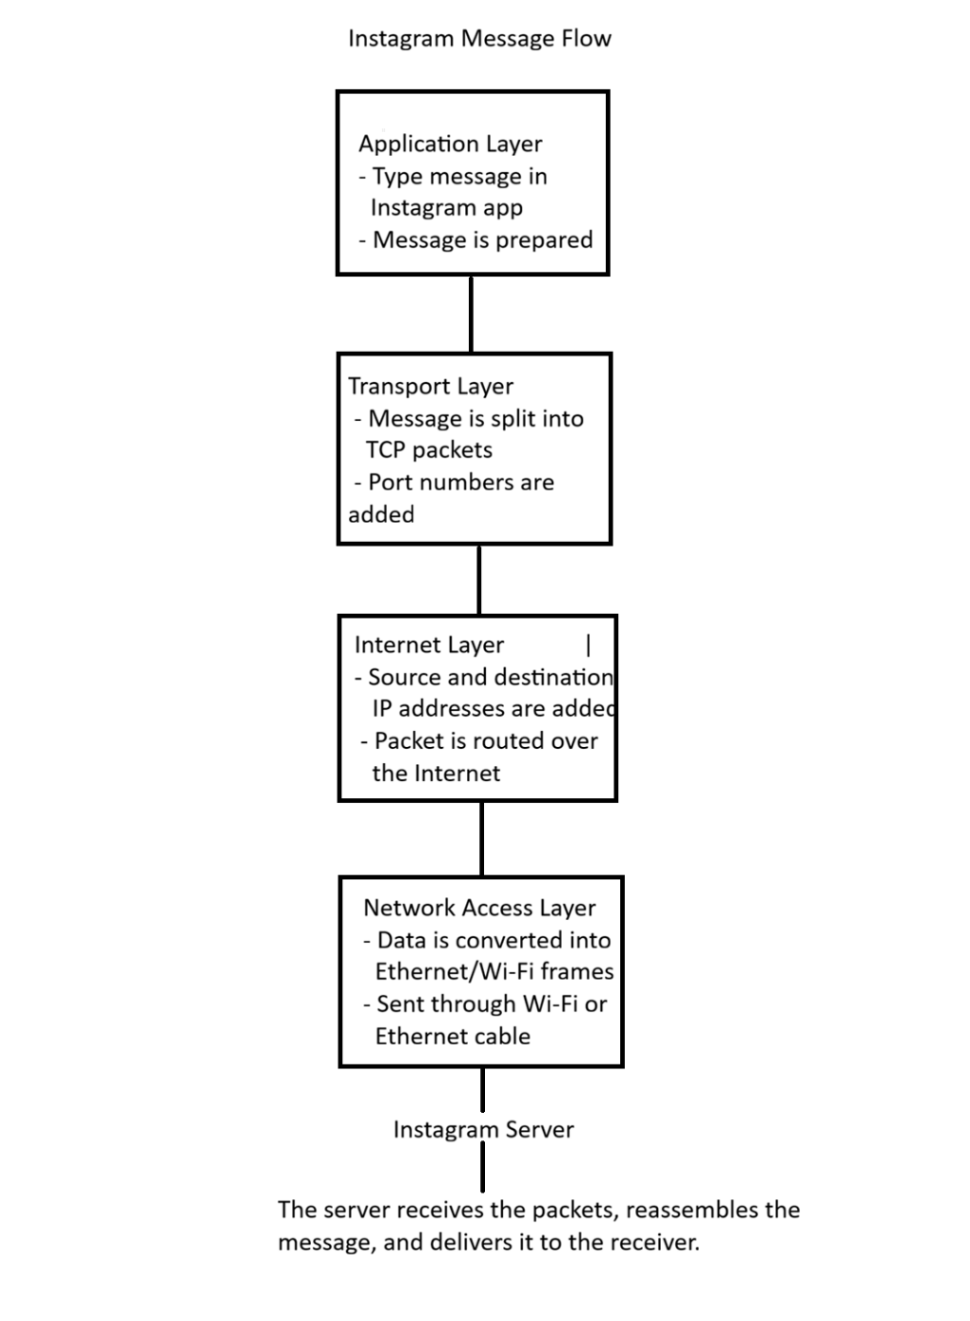
5.Pick any one packet you captured in Wireshark and write which TCP/IP layer it belongs to, how you identified it, and what real-world action in an app (like sending a WhatsApp message or booking a ticket on BookMyShow) it represents.
->Packet Analysis in Wireshark
Selected Packet: TCP Packet
TCP/IP Layer: Transport Layer
How I Identified It:
I identified this packet because the Protocol column in Wireshark showed TCP. When I opened the packet details, I found fields such as Source Port, Destination Port, Sequence Number, and Acknowledgment Number, which are part of the TCP header.
Real-World Action:
This packet represents sending a WhatsApp message. When I send a message, TCP divides the data into packets and ensures that all packets are delivered correctly and in the right order. After the receiver gets the message, TCP sends an acknowledgment to confirm successful delivery.
Conclusion
The selected packet belongs to the Transport Layer because it uses the TCP protocol, which provides reliable communication, error checking, and ordered delivery of data between devices.

