1.Log in to Cisco Packet Tracer or any network simulation tool, add a switch, and create two VLANs named 'Sales' and 'Support' with VLAN IDs 10 and 20.
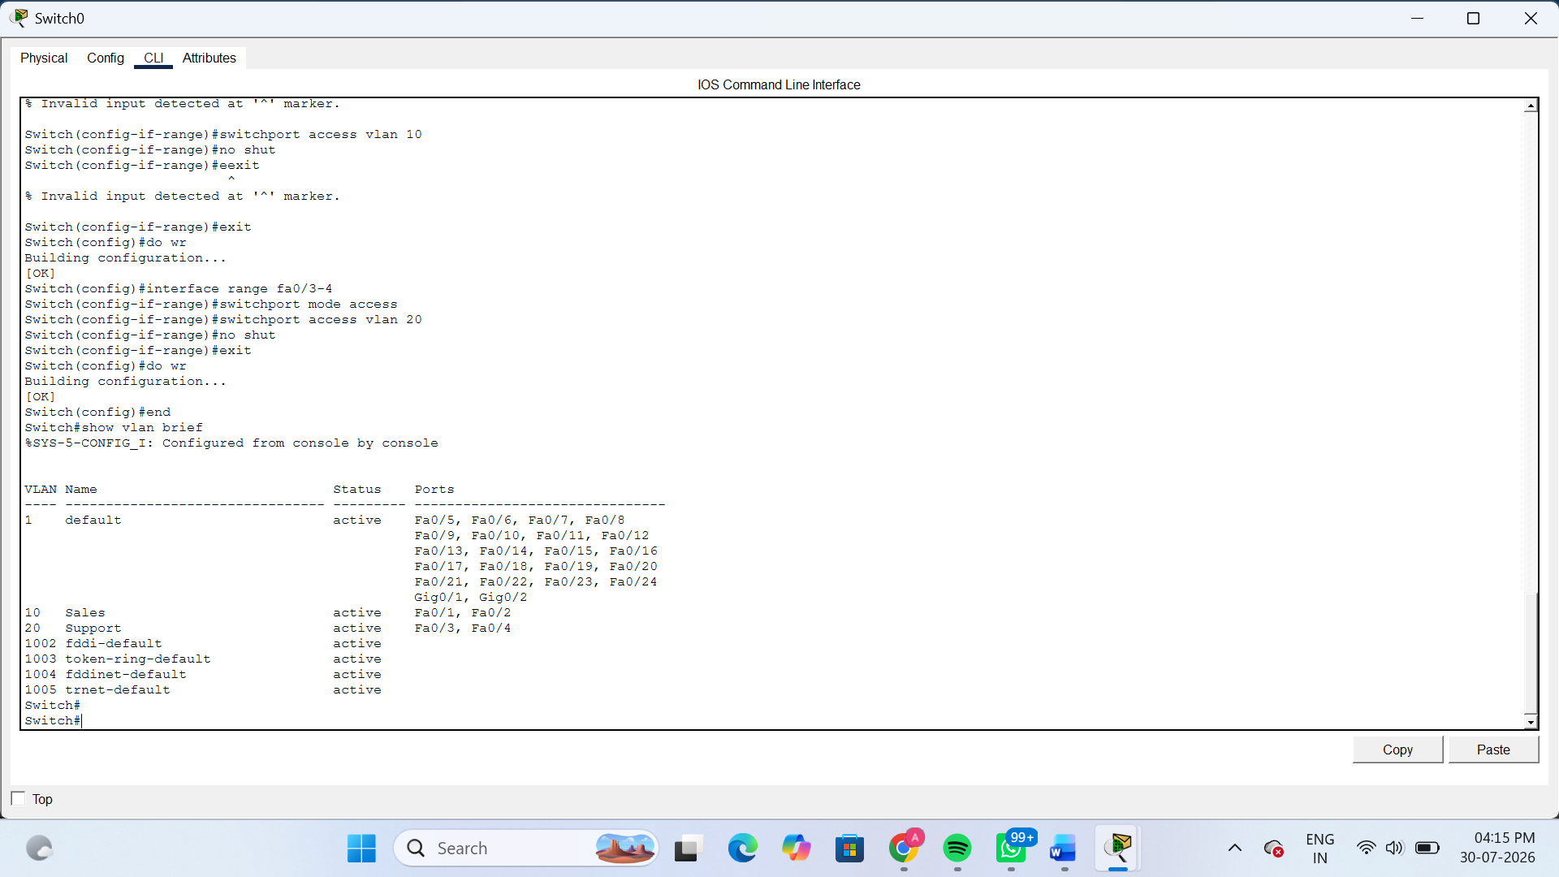
2.Assign three different switch ports to VLAN 10 (Sales) and two ports to VLAN 20 (Support), then verify the VLAN membership using the show vlan command.<br><br><em><strong>Hint:</strong> Use the interface range command to select multiple ports efficiently.</em>
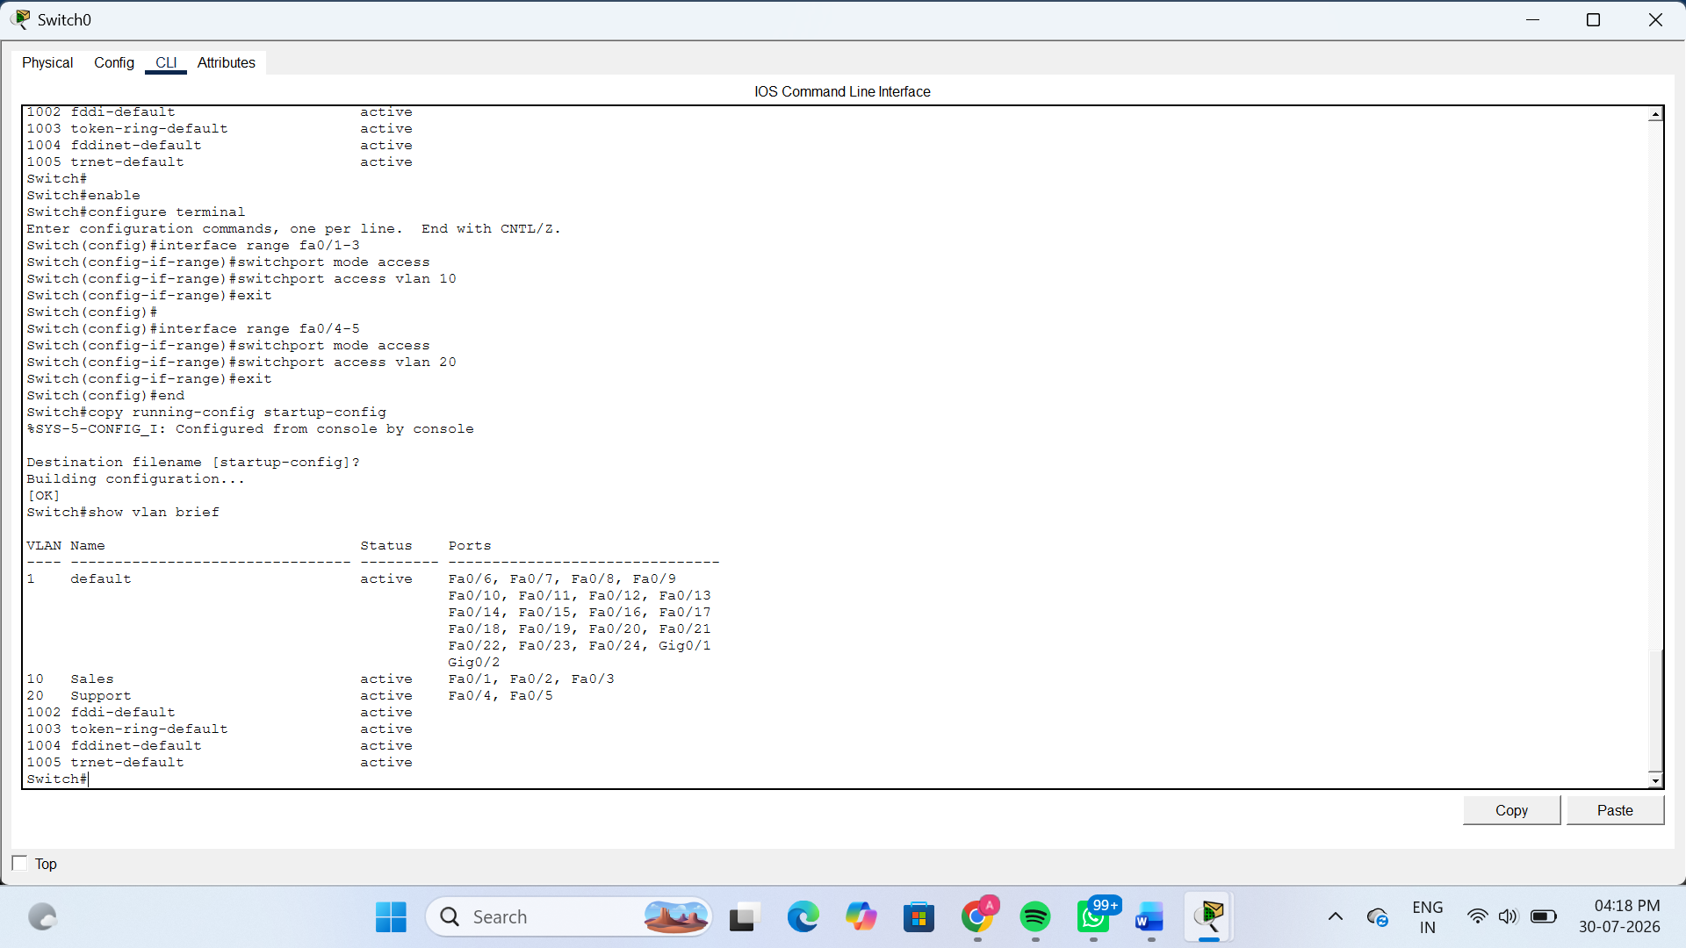
3.Connect two routers using a serial or Ethernet link in your simulation tool, assign IP addresses to their interfaces, and configure a static route on Router 1 to reach the LAN behind Router 2.

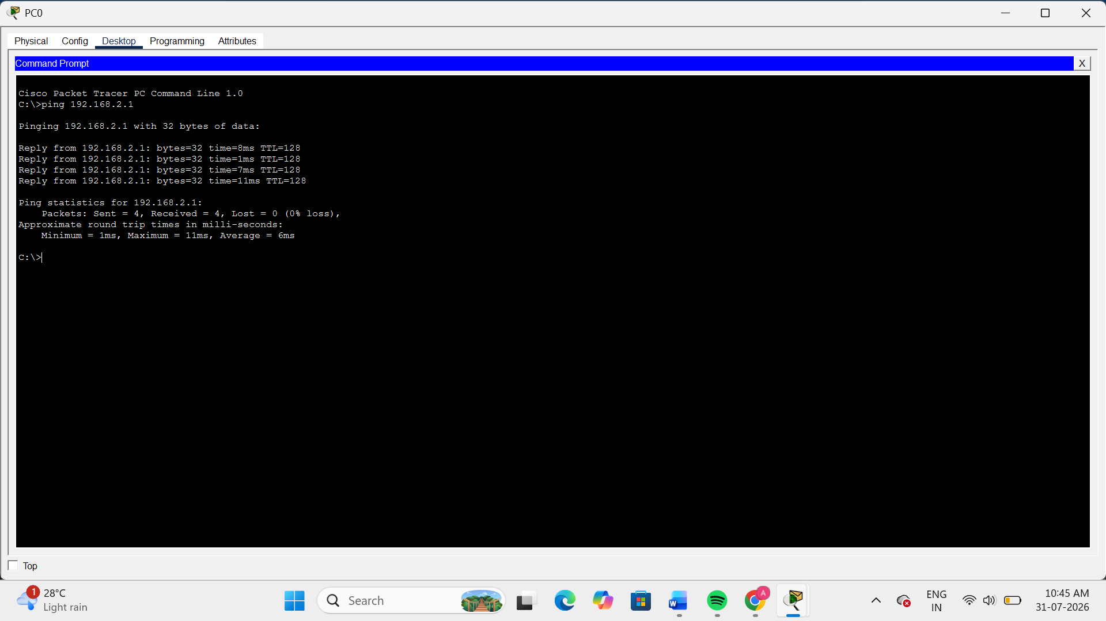
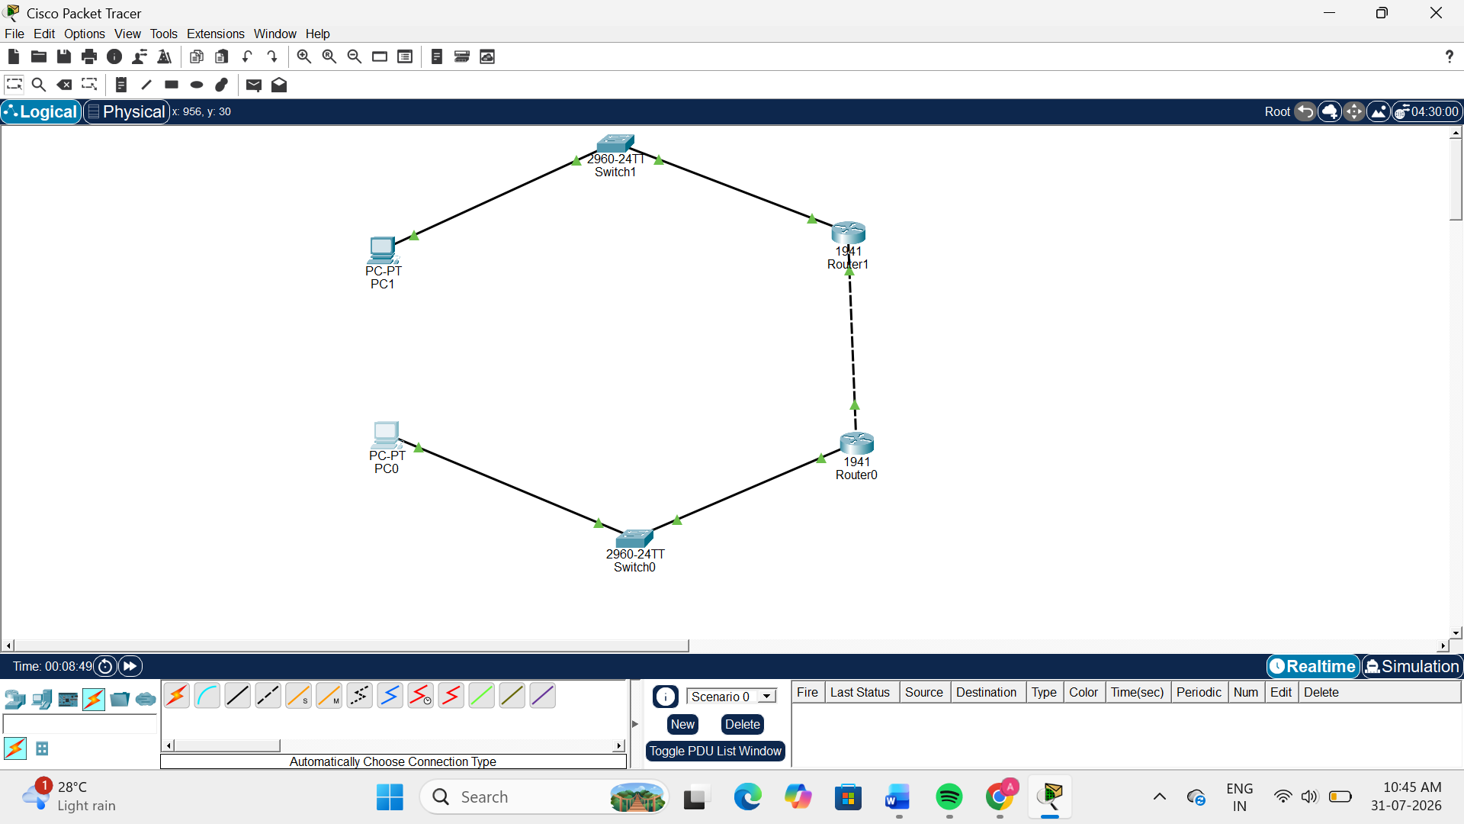
4.Simulate a scenario where a device in the 'Sales' VLAN tries to ping a device in the 'Support' VLAN and explain why the ping fails, then suggest what configuration would allow inter-VLAN communication.<br><br><em><strong>Hint:</strong> Think about router-on-a-stick or Layer 3 switch concepts.</em>
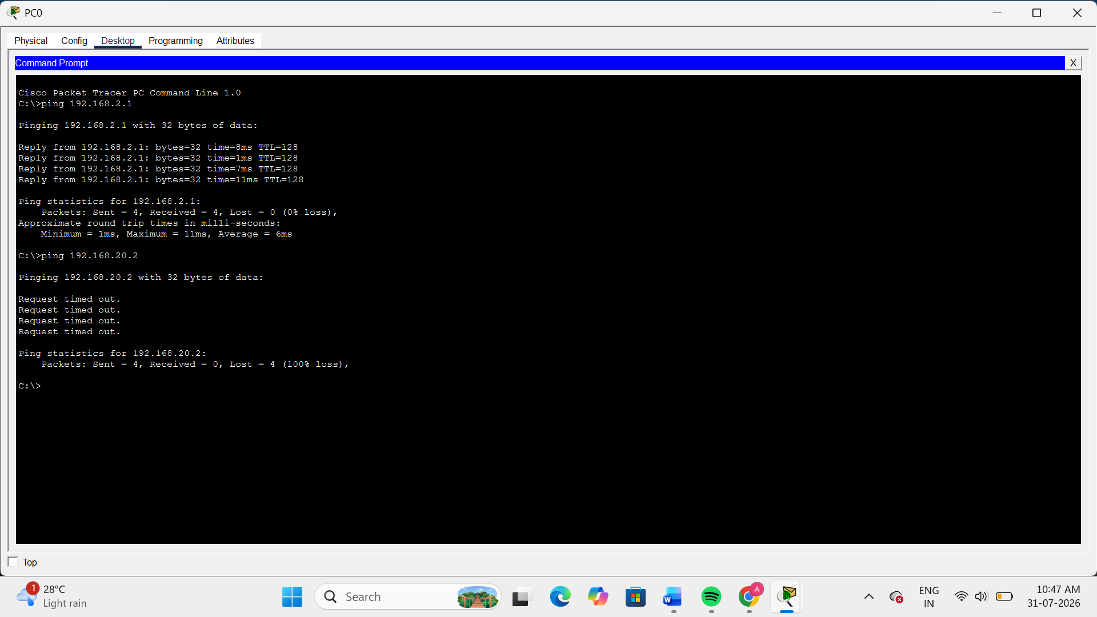
The ping fails because the Sales and Support devices are in different VLANs. A Layer 2 switch forwards traffic only within the same VLAN and cannot route traffic between different VLANs. Therefore, devices in VLAN 10 cannot communicate with devices in VLAN 20 without a Layer 3 device.

