1.List the key differences between IPv4 and IPv6 addressing by creating a two-column table with at least 4 points for each.
IPv4 | IPv6
Uses 32-bit addresses. | Uses 128-bit addresses.
Address format is decimal (e.g., 192.168.1.1). | Address format is hexadecimal (e.g., 2001:0db8:85a3::8a2e:0370:7334).
Supports about 4.3 billion unique IP addresses. | Supports 340 undecillion (almost unlimited) IP addresses.
Uses NAT (Network Address Translation) because of limited addresses. | Does not require NAT due to the huge address space.
Header is more complex and includes checksum. | Header is simpler and more efficient, with no header checksum.
Security (IPsec) is optional. | IPsec support is built into the protocol.

2.Given the following scenario: You have 4 devices (laptop, phone, smart TV, and printer) connected to your home WiFi. Assign a unique static IPv4 address to each device using the 192.168.10.0/24 network, and write down the IP, subnet mask, and default gateway for each device.
Device | IP Address | Subnet Mask | Default Gateway
Laptop | 192.168.10.10 | 255.255.255.0 | 192.168.10.1
Phone | 192.168.10.11 | 255.255.255.0 | 192.168.10.1
Smart TV | 192.168.10.12 | 255.255.255.0 | 192.168.10.1
Printer | 192.168.10.13 | 255.255.255.0 | 192.168.10.1
Network Details:
- Network Address: 192.168.10.0/24
- Subnet Mask: 255.255.255.0
- Default Gateway (WiFi Router): 192.168.10.1
This is a correct static IP addressing scheme where each device has a unique IP address within the same subnet.

3.Calculate the number of valid subnets and hosts per subnet if you use a /27 CIDR subnet mask on a 192.168.1.0 network. List the first three valid subnet address ranges (network address to broadcast address) and the usable host IPs in each.
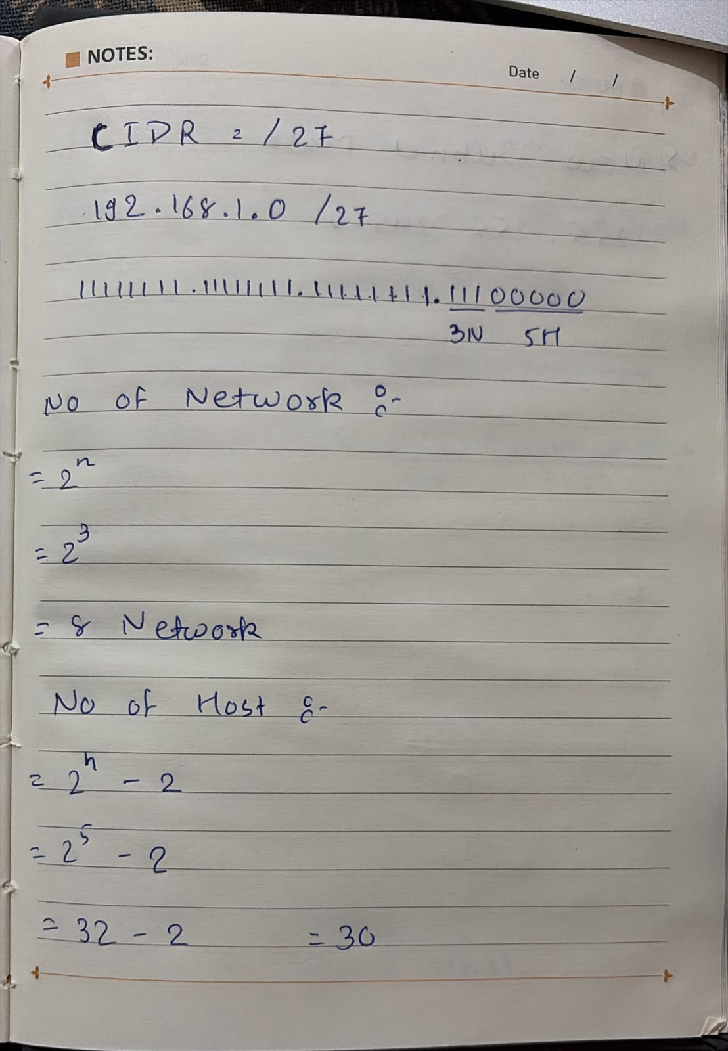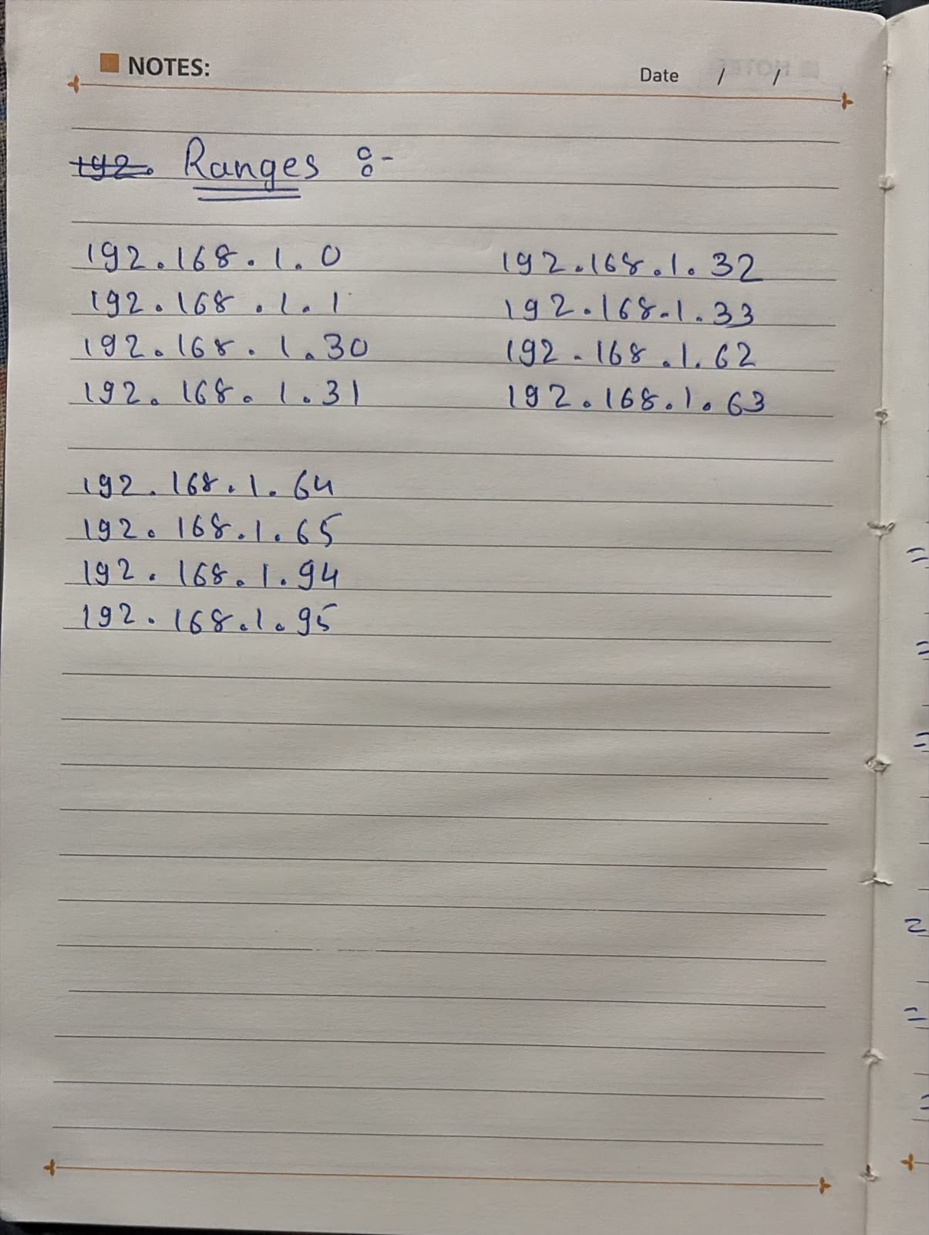
Subnet | Network Address | Usable Host Range | Broadcast Address
1 | 192.168.1.0 | 192.168.1.1 – 192.168.1.30 | 192.168.1.31
2 | 192.168.1.32 | 192.168.1.33 – 192.168.1.62 | 192.168.1.63
3 | 192.168.1.64 | 192.168.1.65 – 192.168.1.94 | 192.168.1.95

4.You are given the IP address 10.0.5.17 with subnet mask 255.255.255.0. Determine the network address, broadcast address, and the range of valid host addresses for this subnet.<br><br><em><strong>Hint:</strong> Convert the subnet mask to CIDR notation and use bitwise AND for network address calculation.</em>
->Step 1: Convert Subnet Mask to CIDR
Subnet Mask = 255.255.255.0
Binary = 11111111.11111111.11111111.00000000
CIDR = /24
Step 2: Network Address (Bitwise AND)
IP Address | 10.0.5.17
Binary | 00001010.00000000.00000101.00010001
Subnet Mask | 11111111.11111111.11111111.00000000
Network Address | 00001010.00000000.00000101.00000000
Network Address = 10.0.5.0
Step 3: Broadcast Address
Since the subnet is /24, set all host bits to 1.
Broadcast Address = 10.0.5.255
Step 4: Valid Host Range
First Host = 10.0.5.1
Last Host = 10.0.5.254
5.Use an online subnet calculator tool (such as https://www.subnet-calculator.com/) to verify your answer for the previous task. Take a screenshot of your calculation and write one line explaining if your manual answer matched the tool's output.
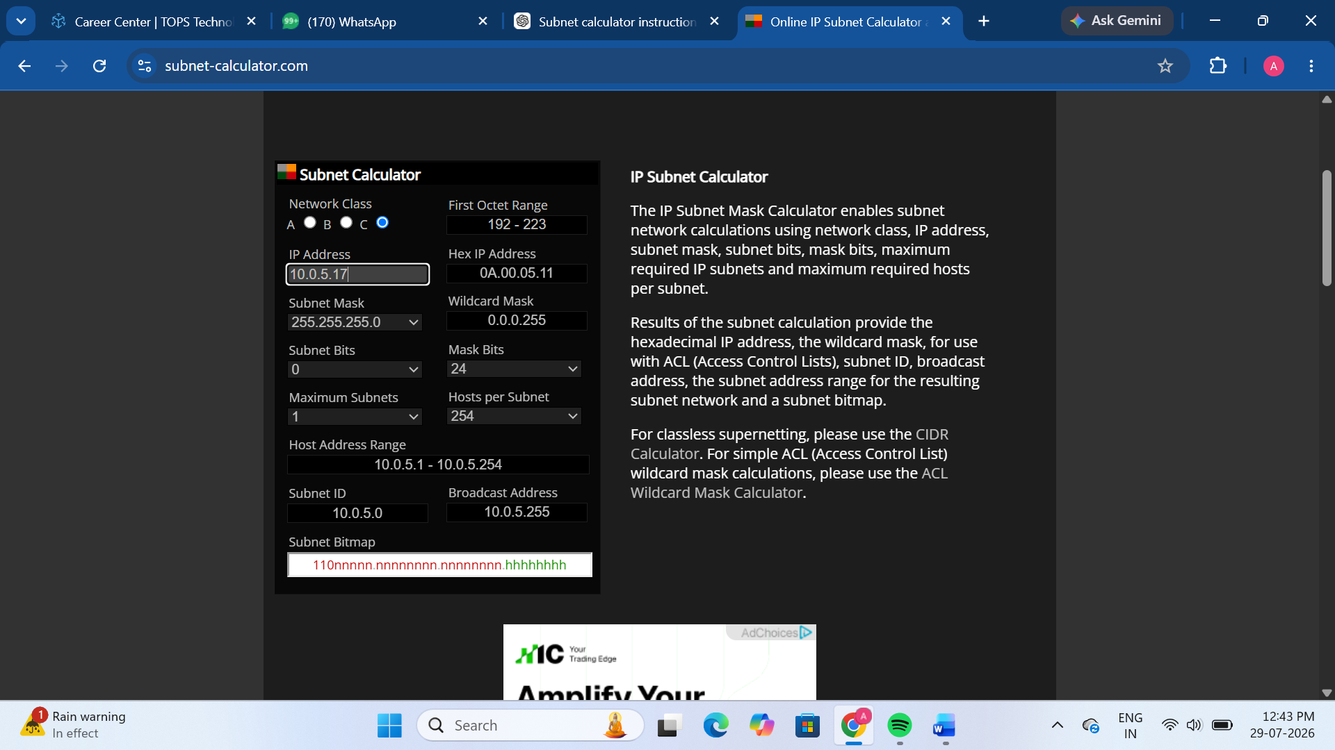
My manual calculation matched the subnet calculator's output. The network address is 10.0.5.0, the broadcast address is 10.0.5.255, and the usable host range is 10.0.5.1 to 10.0.5.254.

