1.Open Windows Defender Firewall settings on your computer and create a new outbound rule to block all traffic from the Spotify desktop app.
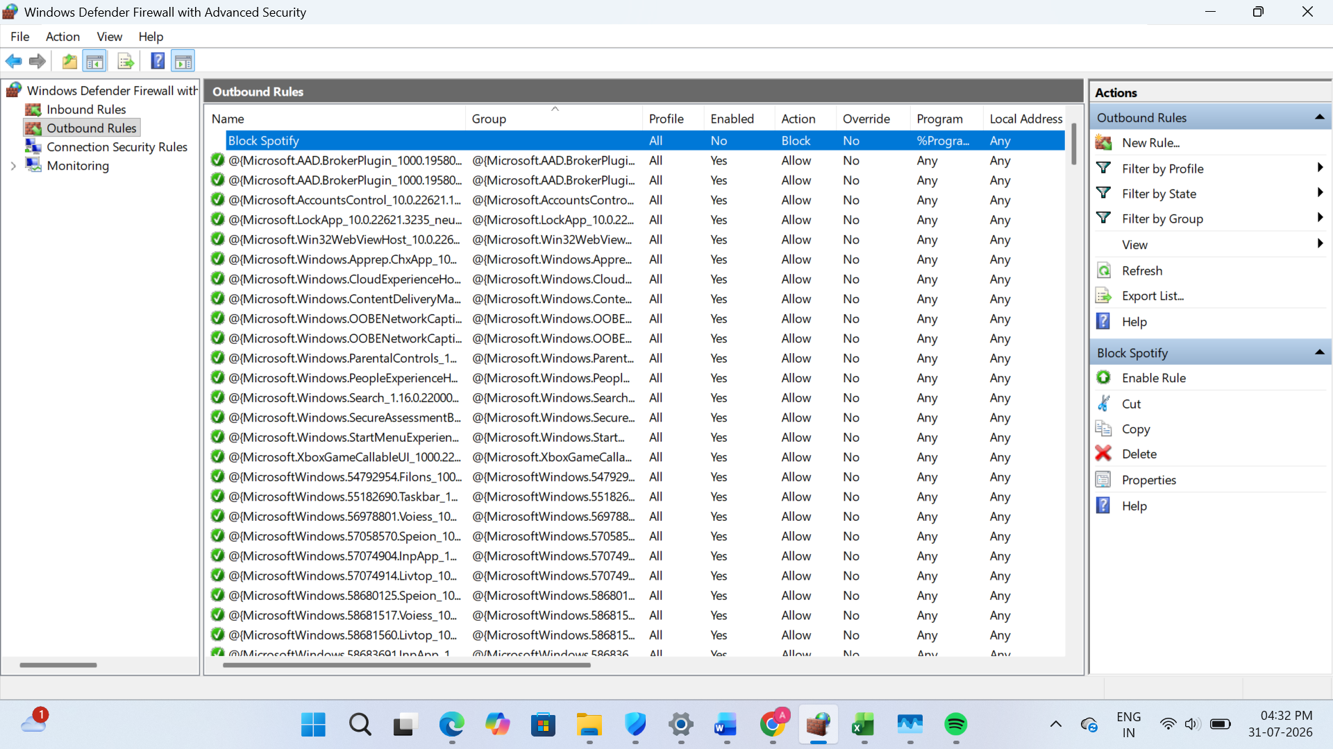
2.Set up an inbound rule in Windows Defender Firewall to allow incoming connections only for Google Chrome on port 443 (HTTPS).
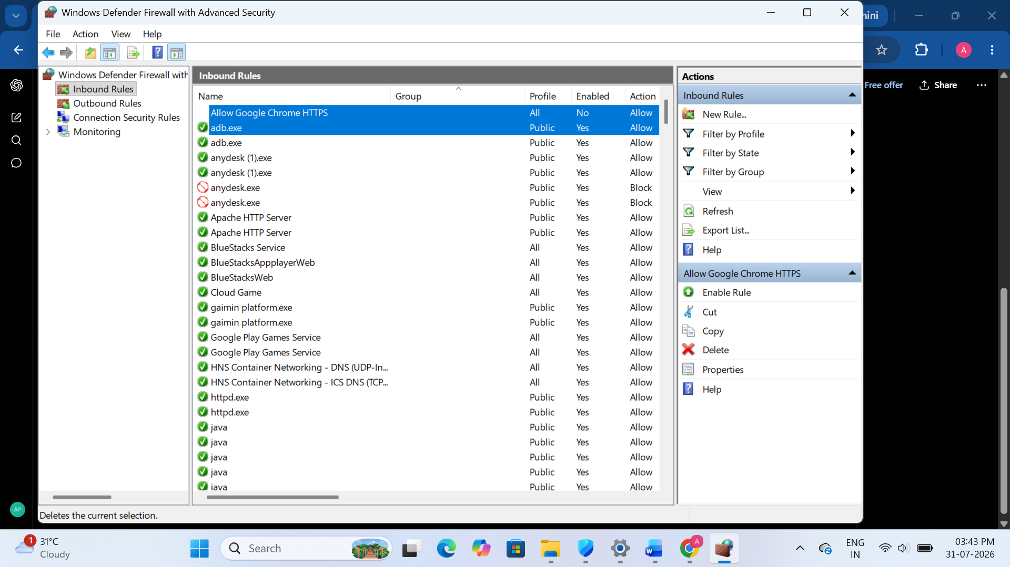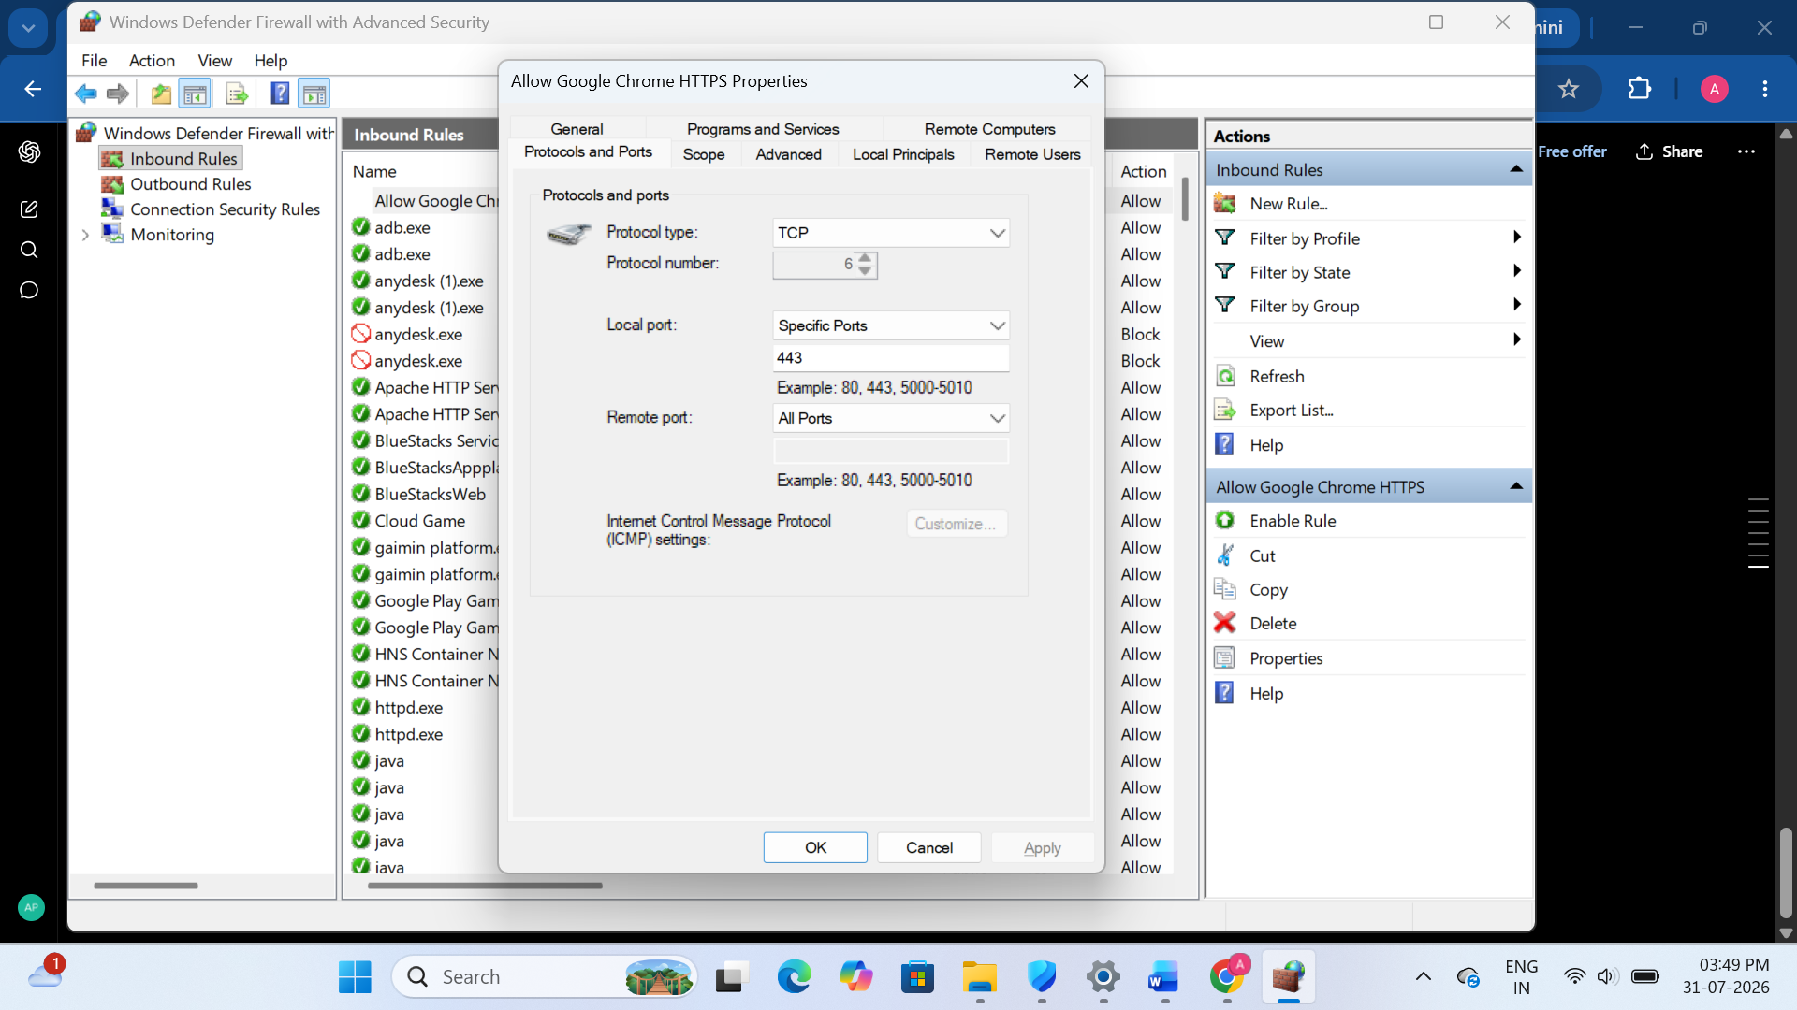
3.Document, step-by-step, how you would block all traffic from a specific IP address (for example, 123.45.67.89) using Windows Defender Firewall.<br><br><em><strong>Hint:</strong> Use the 'Scope' tab when creating a new rule to specify the IP address.</em>
Steps:
- Open Windows Defender Firewall with Advanced Security.
- Click Inbound Rules from the left panel.
- Click New Rule... from the right panel.
- Select Custom and click Next.
- Keep All Programs selected and click Next.
- Keep Any Protocol selected and click Next.
- In the Scope tab:
- Under Which remote IP addresses does this rule apply to?
- Select These IP addresses.
- Click Add.
- Enter the IP address:
- 123.45.67.89
- Click OK, then Next.
8.Select Block the connection and click Next.
9.Select all profiles (Domain, Private, Public) and click Next.
10.Enter the rule name:
- Block IP 123.45.67.89
11.Click Finish.
- Verification
- Open Inbound Rules.
- Confirm that the rule Block IP 123.45.67.89 is listed, enabled, and its Action is Block.
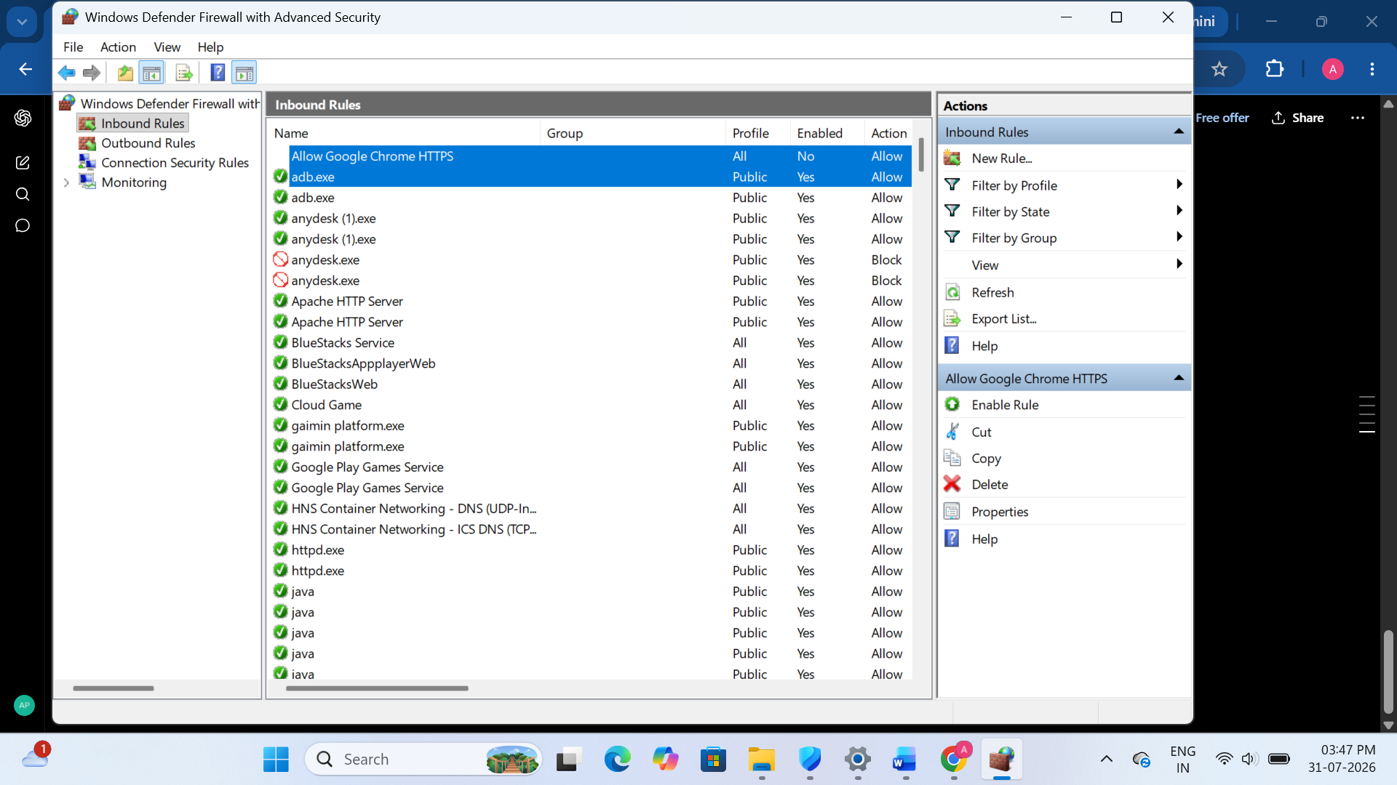
4.Compare hardware firewalls (like those used in large offices) and software firewalls (like Windows Defender) by listing 3 key differences and a use case for each.
Feature | Hardware Firewall | Software Firewall
Location | Installed as a separate physical device | Installed on a computer as software
Protection | Protects the entire network | Protects only the individual computer
Cost | More expensive | Usually free or low cost (e.g., Windows Defender Firewall)

