1.Given a network address of 192.168.10.0/24, divide it into 4 equal subnets and write down the subnet mask, network address, and broadcast address for each subnet.
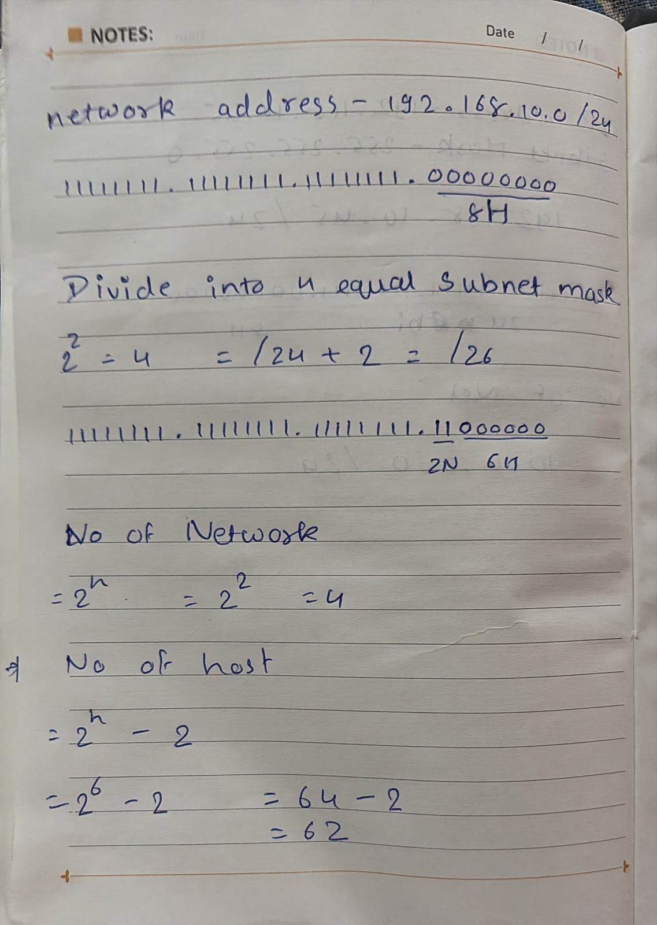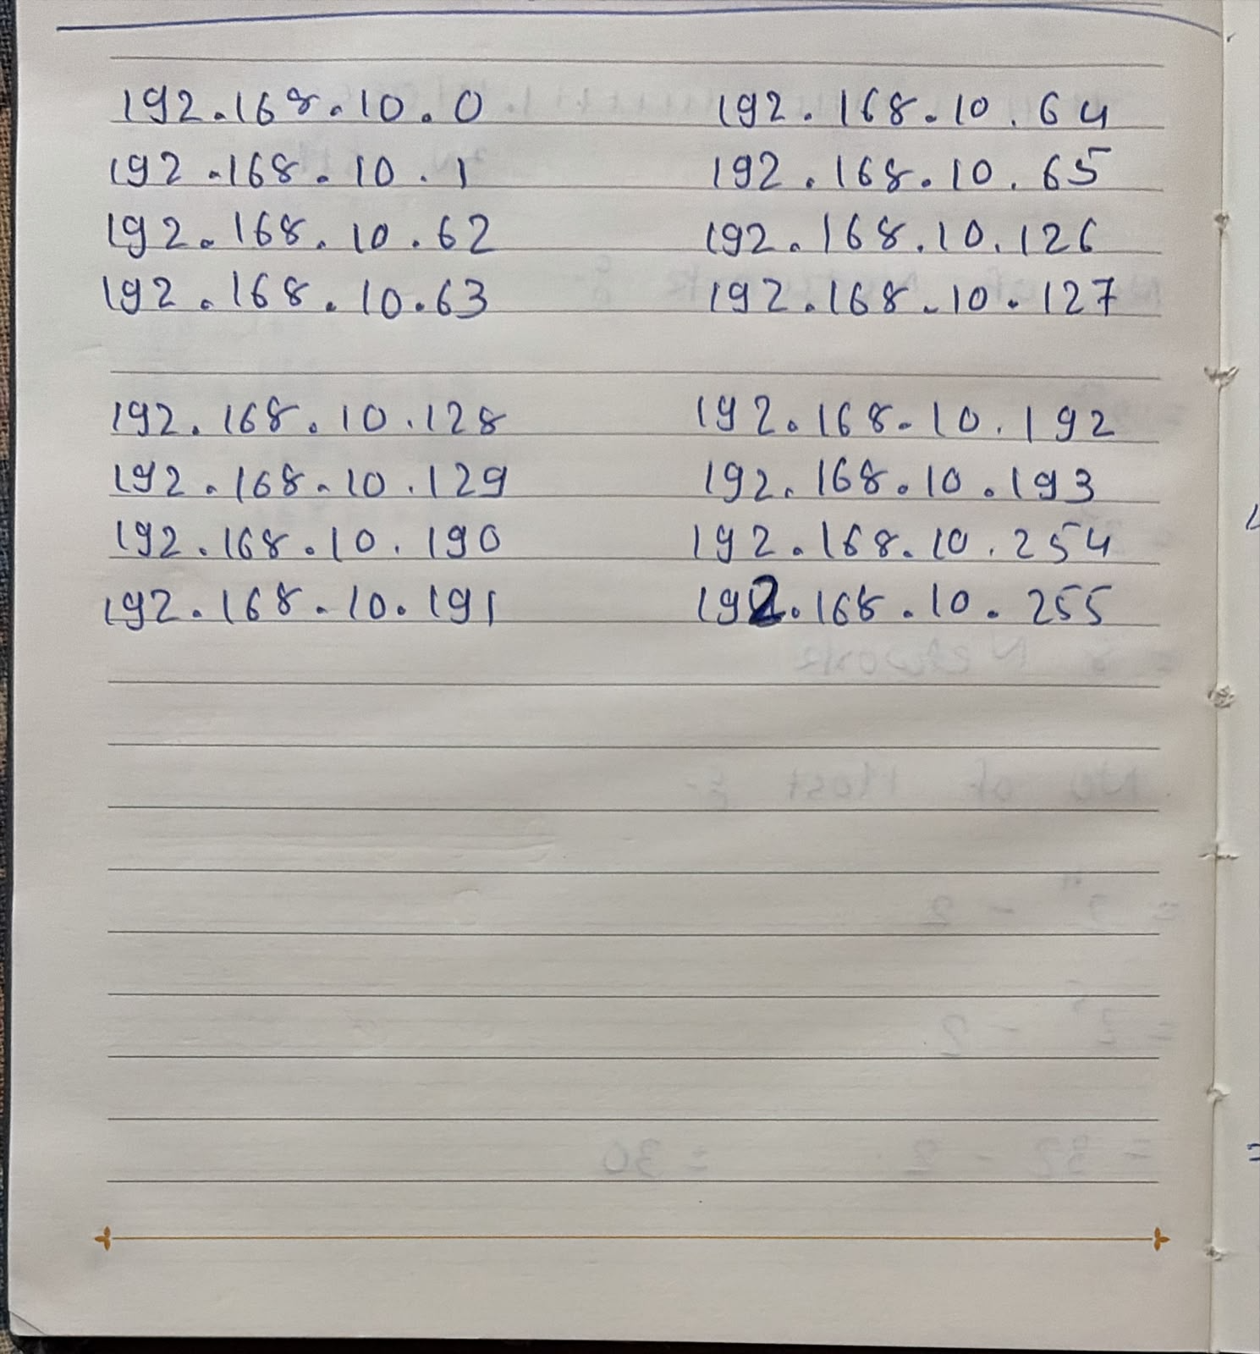
2.For one of the subnets you created, assign valid IP addresses to 5 devices (such as a router, two laptops, a printer, and a mobile) and list which IP goes to which device.<br><br><em><strong>Hint:</strong> Make sure not to use the network or broadcast address for any device.</em>
valid IP range:
192.168.10.1 – 192.168.10.62
Device | IP Address
Router | 192.168.10.1
Laptop 1 | 192.168.10.2
Laptop 2 | 192.168.10.3
Printer | 192.168.10.4
Mobile | 192.168.10.5

3.Draw a simple diagram (hand-drawn or digital) showing your subnet plan: label each subnet, the range of IPs, and where each device is connected.
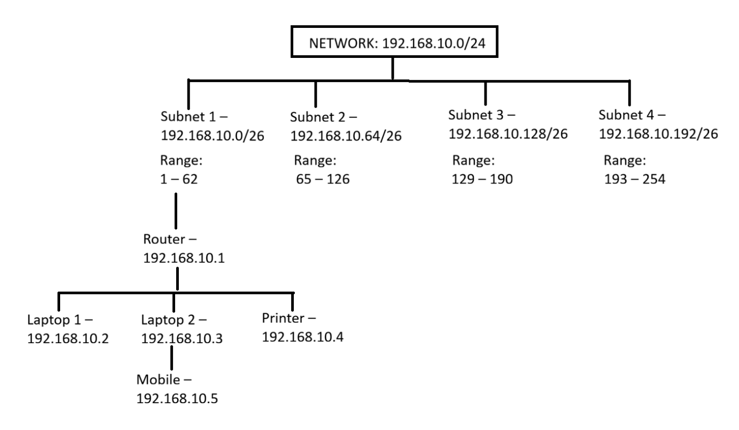
4.Document step-by-step how you calculated the subnet mask, number of hosts per subnet, and assigned IP addresses for your plan, as if you are explaining it to a friend who is new to subnetting.
Step 1: Identify the Network
The given network address is 192.168.10.0/24. A /24 subnet mask means there are 24 network bits and 8 host bits.
Step 2: Divide into 4 Equal Subnets
To create 4 equal subnets, I borrowed 2 bits from the host portion because 2² = 4. Therefore, the new subnet mask became /26 (255.255.255.192).
Step 3: Calculate Hosts per Subnet
After borrowing 2 bits, 6 host bits were left.
Usable Hosts = 2⁶ − 2 = 64 − 2 = 62
So, each subnet can have 62 usable host IP addresses.
Step 4: Create the Subnets
The four subnets are:
- 192.168.10.0/26 → Broadcast: 192.168.10.63
- 192.168.10.64/26 → Broadcast: 192.168.10.127
- 192.168.10.128/26 → Broadcast: 192.168.10.191
- 192.168.10.192/26 → Broadcast: 192.168.10.255
Step 5: Assign IP Addresses
I selected the first subnet (192.168.10.0/26). I did not use the network address (192.168.10.0) or the broadcast address (192.168.10.63) because they are reserved.
The device IP addresses are:
- Router – 192.168.10.1
- Laptop 1 – 192.168.10.2
- Laptop 2 – 192.168.10.3
- Printer – 192.168.10.4
- Mobile – 192.168.10.5

