1.Open Cisco Packet Tracer and create a new project file named 'HomeWiFiNetwork.pkt' with three PCs and one wireless router connected appropriately.
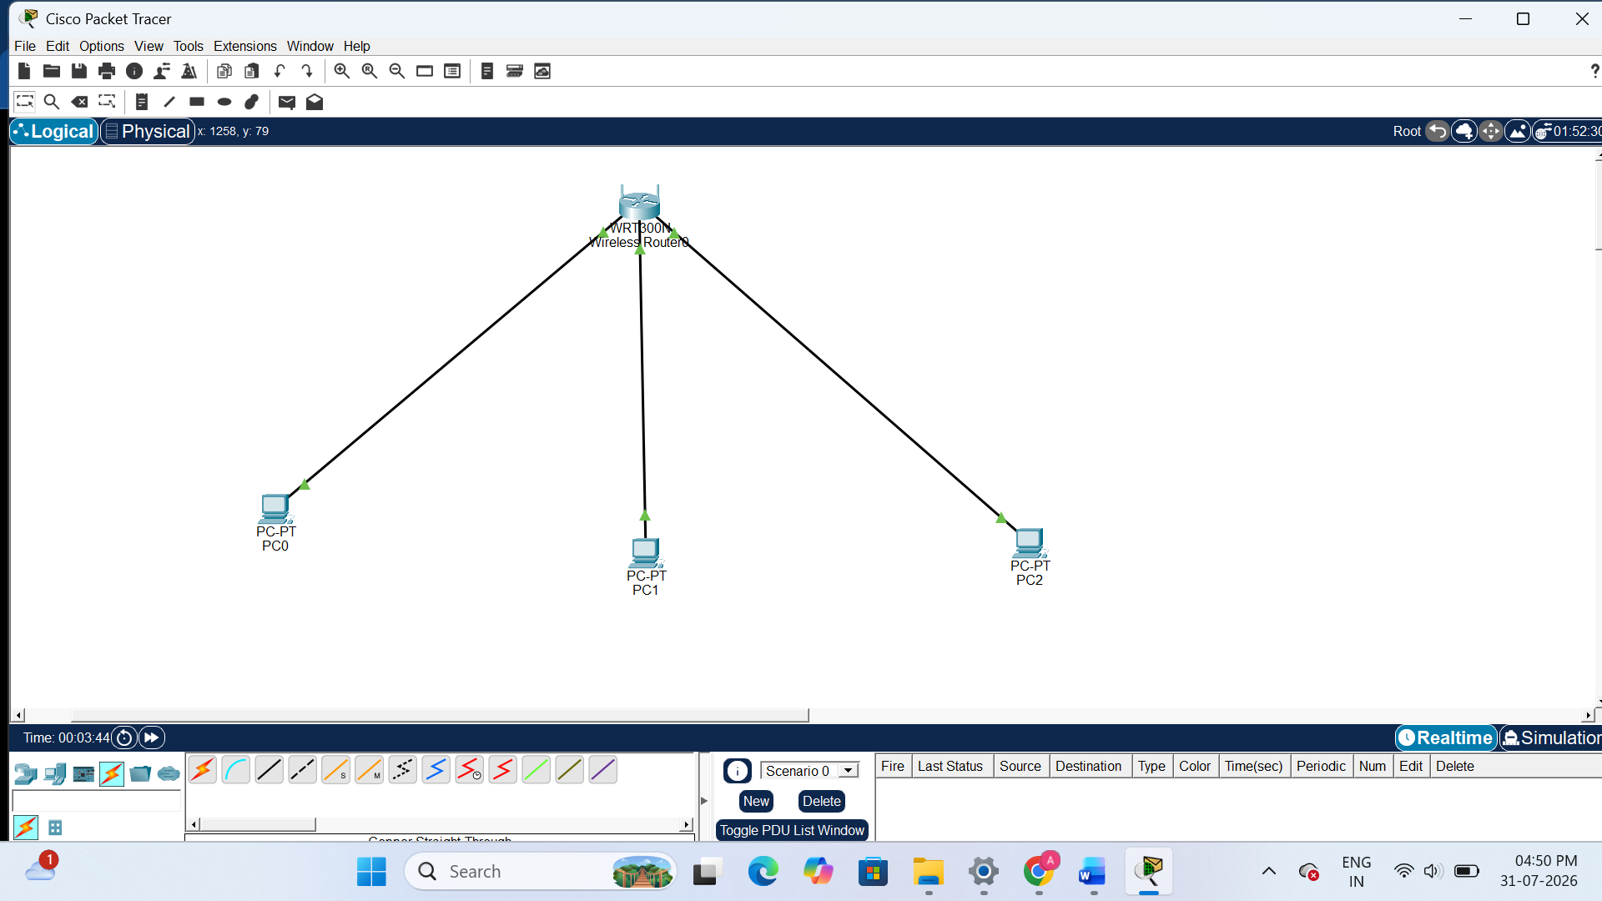
2.Assign static IP addresses to each PC in your Packet Tracer network so they are on the same subnet (e.g., 192.168.10.x), and configure the default gateway to the router's IP.
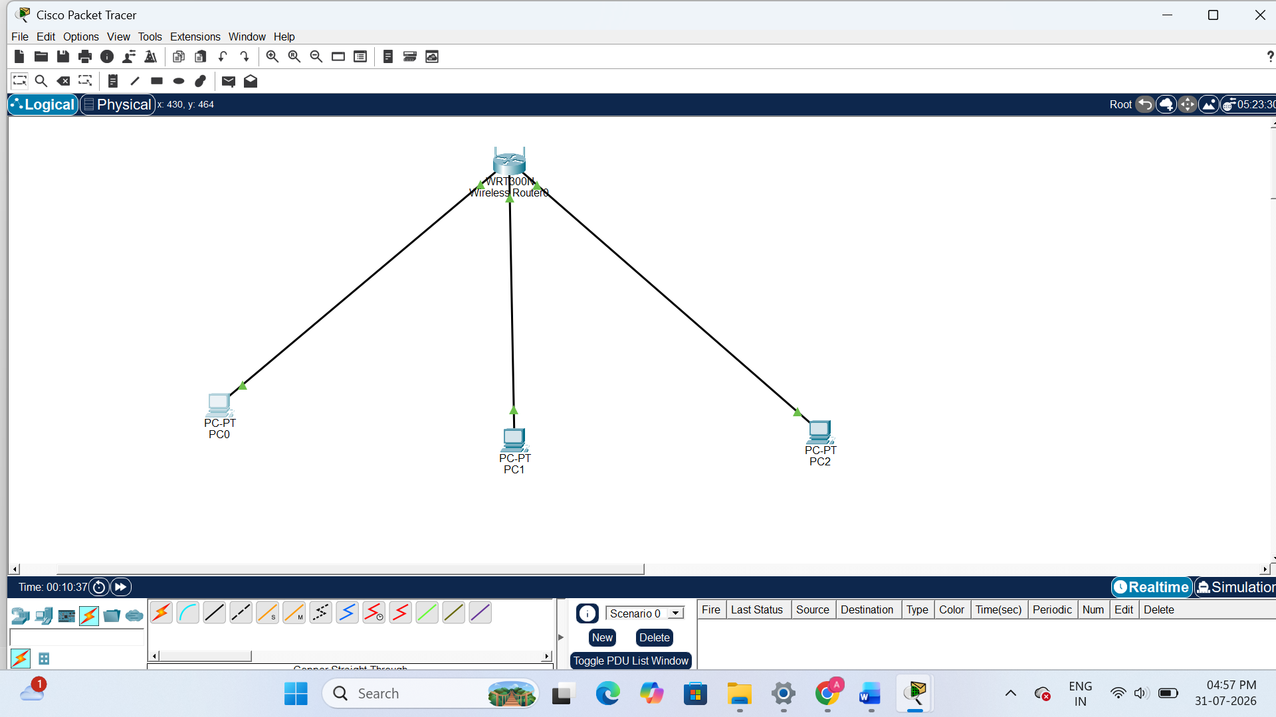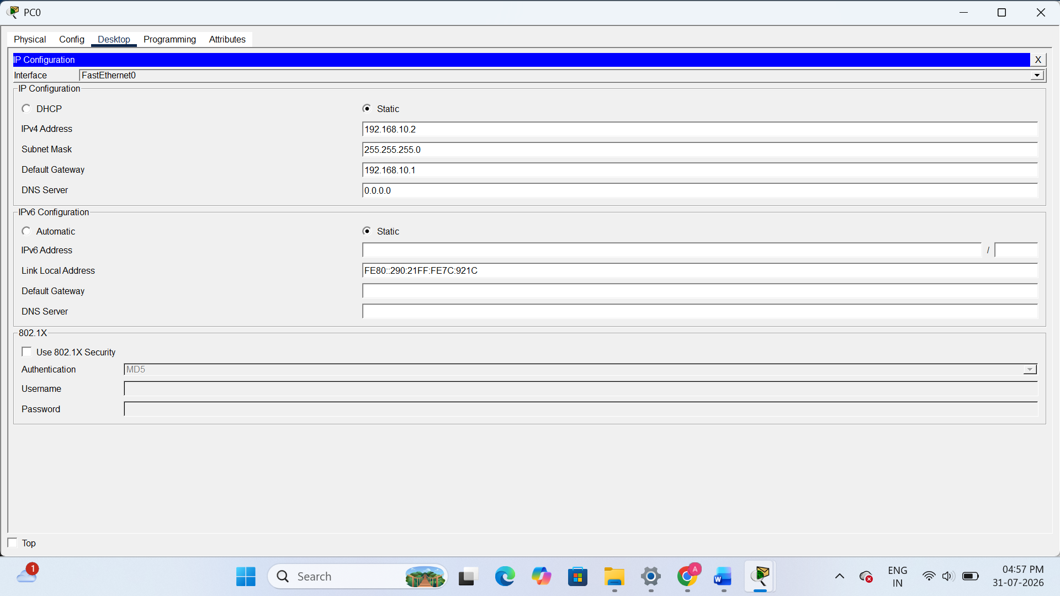
3.Test connectivity by using the Packet Tracer 'ping' tool to verify that all PCs can communicate with each other and the router.<br><br><em><strong>Hint:</strong> Use the Command Prompt tool on each PC and type 'ping [other PC’s IP]'.</em>
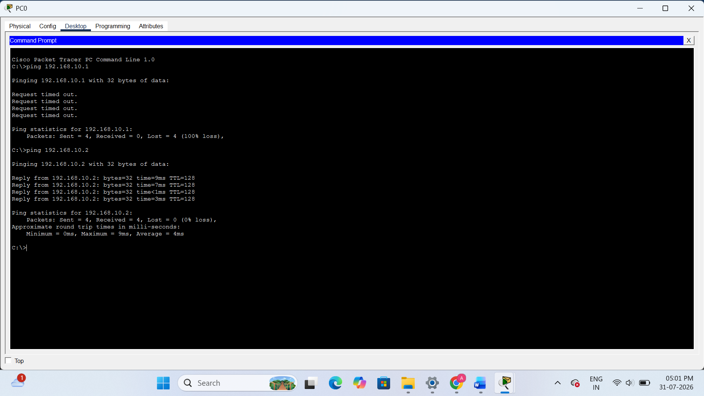
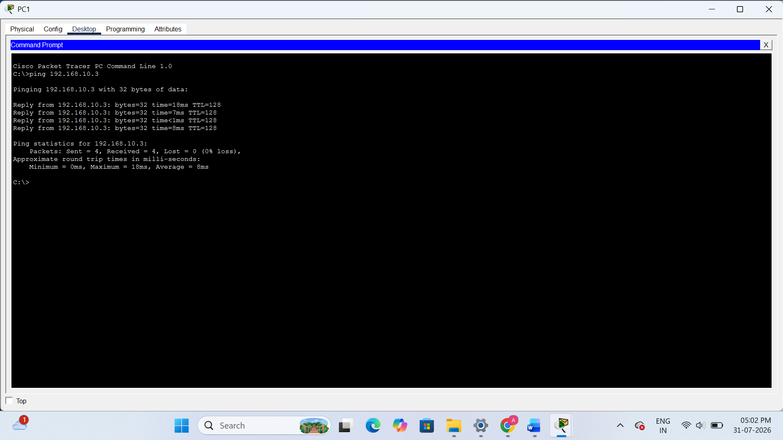
4.Document each step you took to build and configure your Packet Tracer network, including screenshots of your topology and the IP configuration windows for each PC, in a Word or PDF file.
Packet Tracer Network Configuration Report
Experiment: Home WiFi Network
Step 1: Create the Network Topology
- Opened Cisco Packet Tracer.
- Added 3 PCs (PC0, PC1, PC2).
- Added one Wireless Router (WRT300N).
- Connected all PCs to the router using Copper Straight-Through cables.
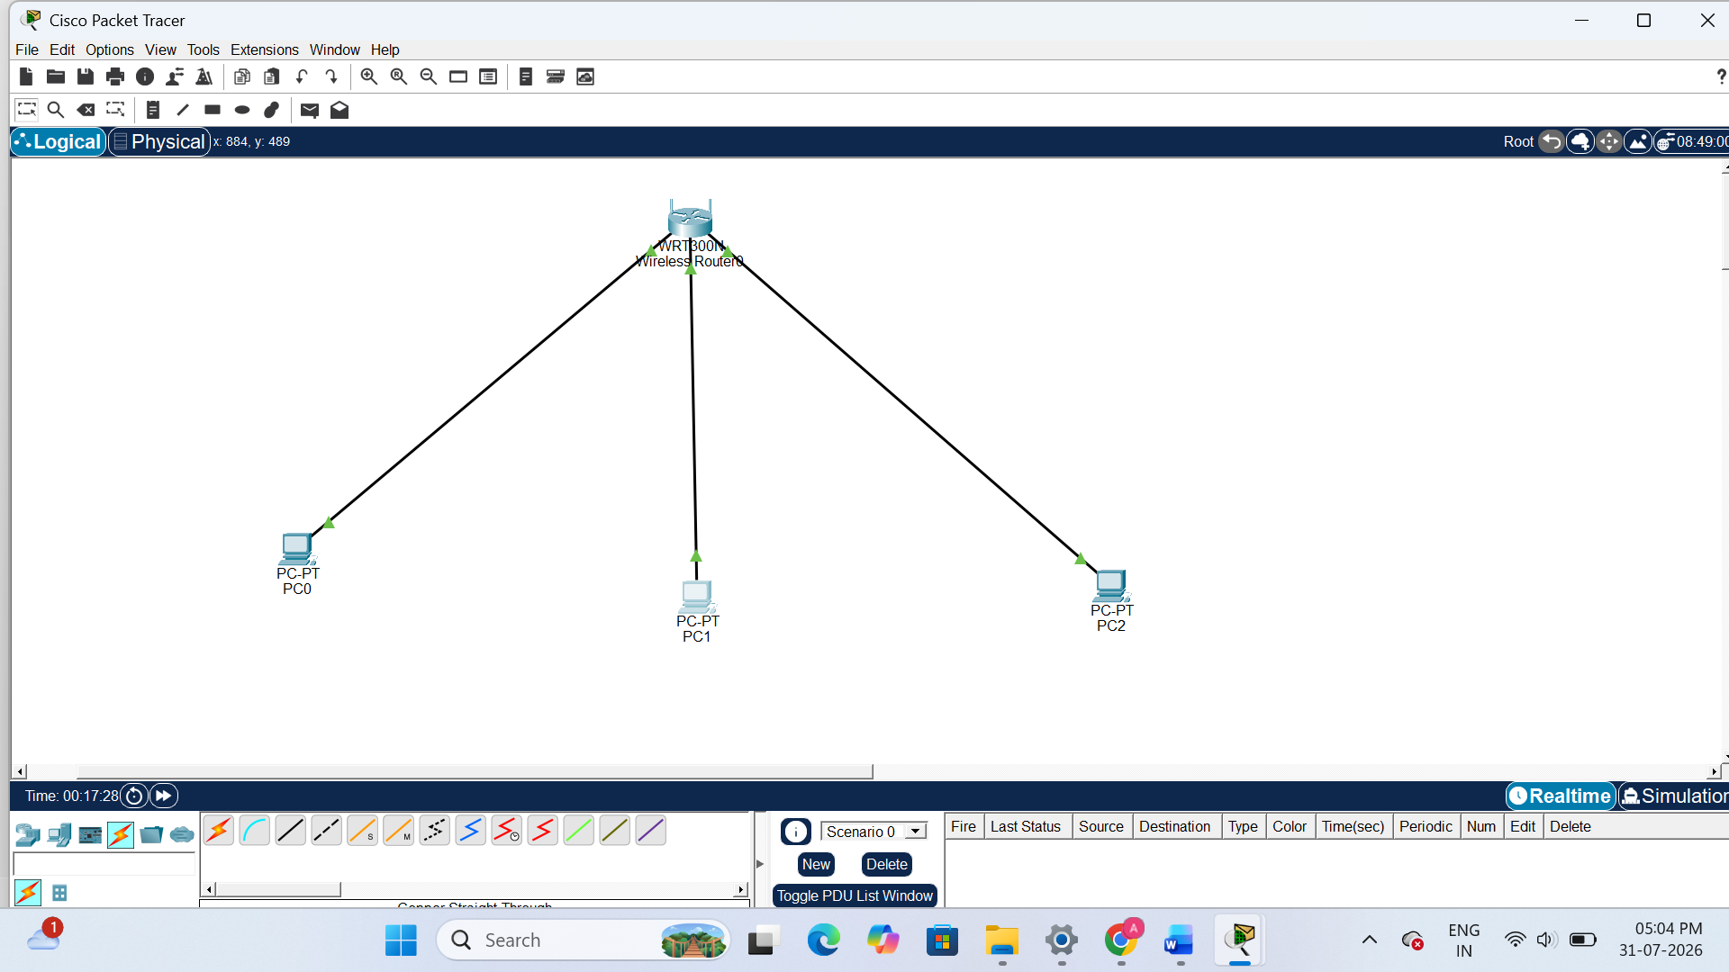
Step 2: Configure Static IP Addresses
PC0
- IP Address: 192.168.10.2
- Subnet Mask: 255.255.255.0
- Default Gateway: 192.168.10.1
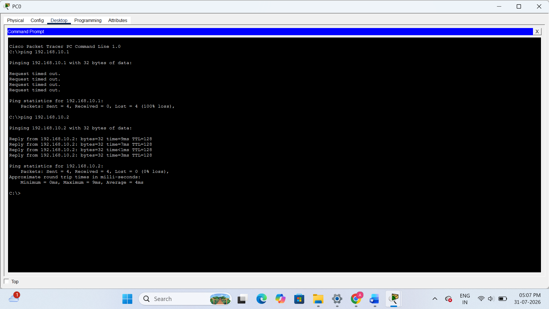
PC1
- IP Address: 192.168.10.3
- Subnet Mask: 255.255.255.0
- Default Gateway: 192.168.10.1
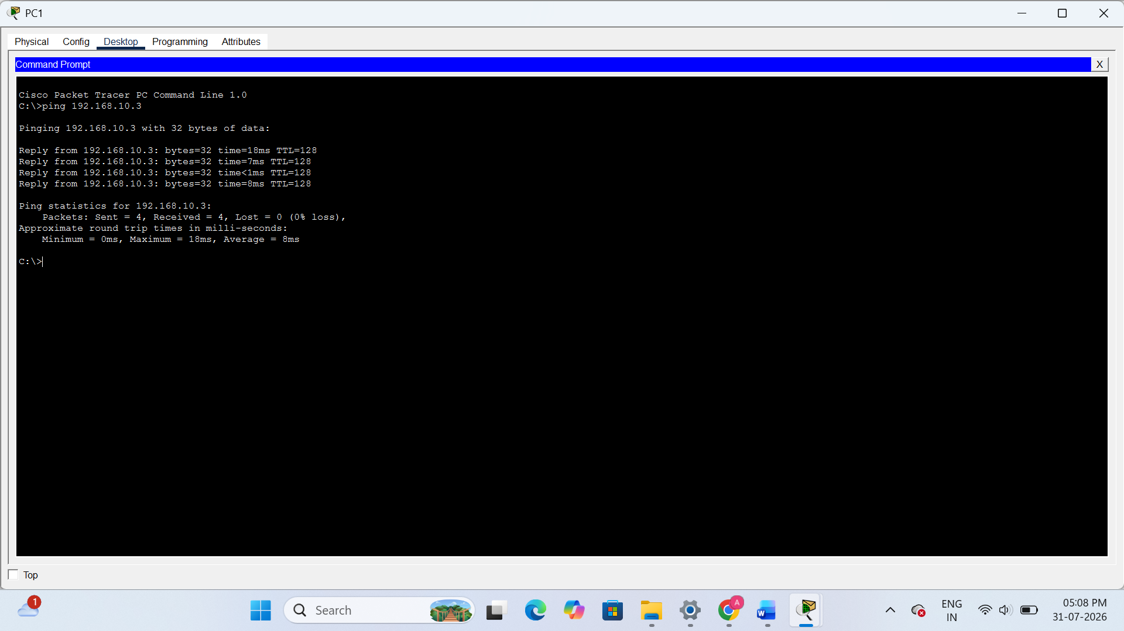
PC2
- IP Address: 192.168.10.4
- Subnet Mask: 255.255.255.0
- Default Gateway: 192.168.10.1
