1.Use the ping command to test connectivity from your computer to www.youtube.com and note the average response time.
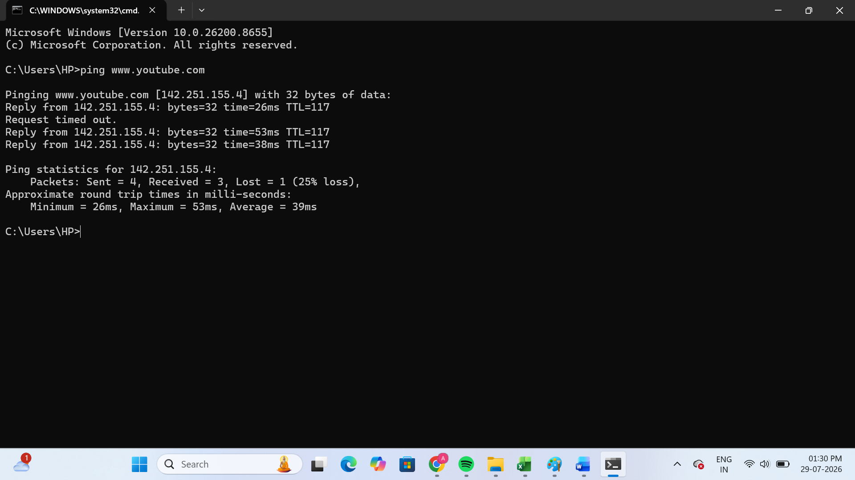
The ping test to www.youtube.com was successful, and the average response time was 39 ms.
2.Run the traceroute (tracert on Windows) command to www.flipkart.com and list all the intermediate hops shown in the output.<br><br><em><strong>Hint:</strong> Each hop represents a network device your data passes through to reach the destination.</em>
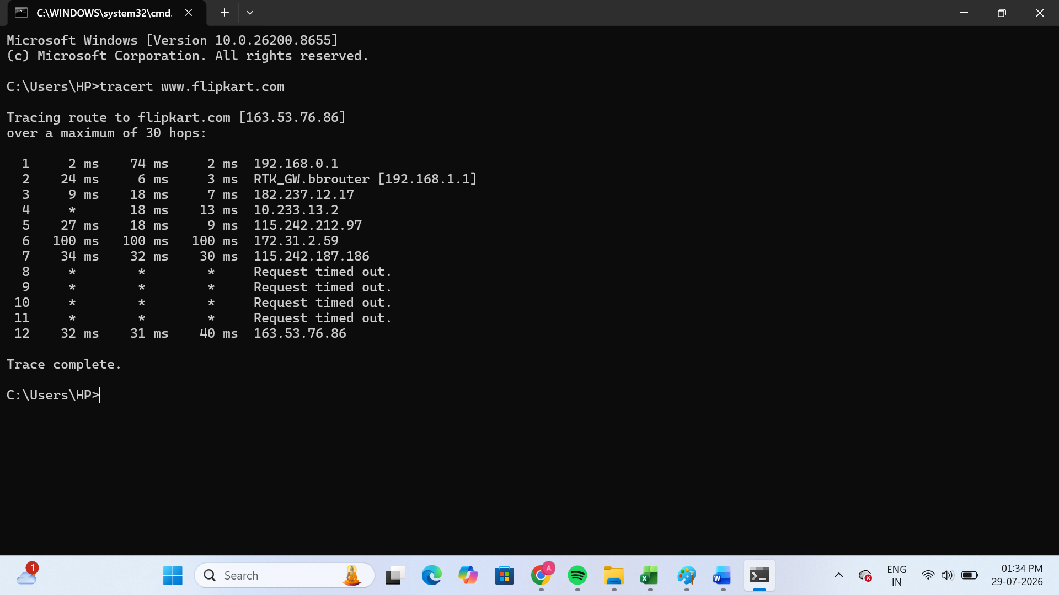
Hop | IP Address / Hostname
1 | 192.168.0.1
2 | RTK_GW.bbrouter (192.168.1.1)
3 | 182.237.12.17
4 | 10.233.13.2
5 | 115.242.212.97
6 | 172.31.2.59
7 | 115.242.187.186
8 | Request timed out
9 | Request timed out
10 | Request timed out
11 | Request timed out
12 | 163.53.76.86 (www.flipkart.com)

3.Use the nslookup tool to find the IP address of www.zomato.com and record the result.
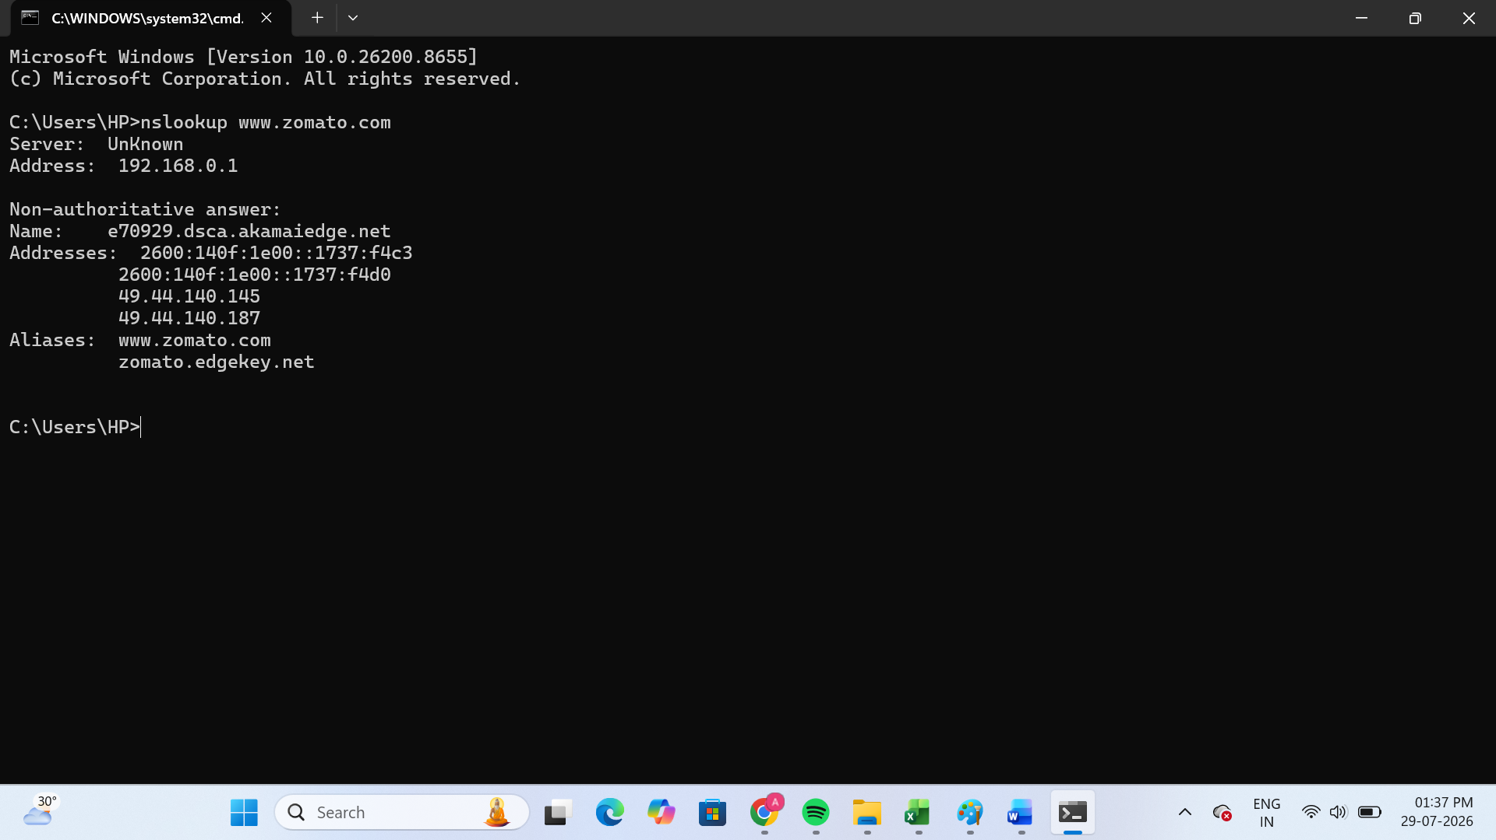
- Domain Name: www.zomato.com
- IP Address (IPv4):
- 49.44.140.145
- 49.44.140.187
- IP Address (IPv6):
- 2600:140f:1e00::1737:f4c3
- 2600:140f:1e00::1737:f4d0
The nslookup command successfully resolved www.zomato.com to its IP addresses. It returned both IPv4 and IPv6 addresses for the website.
4.Test connectivity to another device on your local network (such as your friend's laptop or your phone) using the ping command and describe what happens if the device is offline.
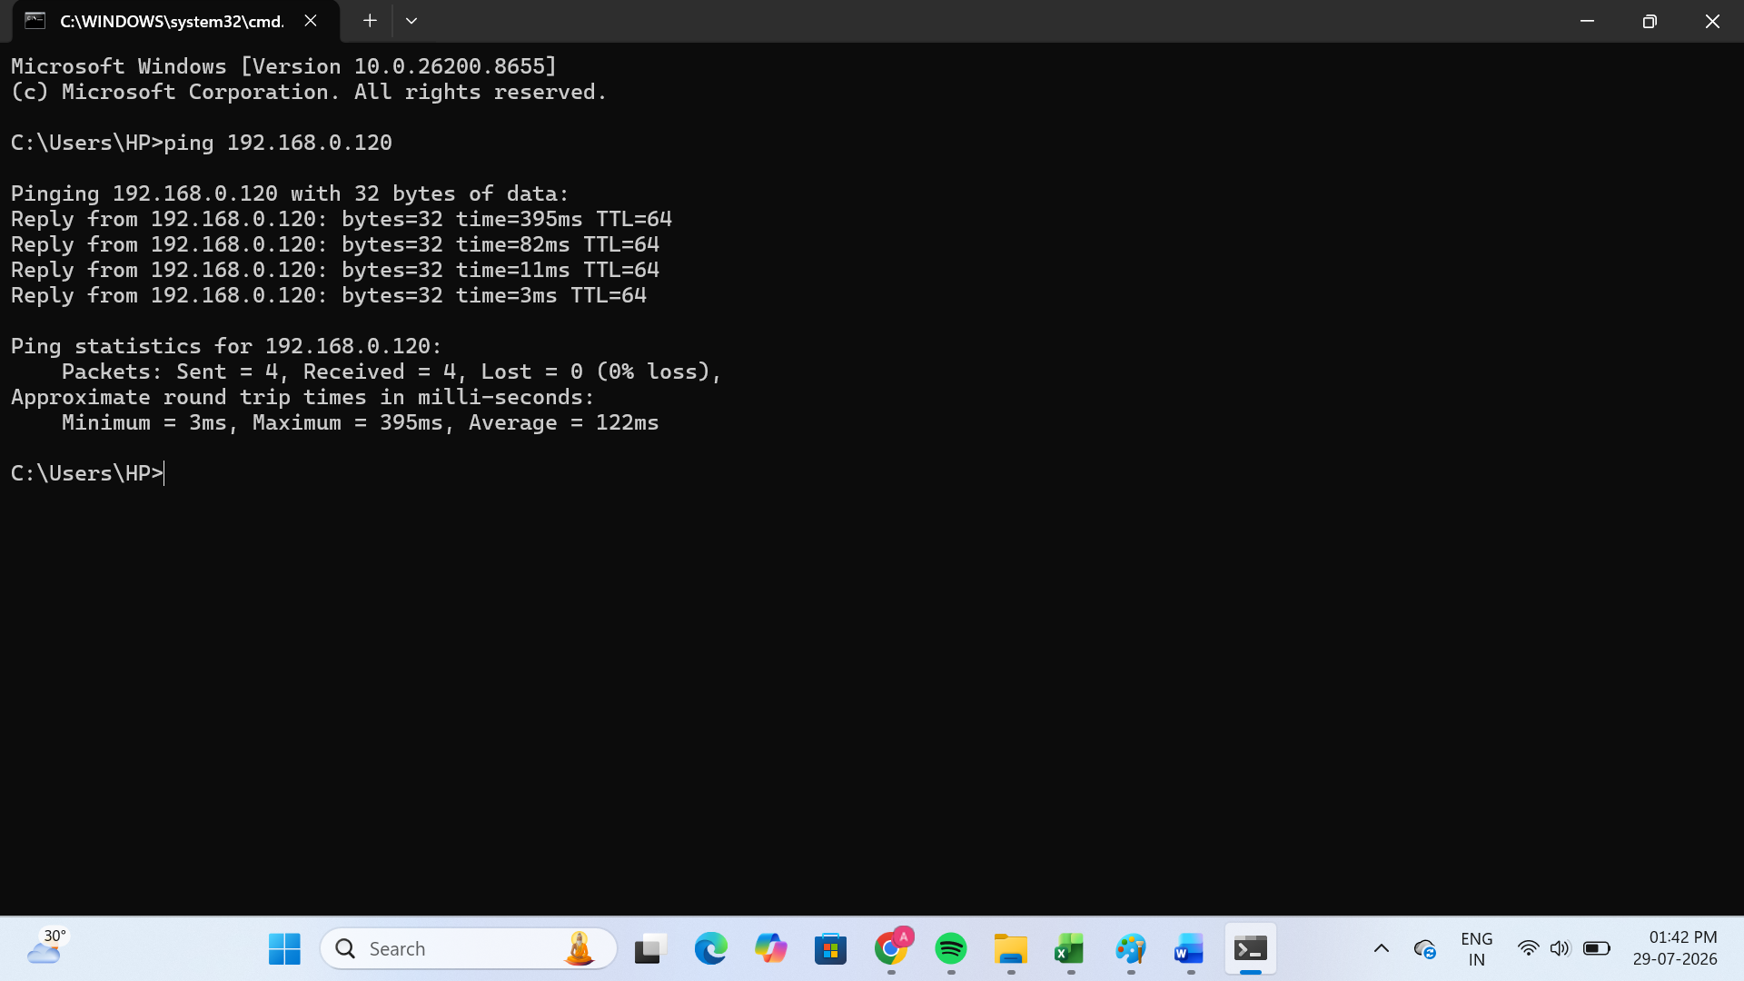
I used the ping command to test connectivity to another device on my local network. When the device was online, it replied successfully. When the device was offline, the ping command showed "Request timed out" or "Destination host unreachable", indicating that the device could not be reached.
5.Create a short report (5-7 lines) summarizing which tool (ping, traceroute, nslookup) is most useful for diagnosing each of these problems: (a) Website not loading, (b) Slow connection, (c) Suspecting DNS issues.<br><br><em><strong>Constraint:</strong> Give a specific example for each tool based on your own test results above.</em>
->During my tests, I found that ping is useful for checking whether a website or device is reachable. For example, when I pinged www.youtube.com, it showed the response time and confirmed that the connection was working. Traceroute (tracert) is useful for diagnosing a slow connection because it shows all the network hops. In my test with www.flipkart.com, it displayed multiple hops and some "Request timed out" entries before reaching the destination. Nslookup is the best tool for DNS-related problems because it converts a website name into its IP address. In my test, nslookup www.zomato.com successfully returned the IP addresses 49.44.140.145 and 49.44.140.187, confirming that DNS resolution was working correctly. Overall, each tool helps diagnose a different type of network problem.

