1.Create a table listing the main functions and typical ports used by switches, routers, hubs, firewalls, and access points in a home WiFi setup.
Device | Main Function | Typical Ports
Switch | Connects multiple wired devices in the same network and forwards data to the correct device. | 8, 16, 24 or 48 Ethernet (RJ-45) ports
Router | Connects the home network to the Internet and routes data between networks. | 1 WAN port and 4 LAN Ethernet (RJ-45) ports
Hub | Connects multiple devices and sends data to all connected devices. | 4, 8 or 16 Ethernet (RJ-45) ports
Firewall | Protects the network by filtering and blocking unauthorized traffic. | Usually 2 or more Ethernet ports (WAN and LAN)
Access Point (AP) | Provides wireless (Wi-Fi) connectivity to devices. | 1 Ethernet (RJ-45) port and Wireless (Wi-Fi) interface

2.Given images or diagrams of network devices, label each device and mark the ports (Ethernet, console, power, antenna) for at least three devices.
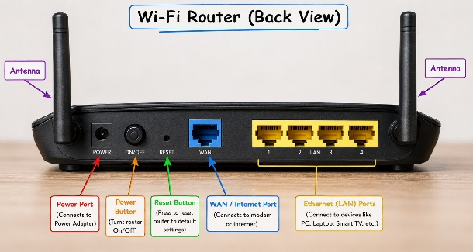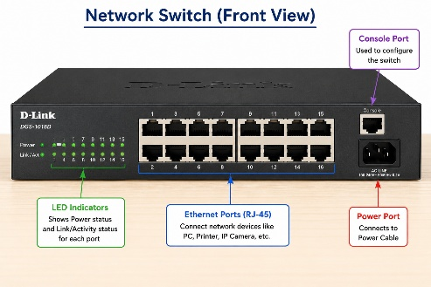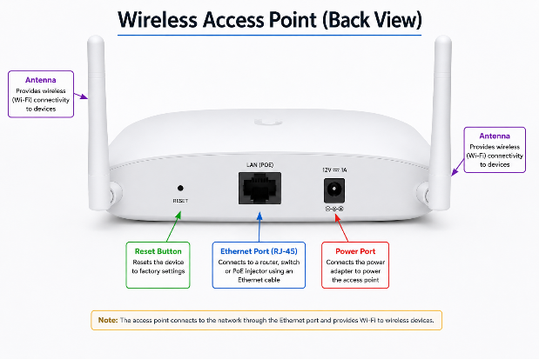
3.Pick a popular app you use daily (like Instagram, Zomato, or Paytm) and describe in 3-4 lines how at least two different network devices (from switches, routers, firewalls, access points) play a role when you use that app.
->App Chosen: Instagram
When I open Instagram, my phone first connects to the Wi-Fi Access Point, which provides wireless internet access. The Router then forwards my request from the home network to Instagram's servers on the Internet. A Firewall helps protect the network by filtering unwanted or unsafe traffic. If multiple wired devices are connected at home, a Switch transfers data efficiently between them.
4.Suppose your college WiFi is slow and sometimes disconnects. Based on the features of access points, switches, and routers, suggest one possible reason for the issue and how upgrading one device could help.<br><br><em><strong>Hint:</strong> Think about device capacity, coverage, and traffic handling.</em>
->The college WiFi may be slow because too many students are connected to the same access point, causing network congestion and weak signal coverage. Upgrading to a high-capacity Access Point with better coverage and support for more users would improve WiFi speed, reduce disconnections, and provide a more stable internet connection for everyone.

