1.Install Wireshark on your laptop, start a capture on your main network interface, and visit any website (like instagram.com). Stop the capture and note down the protocol names you see in the packet list.
->Website Visited: instagram.com
Protocols observed in the packet list:
- DNS
- TCP
- TLSv1.3
- HTTP/2
- QUIC (UDP)
Observation:
When I opened instagram.com, Wireshark captured different network packets. I observed protocols such as DNS for domain name lookup, TCP for reliable communication, TLSv1.3 for secure encrypted data transfer, HTTP/2 for web communication, and QUIC (UDP), which is used by many modern websites to improve speed and performance.

2.Pick any 3 packets from your Wireshark capture and identify which OSI layer each packet mainly represents (for example, HTTP for Application layer, TCP for Transport layer, etc.).<br><br><em><strong>Hint:</strong> Use the Protocol column and Info details in Wireshark to help you map protocols to OSI layers.</em>
Packet / Protocol | OSI Layer | Reason
HTTP/2 | Application Layer (Layer 7) | Used for communication between the web browser and the website.
TCP | Transport Layer (Layer 4) | Ensures reliable delivery of data between devices.
DNS | Application Layer (Layer 7) | Converts the website name (e.g., instagram.com) into an IP address.

3.Create a colorful diagram of the OSI Model using any drawing tool (MS Paint, Canva, or even paper and upload a photo). For each layer, add a real-world example from apps you use daily (e.g., WhatsApp uses the Application layer, Instagram images use the Presentation layer, etc.).
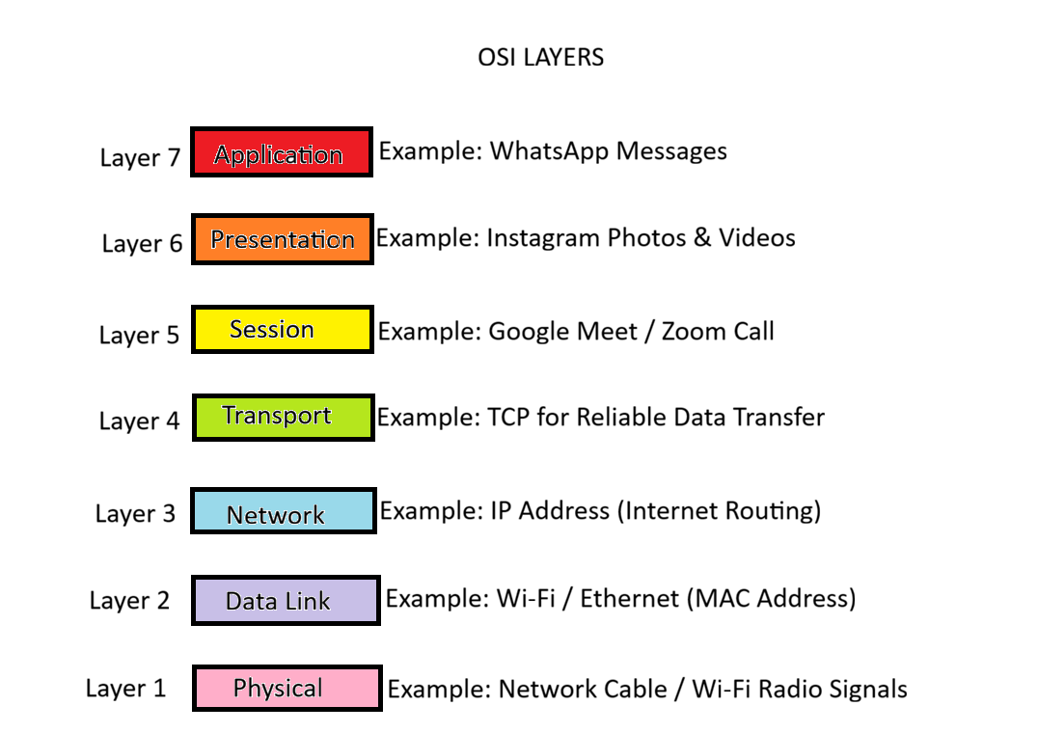
4.Explain how sending a message on WhatsApp travels through at least 4 layers of the OSI Model, describing what happens at each layer in your own words.<br><br><em><strong>Hint:</strong> Think about how your message is typed, packaged, sent over the internet, and received.</em>
->When I send a message on WhatsApp, it passes through different layers of the OSI Model before reaching the receiver.
- Application Layer (Layer 7):
I type my message in WhatsApp and press the Send button. The application prepares the message for sending.
- Presentation Layer (Layer 6):
The message is encrypted so that only the receiver can read it. This keeps the conversation secure.
- Transport Layer (Layer 4):
The message is divided into small packets. This layer ensures the data is sent reliably and in the correct order.
- Network Layer (Layer 3):
The packets are given IP addresses and routed through the internet to the receiver's device.
- Data Link Layer (Layer 2):
The packets are sent over the local Wi-Fi or mobile network using MAC addresses.
- Physical Layer (Layer 1):
The data travels as electrical signals through cables or as radio waves through Wi-Fi/mobile networks to reach the destination.

