1.Create a table listing 5 common network threats (such as phishing, DDoS, man-in-the-middle, malware, and password attacks), and for each, write one real-world example from an app or service you use (like WhatsApp, Instagram, or Paytm).
Network Threat | Description | Real-World Example (App/Service)
Phishing | Fake messages or websites that trick users into sharing personal information. | A fake Paytm SMS asks you to click a link and enter your login details.
DDoS (Distributed Denial of Service) | Attackers flood a server with traffic to make it unavailable. | Instagram becomes temporarily unavailable because its servers are overwhelmed by a DDoS attack.
Man-in-the-Middle (MITM) | An attacker secretly intercepts communication between two users. | Using WhatsApp on an unsecured public Wi-Fi could allow an attacker to intercept network traffic if proper protections are absent.
Malware | Malicious software that damages devices or steals information. | Downloading a fake WhatsApp APK from an unofficial website installs malware on your phone.
Password Attack | Attackers try to guess or steal passwords to access accounts. | Someone repeatedly tries to log in to your Instagram account using common passwords or leaked credentials.

2.Simulate a brute-force attack scenario by writing a simple Python script that tries to guess a 4-digit PIN code by checking all possible combinations against a preset value.<br><br><em><strong>Constraint:</strong> The script should print the number of attempts it took to guess the correct PIN.</em>
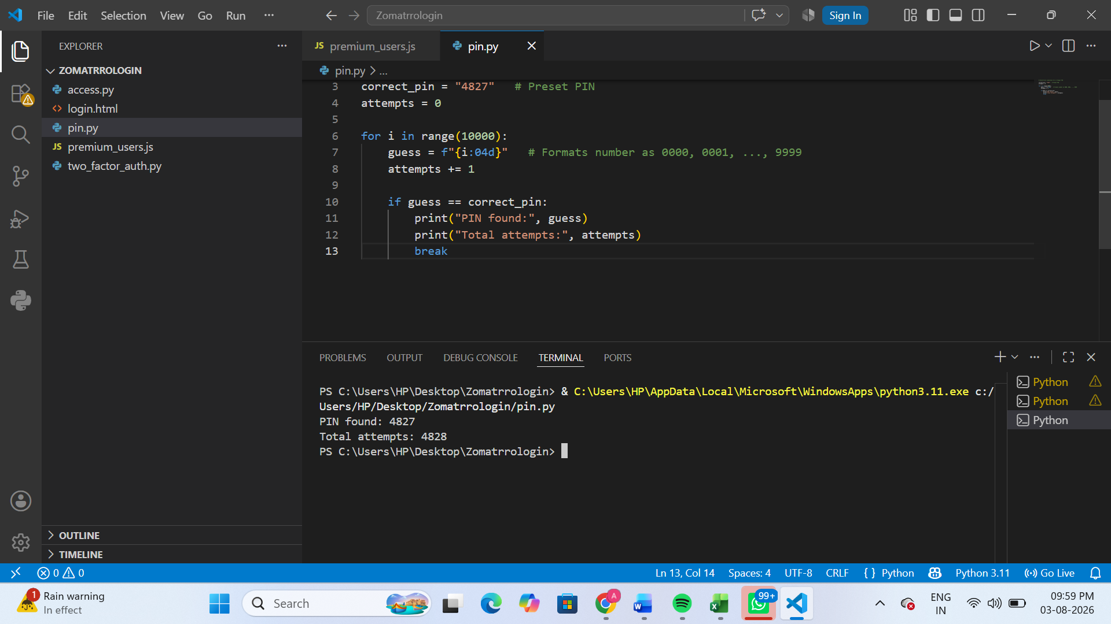
3.List 4 physical security risks that could affect a server room hosting a popular app like Zomato or BookMyShow, and suggest one mitigation step for each risk.
Physical Security Risk | Example | Mitigation Step
Unauthorized Access | An unauthorized person enters the server room and tampers with servers hosting Zomato or BookMyShow. | Use biometric access control, key cards, and CCTV surveillance.
Fire | An electrical short circuit causes a fire that damages the servers. | Install fire detection systems and automatic fire suppression (clean agent) systems.
Power Failure | A power outage shuts down the servers, making the app unavailable. | Use UPS (Uninterruptible Power Supply) and backup generators.
Water Leakage/Flooding | Water from a leaking pipe or flood damages server equipment. | Install water leak sensors, keep servers on raised floors, and ensure proper drainage.

4.Draw a simple floor plan (hand-drawn or digital) of a small office and mark at least 3 physical security measures you would implement to protect network equipment (such as CCTV, biometric access, or cable locks).
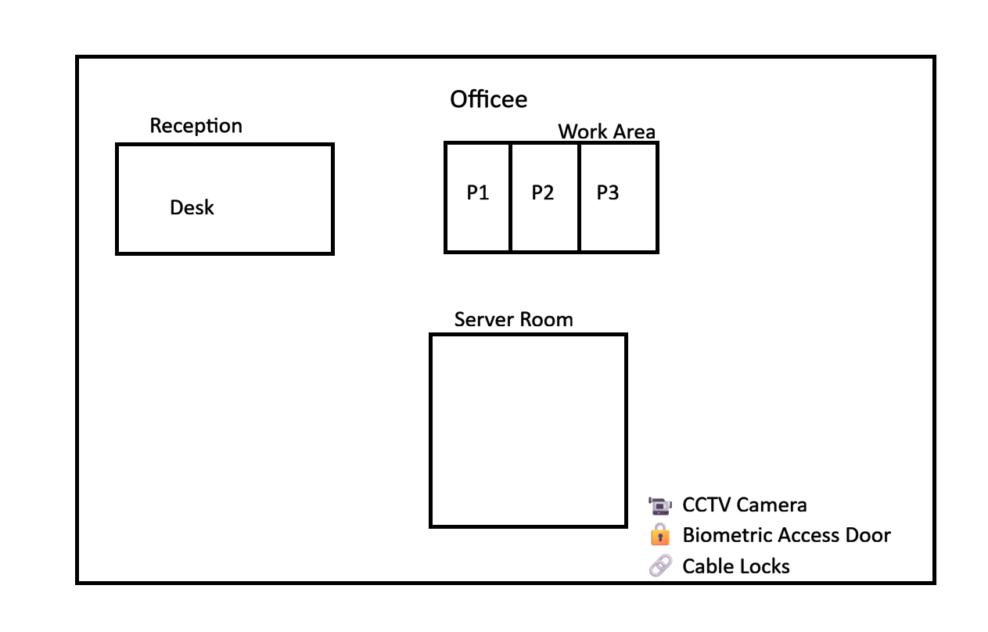
5.Use ChatGPT or a similar AI tool to generate a checklist of 7 actions a network admin should take to mitigate risks from both network threats and physical security breaches, then review and edit the checklist to make it specific for a college computer lab environment.
No. | Action | Specific for a College Computer Lab
1 | Use strong passwords and MFA | Require strong passwords for all lab computers and enable multi-factor authentication for administrator accounts.
2 | Keep systems updated | Regularly install Windows, antivirus, and software updates on every lab computer.
3 | Install and monitor antivirus | Use updated antivirus software and perform scheduled scans on all PCs.
4 | Secure network access | Configure the firewall and allow only authorized students and staff to access the college network.
5 | Restrict physical access | Keep the server room locked and allow entry only to authorized lab staff using key cards or biometric access.
6 | Protect equipment | Install CCTV cameras in the lab and use cable locks to secure computers, switches, and other network devices.
7 | Perform regular backups | Back up student projects, lab data, and server configurations regularly so they can be restored after a failure or cyberattack.

