1.Draw a simple diagram (on paper or using an online tool like draw.io) showing how your phone connects to Instagram's servers from your home WiFi, including the ISP and at least two Wide Area Network (WAN) devices (like routers or switches) in the path.
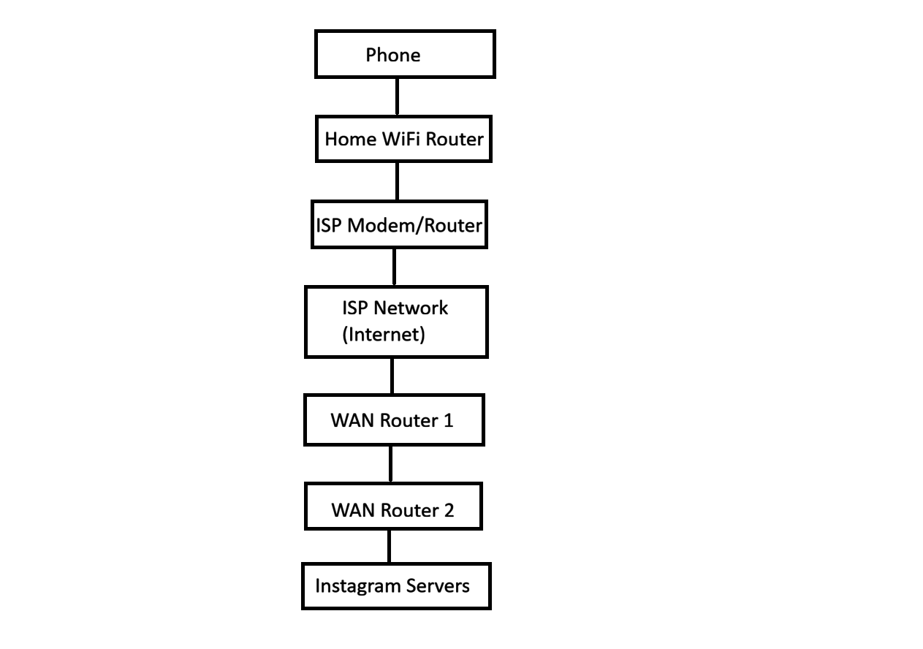
2.Create a table listing three types of WAN technologies (such as MPLS, Leased Line, and Broadband Internet) and compare them based on speed, cost, and where you might see them used in real life (e.g., Zomato office, IRCTC ticketing, your home).
WAN Technology | Speed | Cost | Real-Life Example
MPLS (Multiprotocol Label Switching) | High (10 Mbps – 10 Gbps) | High | Used by large companies such as Zomato offices to securely connect branches.
Leased Line | Very High (100 Mbps – 10 Gbps, dedicated connection) | Very High | Used by IRCTC ticketing systems, banks, and data centers where reliable connectivity is essential.
Broadband Internet | Medium to High (50 Mbps – 1 Gbps) | Low to Medium | Used in homes, small businesses, and shops for internet access, online classes, streaming, and browsing.

3.Research and write a short explanation of how a VPN (Virtual Private Network) uses WANs to let you access apps like Spotify or YouTube securely from a public WiFi at a coffee shop.<br><br><em><strong>Hint:</strong> Focus on how the VPN creates a private tunnel over the public WAN.</em>
->How a VPN Uses WANs to Provide Secure Access
A VPN (Virtual Private Network) uses a WAN (Wide Area Network), such as the Internet, to create a secure and encrypted tunnel between your device and a VPN server. When you connect to public WiFi at a coffee shop, your data normally travels over a public network that could be monitored by attackers. A VPN encrypts your internet traffic before it leaves your device, making it difficult for anyone on the same WiFi network to read or steal your information.
For example, if you open Spotify or YouTube while connected to public WiFi, the VPN sends your requests through the encrypted tunnel to the VPN server. The server then communicates with Spotify or YouTube on your behalf and returns the data through the same secure tunnel. This process protects your login credentials, personal information, and browsing activity from being intercepted.
In short, a VPN uses the public WAN (the Internet) to build a private, secure connection, allowing you to access online apps safely even when using unsecured public WiFi.
4.Imagine Flipkart wants to connect its warehouses in Ahmedabad, Mumbai, and Delhi. Suggest which WAN technology would be best for them and justify your answer with two reasons.
-> Best WAN Technology for Flipkart Warehouses
For connecting Flipkart's warehouses in Ahmedabad, Mumbai, and Delhi, the MPLS (Multiprotocol Label Switching) WAN technology would be the best choice.
Reasons:
- Secure and Reliable Connectivity: MPLS provides a private and secure network with low latency, making it ideal for sharing inventory, order, and payment data between warehouses.
- High Performance: MPLS offers consistent network performance and Quality of Service (QoS), ensuring that important business applications run smoothly without interruptions.
Conclusion:
MPLS is the most suitable WAN technology for Flipkart because it provides secure, reliable, and high-performance communication between multiple warehouse locations across different cities.

