1.Create a simple login form for a mock Zomato admin panel that asks for username and password, then displays 'Access Granted' only if both fields match hardcoded admin credentials.
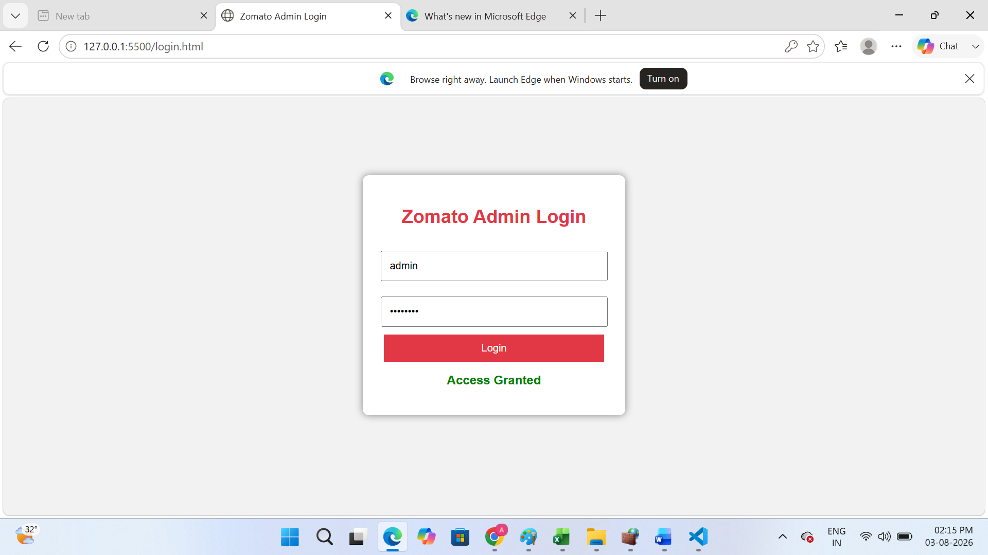
2.Write a Python function check_access(user_role, resource) that returns True if the user_role is allowed to access the resource, otherwise False. Test it with roles like 'customer', 'restaurant_owner', and resources like 'menu_edit', 'order_history', 'admin_dashboard'.<br><br><em><strong>Hint:</strong> Use a dictionary to map roles to allowed resources.</em>
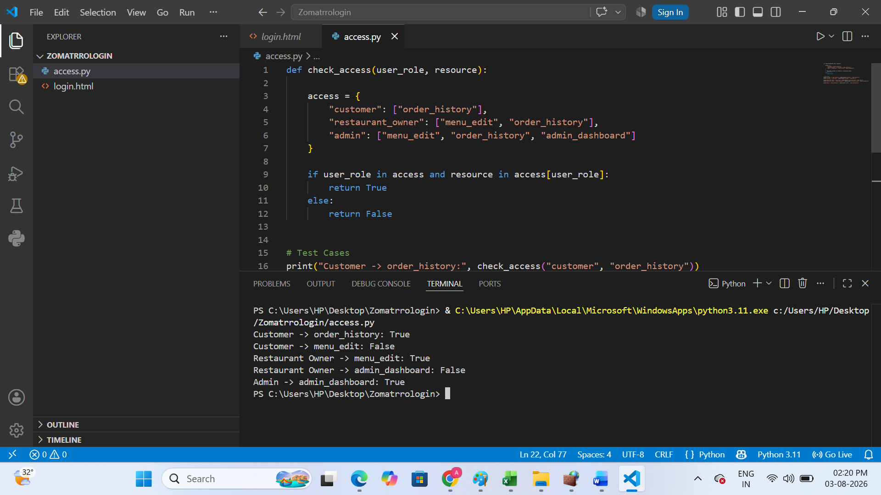
3.Simulate a two-factor authentication flow like Paytm: after a user enters the correct password, generate a 6-digit OTP and display it in the console. Ask the user to input the OTP and display 'Login Successful' only if it matches.
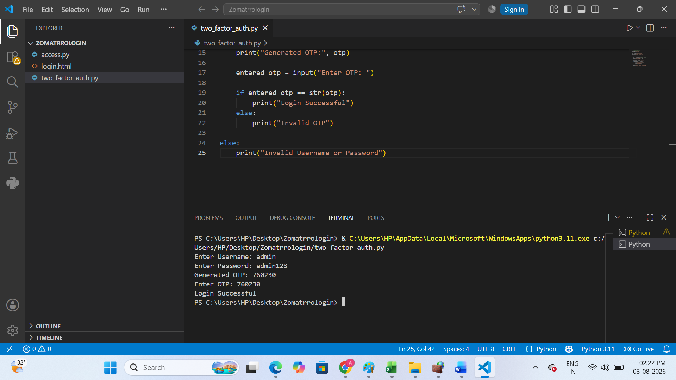
4.Given an array of user objects with properties: username, isPremium, and lastLogin, write a function that returns only those users who are premium and have logged in within the last 7 days.<br><br><em><strong>Constraint:</strong> Assume lastLogin is a date string in 'YYYY-MM-DD' format, and today is '2024-06-10'.</em>
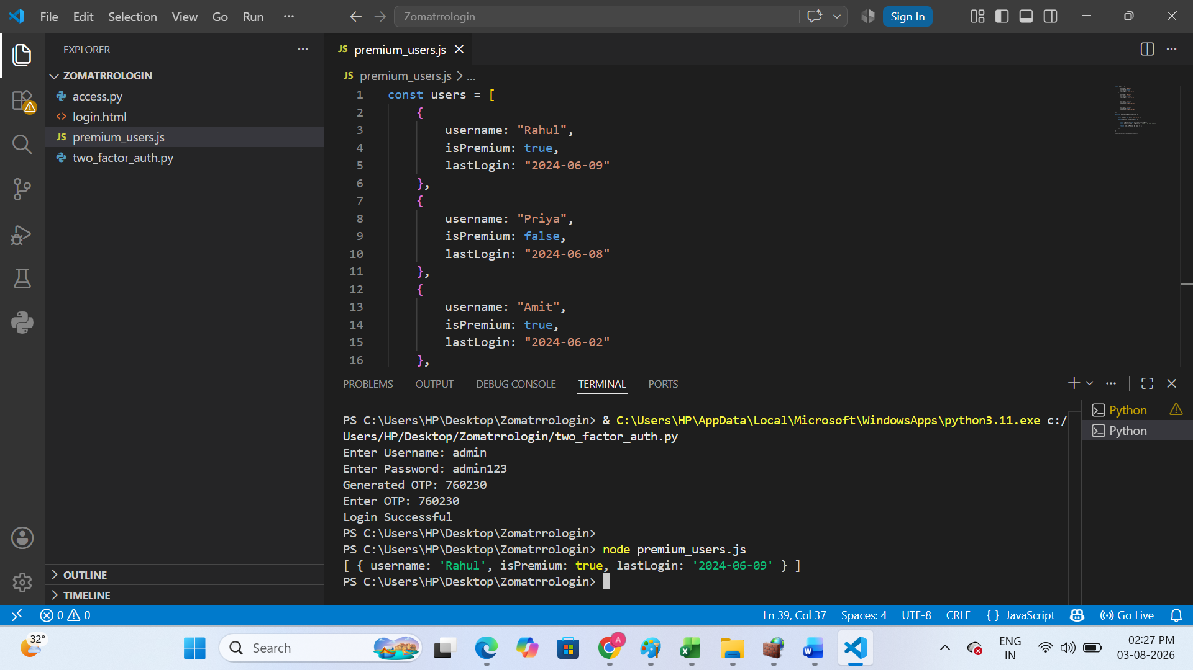
5.Use ChatGPT to generate a list of 5 common access control mistakes developers make in real-world apps like Instagram or Flipkart, and for each, write a one-line fix or prevention tip.
Access Control Mistake | Fix / Prevention Tip
1. Weak or easy passwords | Use strong passwords and enable two-factor authentication (2FA).
2. Giving users unnecessary permissions | Follow the principle of least privilege and give only required access.
3. Not checking user roles before allowing access | Verify user roles (Admin, Customer, Seller) before every protected action.
4. Leaving admin pages accessible without login | Protect admin pages with authentication and authorization checks.
5. Not managing user sessions properly | Use secure session management and automatically log out inactive users.

