1.Draw a network diagram for a small office/home office (SOHO) setup that includes: one broadband internet connection, one Wi-Fi router, two laptops, one smart TV, and one printer. Clearly label each device and connection type (wired or wireless).
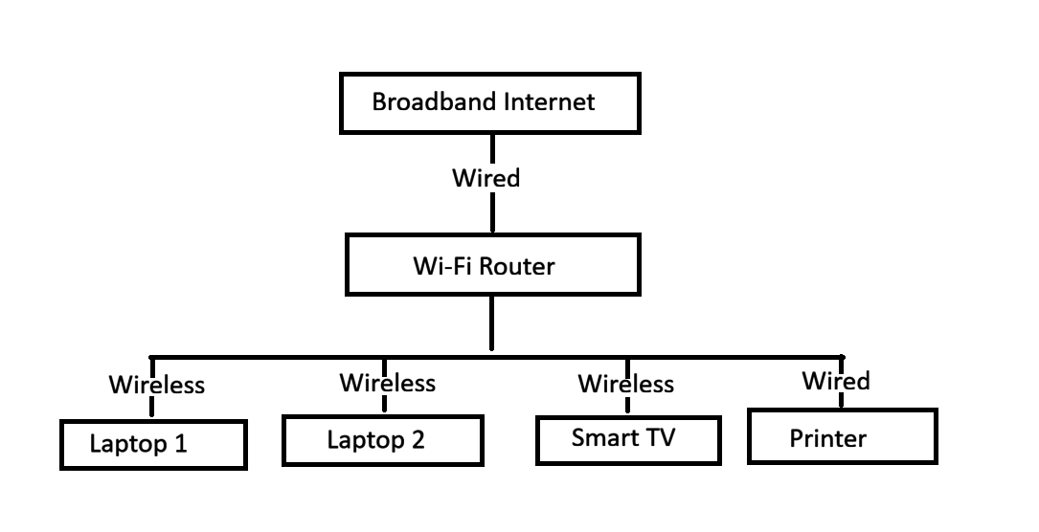
2.List all the hardware components (with brand/model suggestions) you would need to physically build the SOHO network diagrammed above, including cables and any switches or extenders if needed.<br><br><em><strong>Hint:</strong> Check current listings on Flipkart or Amazon for typical device models used in Indian homes/offices.</em>
Hardware Component | Suggested Brand/Model | Quantity | Purpose
Broadband Internet Connection | JioFiber / Airtel Xstream Fiber | 1 | Internet connection
Wi-Fi Router | TP-Link Archer AX10 Dual Band Wi-Fi 6 Router | 1 | Connects all wired and wireless devices
Laptop | Dell Inspiron 15 / HP 15s | 2 | User computers
Smart TV | Samsung Crystal 4K Smart TV | 1 | Streaming and internet access
Printer | HP Smart Tank 580 / Canon PIXMA G3770 | 1 | Printing documents
Ethernet (CAT6) Cable | Cat6 Ethernet Cable 1.5 m | 2 | Connect broadband to router and router to printer
Power Adapter | Comes with each device | As required | Power supply
Wi-Fi Range Extender (Optional) | TP-Link RE315 | 1 | Extends Wi-Fi coverage if the office is large
Network Switch (Optional) | TP-Link TL-SG105 (5-Port Gigabit Switch) | 1 | Required only if more wired devices need to be connected

3.Write step-by-step instructions to configure the Wi-Fi router for your SOHO network, including setting up a unique SSID, enabling WPA2 security, and changing the default admin password.
Step-by-Step Instructions to Configure a Wi-Fi Router for a SOHO Network
- Connect the broadband internet cable to the WAN/Internet port of the Wi-Fi router.
- Turn on the router and wait until the power and internet LEDs become stable.
- Connect a laptop to the router using a Wi-Fi connection or an Ethernet cable.
- Open a web browser and enter the router's default IP address (for example, 192.168.0.1 or 192.168.1.1).
- Log in using the default username and password provided on the router label or in the user manual.
- Go to the Wireless Settings section.
- Enter a unique SSID (Wi-Fi name), for example: Ashiti_Home_WiFi.
- Select WPA2-PSK (AES) as the Wi-Fi security mode.
- Create a strong Wi-Fi password using a mix of uppercase letters, lowercase letters, numbers, and special characters.
- Go to the Administration/System settings.
- Change the default administrator password to a new strong password.
- Click Save/Apply to save all the settings.
- Restart the router if required.
- Reconnect all devices (laptops, Smart TV, and printer) using the new SSID and Wi-Fi password.
- Test the internet connection to ensure all devices are connected successfully.
4.Configure IP addresses for all devices in your SOHO network: assign static IPs to the printer and smart TV, and use DHCP for the laptops. Show a table listing each device, its MAC address (make one up), and the assigned IP address.
Device | MAC Address | IP Address | IP Assignment
Wi-Fi Router | 00:1A:2B:3C:4D:5E | 192.168.1.1 | Static (Gateway)
Laptop 1 | A4:1B:C2:34:D5:E6 | 192.168.1.100 | DHCP
Laptop 2 | B5:2C:D3:45:E6:F7 | 192.168.1.101 | DHCP
Smart TV | C6:3D:E4:56:F7:A8 | 192.168.1.10 | Static
Printer | D7:4E:F5:67:A8:B9 | 192.168.1.20 | Static

5.Explain how you would troubleshoot if one of the laptops cannot connect to the internet in your SOHO network. List at least 3 possible causes and what steps you would take to diagnose and fix each issue.
Troubleshooting a Laptop That Cannot Connect to the Internet
If one of the laptops cannot connect to the internet in the SOHO network, I would check the following:
Possible Cause | Diagnosis | Solution
1. Wi-Fi is disconnected or wrong password | Check if the laptop is connected to the correct Wi-Fi (SSID). | Reconnect to the correct Wi-Fi and enter the correct password.
2. No IP address assigned (DHCP issue) | Open Command Prompt and type ipconfig to check the IP address. | Renew the IP address using ipconfig /release and ipconfig /renew, or restart the router.
3. Router or Internet connection problem | Check if other devices can access the internet and verify the router's Internet LED. | Restart the router and modem. If the issue continues, contact the Internet Service Provider (ISP).

Additional Troubleshooting Steps
- Restart the laptop.
- Restart the Wi-Fi router.
- Check if Airplane Mode is turned off.
- Forget the Wi-Fi network and connect again.
- Run the Windows Network Troubleshooter.
- Test the internet on another device to confirm whether the problem is with the laptop or the internet connection.

