1.Use Wireshark to capture network traffic while you load www.spotify.com in your browser, then identify and note down at least two DNS packets and two HTTP or HTTPS packets in the capture.
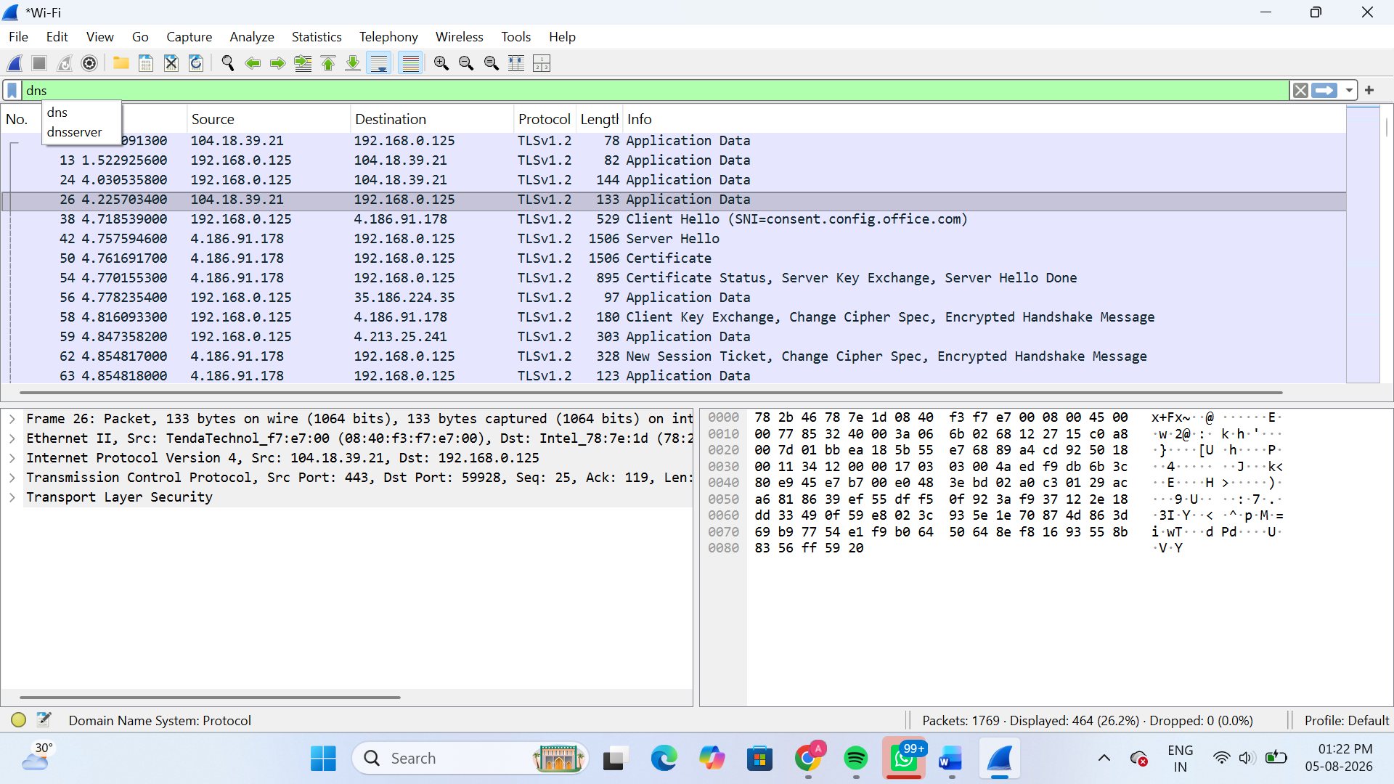
1.DNS Standard Query
- Source: 192.168.0.125
- Destination: 192.168.0.1
- Info: Standard Query – HTTPS gae2-spclient.spotify.com
2.DNS Standard Query Response
- Source: 192.168.0.1
- Destination: 192.168.0.125
- Info: Standard Query Response – gae2-spclient.spotify.com (CNAME response)

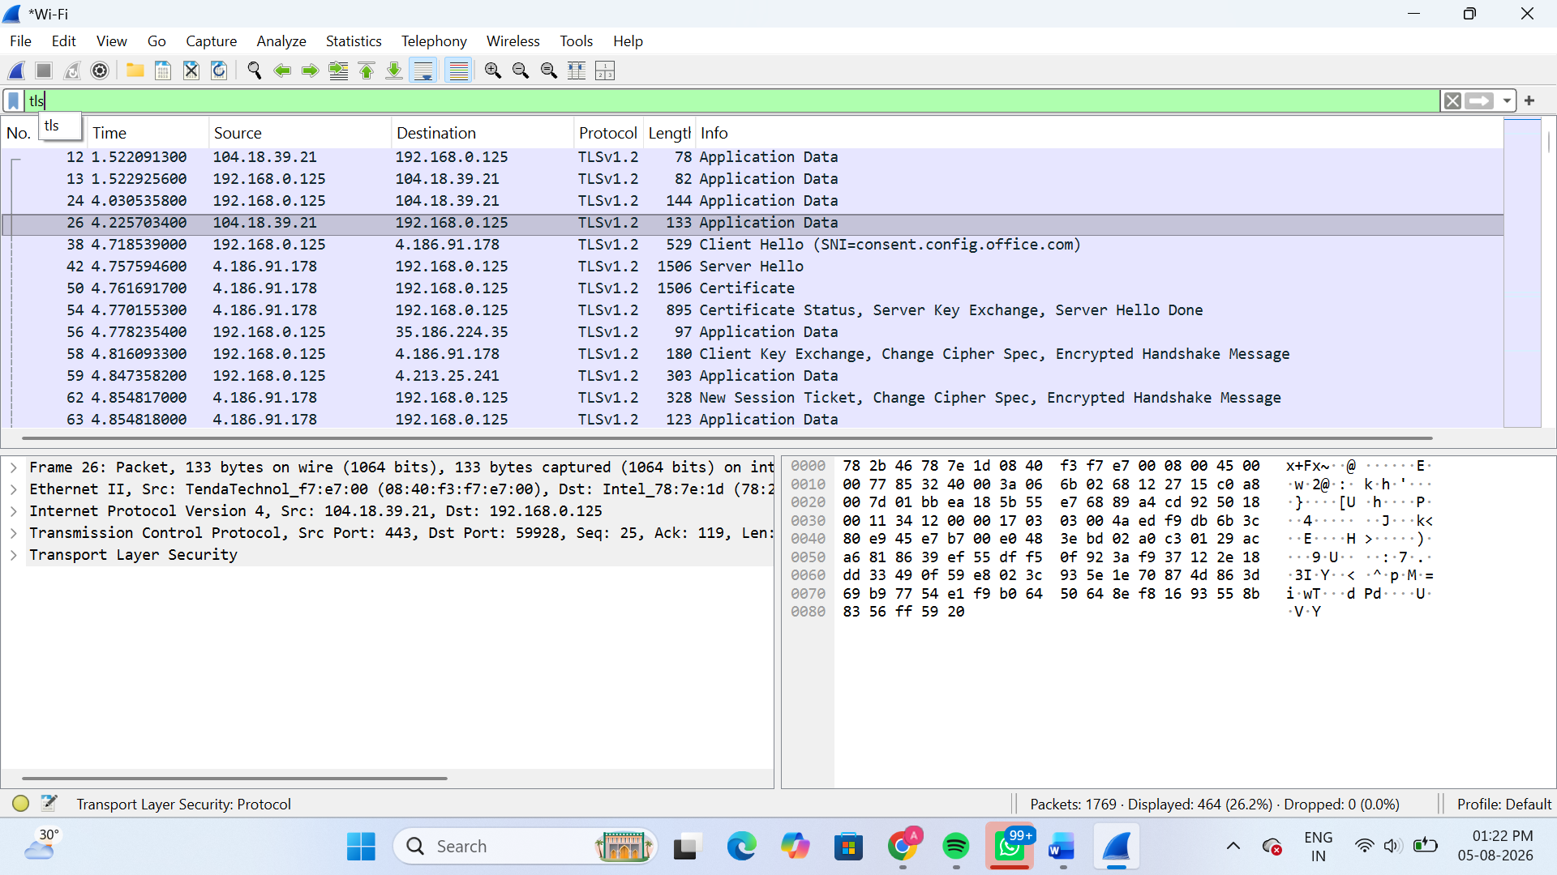
1.TLS Client Hello
- Source: 192.168.0.125
- Destination: 4.186.91.178
- Info: Client Hello (SNI = consent.config.office.com)
2. TLS Server Hello
- Source: 4.186.91.178
- Destination: 192.168.0.125
- Info: Server Hello

2.Simulate a DNS lookup for www.flipkart.com using the nslookup command in your terminal and write down the IP address returned along with a brief explanation of what this result means.
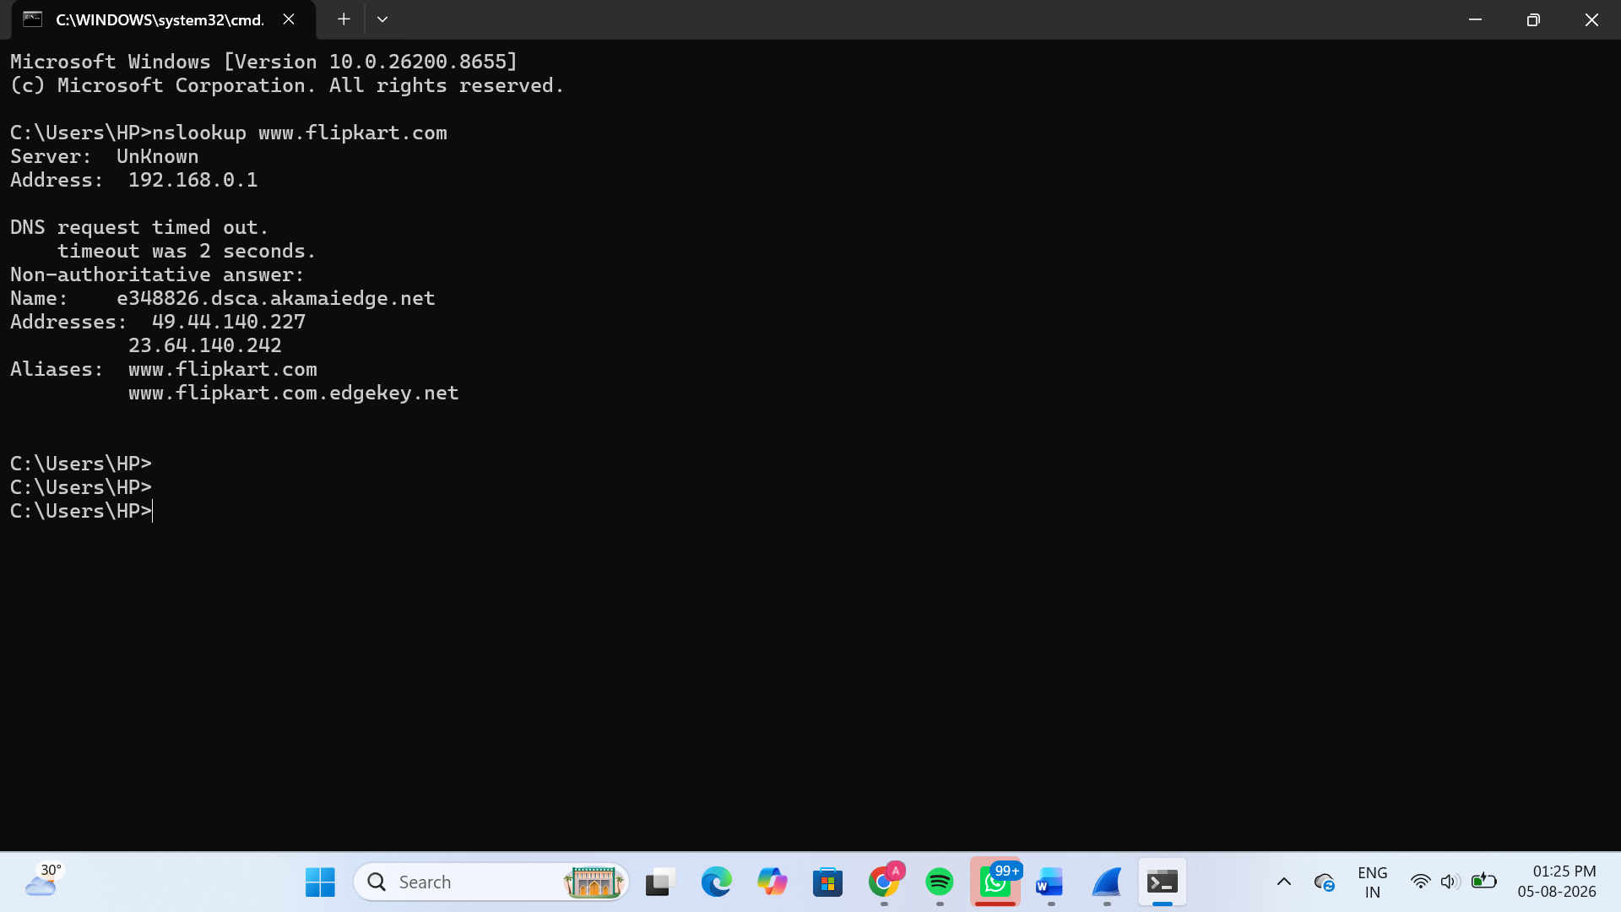
3.Explain the difference between HTTP and HTTPS by listing 3 key differences, and give a real-world example of an app or website you use that relies on HTTPS for secure communication.
HTTP | HTTPS
HTTP data is not encrypted. | HTTPS data is encrypted using SSL/TLS.
HTTP is less secure and data can be intercepted. | HTTPS is more secure and protects user data from attackers.
HTTP uses Port 80. | HTTPS uses Port 443.

Real-world Example
Website/App: Spotify (or Flipkart, Instagram, Google, WhatsApp Web)
Explanation:
Spotify uses HTTPS to securely transmit user login credentials, music requests, and other data between the user's device and the server. This encryption helps protect sensitive information from unauthorized access.
4.Open Wireshark and filter for DNS protocol traffic. Try searching for a new website (one you haven't visited recently) in your browser and describe the sequence of DNS queries and responses you observe.<br><br><em><strong>Hint:</strong> Look for packets with 'Standard query' and 'Standard query response' in the Info column.</em>
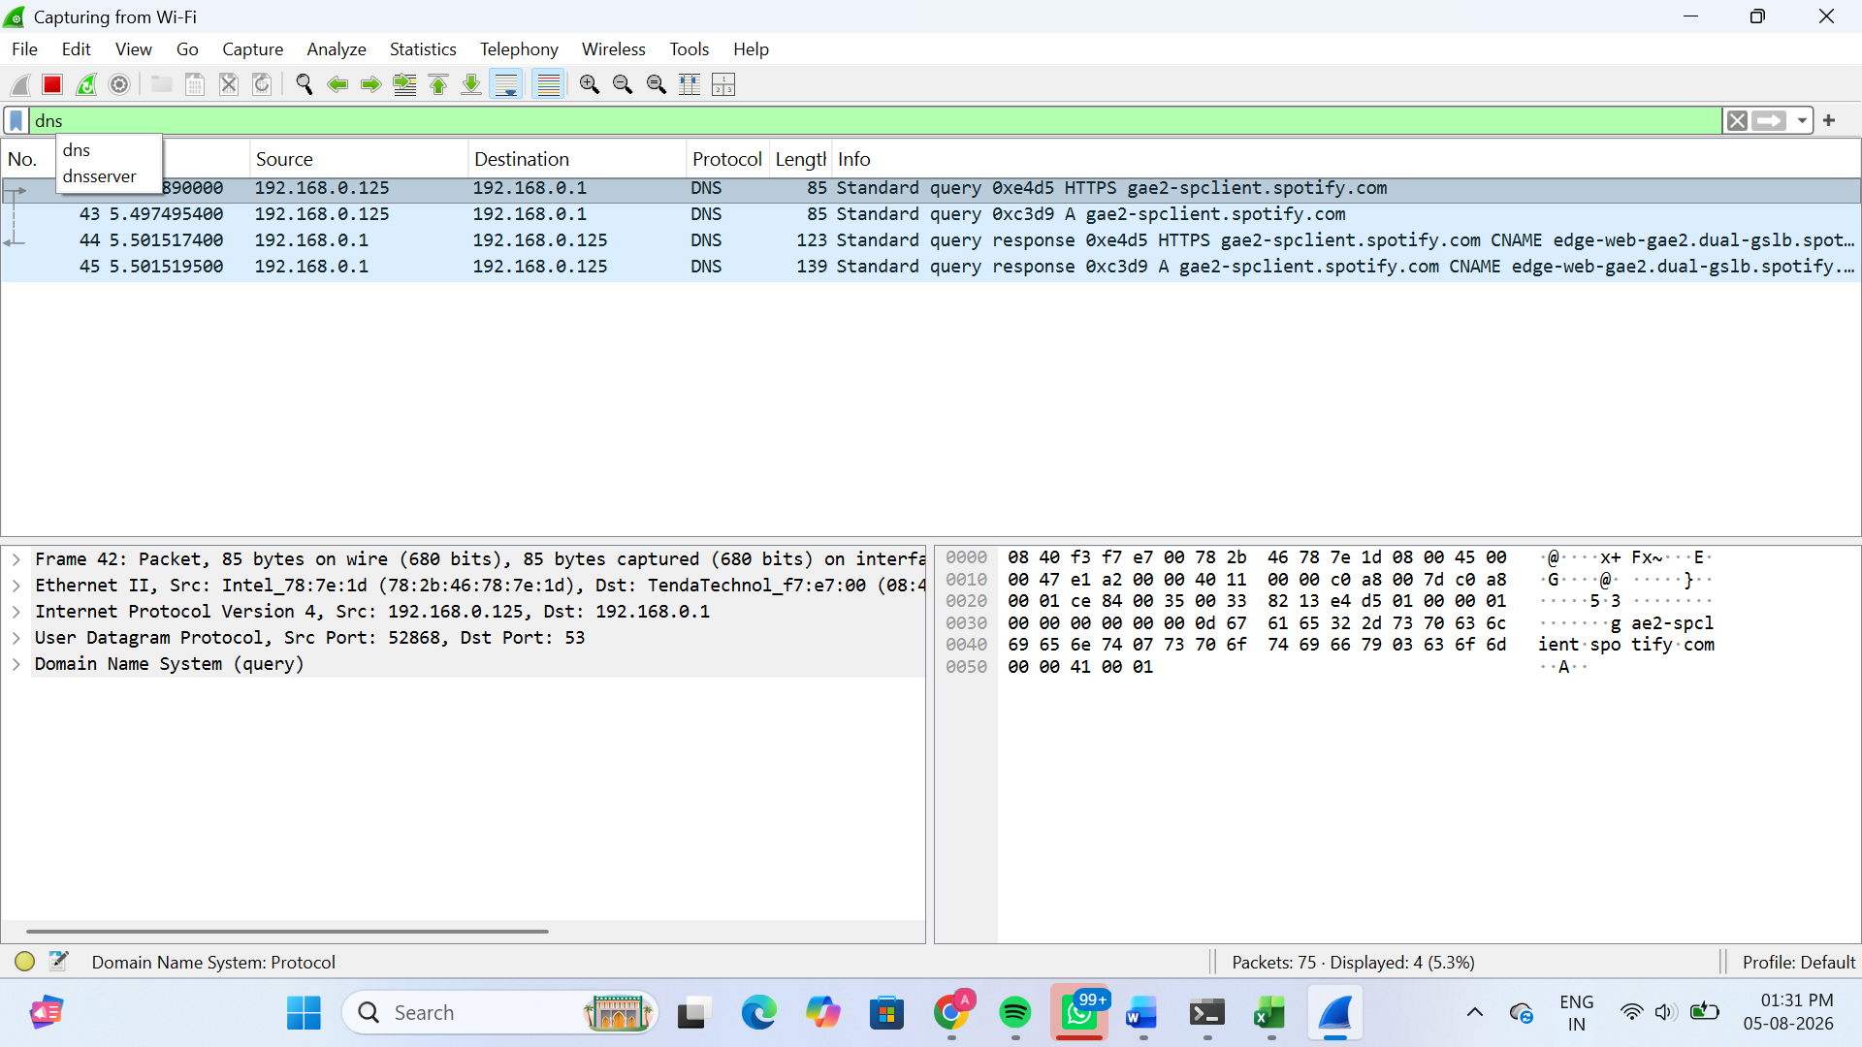
Sequence of DNS Queries and Responses
- The browser sends a DNS Standard Query to the DNS server requesting the IP address of gae2-spclient.spotify.com.
- The DNS server processes the request.
- The DNS server sends a DNS Standard Query Response containing the domain information (CNAME/IP).
- The browser uses the returned information to establish a connection with the website.
Observation
The DNS protocol translates the website's domain name into an IP address (or CNAME), allowing the browser to communicate with the correct server and load the website.
5.Pick any one protocol from DNS, DHCP, FTP, or SNMP (other than HTTP/HTTPS) and write a short scenario describing how it would be used in a real-world app or service you use (for example, how DHCP helps your phone connect to WiFi when you open Instagram at a cafe).
Protocol Chosen: DHCP (Dynamic Host Configuration Protocol)
Scenario:
When I visit a café and connect my phone to the Wi-Fi network, the DHCP protocol automatically assigns an IP address, subnet mask, default gateway, and DNS server to my phone. After receiving these network settings, I can open apps like Instagram or Spotify and access the internet without manually configuring any network settings.
Explanation:
DHCP makes it easy for devices to join a network by automatically providing the required IP configuration. This saves time and ensures that each device gets a unique IP address.

