1.In Cisco Packet Tracer, set up a simple network with one DHCP server and two client PCs. Configure the DHCP server to assign IP addresses automatically, then verify on each PC that it receives a different IP address from the DHCP pool.
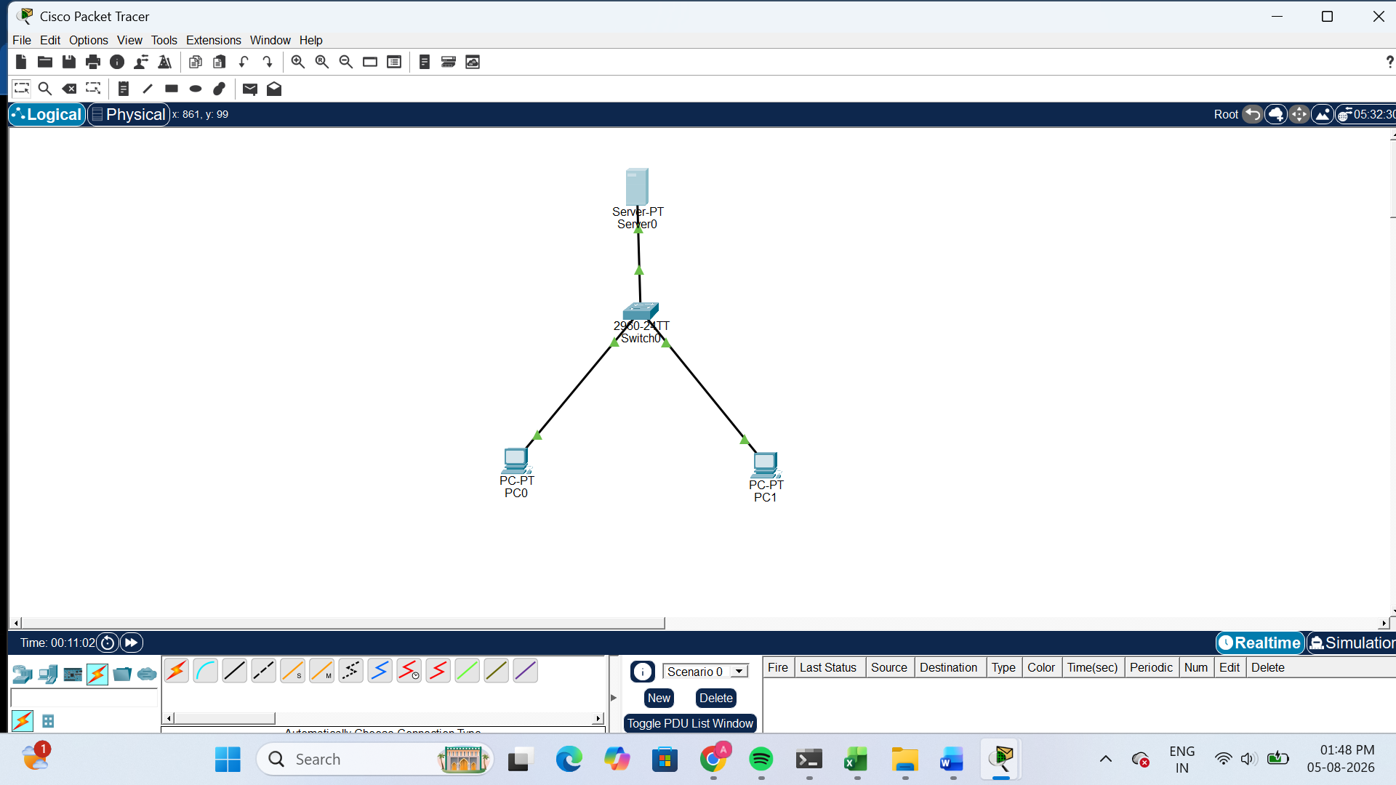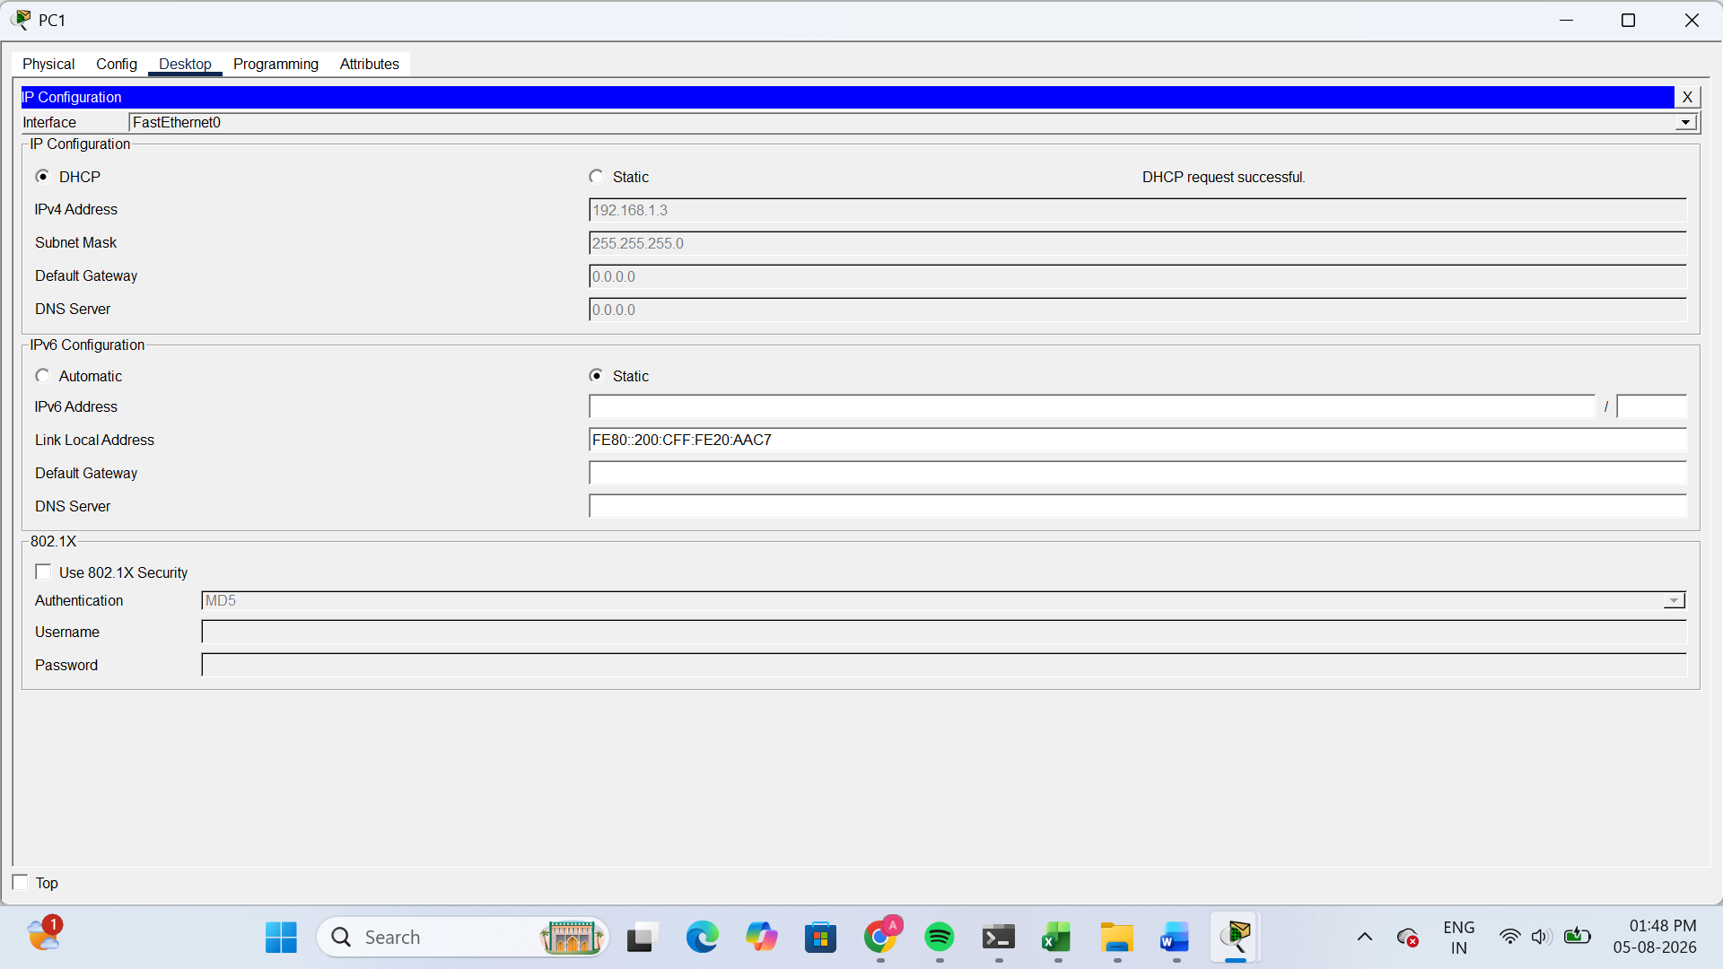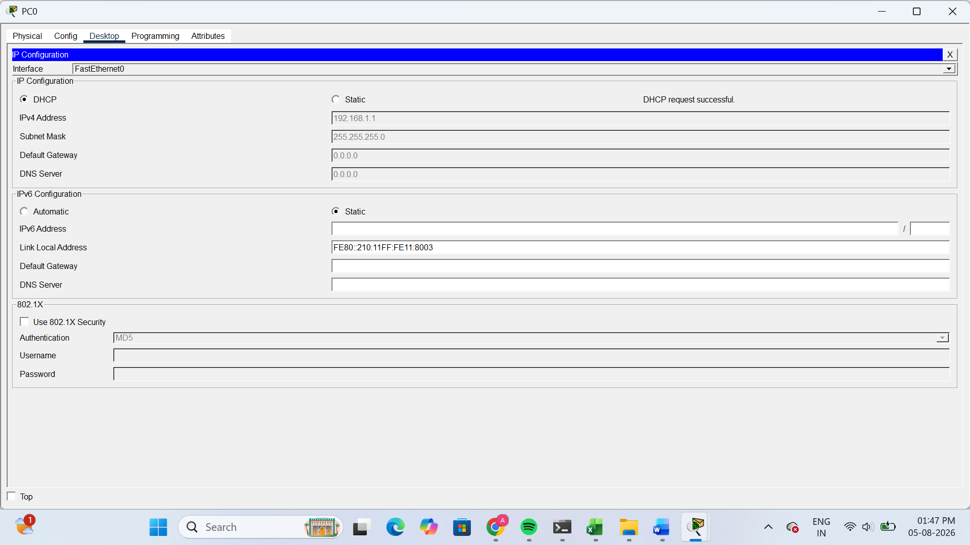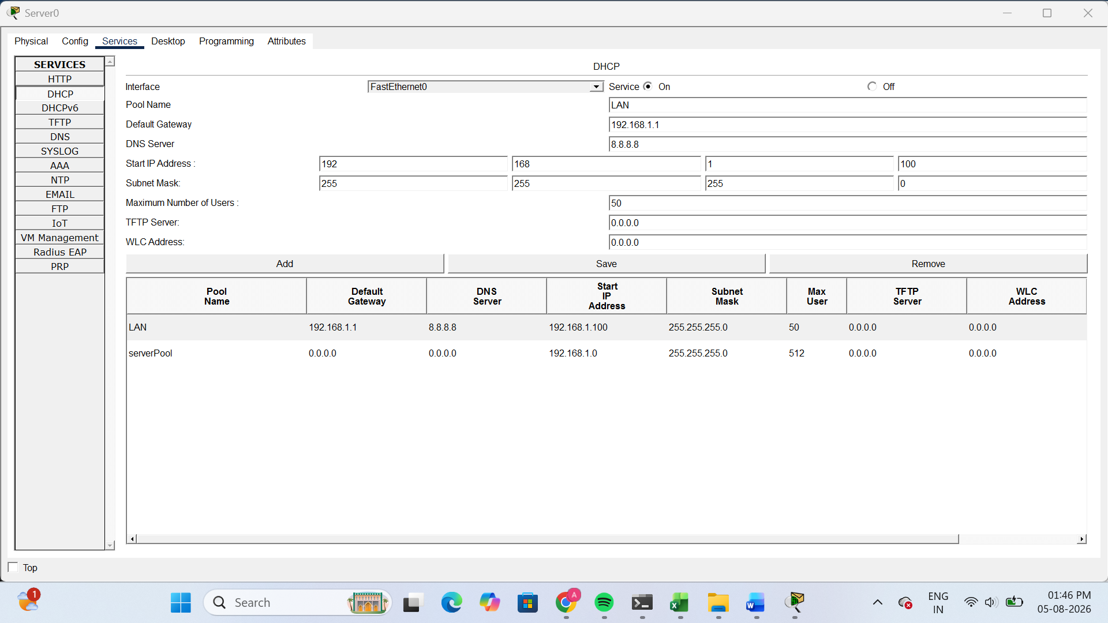
The DHCP server successfully assigned IP addresses automatically to both client PCs. PC0 received the IP address 192.168.1.1 and PC1 received the IP address 192.168.1.3. This confirms that the DHCP server is correctly assigning different IP addresses from the DHCP pool.
2.Draw a sequence diagram (hand-drawn or digital) that clearly shows each step of the DHCP process: Discover, Offer, Request, and Acknowledge, labeling the sender and receiver at each stage.<br><br><em><strong>Hint:</strong> Use arrows to show the direction of each message between client and server.</em>
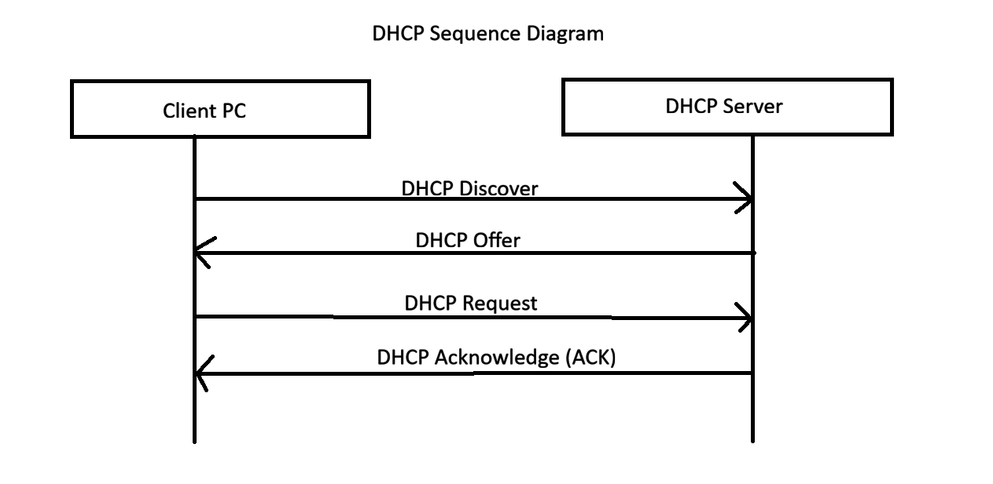
3.Change the DHCP pool range on your Cisco Packet Tracer DHCP server so that only one IP address is available. Add two PCs and observe what happens when both try to get an IP address. Take a screenshot of the result and explain in 2-3 lines why only one PC succeeds.
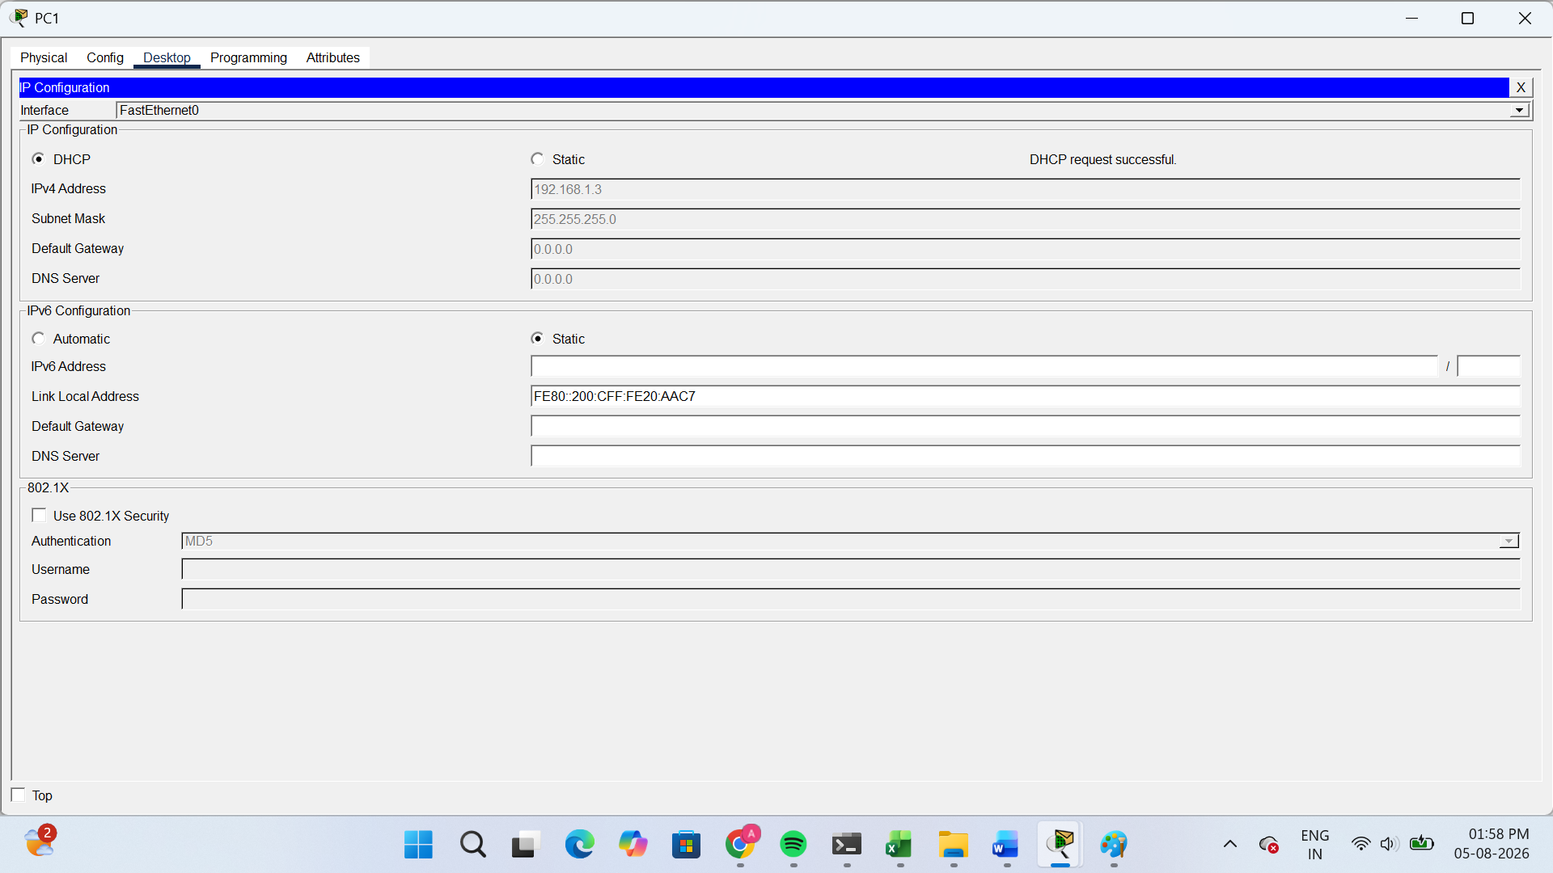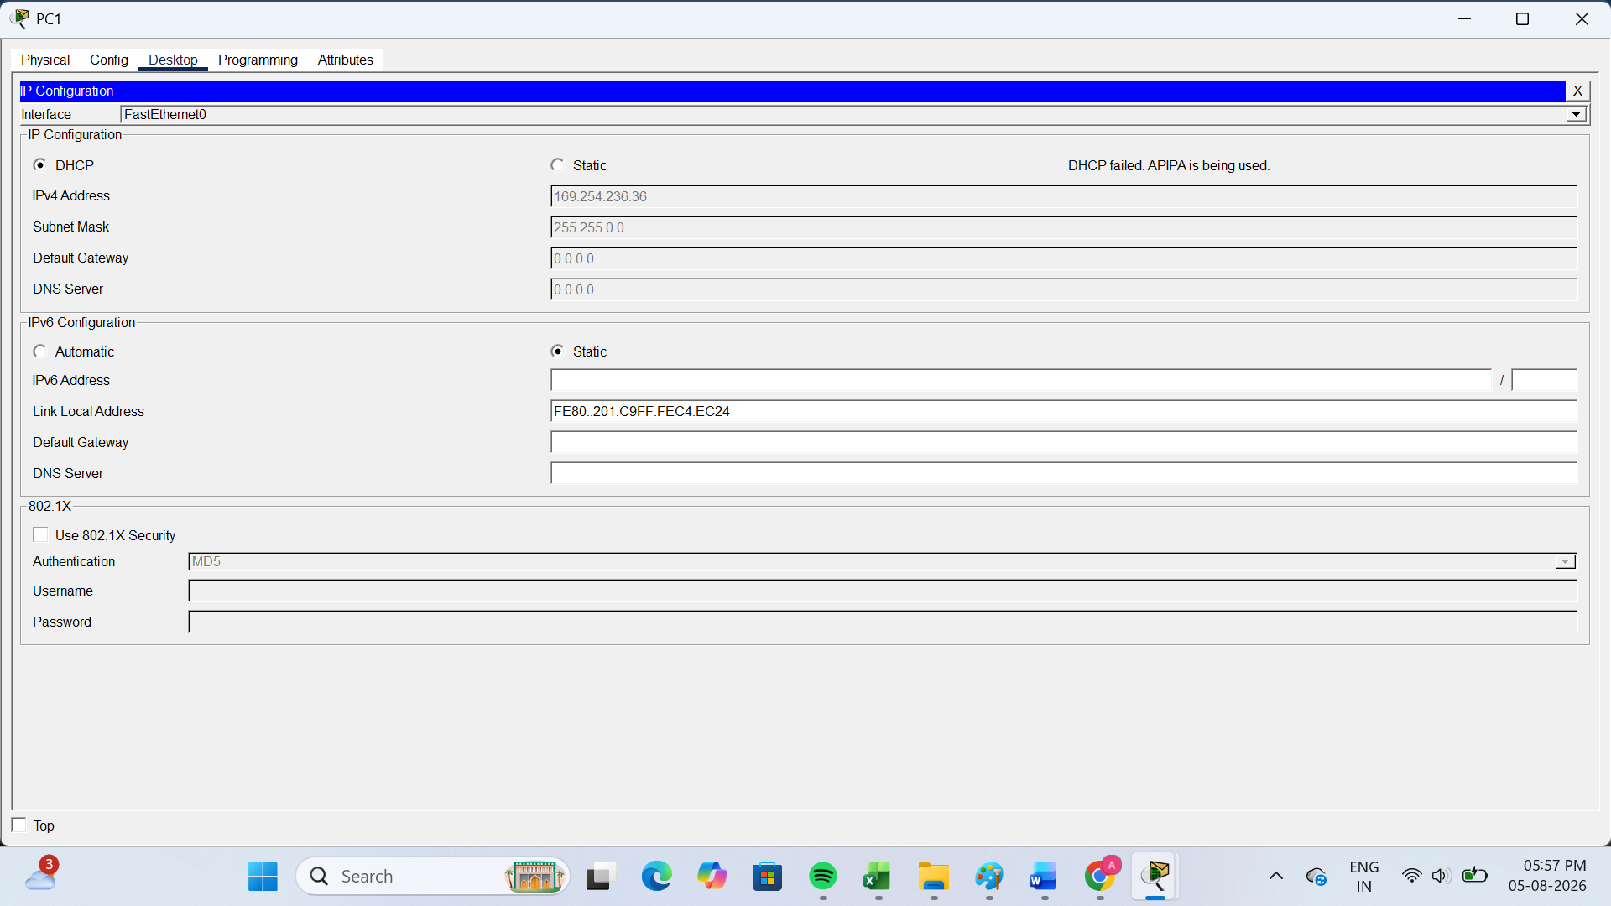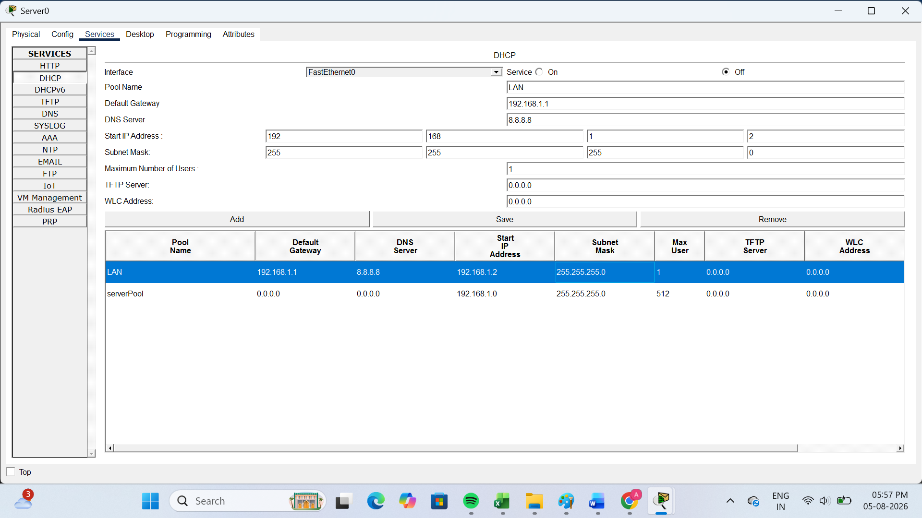
Observation:
- PC0 successfully received IP address 192.168.1.2.
- PC1 failed to obtain an IP address because no IP addresses were left in the DHCP pool.
Explanation (2–3 lines):
The DHCP pool was configured to provide only one IP address. The first PC obtained the available IP address successfully. When the second PC requested an IP address, the DHCP pool had no free addresses remaining, so the DHCP request failed.

4.Simulate a Zomato-style restaurant WiFi scenario in Cisco Packet Tracer: configure a DHCP server to provide IP addresses to both a laptop and a smartphone (use a generic PC as smartphone). Show the assigned IPs and explain why DHCP is useful in this situation.
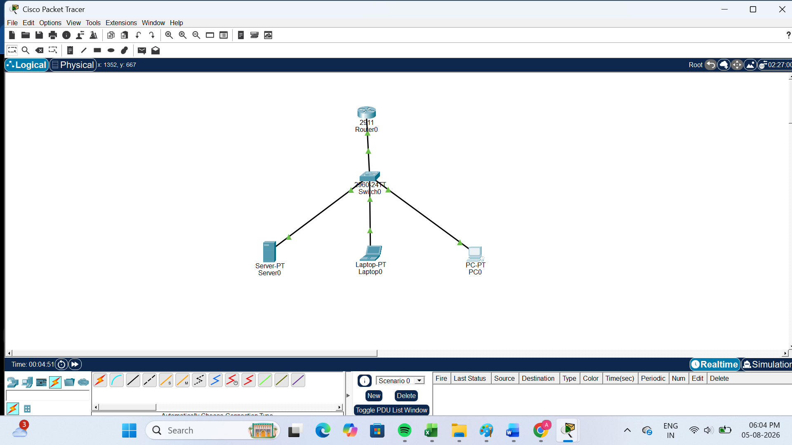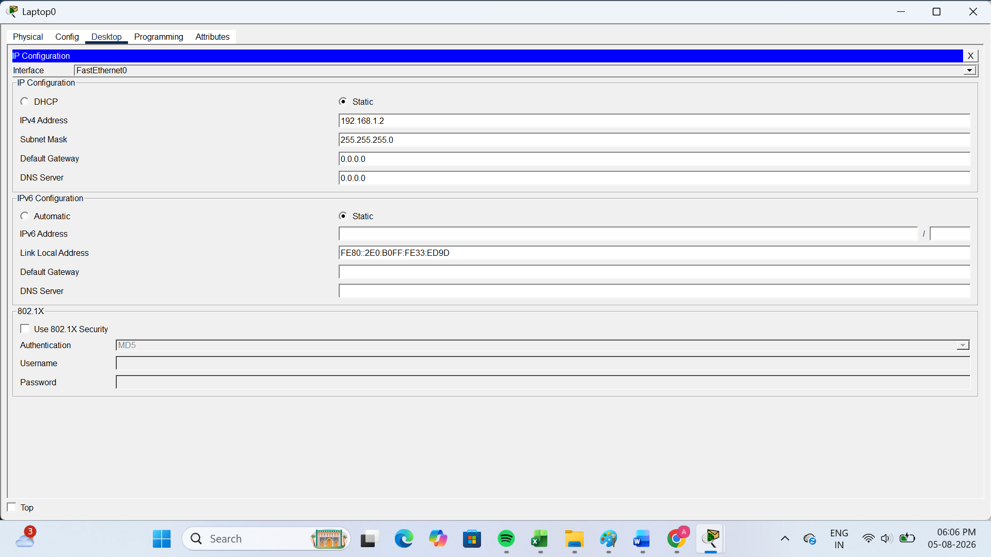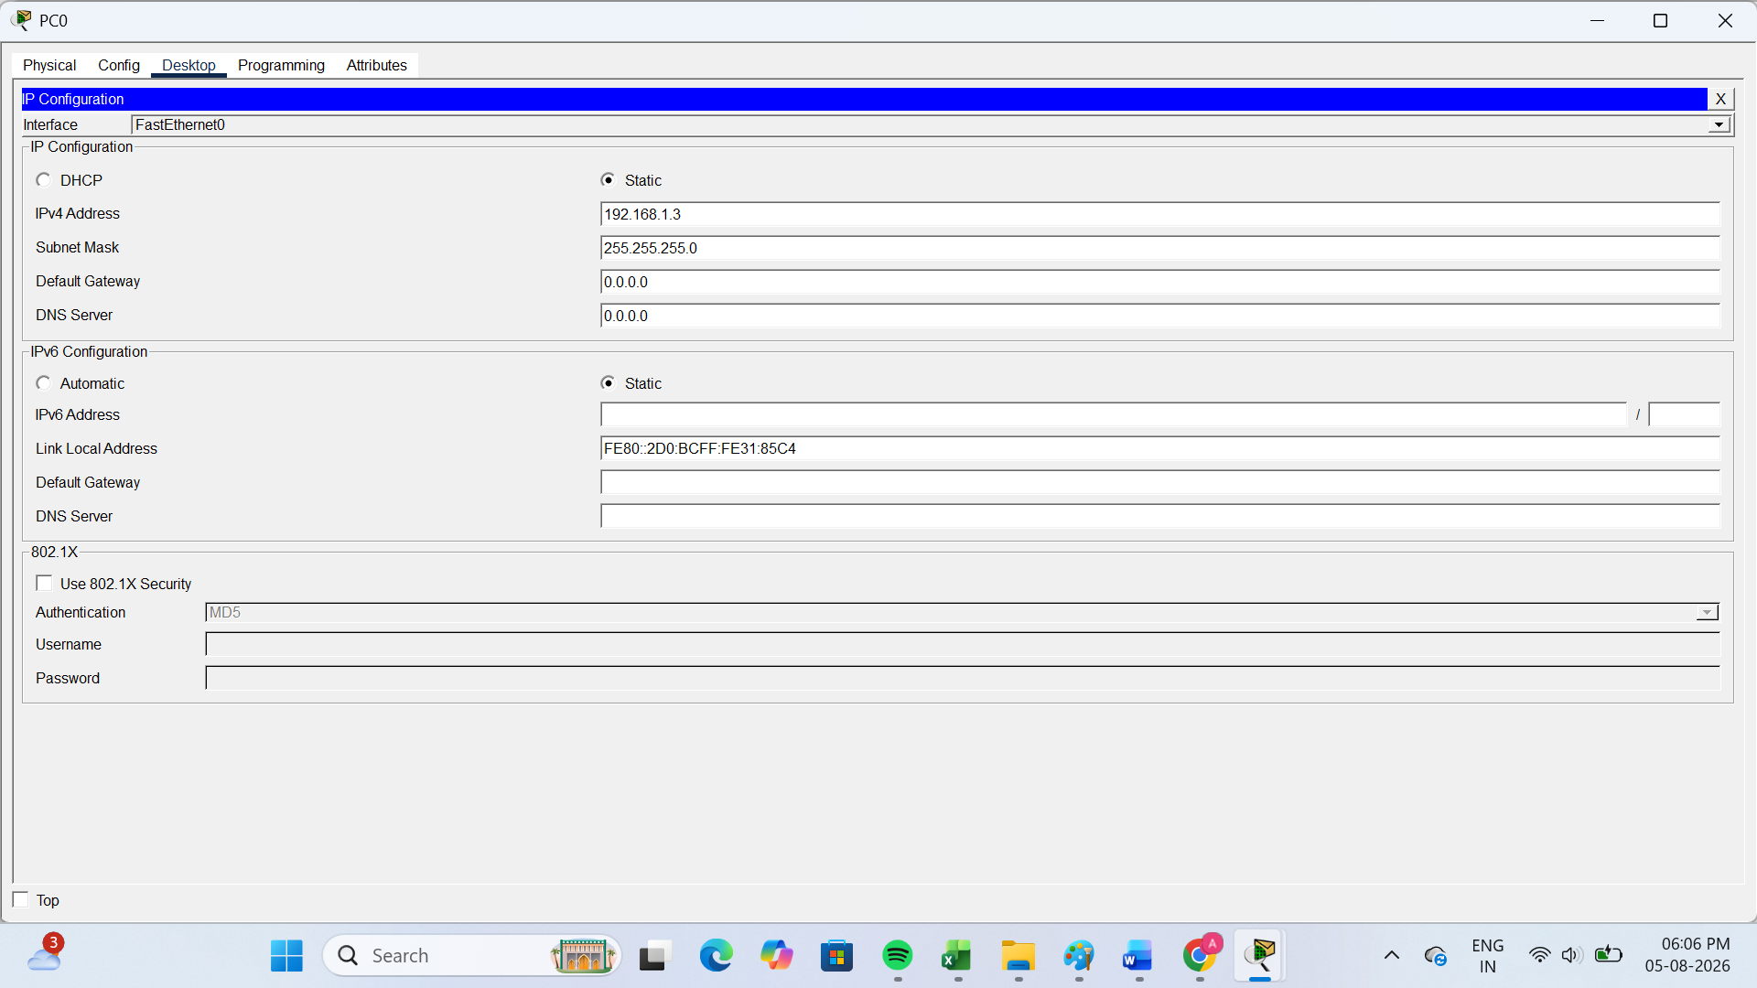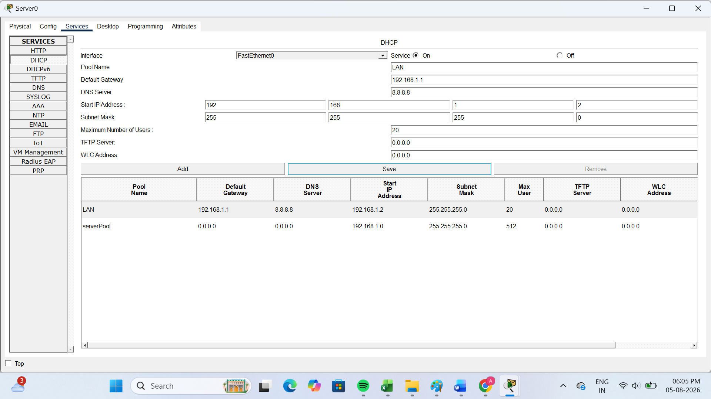
In this simulation, the DHCP server automatically assigned IP addresses to the laptop and the smartphone (represented by a PC). DHCP is useful because it automatically provides IP addresses to devices, reducing manual configuration and allowing customers to connect to the restaurant WiFi quickly and easily.

