BUILD AND CONFIGURE LAN


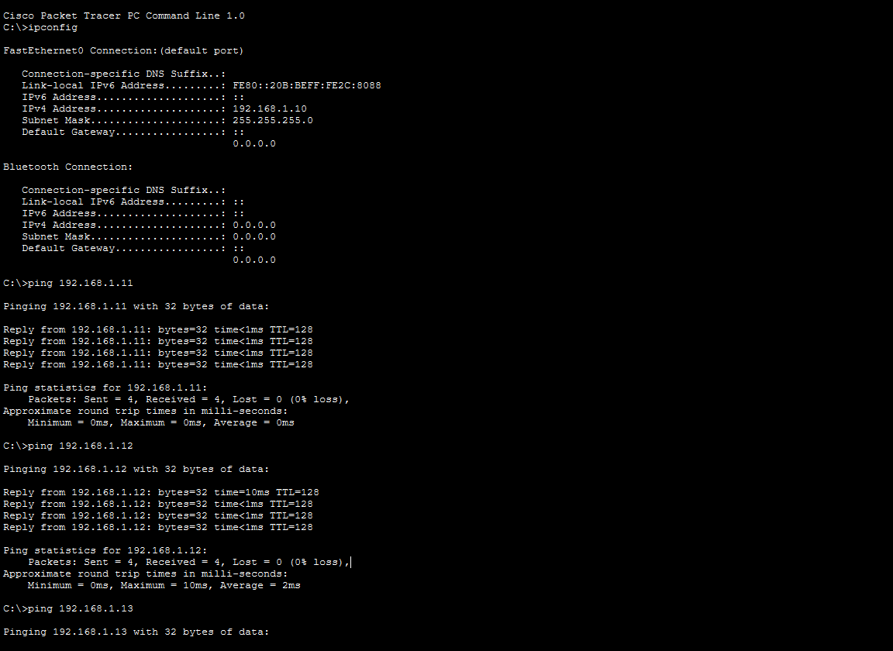
- Assign static IP addresses to five devices (laptops or desktops) on your home or lab network, ensuring each is in the same subnet, and verify connectivity between them using the ping command.


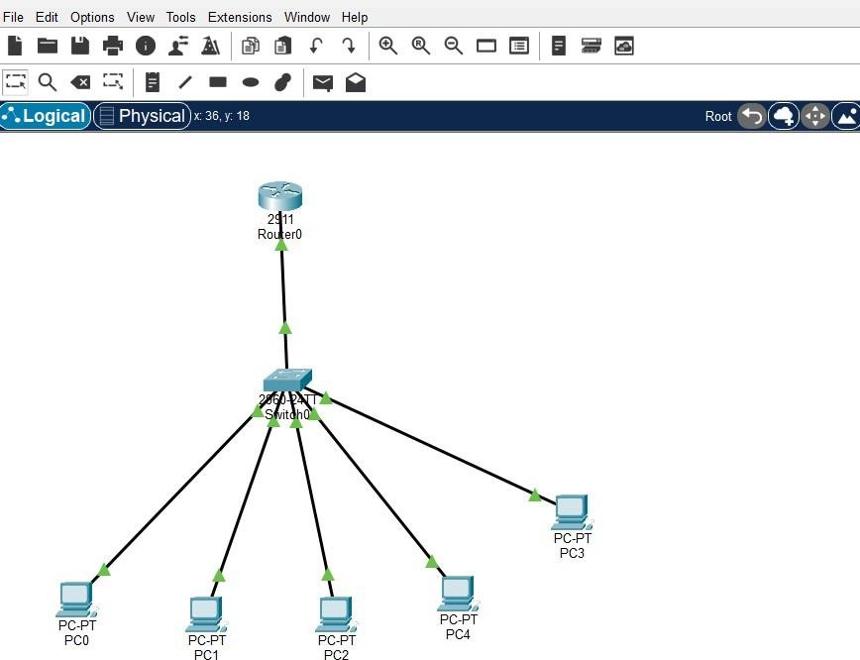
- Set up a DHCP server (using your router or software like Packet Tracer/GNS3/VirtualBox) to automatically assign IP addresses to at least three devices, and confirm that each device receives a unique IP from the correct range.

  - Network Topology

  - Router DHCP Configuration
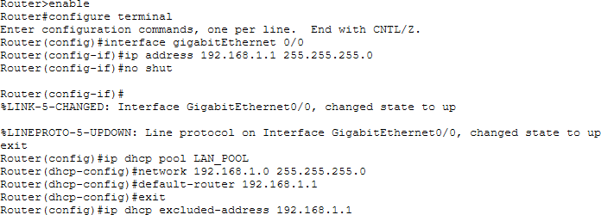
    - DHCP Binding

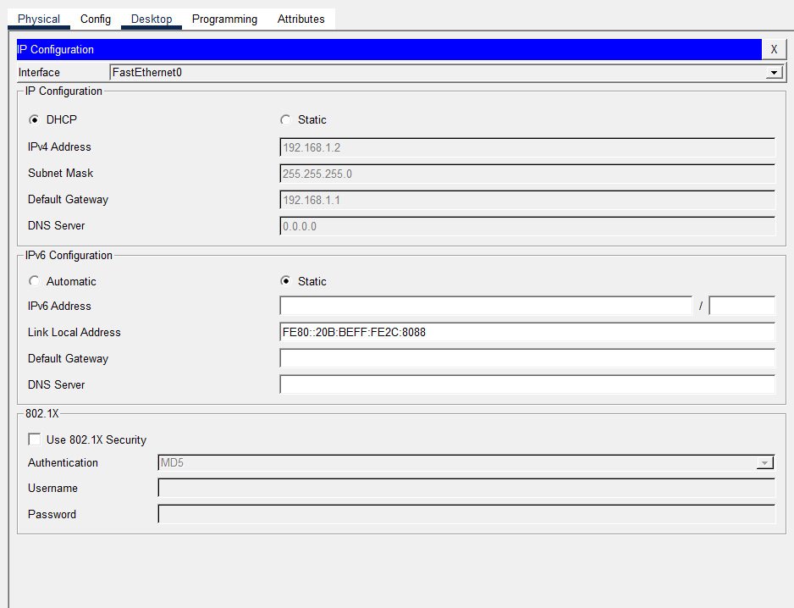
    - The PC will automatically receive an IP address. (PC IP Configuration)


- Configure a DNS service (using your router’s DNS settings or a tool like dnsmasq) so that typing a custom hostname (e.g., musicplayer.local) in a browser on any connected device opens a specific local web page or device interface.<br><br><em><strong>Hint:</strong> You can map hostnames to local IPs using the DNS service or by editing the hosts file for a quick test.</em>
Steps Performed
- Opened Notepad as Administrator.
- Opened the hosts file from: C:\Windows\System32\drivers\etc
\hosts
- Added the following entry: 192.168.1.1 musicplayer.local
- Saved the hosts file.
- Cleared the DNS cache using: ipconfig /flushdns
- Opened a web browser and entered:
http://musicplayer.local
- Verified that the router's local web interface opened successfully.

Command Used
ipconfig /flushdns

Hosts File Entry

192.168.1.1 musicplayer.local

- Create two VLANs (e.g., VLAN 10: 'Workstations', VLAN 20: 'Smart Devices') on your switch or simulation tool, assign at least two devices to each VLAN, and demonstrate that devices in the same VLAN can communicate, but not with devices in the other VLAN.<br><br><em><strong>Hint:</strong> Use ping or file sharing to test connectivity between devices in different VLANs.</em>


Configuration Steps
- Added one switch and four PCs in Cisco Packet Tracer.
- Created VLAN 10 named Workstations.
- Created VLAN 20 named Smart Devices.
- Assigned PC0 and PC1 to VLAN 10.
- Assigned PC2 and PC3 to VLAN 20.
- Configured IP addresses for all PCs.
- Tested connectivity using the ping command.

- Network topology

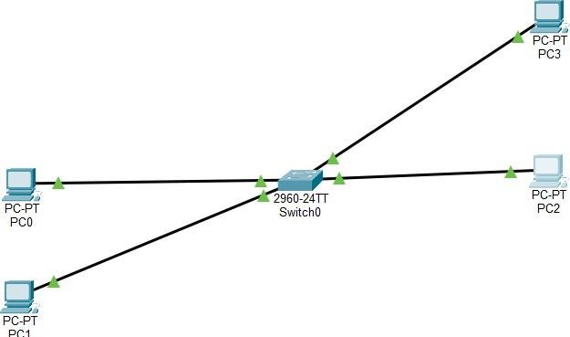

- VLAN configuration (show vlan brief)

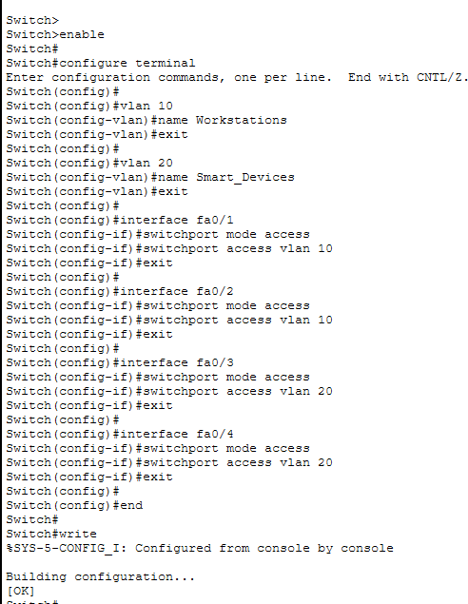

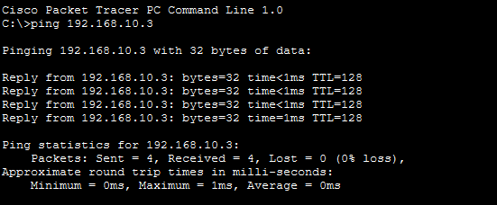
- Successful ping: PC0 → PC1
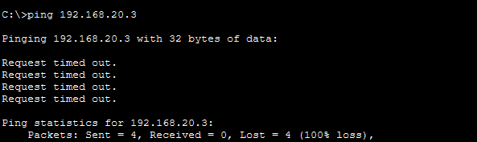
- Failed ping: PC0 → PC2 (Request Timed Out)


- Simulate internet access for your LAN by configuring a router with NAT (Network Address Translation), then test that devices on your LAN can access an external site (e.g., www.wikipedia.org) or a simulated external server.
Configuration Steps
- Created a LAN consisting of one switch, one router, two PCs, and one external server.
- Assigned IP addresses to all devices.
- Configured the router's LAN interface as the NAT Inside interface.
- Configured the router's WAN interface as the NAT Outside interface.
- Created an access list to identify the internal network.
- Enabled NAT overload (PAT) on the router.
- Configured the PCs with the correct default gateway. Tested connectivity by pinging the external

