TROUBLESHOOTING NETWORK SERVICES

Simulate a DNS resolution failure on your local machine by editing the hosts file to point www.spotify.com to a wrong IP address, then try to ping the domain and document the error message you receive.

  - Open Notepad as Administrator.
  - Navigate to C:\Windows\System32\drivers\etc\hosts.
  - Add entry:
Code: 123.123.123.123 www.spotify.com
  - Save and close the file.
  - Open Command Prompt.
  - Type: ping www.spotify.com.
  - Observe the output → it resolves to wrong IP and shows “Request timed out”

errors.
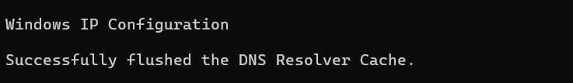
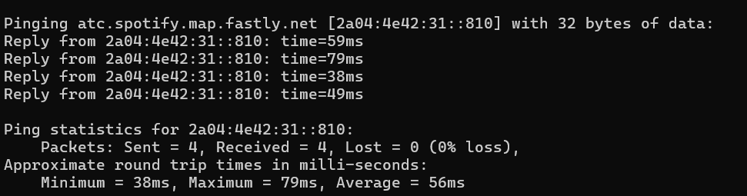

Configure a DHCP server in a network simulator (such as Cisco Packet Tracer or GNS3) and intentionally set an incorrect default gateway; connect a client device and verify the assigned gateway, then describe how you would identify and fix this issue.

Configuration Steps

Step 1: Configure DHCP on Router
Open Router CLI:
Code
Create DHCP pool with wrong gateway: Code
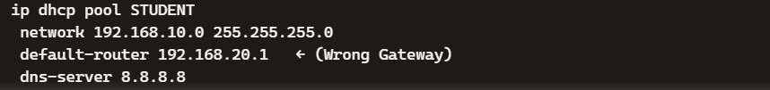
Assign IP to router interface:

Code

Step 2: Connect Client PC
- Go to PC → Desktop → IP Configuration
- Select DHCP
- The PC will receive:
o IP: 192.168.10.x
o Subnet Mask: 255.255.255.0
  - Default Gateway: 192.168.20.1 (wrong) For Verification
On PC Command Prompt:
Code
You will see the wrong gateway (192.168.20.1). Try pinging router:
Code
ping 192.168.10.1
Ping works, but internet/external communication fails because gateway is incorrect.

Given a scenario where devices on your simulated network are unable to access websites by name but can by IP address, use the nslookup or dig tool to diagnose the DNS problem and write down the troubleshooting steps and solution.

Troubleshooting Steps
- Check network connectivity ping 8.8.8.8
  - If it works, the internet connection is fine.

- Test DNS resolution using nslookup
nslookup www.google.com
OR (Linux)
dig www.google.com

- Check the result
  - If it returns an IP address → DNS is working.
  - If it shows "Server failed", "NXDOMAIN", or "DNS request timed out", DNS is not working.

- Check the configured DNS server
  - Windows: ipconfig /all
  - Linux: cat /etc/resolv.conf

- Change the DNS server
Use a public DNS server such as:
  - Google DNS: 8.8.8.8 and 8.8.4.4
  - Cloudflare DNS: 1.1.1.1 and 1.0.0.1

- Clear the DNS cache
  - Windows: ipconfig /flushdns
  - Linux: sudo systemctl restart systemd-resolved
(or restart the DNS service used by your system)

- Test again
nslookup www.google.com
or
dig www.google.com

- A device in your simulated network is not receiving an IP address from the DHCP server and shows an APIPA address (169.x.x.x). List the possible causes for this and document the step-by-step process you would use to resolve it.<br><br><em><strong>Hint:</strong> Check for network connectivity, DHCP scope exhaustion, and server availability.</em>
➢

Possible Causes
  - Network connectivity problem – cable unplugged, wrong VLAN, or switch port down.
  - DHCP scope exhaustion – no free IPs left in DHCP pool.
  - DHCP server unavailable – router/server interface shutdown or service disabled.
  - Incorrect DHCP relay (IP helper) configuration – if DHCP server is on another subnet.
  - Firewall/ACL blocking DHCP traffic (UDP ports 67/68).

Troubleshooting Steps

Step 1: Check Physical Connectivity
    - Verify cable between PC → Switch → Router.
    - On PC:

Code
ipconfig /renew
If still APIPA → move to next step.

Step 2: Verify DHCP Service on Router/Server
On Router CLI:

Code
show running-config
    - Confirm DHCP pool exists.
    - Ensure interface connected to client has IP and no shutdown.

Step 3: Check DHCP Scope Availability
On Router:

Code
show ip dhcp binding
    - If all IPs are leased → expand pool.
    - Example fix:

Code
ip dhcp pool STUDENT
network 192.168.10.0 255.255.255.0
default-router 192.168.10.1
dns-server 8.8.8.8

Step 4: Verify Client Settings
On PC → Desktop → IP Configuration:
    - Ensure DHCP is selected, not static.
    - Release/renew:

Code
ipconfig /release ipconfig /renew

Step 5: Check DHCP Relay (if server on another subnet)
On Router interface:
Code
ip helper-address <DHCP-server-IP>
Without this, DHCP requests won’t reach server.

Create a table documenting at least three common DNS issues and three common DHCP issues you encountered or researched, including symptoms, possible causes, and recommended solutions for each.
Type | issue |  | Symptoms | Possibe Causes | Recommended  Solutions
DNS | Wrong Server | DNS | Can ping IP but not domain | DHCP pool misconfigured | Correct DNS server in DHCP config, renew client IP
DNS | DNS  Down | Server | nslookup timeout | Server off / firewall block | Start DNS service, firewall | check
DNS | Cache Corruption |  | Some sites fail intermittently | Local DNS cache issue | Flush DNS cache
DHCP | Scope Exhaustion |  | New devices get APIPA | Pool full | Increase DHCP scope range
DHCP | Server Down |  | Clients fail to get IP | Router interface shutdown | Enable interface, DHCP service | restart
DNCP | Relay Misconfig |  | Remote subnet clients fail | Missing/wrong helper address | Configure correct

