1.List 5 common hardware issues that can cause network problems in a typical office setup, and for each, describe one symptom that helps identify it.
No. | Hardware Issue | Symptom
1 | Damaged Ethernet Cable | Network connection keeps disconnecting or shows “Network Cable Unplugged.”
2 | Faulty Network Interface Card (NIC) | The computer cannot connect to the network even when the cable and switch port are working.
3 | Faulty Switch Port | Devices connected to one particular port have no network connection, while other ports work normally.
4 | Router Failure | Multiple devices lose internet/network connectivity at the same time.
5 | Wireless Access Point Failure | Users cannot detect or connect to the office Wi-Fi network.

2.Open Cisco Packet Tracer or any network simulator, set up a small network with 3 PCs, 1 switch, and 1 router, and intentionally disconnect one device. Use the simulator's troubleshooting tools to identify which device is faulty and document the steps you took.
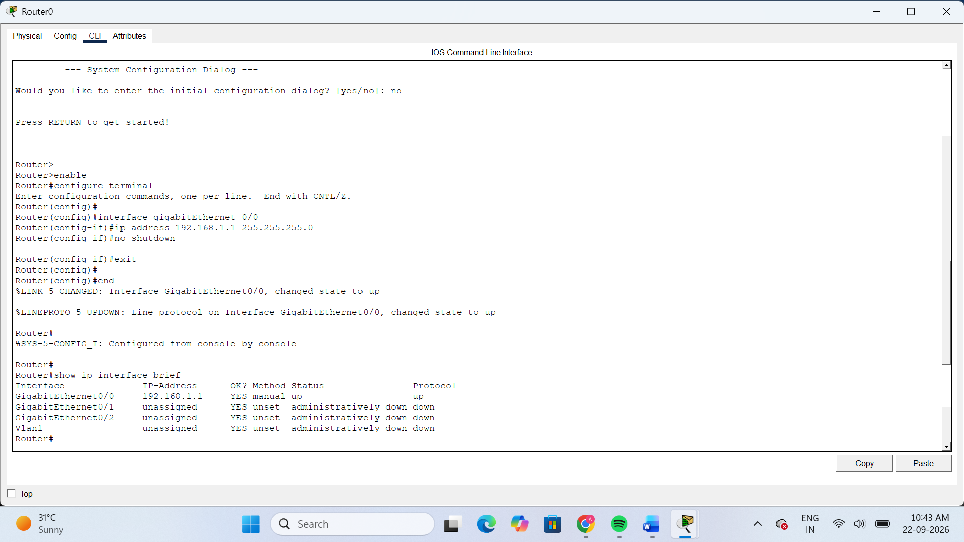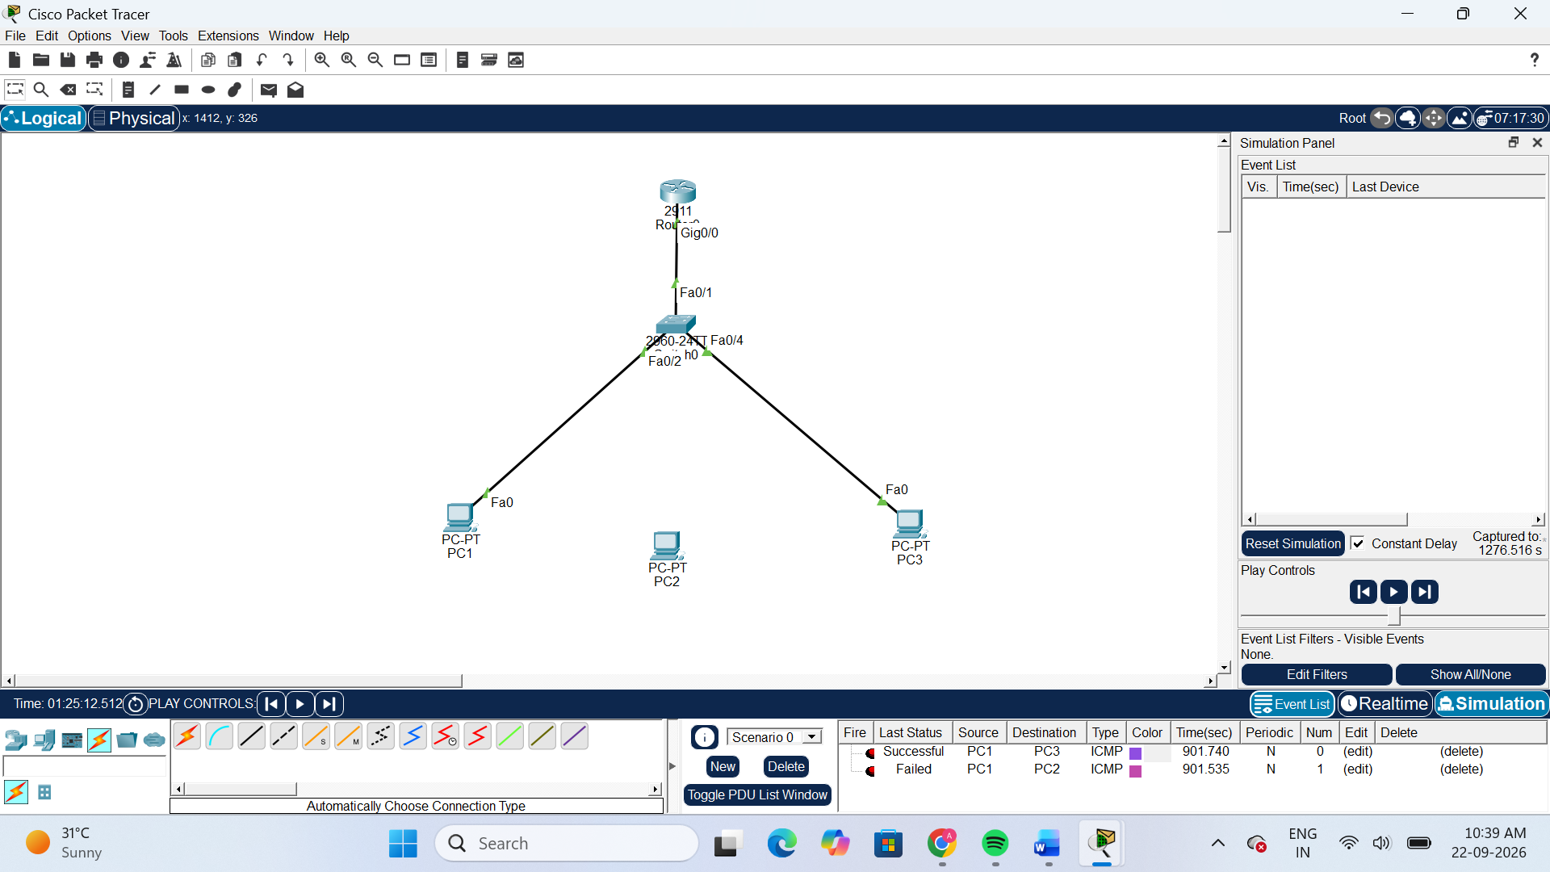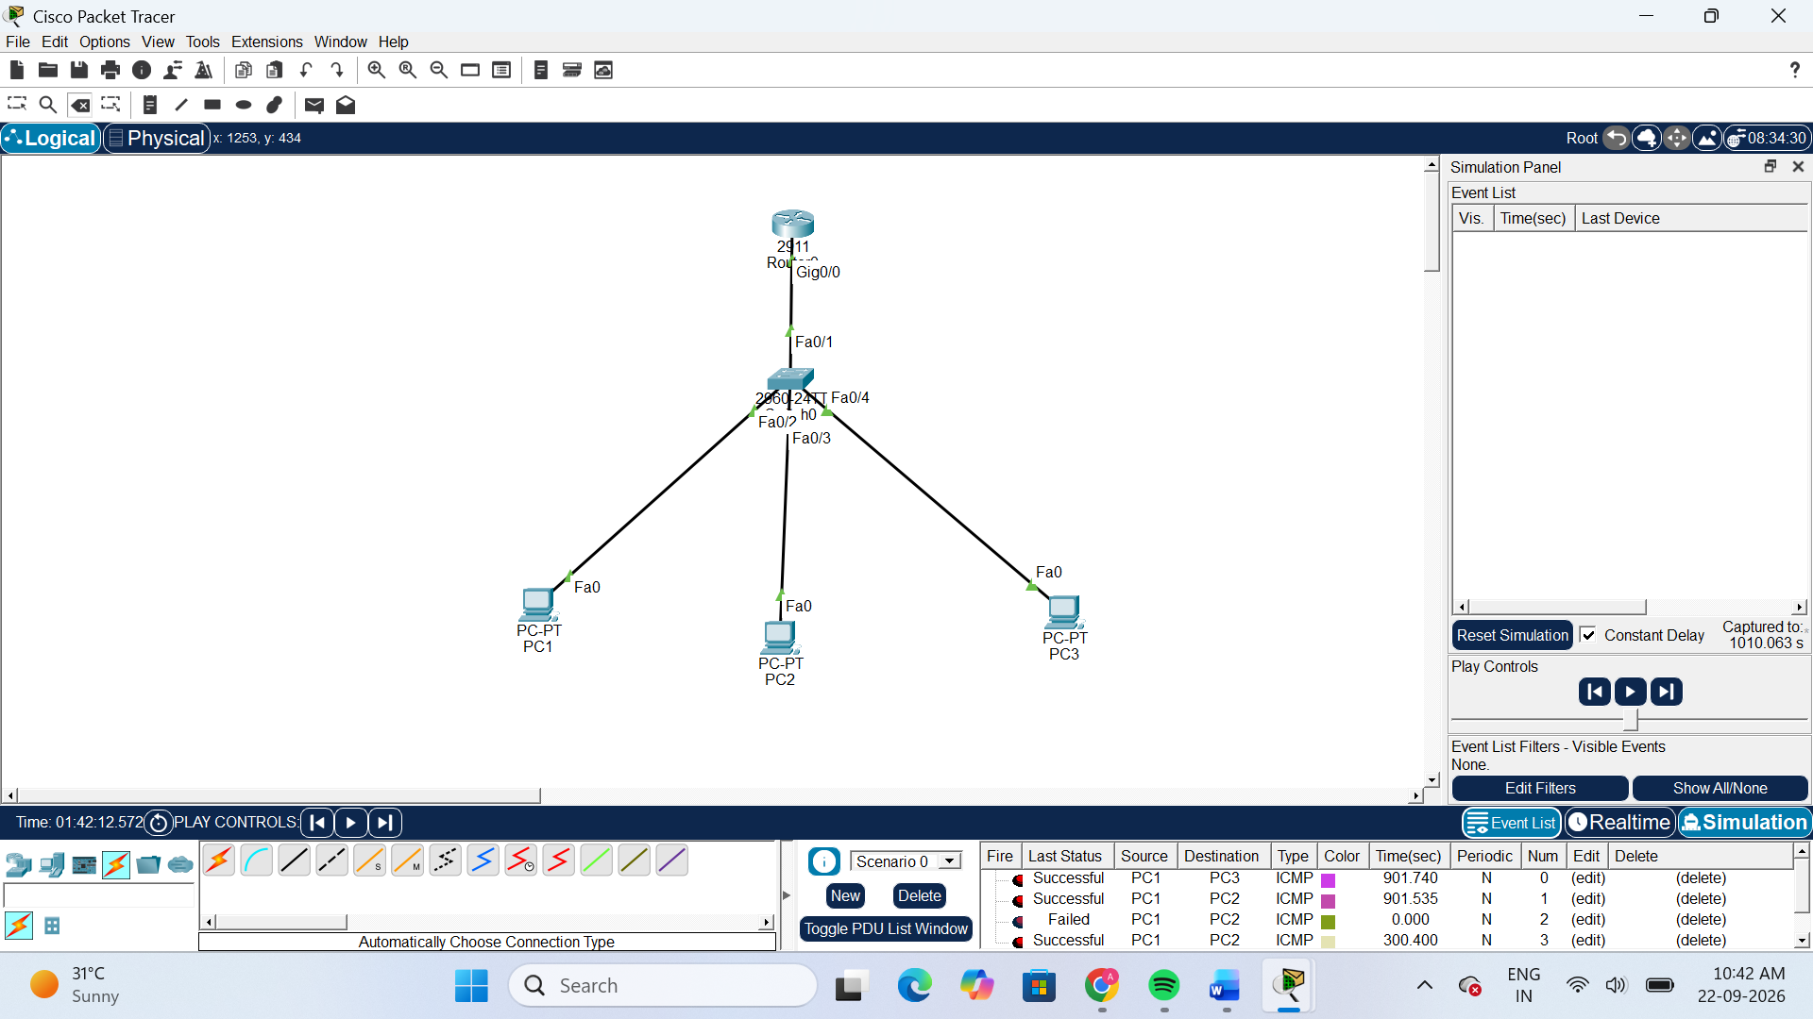
Troubleshooting Steps
- I created a small network using 3 PCs, 1 switch, and 1 router in Cisco Packet Tracer.
- I configured the IP addresses of all three PCs and the router.
- I first tested the network using a Simple PDU (ICMP).
- The connection between PC1 and PC3 was successful, confirming that the network was working properly.
- I intentionally disconnected PC2 from the switch to create a network fault.
- I sent an ICMP packet from PC1 to PC2, which resulted in a Failed status.
- I checked PC2's IP configuration and found it was correctly configured.
- I then checked the physical connection and identified that PC2 was disconnected from the switch.
- I reconnected PC2 to Switch Fa0/3 using a Copper Straight-Through cable.
- I tested the connection again using Simple PDU.
- The PC1 → PC2 connection was successfully restored.
Fault Identified
Fault: PC2 was physically disconnected from the switch.
Symptom: ICMP communication from PC1 to PC2 failed.
Solution: Reconnected PC2's FastEthernet0 interface to Switch Fa0/3.

3.Create a troubleshooting checklist for diagnosing slow internet issues in a home WiFi network, including at least 8 steps covering both hardware and software checks.<br><br><em><strong>Hint:</strong> Think about checking cables, router status lights, device settings, and running ping or speed tests.</em>
Step | Check | What to Do
1 | Check cables | Make sure the router's power and Ethernet/Internet cables are properly connected and not damaged.
2 | Check router status lights | Check the Power, Internet/WAN, and Wi-Fi lights. Unusual red or blinking lights may indicate a problem.
3 | Restart the router | Turn off the router, wait about 30 seconds, and turn it back on. Wait for all required lights to become stable.
4 | Check Wi-Fi signal strength | Move closer to the router and check whether the internet becomes faster. Weak signal can reduce speed.
5 | Check connected devices | Disconnect unused devices because multiple devices using the same Wi-Fi can reduce available bandwidth.
6 | Check device settings | Make sure Wi-Fi is enabled, Airplane Mode is off, and the correct Wi-Fi network is selected.
7 | Run a ping test | Open Command Prompt and run ping 8.8.8.8 to check whether there is high delay or packet loss.
8 | Run a speed test | Use a reliable internet speed-test website and compare the download/upload speed with the speed promised by the ISP.
9 | Check background applications | Stop downloads, cloud synchronization, streaming, or software updates that may be consuming bandwidth.
10 | Update software/drivers | Update the Wi-Fi adapter driver and router firmware if an update is available.

4.You receive a complaint that a user cannot access Instagram and YouTube on their laptop, but WhatsApp Web works fine. Write down the first 5 troubleshooting steps you would perform to identify if the issue is with hardware, software, or network configuration.
