1.Open Command Prompt or Terminal and use the ping command to test connectivity to www.spotify.com. Note the number of packets sent, received, and the average response time.
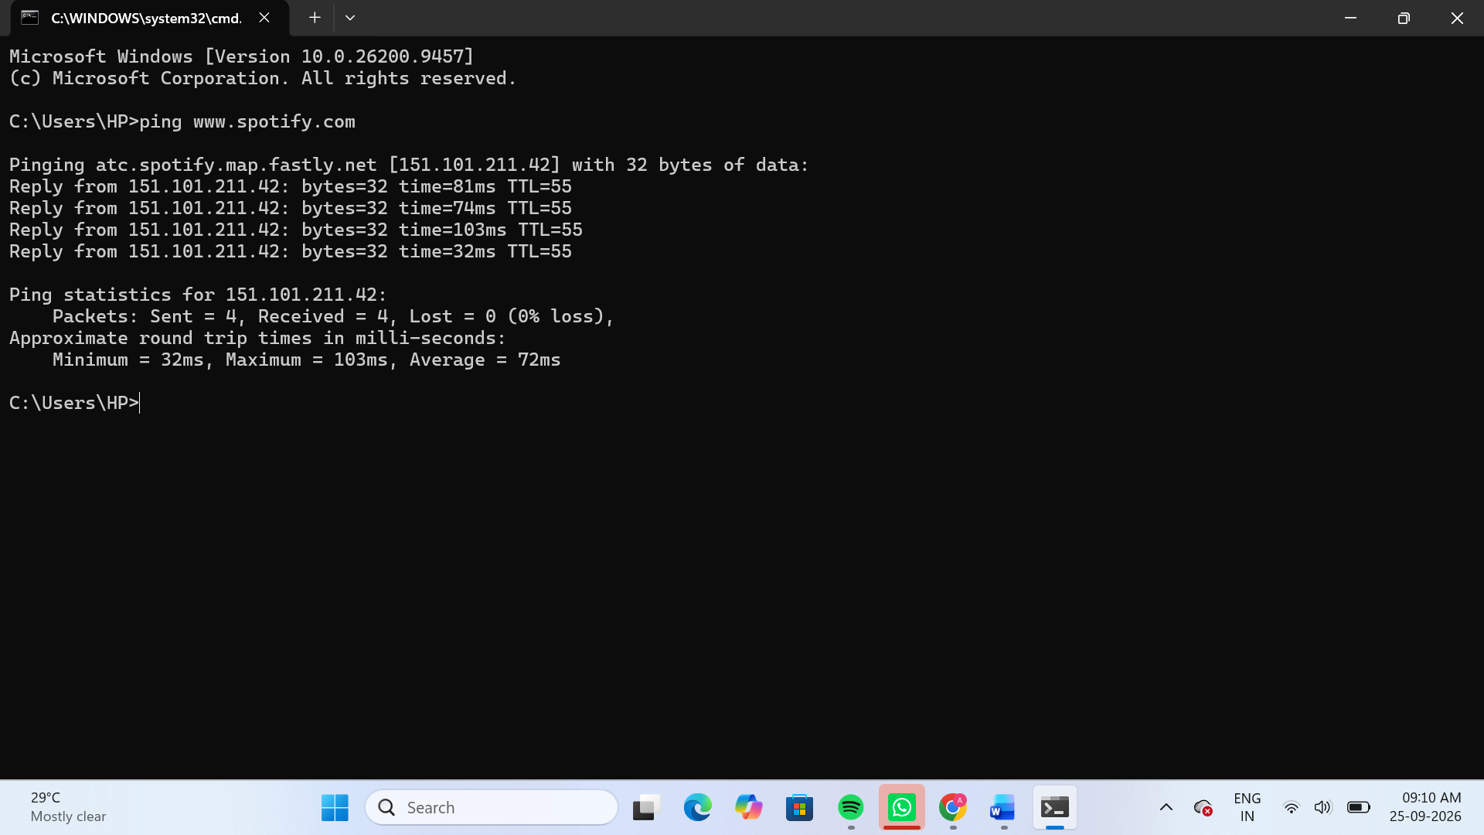
The connectivity to www.spotify.com was successfully tested using the ping command. 4 packets were sent and 4 packets were received, with 0% packet loss. The average response time was 72 ms.
2.Use the traceroute (tracert on Windows, traceroute on Linux/Mac) command to trace the path from your computer to www.flipkart.com. List the number of hops and identify the IP address of the first and last hop.
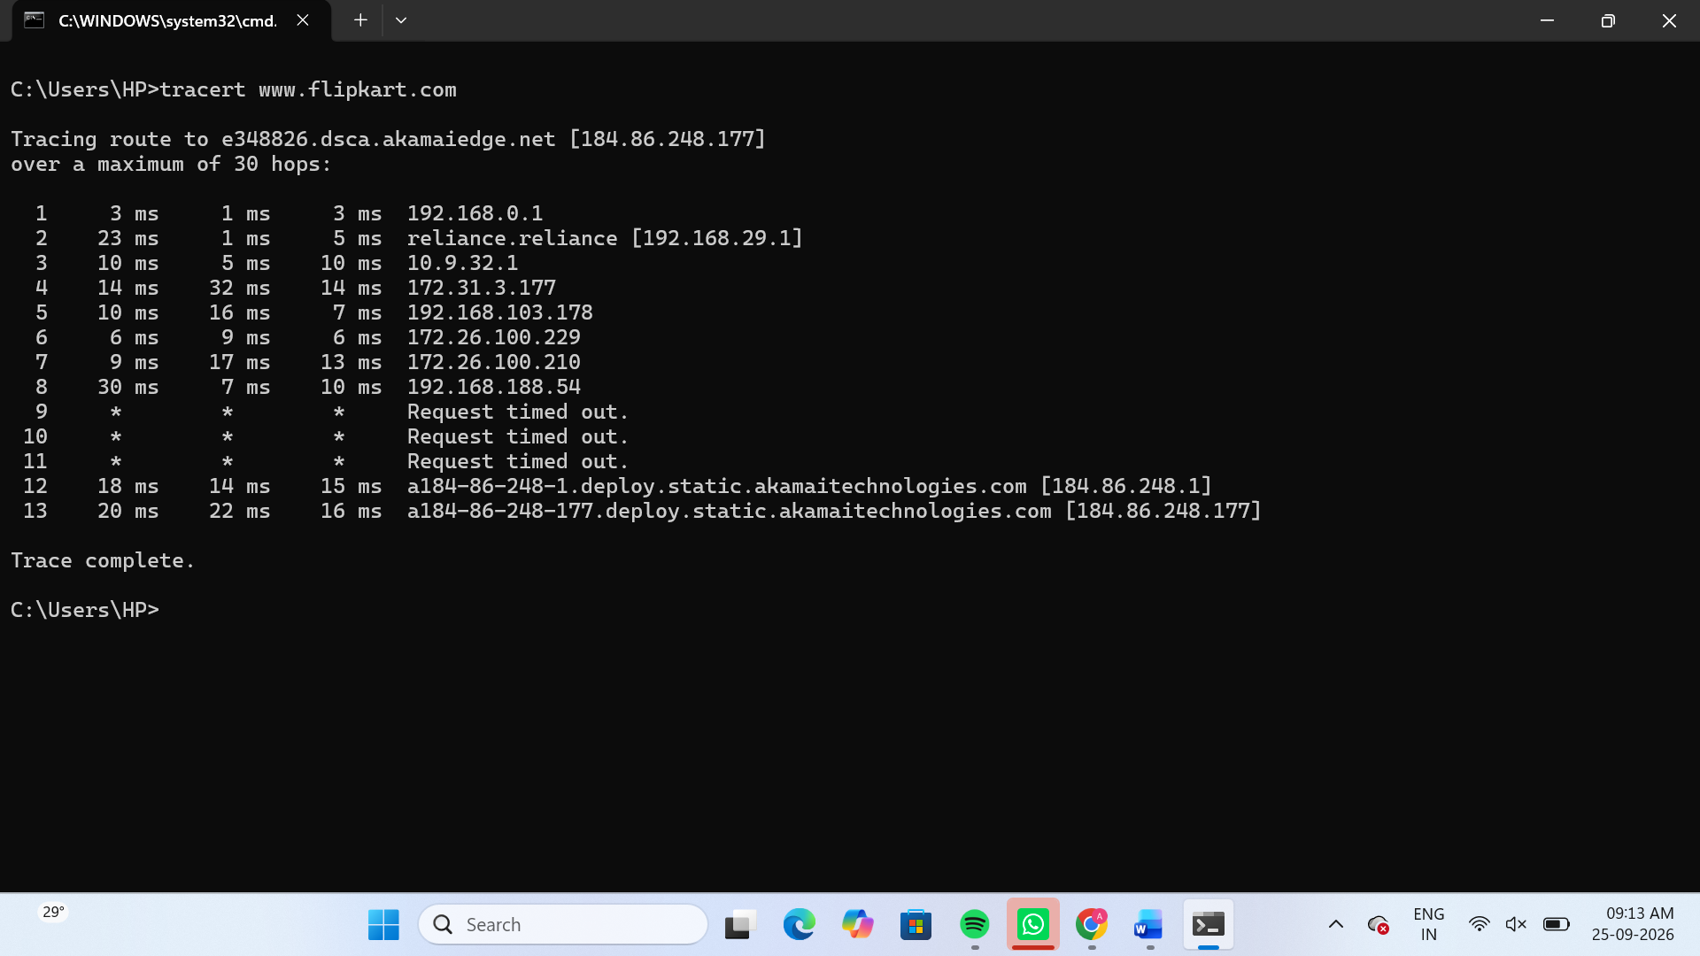
The traceroute command successfully traced the path from the computer to www.flipkart.com. The trace completed in 13 hops. The IP address of the first hop is 192.168.0.1, and the last hop is 184.86.248.177. Some intermediate hops (9–11) did not respond and showed “Request timed out.”
3.Simulate a connectivity issue by pinging a non-existent website (for example, ping www.fakezomato12345.com) and write down the error message your receive.<br><br><em><strong>Hint:</strong> Compare the output to a successful ping and describe the difference in your findings.</em>
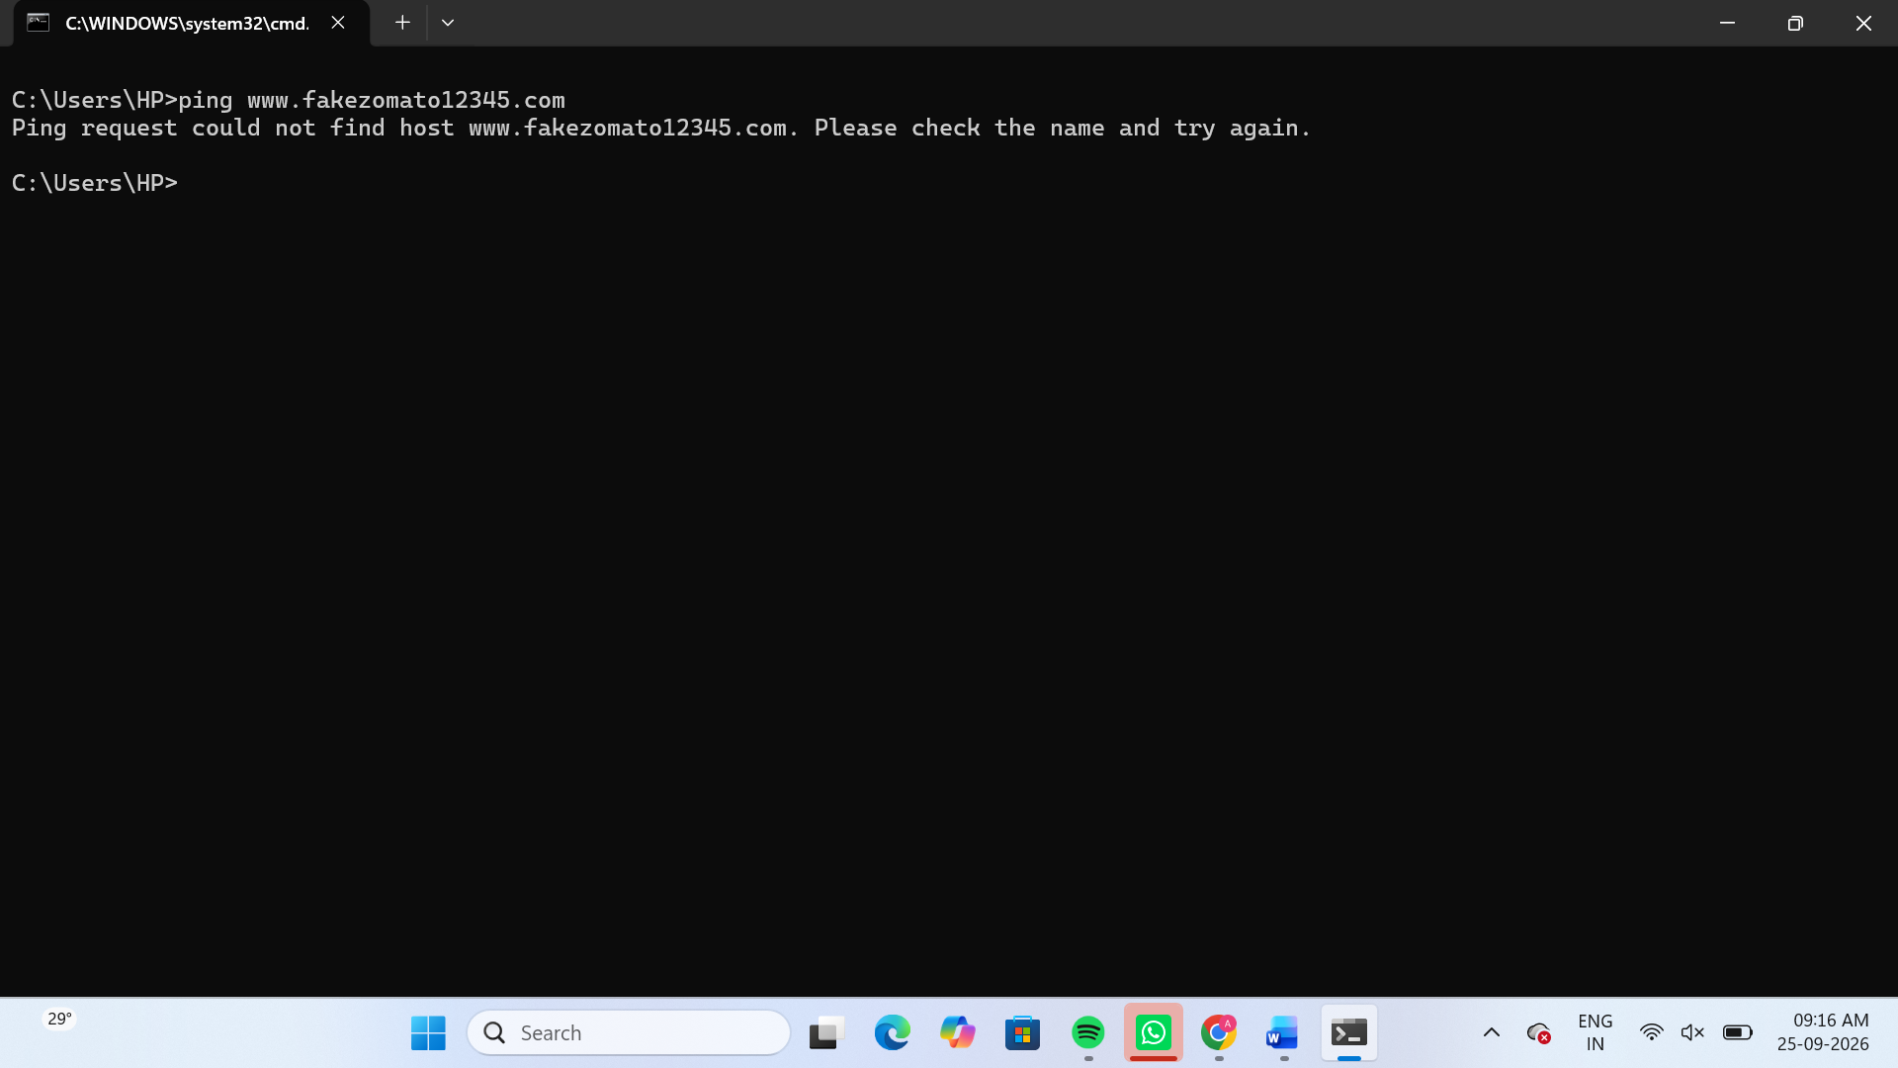
The ping was unsuccessful because the specified domain name could not be resolved. Unlike the successful ping to www.spotify.com, no reply or packet statistics were received. This indicates a DNS/name resolution problem for the non-existent domain.
4.Imagine you are unable to access www.youtube.com from your system. Use both ping and traceroute commands to diagnose the issue and write a short report describing where the connection fails and what the possible reasons could be.
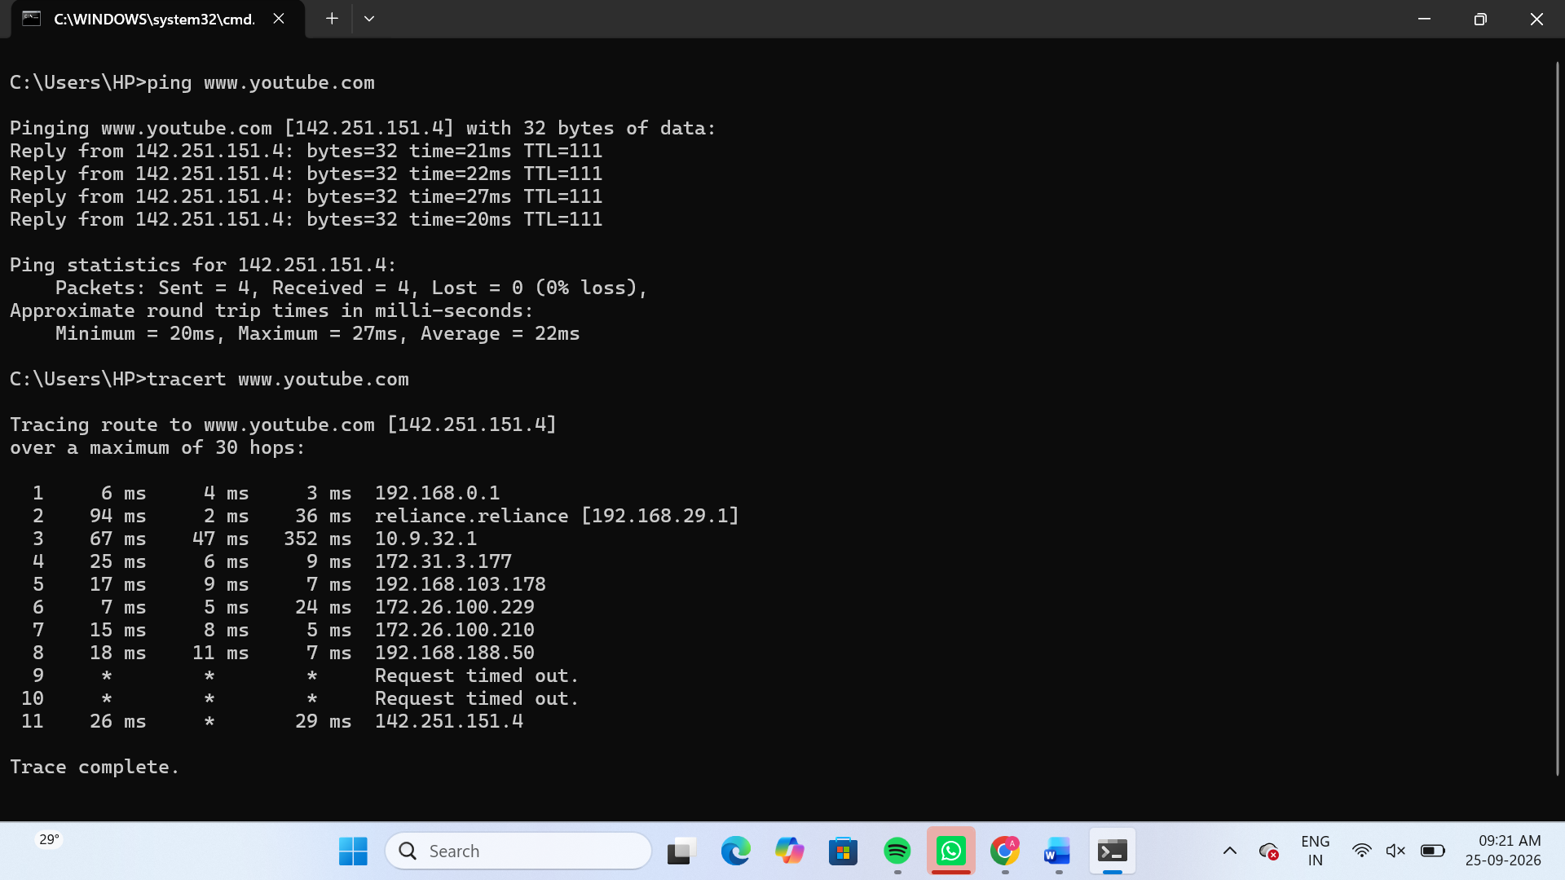
The ping test to www.youtube.com was successful, with 4 packets sent and 4 packets received and 0% packet loss. The average response time was 22 ms. The traceroute reached the destination in 11 hops. Hops 9 and 10 showed “Request timed out,” but the trace continued and successfully reached the destination at 142.251.151.4. Therefore, the timeout at hops 9 and 10 does not indicate that the connection failed; those intermediate devices may simply not respond to traceroute probes.

