1.Install Wireshark on your computer and capture 2 minutes of network traffic while you browse Instagram or YouTube. Save the capture file as insta_traffic.pcap.
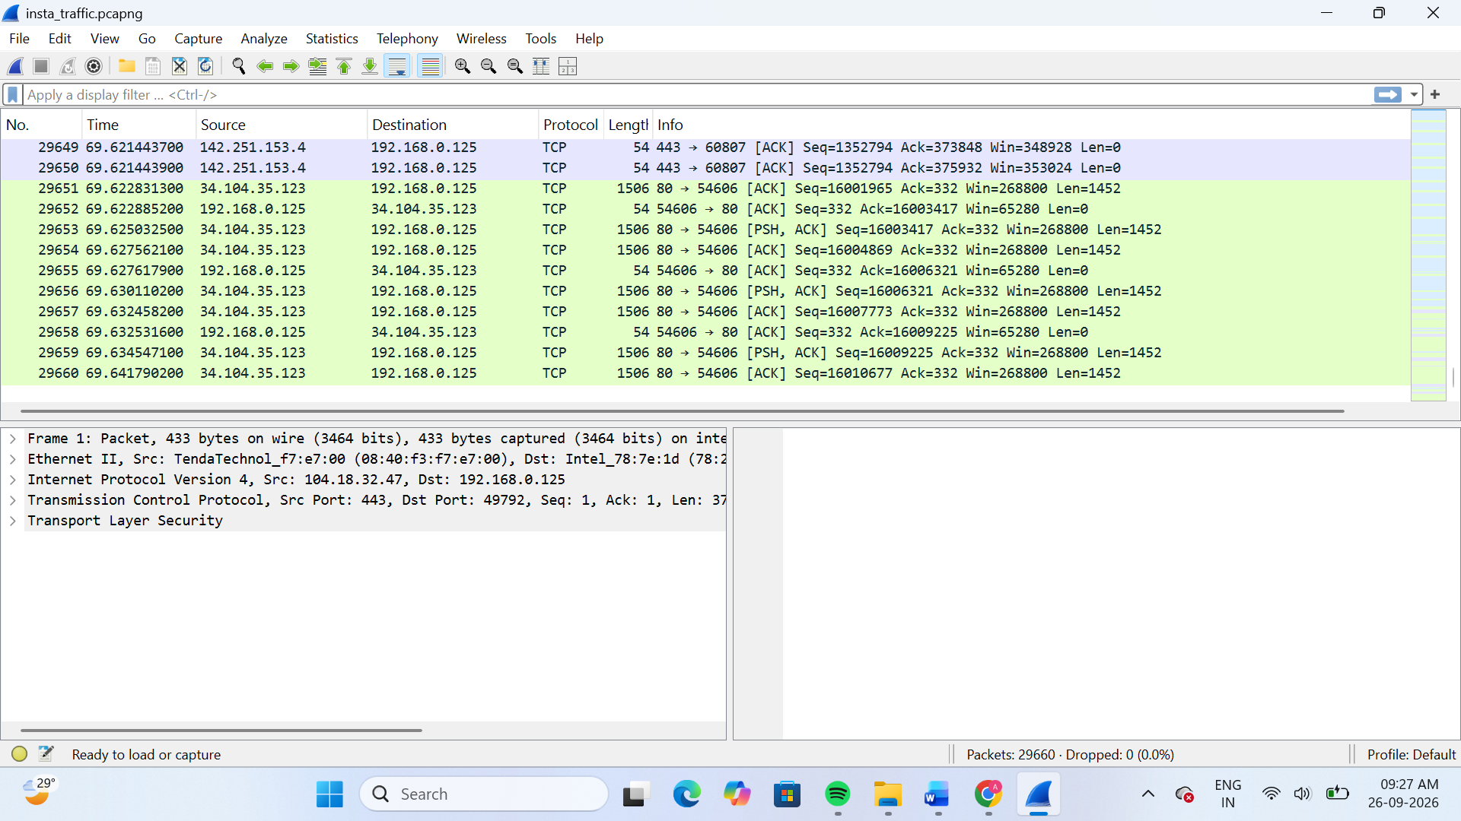
2.Use Wireshark to filter and list all HTTP or HTTPS requests made by your browser during the capture. Write down the domains you see most frequently.
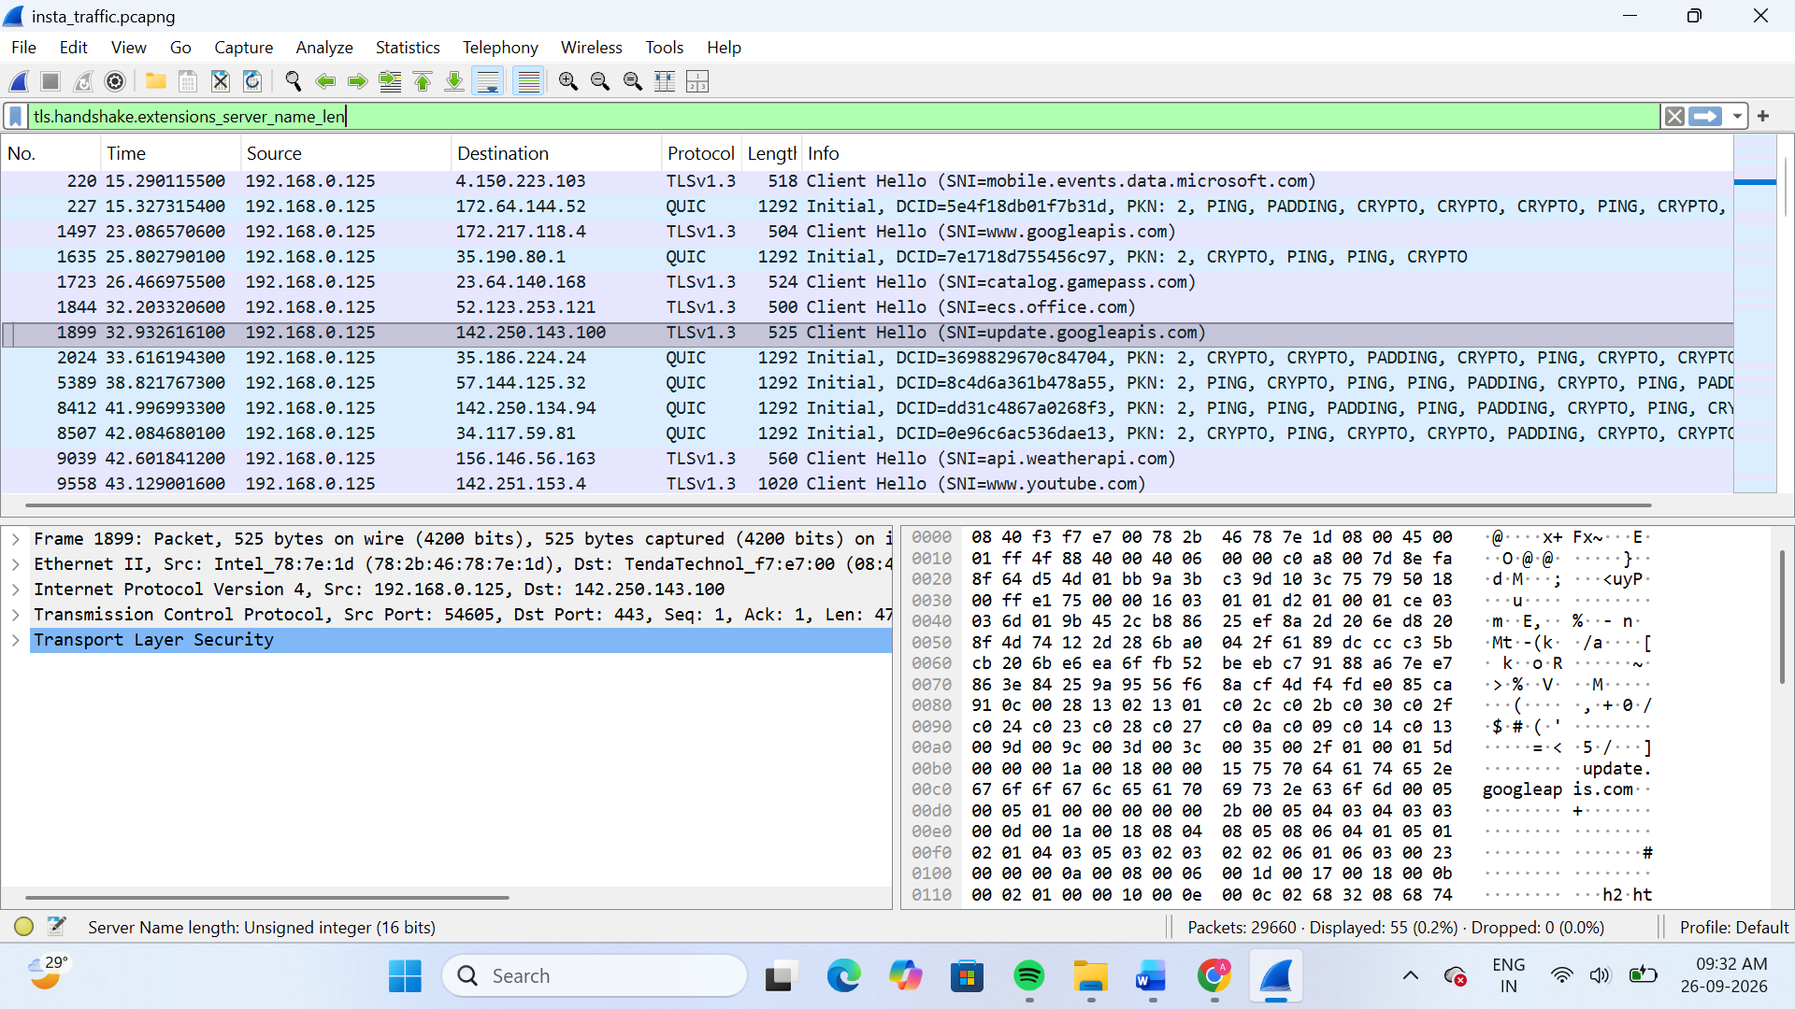
Wireshark was used to filter HTTP/HTTPS traffic generated by the browser. The captured traffic mainly contained HTTPS/TLS connections. The domains observed during the capture included:
- www.youtube.com
- update.googleapis.com
- www.googleapis.com
- mobile.events.data.microsoft.com
- api.weatherapi.com
Result:
The browser generated multiple HTTPS requests during browsing, and the above domains were observed in the captured traffic.
3.Open your insta_traffic.pcap in Wireshark and find a TCP packet. Document the source IP, destination IP, and TCP port numbers for that packet.
Field | Value
Source IP | 34.104.35.123
Destination IP | 192.168.0.125
Source Port | 80
Destination Port | 54606
Protocol | TCP

A TCP packet was identified in Wireshark. The source IP address is 34.104.35.123 and the destination IP address is 192.168.0.125. The source port is 80 and the destination port is 54606.
4.Run an Nmap scan on your own machine (localhost) to detect open ports. Save the command you used and list the open ports found.<br><br><em><strong>Hint:</strong> Use 'nmap 127.0.0.1' in your terminal.</em>
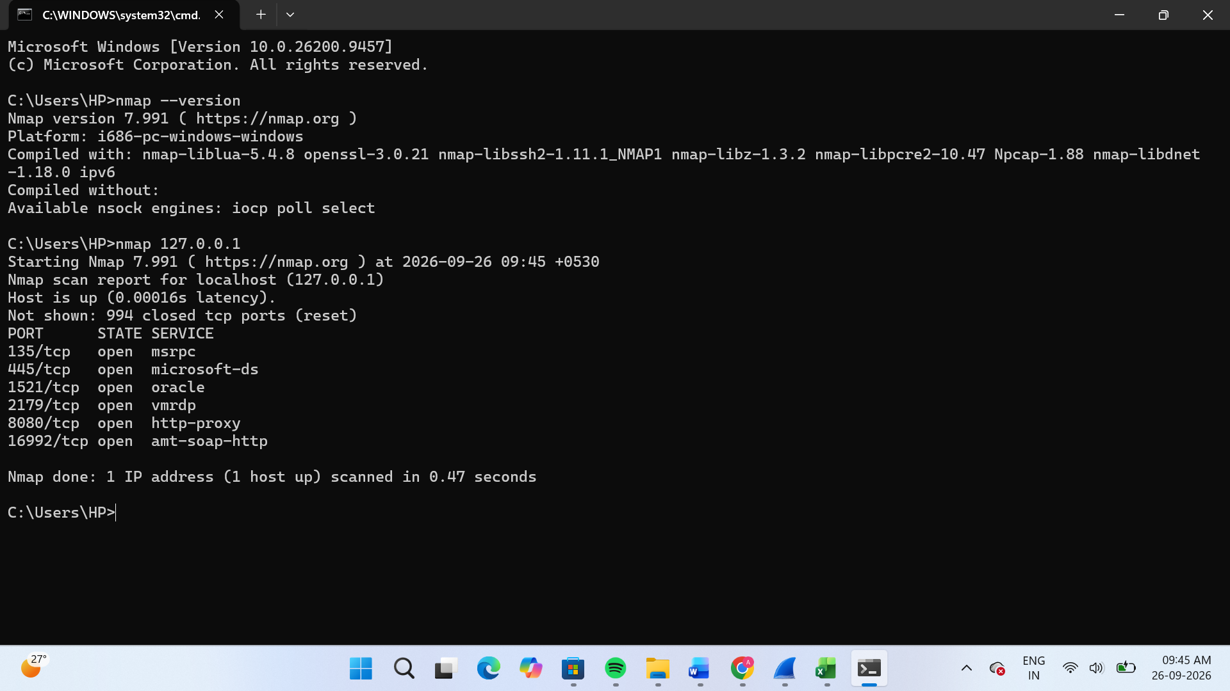
nmap 127.0.0.1
Open Ports Found
- 135/tcp – msrpc
- 445/tcp – microsoft-ds
- 1521/tcp – oracle
- 2179/tcp – vmrdp
- 8080/tcp – http-proxy
- 16992/tcp – amt-soap-http
Result
Nmap scan was successfully performed on localhost (127.0.0.1), and six open TCP ports were detected.
5.Capture network traffic while using a food delivery app (like Zomato or Swiggy) for 1 minute. In Wireshark, identify at least one DNS request and document the domain name being resolved.<br><br><em><strong>Hint:</strong> Use the 'dns' filter in Wireshark to find DNS packets.</em>
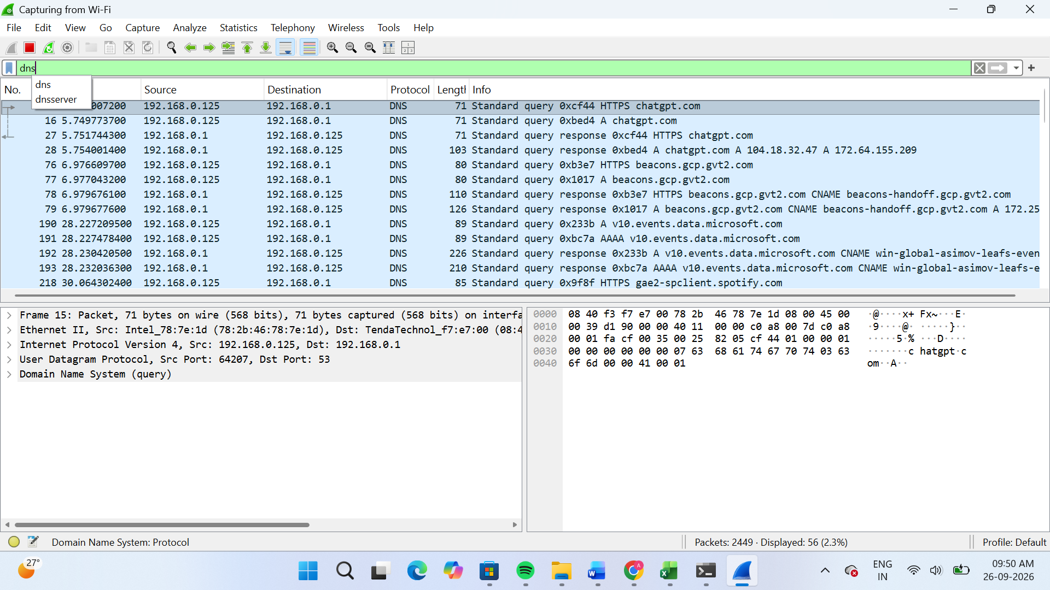
The network traffic was captured for one minute, and the DNS request for chatgpt.com was identified using Wireshark.

