- Use the ping command to test connectivity between two PCs on different subnets in your Packet Tracer network and document the output for both successful and failed attempts.
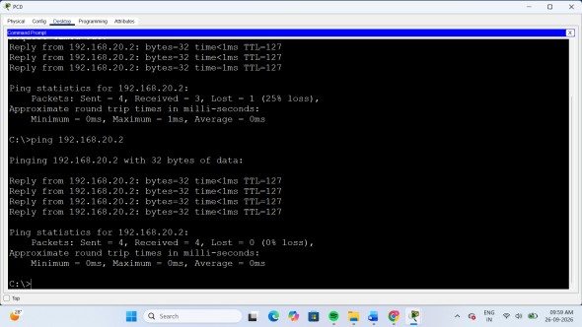
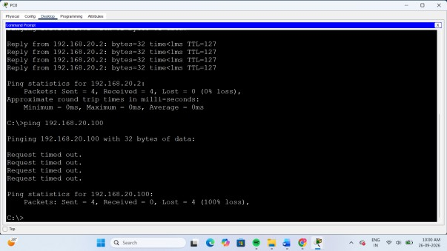
- Identify and fix an incorrect default gateway configuration on one device in your network so that it can access an external web server simulation; submit the steps you took and the command outputs before and after the fix.
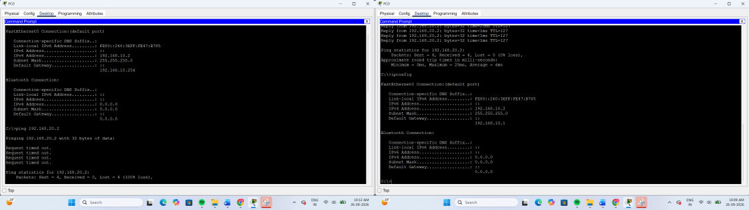
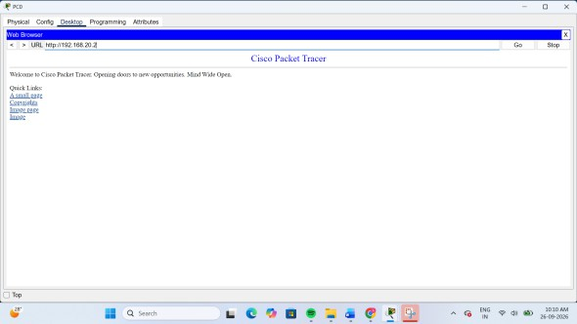

Before Fix:
The default gateway was incorrectly configured as 192.168.10.254. As a result, the PC could not reach the web server 192.168.20.2, resulting in 100% packet loss.

- A user reports they cannot access Flipkart.com from their
simulated network. Trace the path using traceroute (or tracert) and identify where the connection fails; explain how you diagnosed and resolved the issue.
Objective:
To test connectivity between two PCs on different subnets using the ping command.
The ping command is used to check whether two network devices can communicate with each other. When two PCs are on different subnets, communication takes place through a router. The router uses its routing table to forward packets from one network to another.
In this practical:
  - PC0 Network: 192.168.10.0/24
  - Router0 LAN: 192.168.10.1
  - Router0–Router1: 192.168.20.0/24
  - Router1–Server Network: 192.168.30.0/24
  - Server0: 192.168.30.2
Static routes are configured on both routers so that packets can travel between the two different networks.
Important commands: ping 192.168.30.2
show ip route
show ip interface brief

Result:
The ping command is used to verify end-to-end connectivity between PC0 and Server0. Successful replies indicate that the routing and
network configuration are working correctly.
- Simulate a scenario where a router has an incorrect static route that breaks connectivity between two VLANs. Correct the route configuration and verify the solution using appropriate show commands.<br><br><em><strong>Hint:</strong> Use 'show ip route' and 'show running-config' to check current routes and settings.</em>

- Topology

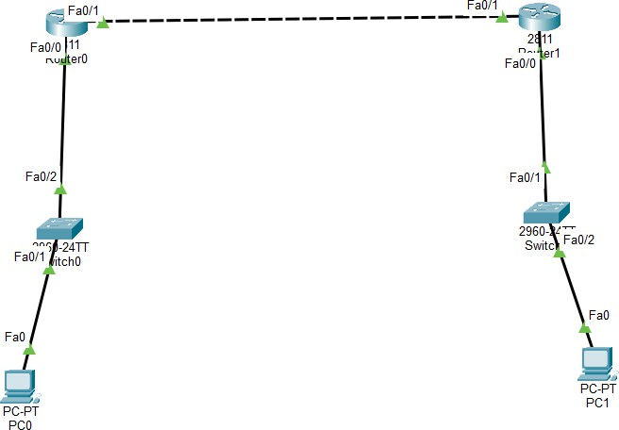

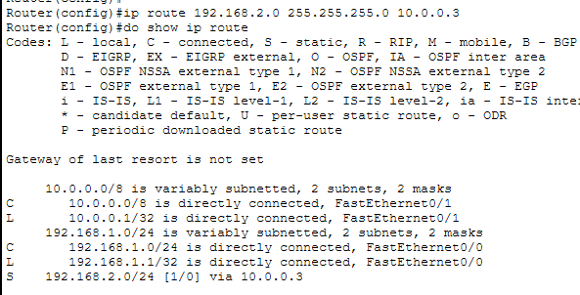
- wrong route

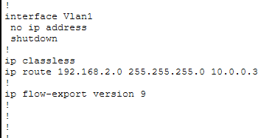
- wrong configratio

- Troubleshooting

Now we know:
Destination network: 192.168.20.0/24

Wrong next-hop:
10.0.0.3

Actual R2:
10.0.0.2
So we need to remove the wrong route.

- Correct route

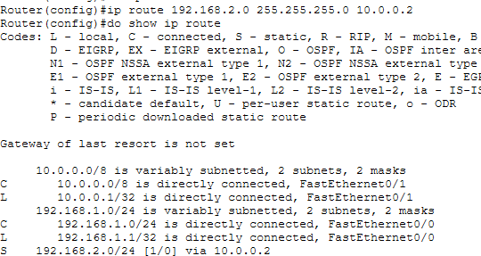

- Ping test
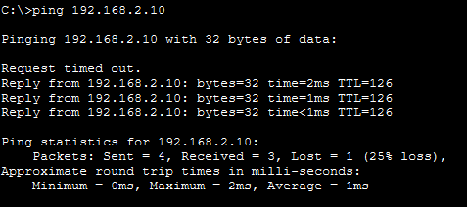

- You receive a network diagram and a set of running-config
outputs for a multi-router setup where WhatsApp voice calls are not working between two branches. Analyze the configs, identify
the misconfiguration, and describe your troubleshooting steps and resolution.

Scenario
A company has two branches connected through routers. Users at both branches can communicate over the network, but WhatsApp voice calls are not working.

The network is:

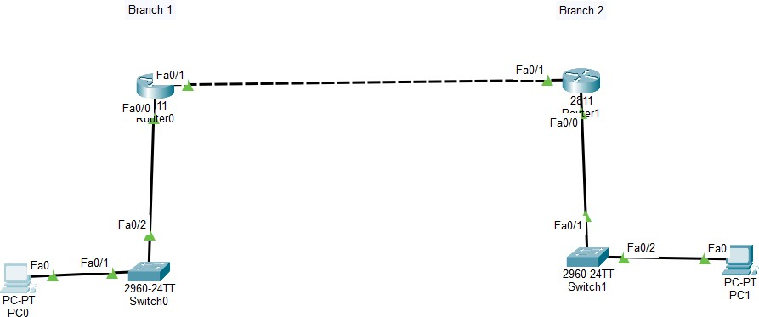

The possible causes checked during troubleshooting are routing, NAT, ACL/firewall rules, UDP traffic, and WAN/Internet connectivity.

Troubleshooting Steps
- Check Router Interfaces
The first step is to check whether all router interfaces are operational. #show ip interface brief
All required interfaces should show up/up status.

Check Local Connectivity
The default gateway of each branch is tested using: ping <default-gateway>
If the ping is successful, the local LAN connectivity is working.

Check WAN Connectivity
The connection between the two routers is tested: #ping 10.0.0.2

A successful reply confirms that the WAN link between the routers is working.

Check Routing Table
The routing table is checked using:
#show ip route
The routers must have routes to the remote branch networks. For example:
S 192.168.20.0/24 via 10.0.0.2
If the route is missing or incorrect, it must be corrected.

Check NAT Configuration
If the branches access WhatsApp through the Internet, NAT configuration should be checked.
Commands:
#show ip nat translations #show ip nat statistics
These commands help verify whether private IP addresses are being translated correctly to public addresses.

Check ACL and Firewall Configuration
Since normal ping may work while voice traffic fails, the ACL configuration must also be checked.
#show access-lists
For example, an incorrect ACL may contain:
#deny udp 192.168.10.0 0.0.0.255 192.168.20.0 0.0.0.255
This can block UDP traffic required by real-time voice communication. The interface configuration can also be checked:

#show ip interface g0/1
This shows whether an ACL is applied to the interface.

Identify the Misconfiguration
After checking the configuration, the problem was identified as an incorrect ACL that was blocking UDP traffic between the two branch networks.
Normal ICMP traffic such as ping was allowed, so basic connectivity appeared to be working, while UDP-based voice traffic was being blocked.

Correct the Configuration
The incorrect ACL was removed from the interface: #configure terminal
#interface g0/1
#no ip access-group 110 out #exit
#no access-list 110 #end
The configuration was then verified again.
- Verify the Solution Check the routing table: #show ip route
Check the ACL: #show access-lists Check the interface:
#show ip interface g0/1

Finally, test connectivity:
#ping 192.168.20.10
In Packet Tracer, Simulation Mode can also be used to observe UDP traffic and verify that packets are successfully passing from Branch A to Branch B.

Resolution
The issue was caused by an ACL blocking UDP traffic between the two branches. The incorrect ACL was removed, and the configuration was verified using show access-lists, show ip interface, and show ip route.
After correcting the configuration, network traffic between the branches was allowed. In a real network, NAT translations, firewall policies, UDP flows, and Internet reachability would also be checked to ensure that voice communication can work correctly.

