**Asiqul Hoque**

**Homework 8**

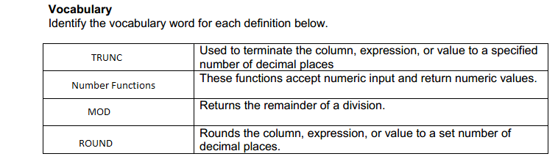

1. SELECT last_name, salary, ROUND(salary/1.55, 2) AS "New Rounded Salary"  
 FROM employees  
 WHERE employee_id BETWEEN 100 AND 102;

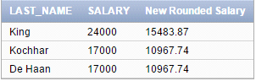

2.SELECT last_name,salary, TRUNC(salary+salary*0.0533,2) AS "Truncated Salary"  
FROM employees  
WHERE department_id=80;

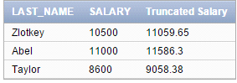

3.SELECT mod(38873,2)  
FROM DUAL;



ODD

4.SELECT ROUND(845.553, 1)

FROM DUAL;



SELECT ROUND(30695.348, 2)

FROM DUAL;



SELECT ROUND(30695.348, -2)

FROM DUAL;



SELECT TRUNC(2.3454, 1)

FROM DUAL;



5.SELECT last_name,salary

FROM employees

WHERE MOD(salary/3,3) = 0



6. SELECT MOD(34,8) AS "EXAMPLE"

FROM DUAL;



7. In my opinion, I would like my paycheck rounded if it was $565.784 a week as I would be receiving more. Receiving $565.784 means that my paycheck went through TRUNC(565.784, 2).

And yes of course it would make a big difference with one million people even if they were getting cut by a few cents.