

Crime Database Management System

Software Project 01

Submitted By

|  |  |
| --- | --- |
| 14-27012-2 | Ahmed, Quazi Nafis |
| 14-27018-2 | Kamruzzaman, Md. |
| 14-27017-2 | Ashique Al Arif |

Department of Computer Science

Faculty of Science & Information Technology

American International University Bangladesh

September 2017

|  |
| --- |
| **Declaration** |

We declare that this project is our original work and has not been submitted in any form for another degree or diploma at any university or other institute of tertiary education. Information derived from the published and unpublished work of others has been acknowledged in the text and a list of references is given.

|  |  |
| --- | --- |
| _______________________________  **Quazi Nafis Ahmed**  14-27012-2  Software Engineering | _______________________________  **Md. Kamruzzaman**  14-27018-2  Software Engineering |
| _______________________________  **Ashique Al Arif**  14-27017-2  Computer Science and Software Engineering |  |
|  |  |

|  |
| --- |
| **Approval** |

The Software Project titled “**Crime Database Management System**” has been submitted to the following respected members of the Board of Examiners of the Faculty of Science and Information Technology in partial fulfillment of the requirements for the degree of Bachelor of Science in Software Engineering on 12th September 2017 and has been accepted as satisfactory.

|  |  |
| --- | --- |
|  |  |

|  |  |
| --- | --- |
| ____________________________________  [**Asif Ur Rahman**](http://fsit.aiub.edu/people/faculty-members)  Assistant Professor & Supervisor  Department of Computer Science  American International University- Bangladesh | ___________________________________ |
| _______________________________________  **Dr. Dip Nandi**  Asst. Professor & Head (Undergraduate)  Department of Computer Science  American International University-Bangladesh | _­­­­­­­­_____________________________________  **Professor Dr. Tafazzal Hossain**  Dean in Charge (Academics)  Faculty of Science & Information Technology  American International University-Bangladesh |
| __________________________________________  **Dr. Carmen Z. Lamagna**  Vice Chancellor  American International University-Bangladesh | |

Acknowledgements

First of all, we would like to be grateful to the almighty Allah who gives us the effort to work on the project. Thanks to our respectable parents for their outstanding support at every point in our life.

We would like to thank our supervisor **Md. ASIF UR RAHMAN** for his enormous support, inspiration and helpful criticism. We are very grateful to him for giving us opportunity to work with him. Without this continuous support, it would be very difficult for us to complete this project.

We would also like to thank all the faculty members for their guideline for making proper documentation of our project.

We convey our thanks to our honorable Dean, **PROF. DR. TAFAZZAL HOSSAIN** for encouragement.

We convey our thanks to our honorable Vice Chancellor, **DR. CARMEN Z. LAMAGNA** for encouragement.

We wish to express our gratitude American International University-Bangladesh (AIUB) providing an excellent environment for research.

|  |
| --- |
| **Table of Contents** |

Chapter 1: Introduction 9

1.1 Purpose 9

1.2 Project Scope 9

1.3 Overall Description 9

1.3.1 Product Perspective 9

1.3.2 Product Feature 10

1.3.3 Operating Environment 10

1.3.4 Design and Implementation Constraints 10

1.3.5 Assumption and Dependencies 11

**Chapter-2: Software Requirement Specification** 12

2.1 Objectives and Scope 12

2.2 Overview of the Present System 12

2.3 System Features  12

2.4 Hardware and Software Requirement (standard) 13

2.5 Human Resource Requirement  13

2.6 Constraints and Limitations 14

2.7 Conclusion 14

**Chapter-3: Specific Requirement and Diagrams**  **15**  3.1 Externam Interface Requirement 15

3.1.1 User Interface 15

3.1.2 Hardware Interface  15

3.1.3 Software Interface 15

3.2 Use case Model 15

3.2.1 Login System 15

3.2.2 Staff Management 18

3.2.3 Account Management 21

3.2.4 Criminal Registration 23

3.2.5 Criminal Table and Searching 26

3.3 Activity Diagram 27

3.4 Class Diagram 28

3.5 ER Diagrams 29

3.6 Use-case Diagram 33

**Chapter-4: Software Requirement Specification** 34

4.1 Tables 34

**Chapter-5: Other Non-functional Requirements** 37

5.1 Performance Requirements 37

5.2 Safety and Security Requirements  37

**Chapter-6: Conclusion** 38

|  |
| --- |
| **List of Figures** |

3.2.1.1 Login System(Use-case) 15

3.2.1.2 Login System(Activity) 16

3.2.1.3 Admin Login - A 16

3.2.1.4 Staff Login 17

3.2.1.5 Admin Login – B 18

3.2.2.1 Menu(Admin) 19

3.2.2.2 Admin Menu(Use-case) 20

3.2.2.3 Admin Menu(Activity) 20

3.2.2.4 Staff Information 21

3.2.3.1 Account Management 22

3.2.3.2 Login Option 23

3.2.4.1 Criminal Registration(Diagrams) 24

3.2.4.2 Criminal Registration(Window) 25

3.2.5.1 Criminal Table and Searching (Activity) 26

3.2.5.2 Criminal Table and Searching (Activity) 27

3.2.5.3 Criminal Information 27

3.3.1 Activity Diagram 28

3.4.1 Class Diagram 29

3.5.1 ER Diagram - 1 30

3.5.2 ER Diagram - 2 31

3.5.3 ER Diagram - 3 32

3.5.4 ER Diagram – 4 33

3.6.1 Use-case Diagram 34

4.1.1 Table -1 35

4.1.2 Table -2 36

4.1.3 Table -3 36

4.1.4 Table -4 37

|  |
| --- |
| **Abstract** |

The “Crime Database Management System” has been developed to override the problems prevailing in the practicing manual system. This software is supported to eliminate and in some cases, reduce the hardships faced by this existing system. Moreover, this system is designed for the particular need of the company to carry out operations in a smooth and effective manner. The application will reduce as much as possible to avoid errors while entering and searching data. It also provides error message while entering invalid data. No formal knowledge is needed for the user to use this system. Thus, by this all it proves it is user friendly.

|  |
| --- |
| **Chapter 1: Introduction** |

* 1. **Purpose**

We know that every organization needs management activities to maintain stability and reduce uncertainty by managing resources and activities, which are in many cases done manually. These management activities take too much time, effort and cost, in a police station, poor management costs more than that. It is very hard to manage criminal information manually where it can be stored in database very easily without any errors. Our proposed system brings solution to all the problems of manual system. It will completely automate the management activity.

* 1. **Project Scope**
* The errors done by the manual system will be reduced by this system.
* User can search, update, delete and read from database about criminal information.
* This system will reduce searching time.
* This system can be easily handled by the person who has elementary knowledge of computer because it’s way too user friendly.
* It will save a lot of time and also cost friendly.
* Can also receive anonymous tips and online complain.
  1. **Overall Description**

1.3.1 Product Perspective

The system is developed completely on C# for now. There are two types of user admin and staff. They both can access the system by entering correct username and password and after that they can store criminal information, edit, delete, search for a specific person from a secure database. All the validations are performed during the entry of the data.

1.3.2 Product Feature

Admin:

Insert

Update/modify

Update/modify/create database info.

Add staffs

Staff:

Update/modify/create criminal info.

* Secured log in system
* Staff management
* Account Management
* Criminal registration
* Criminal searching

Some features are already added and some will be added later on software project 2.

1.3.3 Operating Environment

To run the software the pc needs dot net framework 4.5 application. We recommend windows 7/8 or higher version of windows to run the application.

1.3.4 Design and Implementation Constraints

The software is designed by using C# language. And for the database we used Microsoft SQL Server Database which comes with Microsoft Visual Studio.

1.3.5 Assumption and Dependencies

The system is dependent upon dot net framework which is minimum recommended 4.5 and it’s a Windows based software for now so minimum requirement is windows 7 or higher.

|  |
| --- |
| **Chapter 2: Software Requirement Specification** |

**2.1 Objective and Scope**

In here we will show a complete overview of the whole system. The system will be explained in its context to show how the system interacts with other system and introduce the basic functionality of it. It will also describe for each type of users that will use the system and what functionality is available for each type and also the constraints and the assumptions for the system will be presented.

**2.2 Overview of the Present System**

Current system is very slow and not that secure. Also, the current system has many flaws like people can’t complaint online, website is very slow, no option for submitting online anonymous tips. Our system will remove all these obstacles.

**2.3 System Features**

Admin:

Insert

Update/modify

Update/modify/create database info.

Add staffs

Staff:

Update/modify/create criminal info.

* Secured log in system
* Staff management
* Account Management
* Criminal registration
* Criminal searching

**2.4 Hardware and Software Requirement (standard)**

**Hardware**

* + - Processor: Intel G4560 dual-core
    - Motherboard: gigabyte g31 s2
    - Memory: 4 GB DDR4 2400 bus
    - Hard drive: 250GB
    - Graphics card: on board
    - Monitor: standard
    - Keyboard: standard
    - Mouse: standard
    - Printer: laser

**Software**

Microsoft dot net framework 4.5, operating system windows 7 or higher.

**2.5 Human Resource Requirement**

**Hardware specialist:** A part time hardware specialist is needed for maintaining the hardware and software all the time and managing the computer for good uptime.

**Administrator:** The administrator will run the software for the management.

**Staff:** The staff will run the software for registration purpose.

**2.6 Constraints and Limitations**

**Database:** Microsoft SQL Server Database which comes with Microsoft Visual Studio.

**Language requirement:** Only available in English.

**User:** For government use only.

**2.7 Conclusion**

This requirement specification is developed based upon the studying the common scenario and previous experience of the project manager. Thus, any unusual circumstances rise on the process of the development may derail the values and time frame mention in this document.

|  |
| --- |
| **Chapter 3: Specific Requirements and Diagrams** |

**3.1 External Interface Requirement**

**3.1.1 User Interface**

The main interface that the user will interact with is the user panel. The interface will allow the user to do all kinds of activities. The interface is clear and easy to use.

**3.1.2 Hardware Interface**

The system will interact with printer as it allows user to print criminal profiles and data.

**3.1.3 Software Interface**

The computer, on which the software runs, needs to have a framework called dot net framework and the Microsoft visual studio runtime library.

**3.2 Use case Model**

**3.2.1 Login System**

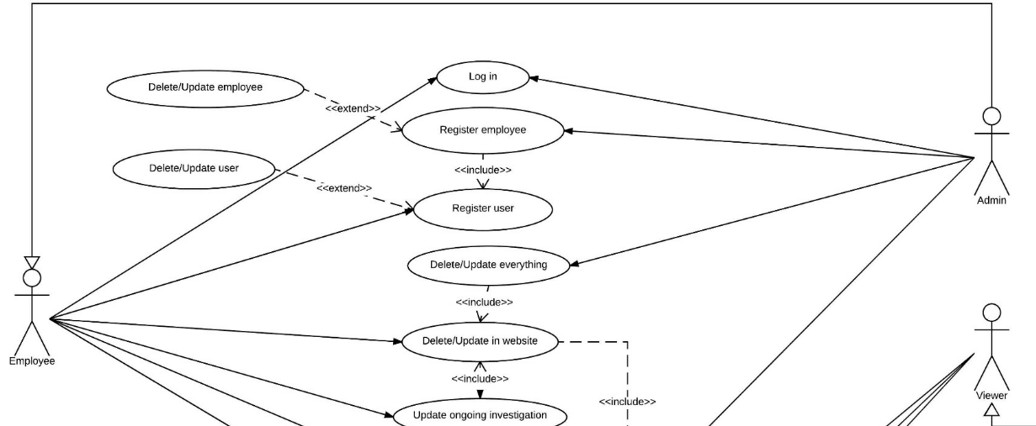

Fig. 3.2.1.1

Two kinds of users (Admin and staffs) can log into the system with their user id and password. The system verifies user id and password and displays the user panel. The software displays an error if invalid id or password is provided.

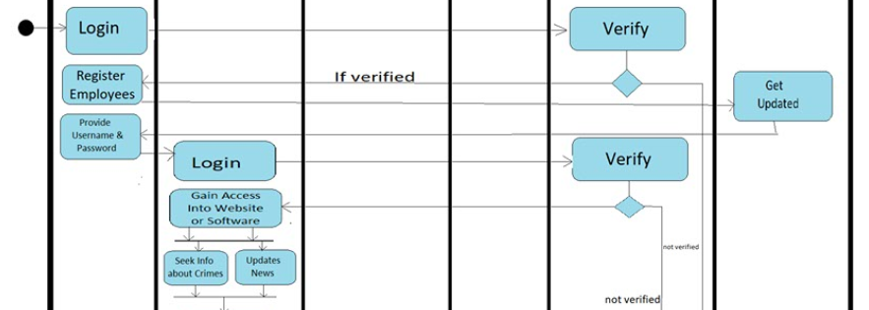

Fig. 3.2.1.2

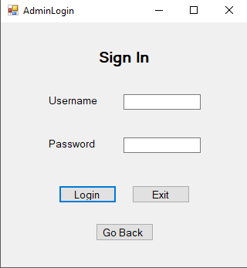 Fig. 3.2.1.3

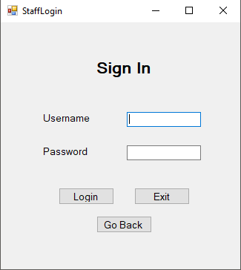 Fig. 3.2.1.4 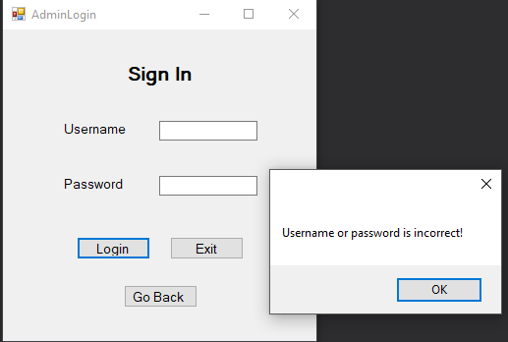 Fig. 3.2.1.5

**3.2.2 Staff Management**

In the menu of admin there is an option for staff management. By clicking on it user can manage staff like add/search/delete staff to the database. It also shows current staffs available in the database.

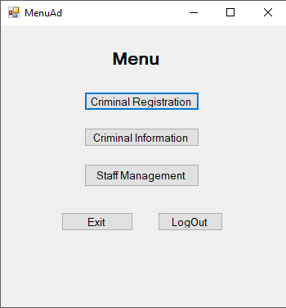 Fig. 3.2.2.1

If the admin wants to search or delete then he has to put the NID in the search box then press the button. 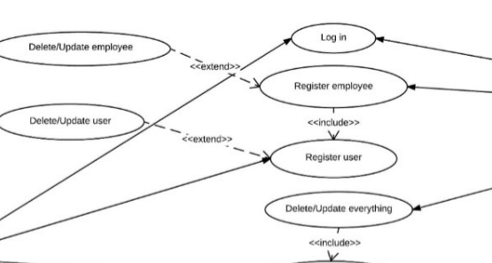

Fig. 3.2.2.2

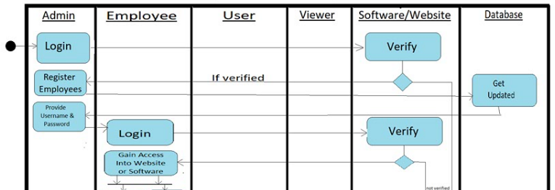

Fig. 3.2.2.3

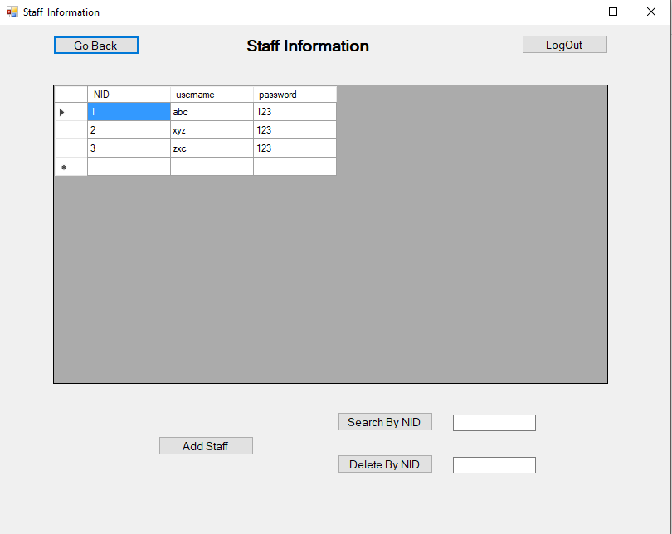 Fig. 3.2.2.4

**3.2.3 Account Management**

There are two options for login which are admin and staff login.

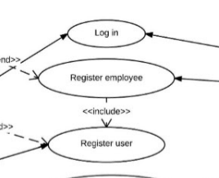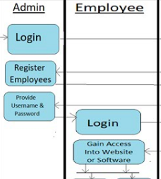

Fig. 3.2.3.1

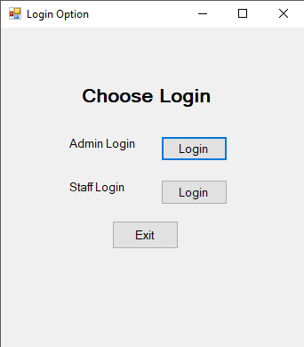 Fig. 3.2.3.2

**3.2.4 Criminal Registration**

Both admin and staffs can register criminals. They can enter the required information about the criminal and add/update/delete or search by their NID which is used as the primary key in the database. 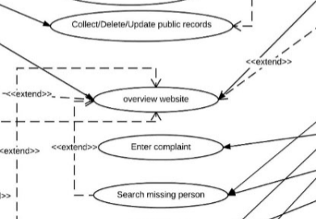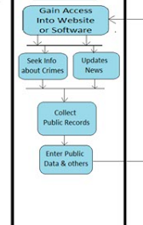

Fig. 3.2.4.1

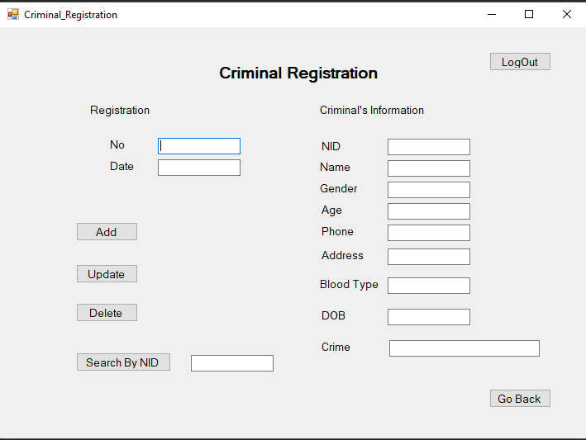

Fig. 3.2.4.2

**3.2.5 Criminal Table and Searching**

This table shows all the registered criminals in the database. There is also an option for searching a specific criminal by their NID.

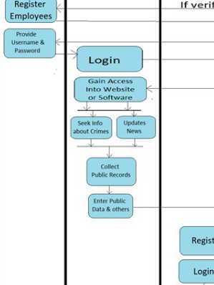

Fig. 3.2.5.1

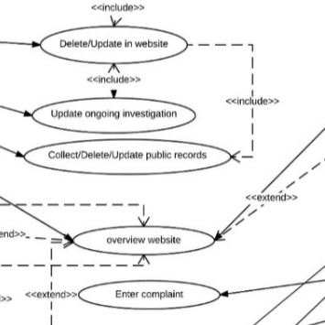

Fig. 3.2.5.2

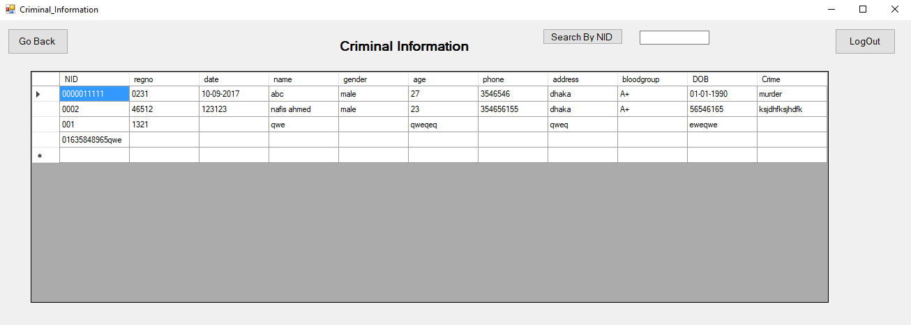

Fig. 3.2.5.3

**3.3 Activity Diagram**

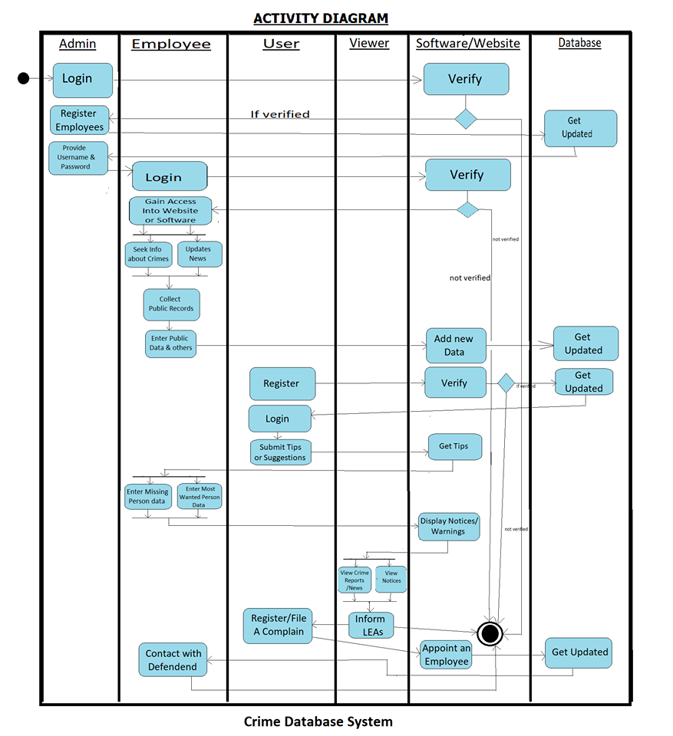

Fig. 3.3.1

**3.4 Class Diagram**

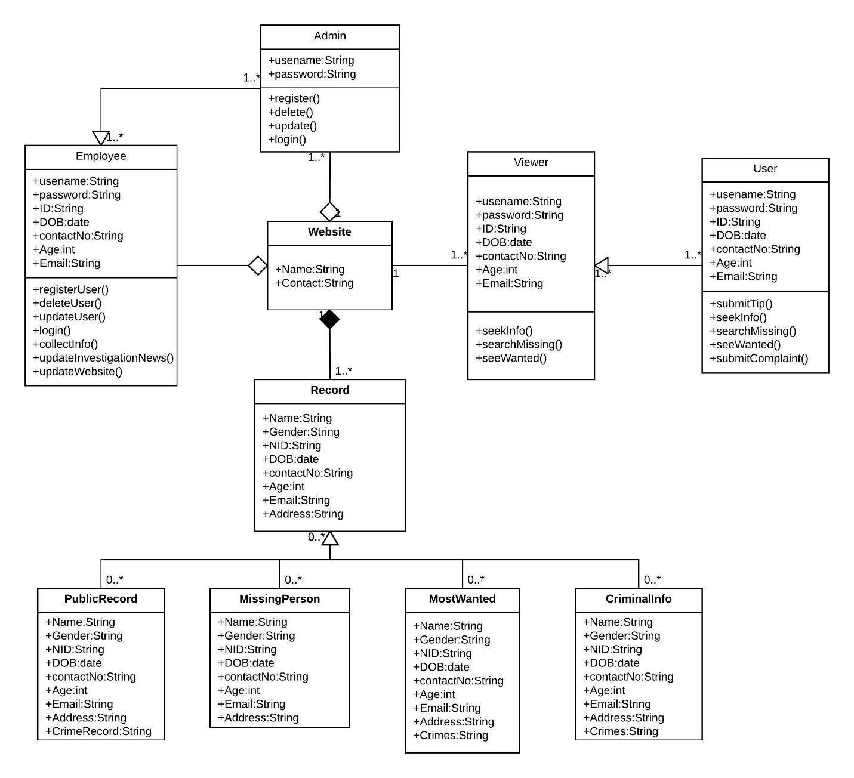

Fig. 3.4.1

**3.5 ER Diagrams**

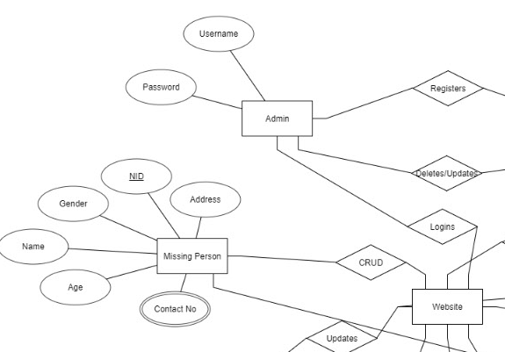

Fig. 3.5.1

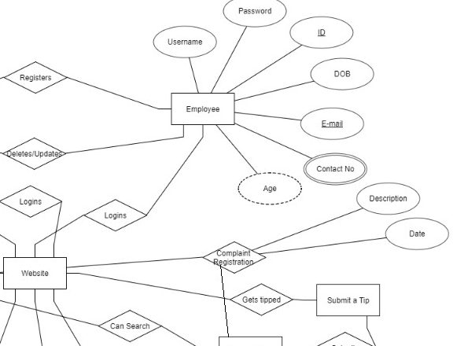

Fig. 3.5.2

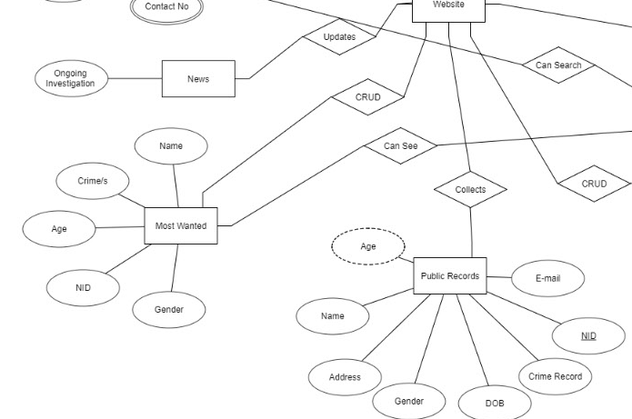

Fig. 3.5.3

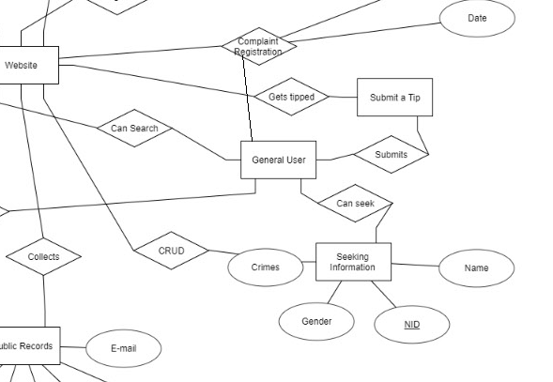

Fig. 3.5.4

**3.6 Use-case Diagram**

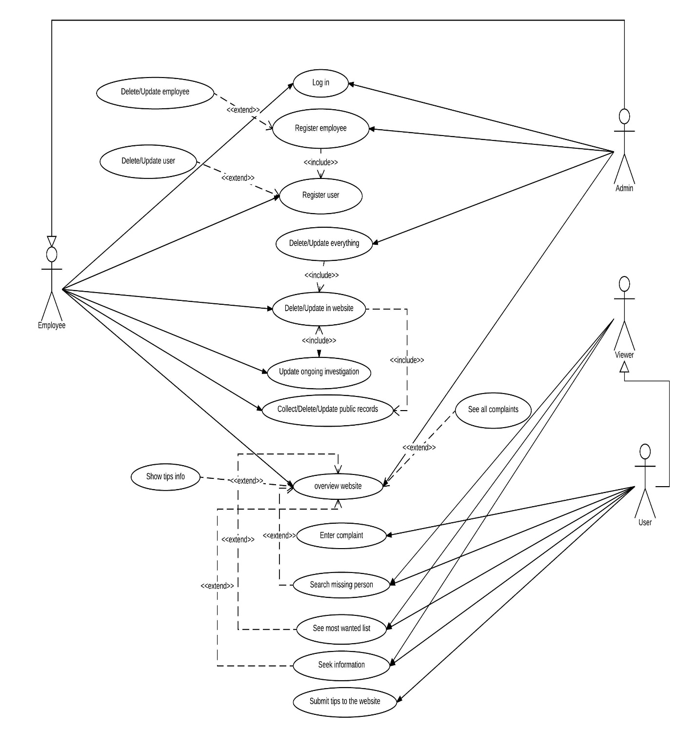

Fig. 3.6.1

|  |
| --- |
| **Chapter 4: Requirements** |

**4.1 Tables**

There are 3 tables currently in our project which are-

1. Login

2. Criminal

3. Staff Login

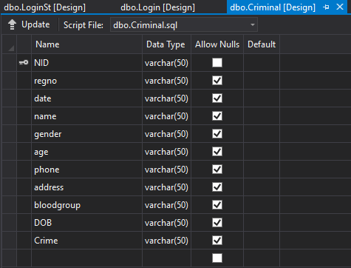

Fig. 4.1.1

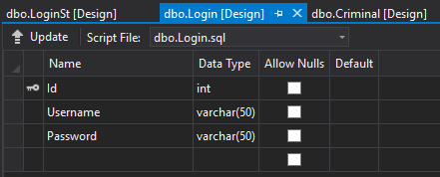

Fig. 4.1.2

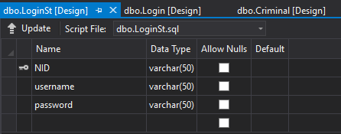

Fig. 4.1.3

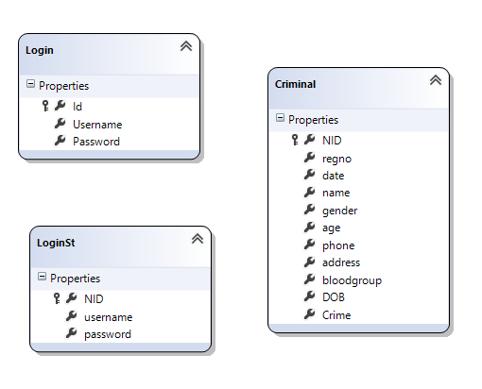

Fig. 4.1.4

|  |
| --- |
| **Chapter 5: Other Non-functional Requirements** |

**5.1. Performance Requirements**

Performance requirements such as efficiency, reliability, correctness should be considered while developing the system. Proper tests and bug fixes improve the quality of software significantly. The speed and the smoothness with which our application retrieves data and performs operations have a significant impact on users’ experience.

**5.2. Safety and Security Requirements**

Our software must implement the core security issues such as:

• Use PCI and Vulnerably Scanning Services: we’ll need to protectively identify and address security issue before any damage.

• Using managed DNS service for the remote login.

• User restriction of the computer.

• Username/password secrecy.

|  |
| --- |
| **Chapter 6: Conclusion** |

Criminal management system needs a huge database to manage. Now if we use manual system for managing this huge sort or database is very time consuming and costly. Also, it has high probability for mistakes. Data mismatch, data loss, calculation error, entry error these are very common mistakes in a complex management system. Our system is very easy to use and hopefully it will overcome all these problems. Our system provides a very user-friendly interface which is easy to use for anyone with qualification.

|  |
| --- |
| **References** |

* <https://www.draw.io/>
* <https://www.tutorialspoint.com/>
* <https://stackoverflow.com/>

1. Abraham B., O. Camps, and M. Sznaier, “Dynamic texture with Fourier descriptors,” *International Workshop on Texture Analysis and Synthesis*, pp. 53–58, 2005.
2. Allen A. O., “Probability, Statistics and Queuing Theory with Computer Science Applications,” 2nd Edition, *New York: Academic Press*, 1999.
3. Ardizzone E., A. Capra, and M. Cascia, “Using Temporal Texture for Content-Based Video Retrieval,” *Journal of Visual Languages and Computing*, vol. 11, pp. 241–252, 2000.
4. Basseville M., “Distance measures for signal processing and pattern recognition,” *Signal Process*, vol. 18, pp. 349–369, 1989.
5. Berezait D., I. Herlin, and L. Younes, “A generalized optical flow constraint and its physical interpretation,” *IEEE computer society conference on Computer Vision and Pattern Recognition* (CVPR), 2000.
6. Bouthemy P. and R. Fablet, “Motion characterization from temporal cooccurrences of local motion-based measures for video indexing,” *International Conference on Pattern Recognition* (ICPR), vol. 1, pp. 905–908, Brisbane, Australia, 1998.
7. Brox T., A. Bruhn, N. Papenberg, and J. Weickert, “ High accuracy optical flow estimation based on a theory for warping,” *European Conference on Computer Vision* (ECCV), vol. 4, pp. 25–36, Prague, Czech Republic, 2004.
8. Bruhn A., J.Weickert, C. Feddern, T. Kohlberger, and C. Schnorr, “Real-time optic flow computation with variational methods,” *CAIP*, pp. 222–229, Groningen, The Netherlands, 2003.
9. Buf J. M. H., M. Kardan, and M. Spann, “Texture feature performance for image segmentation,” *Pattern Recognition*, vol. 23, pp. 291–309, 1990.
10. Campbell N. W., C. Dalton, D. Gibson, and B. Thomas, “Practical Generation of Video Textures using the Auto-Regressive Process,” *British Machine Vision Conference*, pp. 434–443, 2002.