JMETER Assignment 01 Reports

1. 166 users for 60 seconds

* Throughput – 2.8/sec

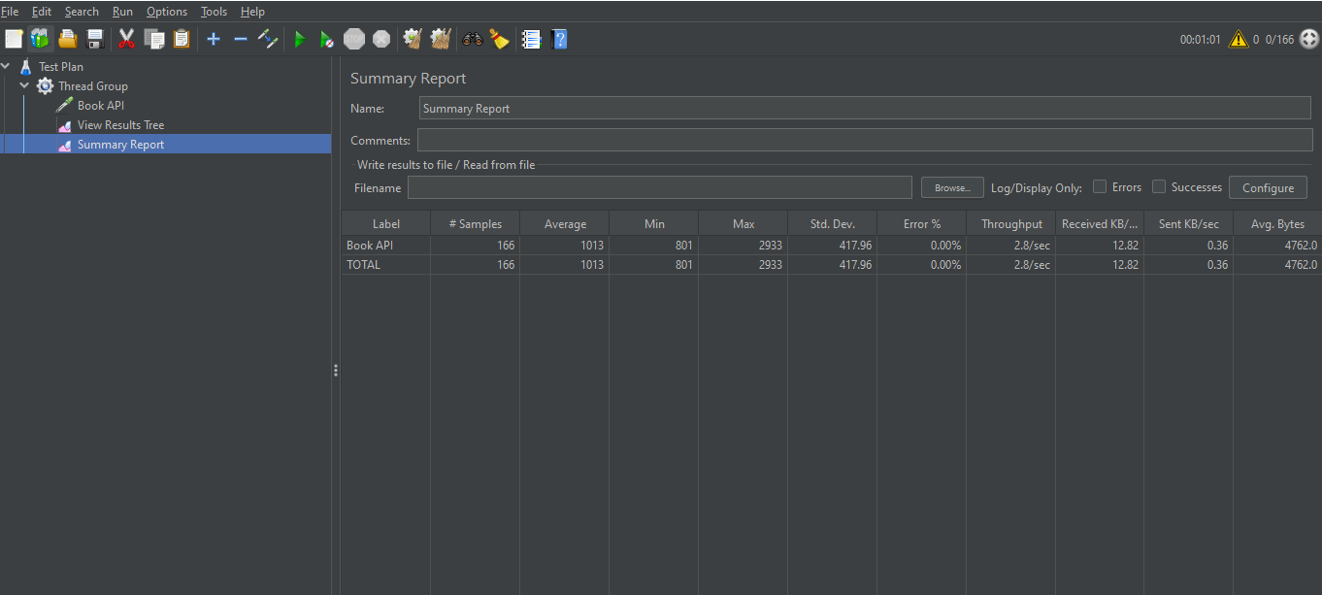

***Figure 1: First test for 60 seconds 167 users***

1. 833 users for 300 seconds

* Throughput – 2.8/sec

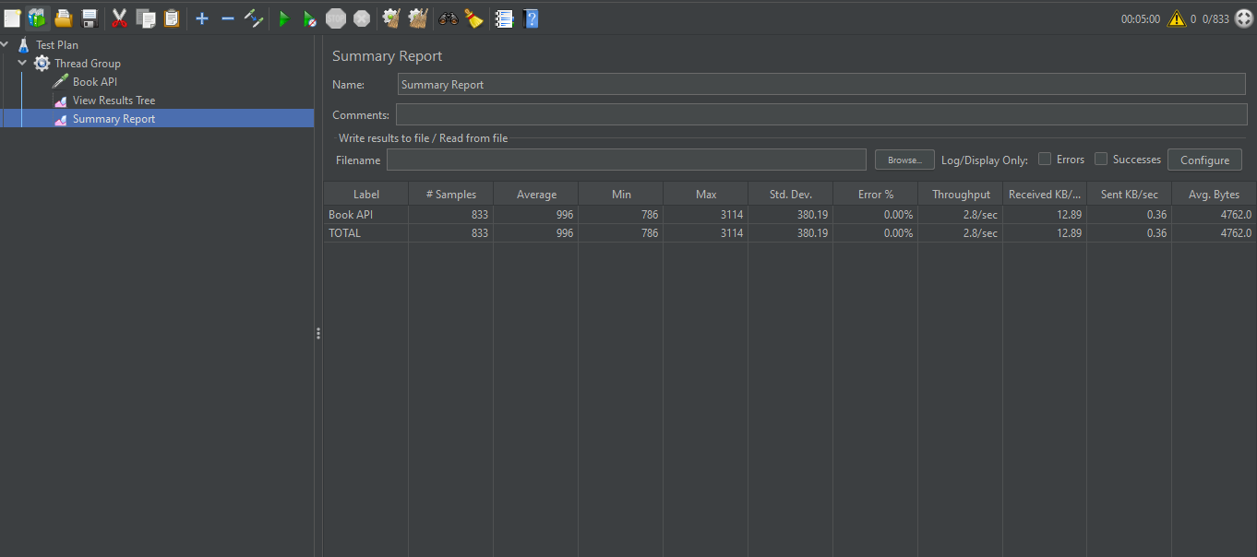

***Figure 2: Second test for 300 seconds 833 users***

1. 1667 users for 600 seconds

* Throughput – 2.8/sec

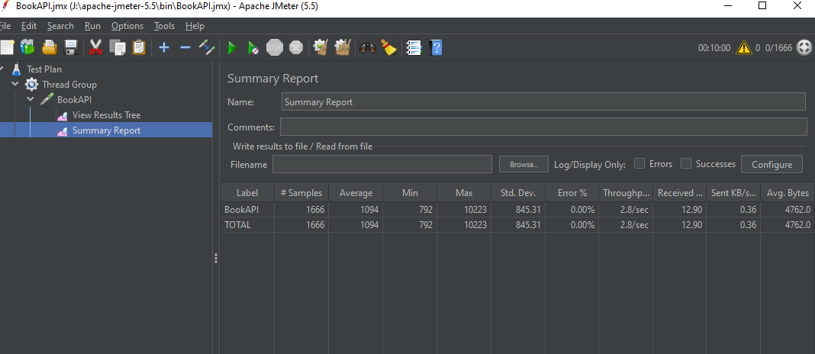

***Figure 3: Third test for 600 seconds 1667 users***

1. 2500 users for 900 seconds

* Throughput – 2.8/sec

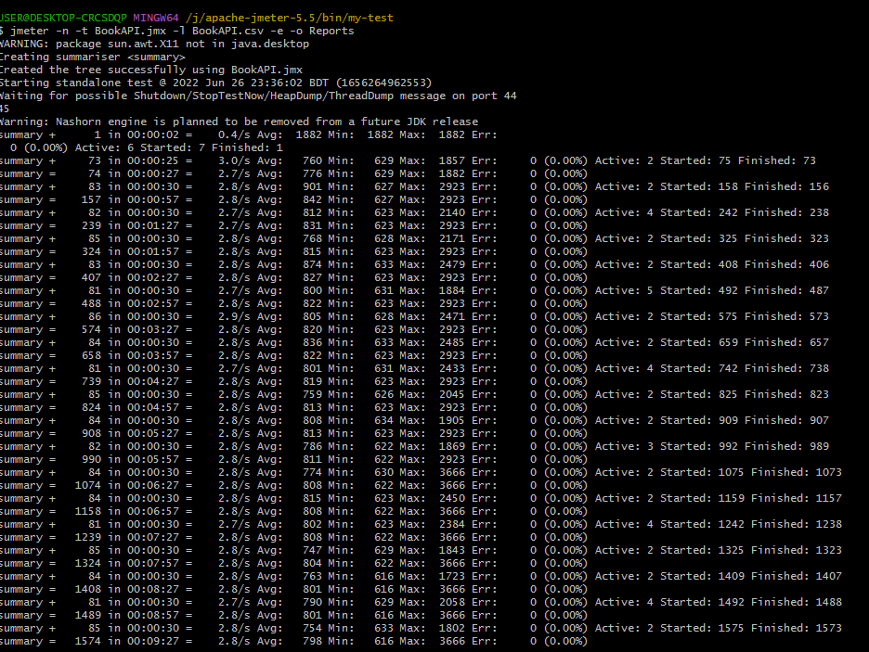

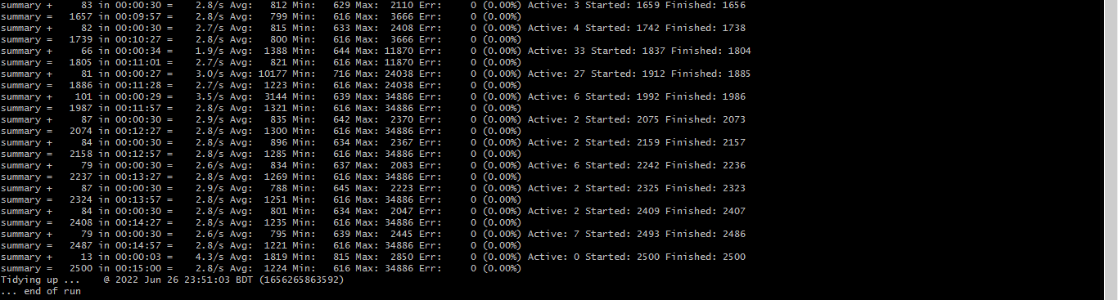

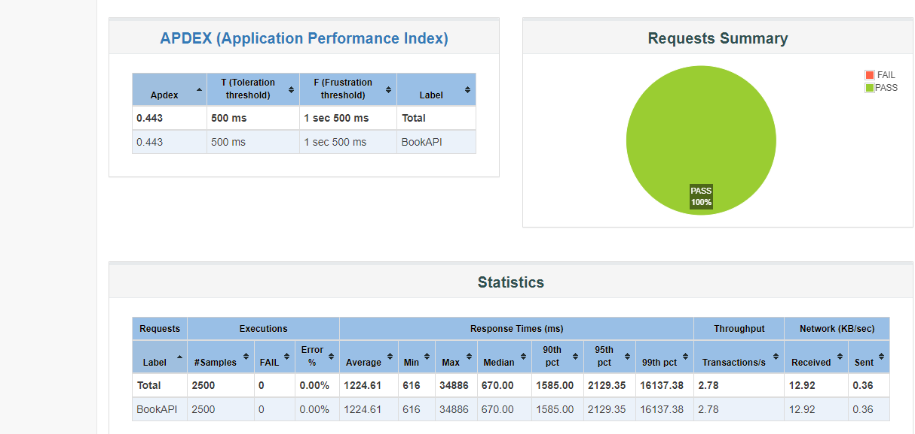

**Figure 4: Fifth test for 900 seconds 2500 users**