GoodKoding – Social Media Share

User Manual

Thank you for purchasing the module. For any issue related to the module please post a comment on Open Cart module’s comment section or send email to [info@goodkoding.com](mailto:info@goodkoding.com)

This module is tested with Open Cart 1.5.4

Installation

**Step 1:** Backup the /admin/model/catalog/product.php file from your Open Cart installation.  
If you already have a robots.txt file, then backup that one too.

**Step 2:** After extracting the module archive upload all the contents inside the ‘upload’ directory to your Open Cart installation. This will only overwrite the /admin/model/catalog/product.php file.

**Step 3:** Go to Administration > Extensions > Modules

**Step 4:** Install “**GoodKoding** - Social Media Share” module.

**Step 5:** If you already have a robots.txt file then add only the second line of module’s robots.txt to your existing file.

For advanced users and developers:

Please do not go through the following steps if you are not familiar with PHP coding and are not confident to modify the source code.

If you are already have custom code on your product.php then copy following areas into your file instead of overwriting.

Copy line 109 to 120 from the module’s product.php and paste at the end of your *addProduct* function.

*/** Share to social media **/*

*if(!empty($data['image'])){*

*$param = array(*

*'title' => $data['product_description'][1]['name'],*

*'image' => $data['image'],*

*'description' => $data['product_description'][1]['description'],*

*'link' => 'index.php?route=product/product&product_id='.$product_id,*

*'product_id' => $product_id,*

*'post_type' => 'add'*

*);*

*$this->gk_social_media_share($param);*

*}*

Copy line 257 to 269 from the module’s product.php and paste at the end of your *editProduct* function.

*/** Share to social media **/*

*$image_row = $this->getProduct($product_id);*

*if(!empty($image_row['image'])){*

*$param = array(*

*'title' => $data['product_description'][1]['name'],*

*'image' => $image_row['image'],*

*'description' => $data['product_description'][1]['description'],*

*'link' => 'index.php?route=product/product&product_id='.$product_id,*

*'product_id' => $product_id,*

*'post_type' => 'edit'*

*);*

*$this->gk_social_media_share($param);*

*}*

Copy the whole *gk_social_media_share* function (line 734 to 774) and paste right before ending your *ModelCatalogProduct* class.

*/** Share product info to social media **/*

*public function gk_social_media_share($params = array()){*

*$this->load->model('setting/setting');*

*$gk_social_media_share = $this->model_setting_setting->getSetting('gk_social_media_share');*

*$social_data = unserialize(base64_decode($gk_social_media_share['gk_social_media_share']));*

*if(!isset($social_data['facebook']) || !isset($social_data['facebook']['share_fb'])) {*

*return;*

*}*

*$share_fb_enable = $social_data['facebook']['share_fb'];*

*if(isset($share_fb_enable) && $share_fb_enable == 1 ){*

*$img = $params['image'];*

*$status = html_entity_decode($params['description']);*

*$status=strip_tags($status);*

*$link=$params['link'];*

*require_once(DIR_SYSTEM.'library/gk_social_media_share_facebook.php');*

*if(!empty($social_data['facebook']['page_id']) && !empty($social_data['facebook']['page_access_token'])) {*

*$args = array(*

*'access_token' => $social_data['facebook']['page_access_token'],*

*'message' => $status,*

*'picture' => HTTP_CATALOG."image/".$img,*

*'link' => HTTP_CATALOG.$link*

*);*

*$facebook = new Facebook(array(*

*'appId' => $social_data['facebook']['app_id'],*

*'secret' => $social_data['facebook']['app_secret'],*

*'allowSignedRequest' => false*

*));*

*$page_id = $social_data['facebook']['page_id'];*

*$post_id = $facebook->api("/$page_id/feed","post",$args);*

*if($post_id) {*

*$this->db->query('INSERT INTO `'.DB_PREFIX.'gk_social_media_share` SET `product_id` = '.(int)$params['product_id'].', `post_id` = "'.$post_id.'", `post_date` = NOW(), `post_type` = "'.$params['post_type'].'"');*

*}*

*}*

*}*

*}*

Setting up options

Before start sharing the products you need to set the options for the module. First you need to create a Facebook application of your own to share the products. Visit <https://developers.facebook.com/apps> to create a Facebook application. Collect the APP ID and APP Secret of your Facebook application.

To edit the options of your module, go to Go to Administration > Extensions > Modules. Click on the “Edit” link beside “**GoodKoding** - Social Media Share” module. Then follow these steps:

**Step 1:**

Provide APP ID and APP Secret from your Facebook application and Save.

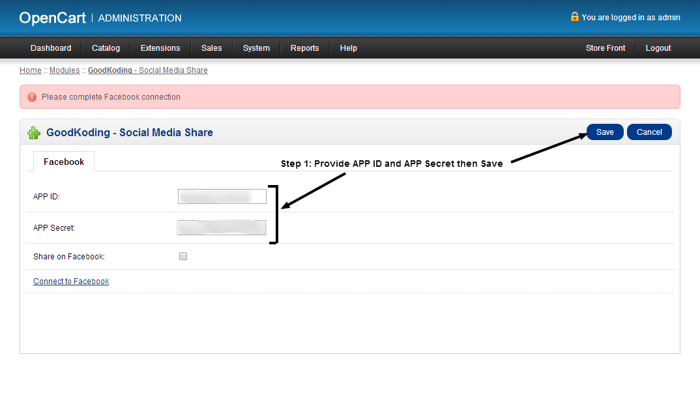

**Step 2:**

Click on the “Connect to Facebook” link to let the module have permission to post on Facebook. Clicking on this link will take you to Facebook.

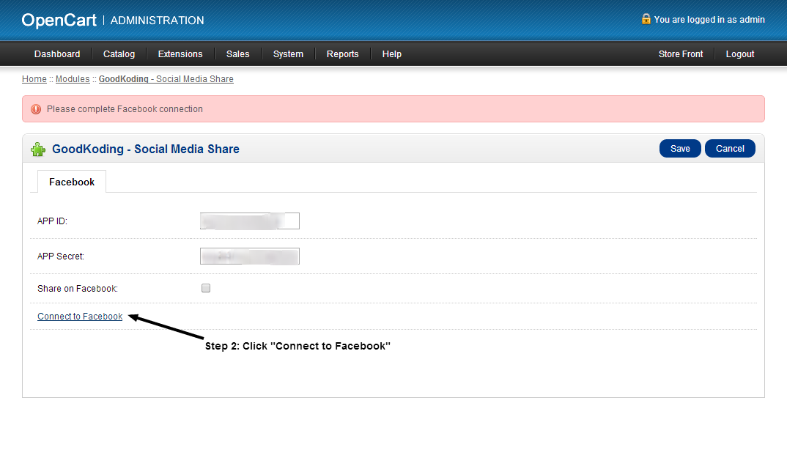

After logging in using your Facebook credentials, there will be three popups. Click Okay on all three of them. See the following images for clarification.

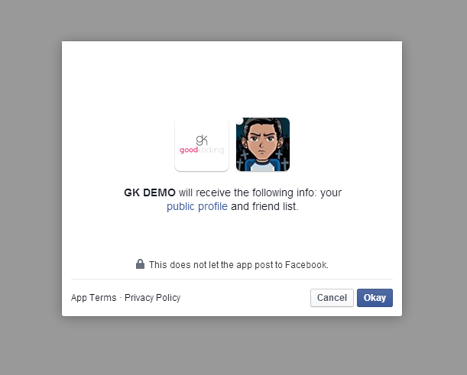

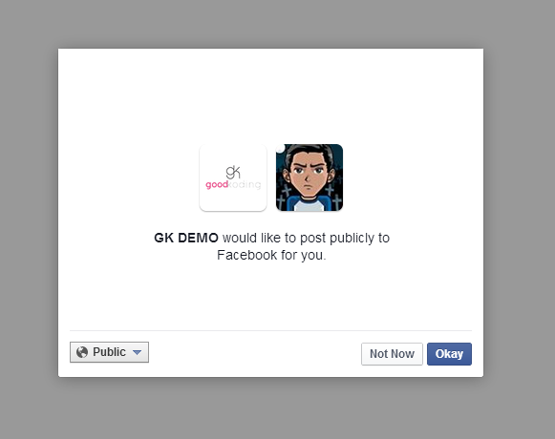

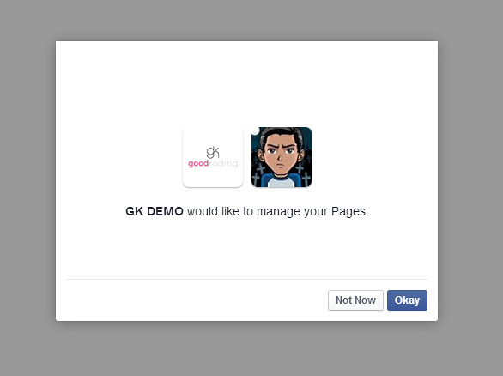

**Step 3:**

You will be redirected back to the administration area. Here you will see the list of pages you administer on Facebook. Click on the page you want to post the products on.

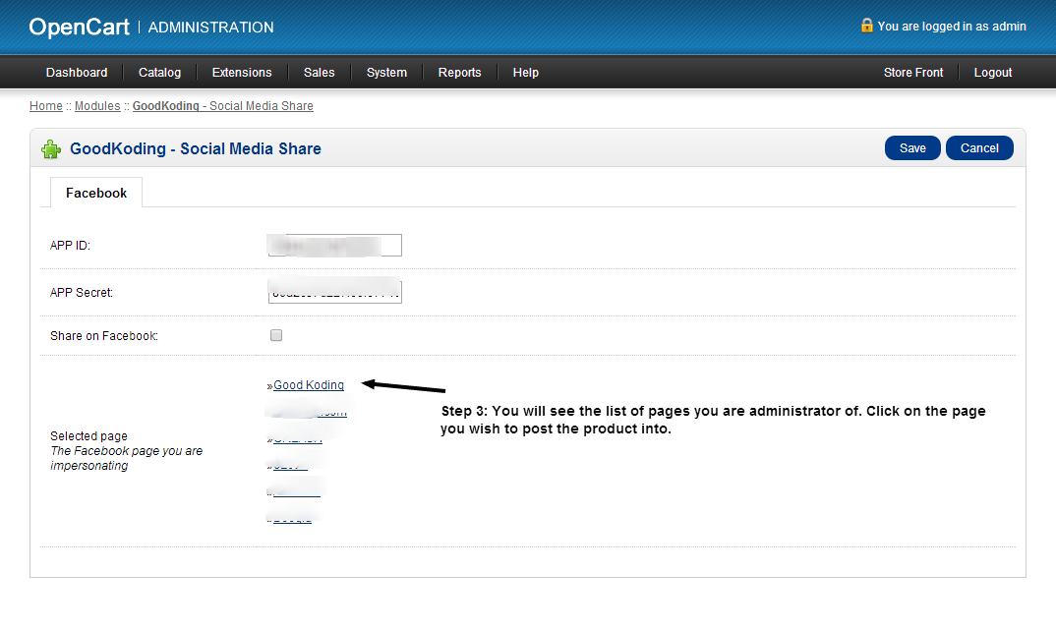

**Step 4:**

Check the “Share on Facebook” checkbox and save the settings.

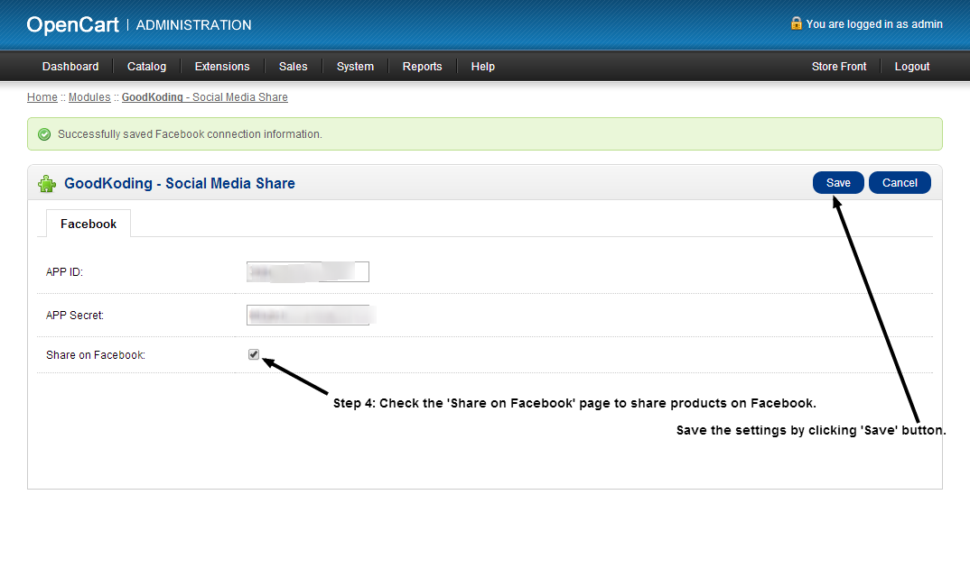

Once all these steps are completed products will be published on Facebook as soon as they are added or edited. Product must have at least one image to be shared on Facebook.

Stop sharing

If you want to stop sharing your product to Facebook, just uncheck the “Share on Facebook” checkbox from module’s settings page.

You can also click on the “Remove Facebook authentication” link to remove the publishing permission of the module.

Uninstall

You can click the “Uninstall” link beside “**GoodKoding** - Social Media Share” module on your modules list page to uninstall this module. Uninstalling the module will remove all the module related data from settings.

FAQ

**Why doesn’t my product show up on Facebook?**

There can be several reasons for that. Please make sure  
- You have set all the options properly  
- The “Share on Facebook” checkbox is checked  
- At least one page is chosen to impersonate  
- The product you are sharing has an image  
- You haven’t removed/blocked the application from your Facebook account (see more about this here: <https://www.facebook.com/help/262314300536014/>)

**Why do I have to place files inside system directory?**

There are two files needed to be saved inside “*system/library*” directory. They are Facebook’s API libraries which are used to post the product information to Facebook. They do not interact or overwrite any other library or Open Cart feature.

**Why do I have to place a new PHP file at the root directory?**

This file (gk_social_media_share_redirect.php) saves the options for connection between the module and Facebook. We had to place this file at the root of installation because Facebook does not support “&” in the URL which is required for the admin area. This file is completely safe and is hidden from search engines using robots.txt file.

**Does this module save my Facebook credentials?**

NO. This module does not save your Facebook credentials or anything that can compromise your Facebook account.

Support

Having problem with the module? Drop us a line at Open Cart website on module’s comment section or send an email to info@goodkoding.com.