The Application of Machine Learning Technique for Malaria Diagnosis

C. Ugwu¹ N. L Onyejegbu² and Obagbuwa Ibidun Christiana³
¹MNCS,MCPN, Department of Computer Science, University of Port Harcourt
²MNCS,MCPN, Department of Computer Science, University of Port Harcourt
³MNCS,MCPN, Department of Computer Science, Lagos State University

¹austinechidumo@yahoo.com, ²nneka2k@yahoo.com, ³ibidunobagbuwa@yahoo.com

ABSTRACT
Health care delivery in black nations has been a huge hydra-headed problem to the world at large. That is why the United Nation and World Health Organization always seek for ways of alleviating these problems to reduce the number of lives that are lost every year due to poor health facilities, inadequate health care administration. Nigeria is not an exception to this problem being the largest black nation in the world; the problem is more predominant here. The fundamental ways of eradicating these problems is a collective responsibility of medical researchers. It became imperatively clear to automate the system of medical diagnosis. This paper explored the potential of machine learning technique (Decision Tree) in development of a malaria diagnostic system. The Decision tree algorithm was used in the development of the knowledge base. Microsoft Access and Java programming language were used for database and user interfaces respectively. During the diagnosis, symptom are provided by the patient in the diagnostic system, a comparison will made to find a match for the symptoms provided in the knowledge base. Once there is a match, diagnosis is achieved or not achieved when there is no match.

Keywords: Artificial Intelligence, Decision Tree, Diagnosis, Machine Learning, Prognosis

1.0 Introduction
In most developing countries of the world, insufficiency of medical specialist has increased the mortality of patients who suffer from various diseases. The insufficiency of medical specialist will never be overcome within a short period of time. The institutions of higher learning could however, take an immediate step to produce as many doctors as possible. However, while waiting for students to become doctors and doctors to become specialist, many patients may die. Current practice for medical treatment requires patients to consult specialists for further diagnosis and treatment. Other medical practitioners may not have enough expertise or experience to deal with certain high-risk diseases. However, the waiting time for treatments normally takes a few days, weeks or even months. By the time the patients see the specialist the disease may have already spread out, as most of the high-risk diseases could only be cured at the early stage. Consequently, computer technology could be used to reduce the number of mortality and reduce the waiting time to see the specialist.
This paper explored the potential of information technology in the developments of a malaria diagnostic system using algorithms that could learn from experience. This algorithm is called decision tree which is a machine learning technique used in the design and development of software for the diagnostic model for malaria parasite. The software is not to replace the specialists or doctors but developed to assist medical practitioners in diagnosing and predicting patient condition from certain rules or experience.

- Literature Review
The concepts of Artificial Intelligence in medicine have been researched upon in several respects. Hong (1988) summarized the potential of AI techniques in medicine as follows:
- Produces new tools to support medical decision making, training and research.
- Integrates activities in medical, computer, cognitive and other sciences, etc.
Early studies in intelligent medical system such as MYCIN, (ASNET, PIP and internist-I have shown to out perfume manual practice of diagnosis in several disease domain (shortlitte, 1987).

Machine learning is a branch of Artificial Intelligence; Artificial intelligence (AI) is the science and technology whose goal is to develop computers that can think, see, perceive, hear, talk and feel etc. Anigbogu (2003) in order words, artificial intelligence involves developing a machine (computer system), which functions are normally associated with human intelligence, which include; reasoning, inference, hearing and problem solving etc Patterson (1990).

Diagnosis is the identification of abnormal condition that afflicts a specific patient, based on manifested clinical data or lesions. If the final diagnosis agrees with a disease that afflicts a patient, the diagnostic process is correct; otherwise, a misdiagnosis occurred. Carlos Feder (2006). The diagnostic algorithm will be based on disease models stored in the computer knowledge base including the name of disease with the cause, pathogenesis, lesion, pathophysiology, clinical data, syndromes, clinical presentation and complications.

Symptoms in strict medical sense, are subjective clues (e.g. pain, nausea) that the patient experiences. These are revealed by the patient during history taking.

Signs are objective clues (e.g. swelling, wheezing) that a clinician detects during steps of physical examination.

Result of test is clues obtained through laboratory test and other techniques. Carlos (2006)

Decision Trees is a logical model represented as a binary (two-way split) tree that shows how the value of a target variable can be predicated by using the values of a set of predicator variables, Quinlan, (1986)

Branch
Node Leaf

Leaf

Fig 1: A typical decision tree

- Materials /Method
The data used in the construction of the database were obtained from malaria research laboratory of University of Port Harcourt and also from our interactions and questions from five medical Doctors from University of Port Harcourt Teaching Hospital. The symptom were gathered, compared and summarized as follows; fever, loss of appetite, bitter taste, body and joint pains and headache.

3.1 Methodology
The research methodology adopted is the Structured System and Design methodology (SSADM), which is an acceptable software Engineering principle for designing software. This involves taking a feasibility study of the manual method for performing a medical diagnosis and the information system required for such method. Then, putting this method into analysis to reveal its weakness, and finally stating the objectives of the proposed system and its relative design.
In the general concept of medicine, diagnosis can be performed on a patient by taking three fundamental steps viz:
a. History of the patient
b. Physical examination
c. Possible investigation.

3.2 Objectives of the Proposed System.
The new system is aimed at ameliorating the general problems and weakness of the manual system of medical diagnosis. The new system will help in the following.
- Reducing the number of patients in the waiting list to consult the medical practitioner on minor cases.
- Reducing or eradicating the time required for medical diagnosis
- Does not require sophisticated medical equipment
- Reducing the cost of medical diagnosis etc.

3.3 System Design
From the feasibility study, it is clear that the design specification for the new system will be a knowledge based system, since there are no separate independent units but a one system workflow.
Consequently, a knowledge-based system is a computer program that uses an encoding of human knowledge to help solve problems. Nilson, Nils (1998), knowledge based system are computer system which contain stored knowledge and solve problems like human would, Jerry M. (1997), Knowledge based system focuses on systems that uses knowledge-base techniques to support human decision making, learning and action, William (2004). The paper explored the potential of decision tree a machine learning technique which is a branch of artificial intelligence for the design of proposed system.

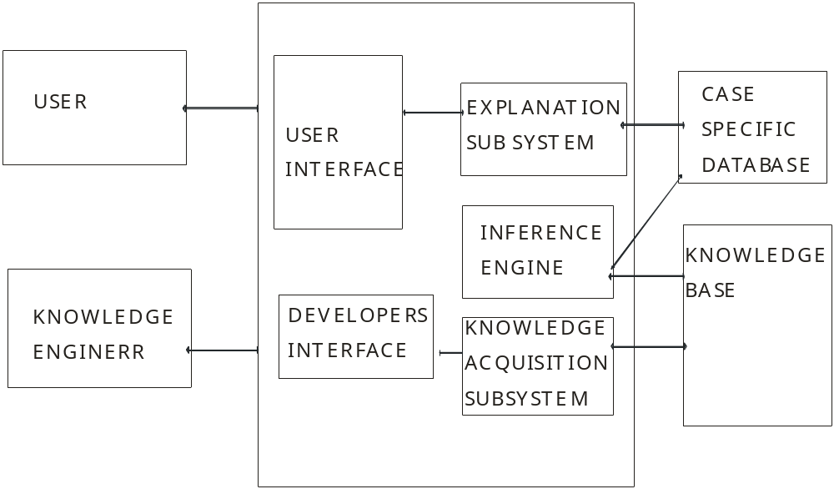

Fig 2: A knowledge Base System

3.4 Decision Tree Analysis
Below is the figure showing the decision tree design for a single disease condition (malaria in specific). The design will serve as a sample to explain generally the concept of using decision trees to make effective decision in medical diagnosis. Given the basic symptoms for malaria which include; fever, loss of appetite and bitter taste, body and joint pains, and headache, we can now use our decision tree to design a diagnosis for malaria as thus:

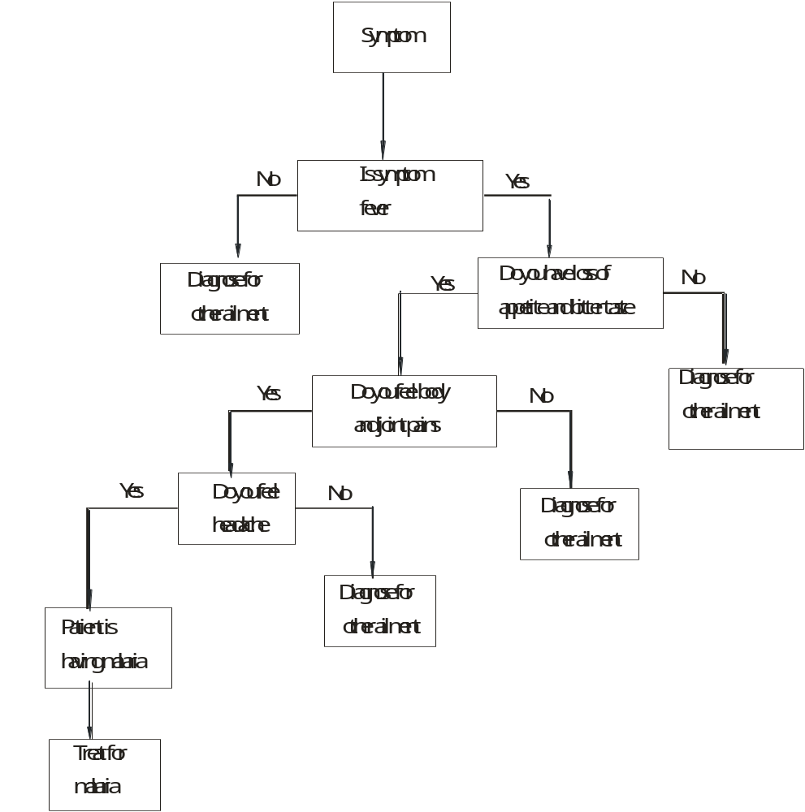

Fig 3: A decision tree for malaria Diagnosis

4.0 Operating System and Programming Platform
Windows ‘98’ and above, Microsoft Access and Java programming languages are chosen for the implementation of the database and the application package respectively.

5.0 Implementation
Implementation refers to the development, installation and testing of system components. It involves the transformation of ideas into real process flow of information. Ideas such as flow charts, computer run chart, algorithm and programming language used, as well as the results obtained.

The malaria diagnostic system steps include
1. Opening malaria Diagnostic Folder
2. Enter your account details (user name and password) to give you access to
the Welcome page
3. Select the Patient record form
4. Enter the symptoms appropriately.
5. Click at Disease and treatment form it leads you to patient and diagnostic
engine
6. Click Save for the patient diagnostic result

6.0 Results: The result of the program has confirmed the automated process. The sample forms below show the input and output for the malaria diagnostic system.

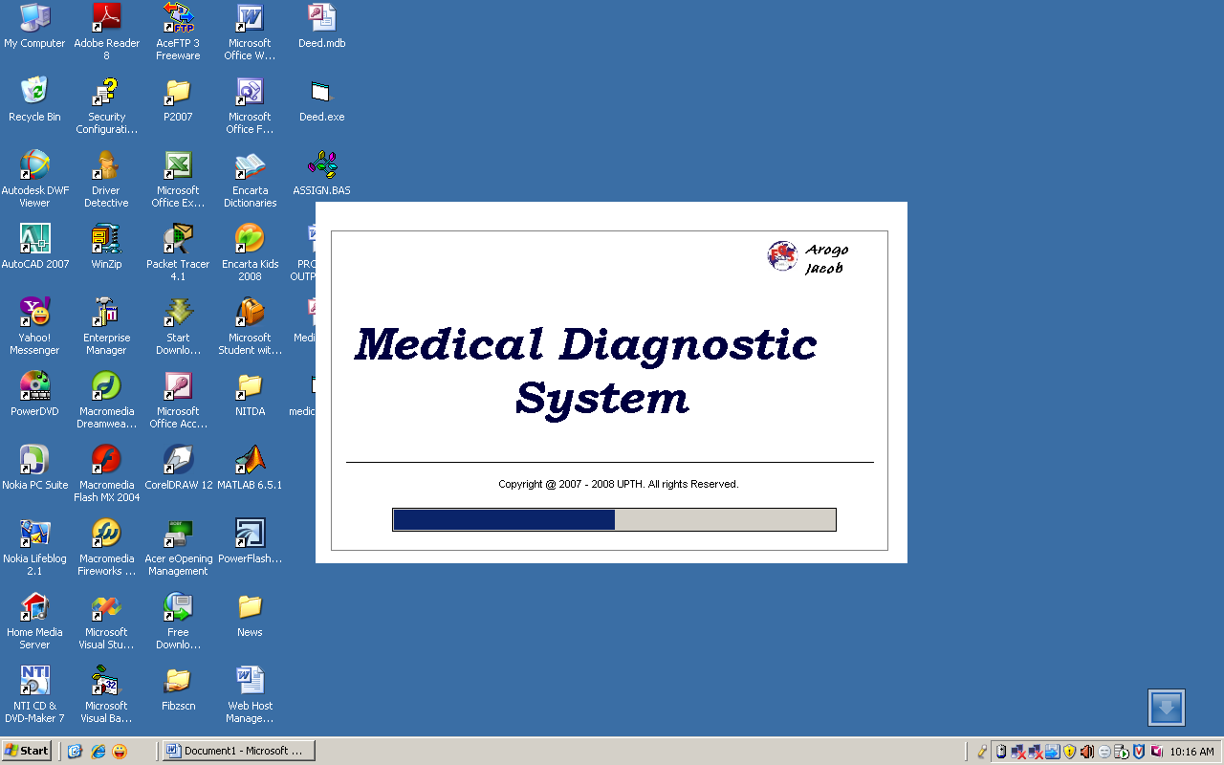

Fig 4: Medical Diagnosis Home page

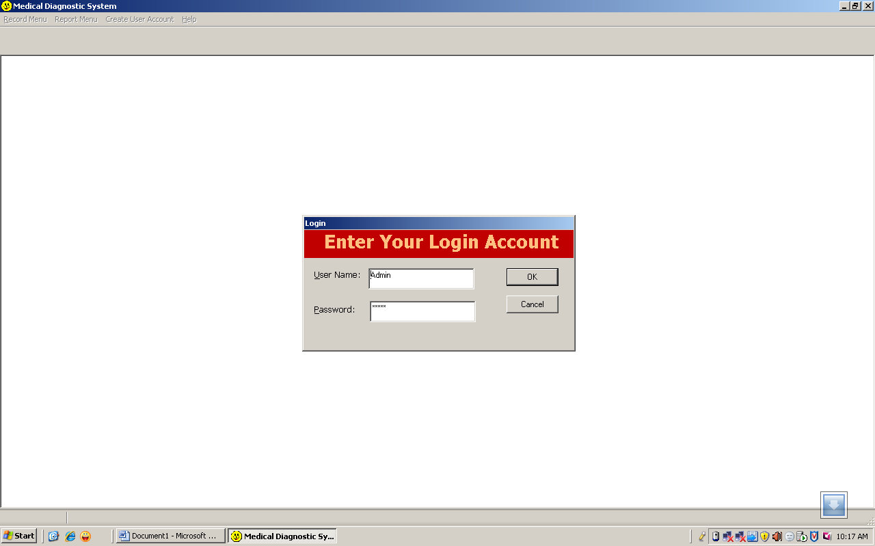

Fig 5: Account Dialog box

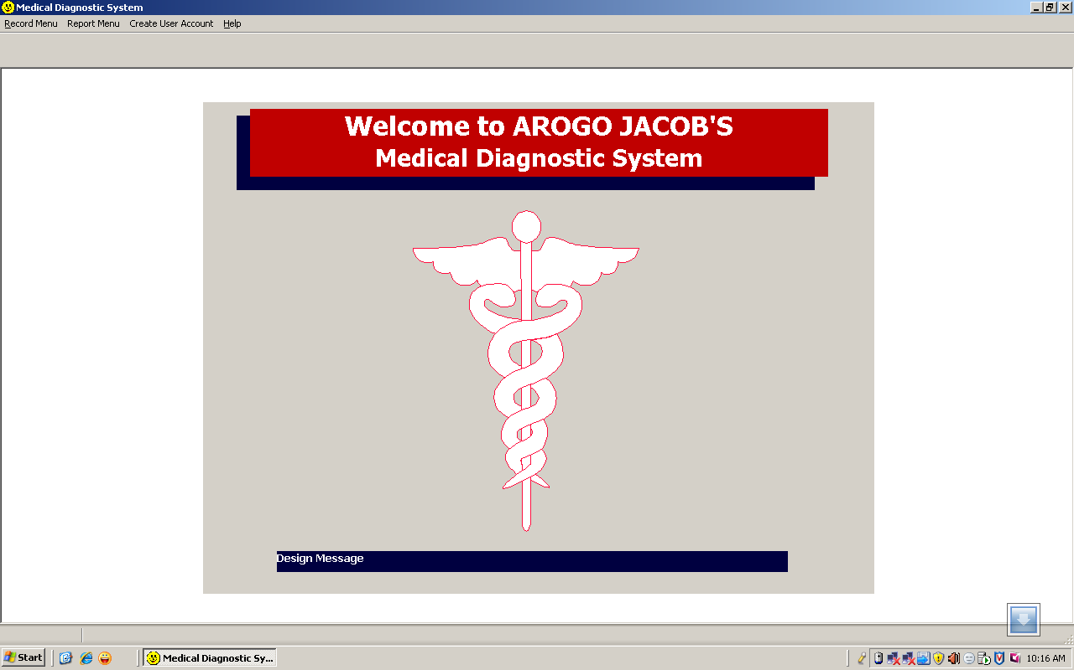

Fig 6: welcome page

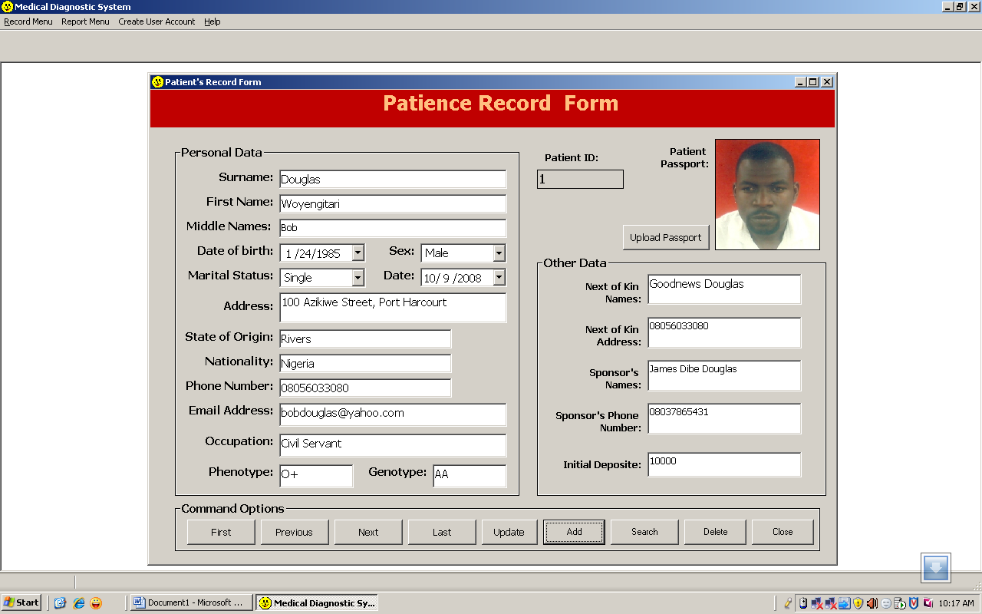

Fig 7: Patient record form

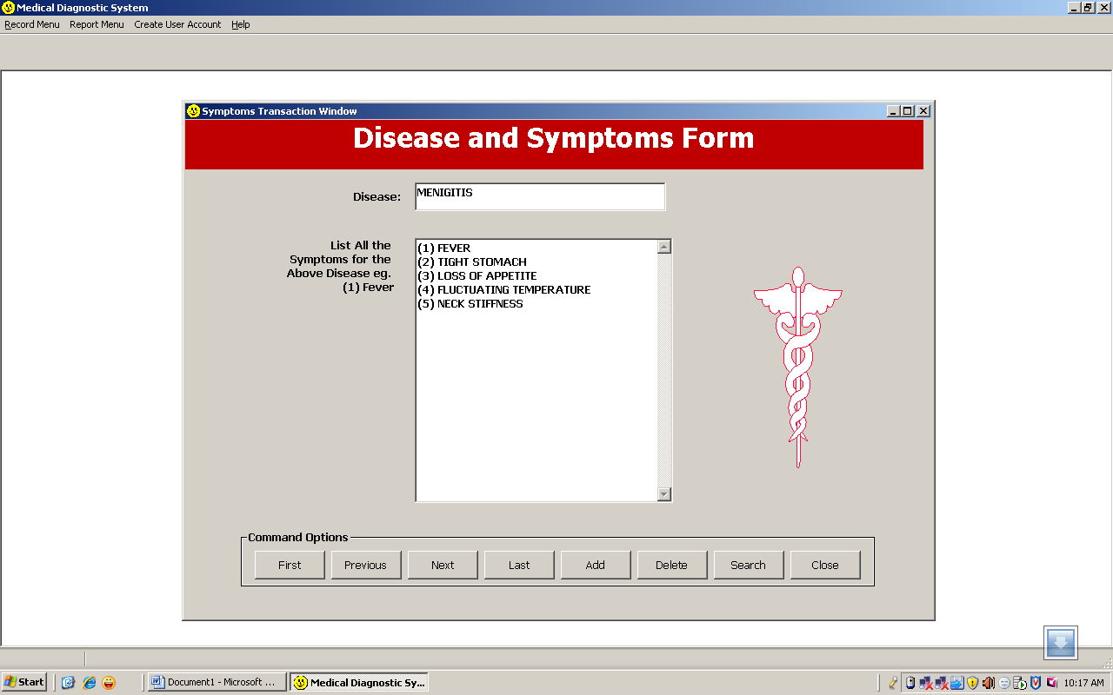

Fig 8: Disease and Symptoms Form

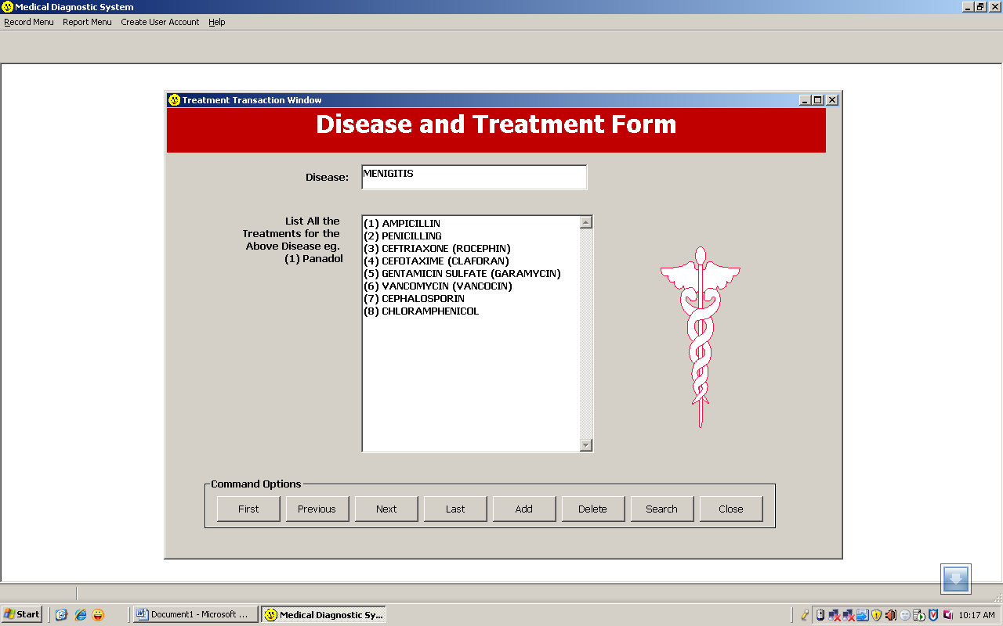

Fig 9: Disease and Treatment Form

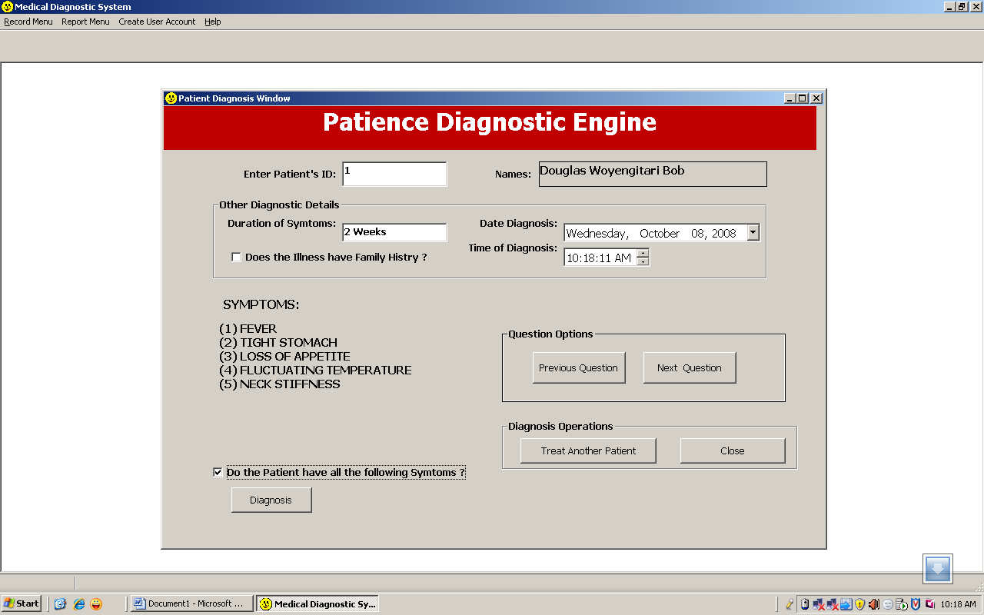

Fig 10: Patient Diagnostic Engine

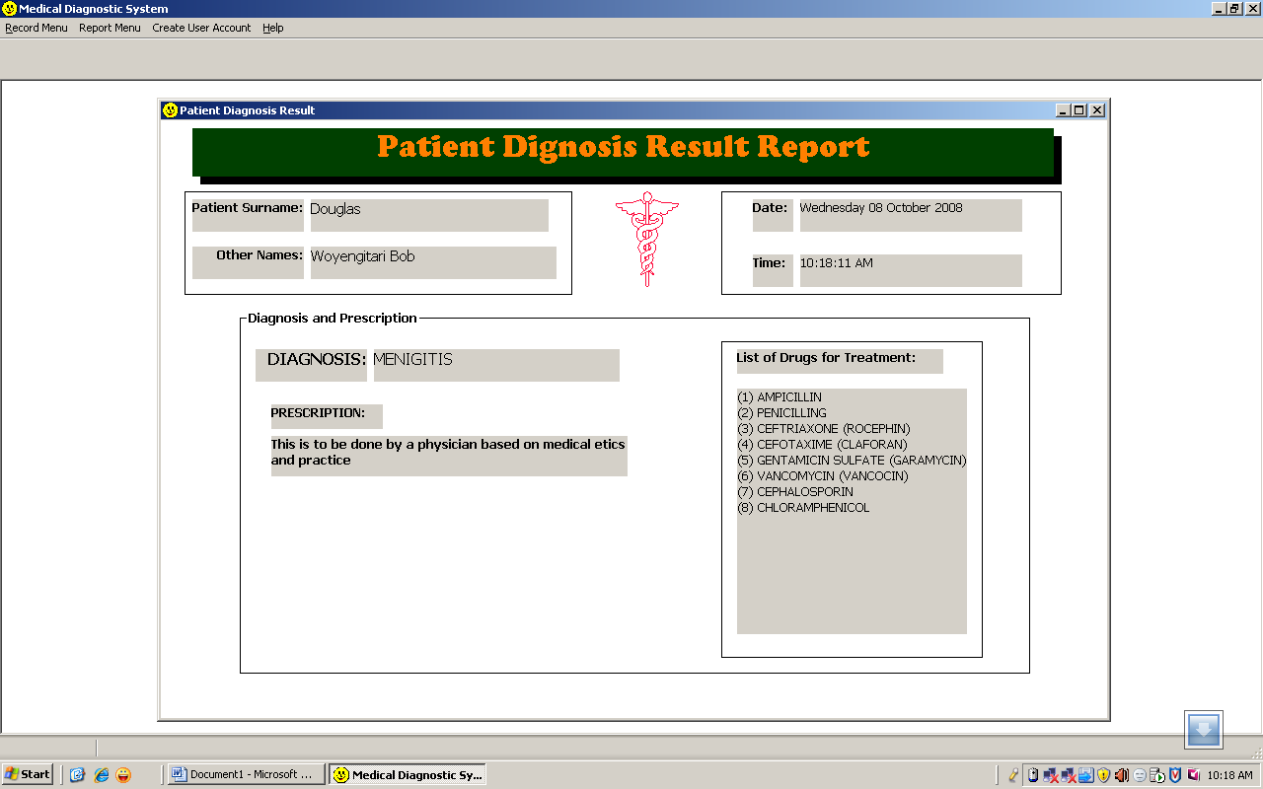

Fig 11: Patient Diagnostic Result

6.0 Discussion: A machine learning technique has been used to develop a diagnostic system for malaria parasite and recommendation of treatment appropriately. The results generated by the diagnostic system are in line with the expected result as they compare favorably with decisions human domain experts would take in similar situation. From the sample outputs presented above, obviously this medical system can be used by professionals and non professionals in malaria diagnosis. The output samples also showed the proper development of the forms involved in this diagnostic system starting from the fig 4; The Home page to Fig 11; the patient diagnostic result and treatment recommendation. This work is of a special kind since Decision Tree a Machine learning technique has been applied in solving problems relating to congestion, Educational problems and other diagnostic problem but has not been applied in the diagnostic system of malaria.
Again, the diagnostic system can be used by Medical Professionals and Non Professionals in the treatment of malaria parasite.

7.0 CONCLUSION
The automated system that has been developed will facilitate the diagnosis and treatment of malaria parasite. If adopted for implementation, will reduce the problems with the manual method and the interface user friendliness will always encourage patient to go for diagnosis when they start feeling any of this signs and symptoms mentioned above. This system developed can be hosted in the internet which will encourage exchange of medical information across the globe to the benefit of mankind. The use of information technology in medicine makes consultation to be more attractive and interactive.
More so, as computer technology becomes sophisticated, centralized databases over the World Wide Web (WWW) have many advantages. Information sharing, collaboration between medical practitioners, on-line discussion, on-line treatment and diagnosis are among the main features which enable the doctors from around the world to share their knowledge and expertise.
As to this end, it is important for individuals, medical practitioners, business organizations, religious institutions, academic institutions etc to embrace the spirit of adopting this automated system (package) of medical diagnosis for effective health care delivery without subjecting oneself to the problems and weaknesses of the manual method, except when the condition persist then a specialist in that field of disorder can be consulted.

References
Anigbogu, S.O (2003): Fundamental principles of Artificial intelligence
and Expert System. Rex-Charles & Patrick’s Ltd, Nimo, Nigeria.
Biggs, D., de Ville, B. and Suen, E. (1991) A method of choosing multiway partitions for classification and decision tree. Journal of Applied Statistics 18(1): 49-62.
Carlos Feder (2006) Computerized Medical Diagnosis: A Novel Solution to An
Old Problems. Infinity Publishing.

Jerry M. (1997), Business Dictionary of Computers .p. 180,275. Dubline
Publishers ISB 2014 Pittsburg.

Jacques J.A. (1972), Computer Diagnosis and Diagnostic Methods. P. 45
Jasmine Publishing Company Springfield, Illinois.

Lugar, George and Stubblefield, William (2004). Artificial Intelligence:
Structure and strategies for complex problem solving (5th ed)
p.24,25,26. Benjamine /Cummings Publishing Co. NY 30124.

Lonnie D. Bentley MS CDP (Prof), Jeffery L. Whiten, MS CDP(Prof) Victor
M. Barlow. MBA, CDP, (Ass. Prof) Systems Analysis and Design (2004)
third edition. Purdure University/West Lateytte Publishers, CN.

Malaria foundation International (2003):
http://www.malaria.org/lifehealth.html

Mc Graw Hill, Tom M. Mitchell (1997) Machine Learning P. 47,70.

Nilson, Nils (1998), Artificial Intelligence: A new synthesis P. 34 Morgan Kaufmann Publishers.

Patterson, Dan W. (1990): Introduction to Artificial Intelligence and
Expert Systems. Prentice Hall Ltd. New Delhi.India
Quinlan, J.R. (1986) Induction of Decision Trees. Machine Learning 1: 81-106.
Ted Pedersen. (2001). A decision tree of bigrams is an accurate predictor of word sense. In Proc. of the Second NAACL, pages 79–86.

Htt://org/wiki/the_Computer_Revolution/Artificial_Inteligence/Diagnosis
Http://www-formal.standfor.Edu/jmc/whatisai/node./.html
http://freepatentsonline.com/473353.html
Http:llen.Wikipedia.Org/Wiki/Diagnosis_intelligence
Http://en.Wikibooks.Org/wiki/the_computerRevolution/ArtificialIntellige
/Diagnosis.

