First version: May 31, 2018

Current version: March 15, 2020

**Experimental Procedure for AIIMS 3D Motion Project – 2020**

**Rijul Soans**

1. **Hardware Setup:**

Please make sure the following items are ready and connected as per figure below:

1. FOVE Virtual Reality headset – it has 3 wires:

* HDMI cable – connect it to the HDMI port of the Nvidia GTX 1080 graphic card at the rear of the PC cabinet.
* One USB 3.0 cable – connect it to a USB 3 port – labelled as “SS” (Super-speed)
* One USB 2.0 cable – connect it to any USB port.

1. FOVE Headtracking camera – connect it to any USB port.
2. PC Cabinet with Nvidia GTX 1080
3. Display Monitor with display port.
4. Power cord for Display Monitor
5. Power cord for PC Cabinet
6. LAN Cable to be connected between Eyetracker and PC cabinet (Note: This does not give internet access. It is necessary for communication between the Eyetracker and PC)
7. Keyboard + Mouse
8. Display Port Cable between the monitor and PC Cabinet (Connect from the Display port back of the Nvidia GTX 1080 to the Display port behind the monitor.

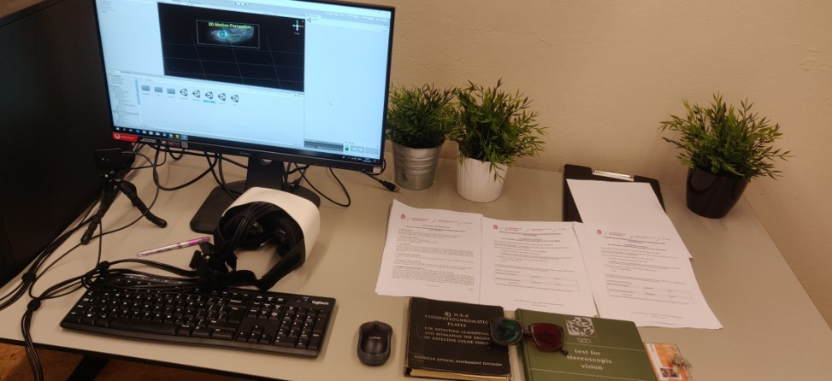

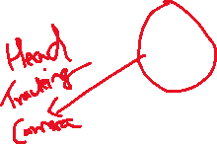

1. **Software Setup:**

Please make sure the following items are ready:

1. Power on the PC. Select Windows 7 in the BIOS settings. But you will see Windows 10 is loading. This is normal. Wait for some time till Login page loads. Select “DELL” user. Ask Rijul for the password. Once logged on, close any applications if already open.
2. Next check whether FOVE is working properly or not after plugging all the previously mentioned connections. Do the following steps for checking:

* Type “FOVE” in Windows search bar 🡪 select the FOVE VR App. You should see the following appear on the right-side of your desktop

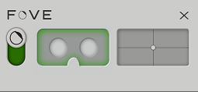

The green toggle on the left side of this picture can be used to switch on and off the FOVE system. Next to the toggle is the “Eyetracking asleep/awake indicator”. Next to that is the “Headtracking asleep/awake indicator”.

* Next, right-click on this app 🡪 Launch Debug tool. You should see the following appear:

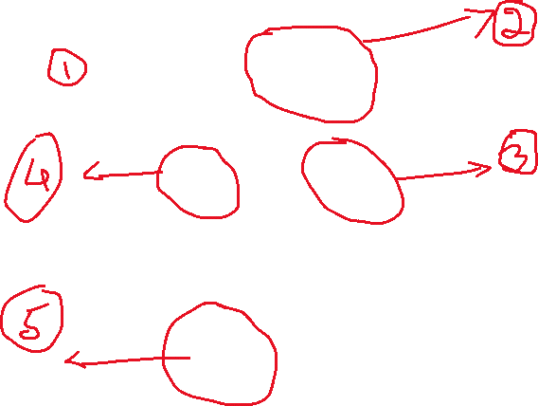

* Label 1 – this is the spatial orientation and position information relative to the placement of the headtracking camera
* Label 2 – this is the eyetracking information – X, Y should be 0 and Z should be 1 at this stage i.e .before anyone wears the headset.
* Label 3 – Move a finger to make sure that the headset is receiving the video input.
* Label 4 – Move a finger here as well.

**In case you notice that your finger is not getting displayed properly or see some lag while moving your finger, switch off the FOVE toggle (green toggle) + remove the FOVE connections and re-connect.**

* Label 5 – Make sure that the white dots are seen within the black window i.e. that the headtracking camera is seeing the FOVE VR headset.
* Once these checks are done, now you may click on the “X” mark of the FOVE app.

1. Double click on **Unity Hub located on the desktop**
2. Once inside Unity Hub, click on **VR_3D_Motion_Project_AIIMS in the menu**. Make sure that Unity version selected is “**2017.4.30f1**”. Single click on this project. The project opens in Unity.
3. Inside Unity, click on **Assets 🡪Scenes🡪Main Scene.**
4. **Things to keep in mind whenever any patient/volunteer arrives:**
5. **Make sure the patient who comes in for this test does not fall in our exclusion criteria i.e. NO HISTORY OF VERTIGO / EPILEPSY / SENSITIVE TO STRONG LIGHT AND MOTION.**
6. Include the following patients: (***you can ask Dharamraj or another medical professional on duty in that room for confirmation if having doubts in Point 2 and Point 3***)

* Strabismus patients – try getting **minimum 30 such Strabismus patients**.
* Under Strabismus – get Post-operated Esotropic patients
* Also see if you get Esotropic patients who have binocular function. These may be rare – but if you get do include and document them!

1. **Exclude** the following patients as well:

* Patients with any visual field defect
* If patient has Exotropia Strabismus (divergent cross eyed i.e. their eyes are looking in different directions outward).
* Patients with spectacles whose refractive power is more than 2D

1. **Healthy Volunteer Group: At least 30 subjects** who have normal stereo-vision as tested by the TNO Test and other stereo-tests. They should be age-matched to the patient group
2. **Just before starting experiment:**
3. Welcome the subject - - mention briefly the purpose of the task. Please show the Participation Information sheet to them.
4. You can make some preliminary entries in the Excel sheet.
5. Make sure they are seated comfortably. Use the horizontal and vertical straps on the FOVE VR headset to securely place the head inside the headset.
6. Make sure that their eyes are in the middle of the Eye Image view as shown below. If not, adjust the headset to keep the eyes in middle.

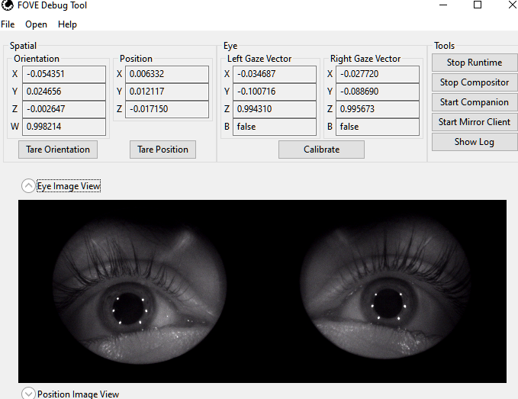

1. Exit the FOVE VR App after verification. Otherwise, it may interfere when UNITY is running.
2. **Starting the Experiment:**

* **Press Play Button in the Scene window (top middle) while being in the “Main Scene”. [as continued from Section 2]. You should see the calibration phase view as shown below:**
  1. **Calibration Phase:**

*Example Dialogue*: “Hello sir/madam. Now, we are going to perform a small test. You will see a green dot coming up on the screen. All you have to do is look at the dot wherever it goes.”

* **Press C to calibrate**. Make sure that the result of the calibration is good.
  1. **Experimental Phase:**

**Once the calibration is successful, the participant should see this screen. You may see it earlier itself on the monitor – BUT the participant will see it only after successful calibration. So you can use this as a calibration check.**

*Example Dialogue*: “Okay now, we will start your main test. There will be a white ball. First 5 seconds it will be stationary. Use this time to focus on the ball. After 5 seconds it will move randomly for 20 seconds. You have to keep following the ball. You can blink your eyes in between if you want – but keep following the ball.”

* Each trial runs for 20 seconds. Participants are allowed to take a break only when the menu screen is displayed.

**Additional Info for the Experimenter:**

* ***6 trials each – each trial 20 seconds. (~5 min per subject)***
* ***Give break to them if they ask (only between trials).***
* ***Make sure the participant is not sleeping / make sure they are paying attention to your instructions.***

1. **End of the Experiment:**

* Thank the patient for their time.
* Click photos of the patient documents – for example, the first orthoptic report, Basic History etc. Do not photograph the patient!
* Name the photos by Participant Number + Description. Useful for organizing all the files at the end of the day.
* Fill up the “**Participant_Data_Sheet_3D_Motion_AIIMS**” excel sheet. Note down if something peculiar or interesting details emerge - - for example, participant was not able to see any depth, participant felt movement of the ball is too fast etc. Always ask for medical personnel if in doubt.
* **Very Imp: Check if 6 Excel sheet files have been written in the project folder for every particpant!**
* **Make sure they sign the Participant Informed Consent Form – either in English or Hindi whichever they prefer.**
* **Check the data quality by plotting time-series in MATLAB. Use MATLAB R2019b on the desktop.**