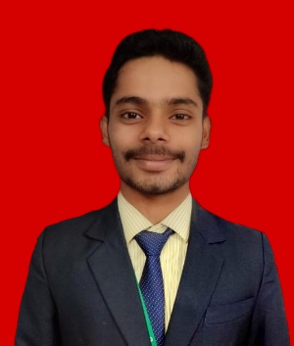**Name: Ashirwad Pandey**

**Branch: Electrical & Electronics Engineering**

C/O-

Email: ashupandeyonly2002@gmail.com

Phone: +91 82607 65890

Portfolio: <https://personalportfolio15.netlify.app>

Github: https://github.com/ashirwadpandey

**Career Objective**

To make successful contributions in a dynamic and challenging work environment by utilizing my abilities, expertise, and experience. I'm looking for a role where I can use my skills to advance professionally while having a big impact on the company's performance. I am inspired by the chance to develop new skills, take on new responsibilities, and work with a varied team to promote innovation and fulfil both my own and the organization’s objectives.

**Educational Qualifications**

|  |  |  |
| --- | --- | --- |
| Degree and Year | Institute | Percentage/CGPA |
| 10th in 2018 | Ghanashyam Hemlata Vidya Mandir, Jharsuguda | 62.4% |
| +2 Science in 2020 | Ghanashyam Hemlata Vidya Mandir, Jharsuguda | 62.2% |
| B. Tech (EEE) | Gandhi Institute of Engineering & Technology, Gunupur | 7.64 CGPA |

**Training / Certification**

## GIET University, Gunupur — Training

April 2020 - May 2020

* Undergone training for 15 days on “PHP”.
* Successfully completed the project entitled ‘Online Examination System’.

**GIET University,** Gunupur — Training

July 2022

* Undergone training for 15 days on “MEAN”.
* Successfully completed the project entitled ‘Online Parking Management System’.

**Great Learning Academy** — Certification

October 2022

* Undergone certification course of 21 days on “PYTHON”.
* Successfully completed the project entitled ‘WEATHER APP’.

**Coursera** — Certification

* Undergone certification course of 28 days on “PYTHON”.
* Successfully completed the project entitled ‘Sentiment Analysis’.

**Technical Skills**

1. Programming Languages Known: Python, C, C++.
2. Web Development: HTML, CSS, JavaScript, Node.js, Express.js, Angular.js, React.js, Bootstrap, PHP.

**3**. Database: MySQL, MongoDB.

**4**. Basics of ML, IOT and Data Science.

**5**. Microsoft Office Applications.

**Internship Programs**

* Successfully completed one-months internship program on “Web Development” from BharatIntern.
* Successfully completed one-month internship program on “Python” from LearnSmasher.
* Successfully completed one-months internship program on “Full stack Web Development” from BharatIntern.

**Personal Details**

|  |  |
| --- | --- |
| **Date of Birth** | 15/06/2002 |
| **Gender** | Male |
| **Father's Name** | Birendra Pandey |
| **Mother’s Name** | Sunita Pandey |
| **Nationality** | Indian |
| **Marital Status** | Unmarried |
| **Language Known** | Odia, Hindi, English |
| **Hobbies** | Badminton, Online Game |
| **Interests** | Web Development, Data science |

Place: Gunupur Signature

Date: