Classic Interactive Report

Interactive program generally interacts with user on the output screen. Let us suppose we have an output for a particular program/report. Now if we want details description by double clicking on a particular field or clicking on a button then it will be called interaction with output. By doing this we can go to the detailed report or secondary output. When we are on the secondary output then we can back to our first out by clicking on Back button. **We can generate 19 secondary list of output. Hence a total of 20 output screen (1 Primary + 19 Secondary) can be generated by Interactive program.**

We have a requirement where we have to prepare a primary output containing Purchase Order, Company Code, Category, Type and Vendor with PO Info. The secondary list will be generated with PO Item, Material, Plant, Storage Location, Material Group, Quantity and Unit of measure. The secondary list will be generated if we double click on PO field in primary output.

We have mentioned the tables EKKO, EKPO and T161T. Now we have declared the structure types of internal tables of it_ekko, it_text, it_out1 and it_ekpo. Here it_out1 contains the combination of two internal tables it_ekko and it_text and it_ekpo is for the secondary output. For internal operation we have declared work area of every internal tables.

Next we have mentioned the event INITIALIZATION. Under this we are calling program name, user name and system date of the program. We have declared here selection screen begin with block b1 and under this we are mentioning obligatory select option.

Now under START-OF-SELECTION we are declaring all the operations for primary listing. We have made 4 subroutines. In get_ekko we select fields from EKKO into internal table it_ekko. Then in get_t161t we select fields from t161t into internal table it_text for all entries in it_ekko. After that we are preparing the primary output in the basic_output subroutine. Now we have made another subroutine for displaying the primary output and that is disp_basic.

Hence the primary list is prepared now and now we have to create the secondary list. To make the secondary list we are calling event AT LINE-SELECTION which raises functionality when user double clicks in any field. Now we are mentioning GET CURSOR for that field and for that value of the field. When these two are matches with Purchase Order (EBELN) field then we are calling two subroutines for secondary list.

Subroutine get_ekpo Selects fields from EKPO into table it_ekpo for all entries in it_ekko. Then it prepares the secondary output display in the subroutine of ekpo_output.

We also have raised events TOP-OF-PAGE which shows the header list of primary output and TOP-OF-PAGE DURING LINE-SELECTION which shows the top list of secondary output. Here TOP-OF-PAGE DURING LINE-SELECTION is used only for interactive reports. That means when user double clicks on the field the TOP-OF-PAGE DURING LINE-SELECTION event triggers to make the secondary output header.

*&---------------------------------------------------------------------*  
*& Report  ZSR_TEST  
*&  
*&---------------------------------------------------------------------*  
*&  
*&  
*&---------------------------------------------------------------------*  
  
REPORT  zsr_test.  
  
TABLES: ekko, ekpo, t161t.  
TYPES: BEGIN OF ty_ekko,  
        ebeln TYPE ekko-ebeln, "Purchase Order  
        bukrs TYPE ekko-bukrs, "Company Code  
        bstyp TYPE ekko-bstyp, "Category  
        bsart TYPE ekko-bsart, "Type  
        lifnr TYPE ekko-lifnr, "Vendor  
       END OF ty_ekko,  
  
       BEGIN OF ty_text,  
        spras TYPE t161t-spras,  
        bsart TYPE t161t-bsart,  
        bstyp TYPE t161t-bstyp,  
        batxt TYPE t161t-batxt, "PO Info  
       END OF ty_text,  
  
       BEGIN OF ty_ekpo,  
        ebeln TYPE ekpo-ebeln,  
        ebelp TYPE ekpo-ebelp, "PO Item  
        matnr TYPE ekpo-matnr, "Material  
        werks TYPE ekpo-werks, "Plant  
        lgort TYPE ekpo-lgort, "Storage Location  
        matkl TYPE ekpo-matkl, "Material Group  
        menge TYPE ekpo-menge, "Quantity  
        meins TYPE ekpo-meins, "Unit  
       END OF ty_ekpo,  
  
       BEGIN OF ty_out1,  
        ebeln TYPE ekko-ebeln,  
        bukrs TYPE ekko-bukrs,  
        bstyp TYPE ekko-bstyp,  
        bsart TYPE ekko-bsart,  
        lifnr TYPE ekko-lifnr,  
        batxt TYPE t161t-batxt,  
       END OF ty_out1.  
  
DATA: wa_ekko TYPE ty_ekko,  
      it_ekko TYPE STANDARD TABLE OF ty_ekko,  
      wa_text TYPE ty_text,  
      it_text TYPE STANDARD TABLE OF ty_text,  
      wa_out1 TYPE ty_out1,  
      it_out1 TYPE STANDARD TABLE OF ty_out1,  
      wa_ekpo TYPE ty_ekpo,  
      it_ekpo TYPE STANDARD TABLE OF ty_ekpo,  
  
      v_repid TYPE sy-repid,  
      v_user  TYPE sy-uname,  
      v_date  TYPE sy-datum,  
  
      v_field1 TYPE char40,  
      v_field2 TYPE char40,  
      v_value1 TYPE char40,  
      v_value2 TYPE char40.  
  
INITIALIZATION.  
  v_repid = sy-repid.  
  v_user  = sy-uname.  
  v_date  = sy-datum.  
  
  SELECTION-SCREEN BEGIN OF BLOCK b1 WITH FRAME TITLE text-001.  
  SELECT-OPTIONS   s_ebeln FOR ekko-ebeln OBLIGATORY.  
  SELECTION-SCREEN END OF BLOCK b1.  
  
START-OF-SELECTION.  
  PERFORM get_ekko.  
  PERFORM get_t161t.  
  PERFORM basic_output.  
  PERFORM disp_basic.  
  
AT LINE-SELECTION.  
  GET CURSOR FIELD v_field1 VALUE v_value1.  
  CASE v_field1.  
    WHEN 'WA_OUT1-EBELN'.  
      PERFORM get_ekpo.  
      PERFORM ekpo_output.  
  ENDCASE.  
  
  GET CURSOR FIELD v_field2 VALUE v_value2.  
  CASE v_field2.  
    WHEN 'WA_EKPO-MATNR'.  
      PERFORM get_mara.  
  ENDCASE.  
  
TOP-OF-PAGE.  
  PERFORM top_page1.  
  
TOP-OF-PAGE DURING LINE-SELECTION.  
  PERFORM top_page2.  
  
*&---------------------------------------------------------------------*  
*&      Form  get_ekko  
*&---------------------------------------------------------------------*  
*       text  
*----------------------------------------------------------------------*  
*  -->  p1        text  
*  <--  p2        text  
*----------------------------------------------------------------------*  
FORM get_ekko .  
  
  SELECT ebeln bukrs bstyp bsart lifnr  
  FROM ekko INTO TABLE it_ekko  
  WHERE ebeln IN s_ebeln.  
  
  IF sy-subrc = 0.  
    SORT it_ekko BY ebeln.  
  ELSE.  
    MESSAGE 'Purchase Order doesn''t exist.' TYPE 'I'.  
    LEAVE LIST-PROCESSING.  
  ENDIF.  
  
ENDFORM.                    " get_ekko  
*&---------------------------------------------------------------------*  
*&      Form  get_t161t  
*&---------------------------------------------------------------------*  
*       text  
*----------------------------------------------------------------------*  
*  -->  p1        text  
*  <--  p2        text  
*----------------------------------------------------------------------*  
FORM get_t161t .  
  
  IF it_ekko IS NOT INITIAL.  
    SELECT spras bsart bstyp batxt  
    FROM t161t INTO TABLE it_text  
    FOR ALL ENTRIES IN it_ekko  
    WHERE spras = sy-langu  
      AND bsart = it_ekko-bsart  
      AND bstyp = it_ekko-bstyp.  
  
    IF sy-subrc = 0.  
      SORT it_text BY bsart bstyp.  
    ENDIF.  
  ENDIF.  
  
ENDFORM.                                                    " get_t161t  
*&---------------------------------------------------------------------*  
*&      Form  basic_output  
*&---------------------------------------------------------------------*  
*       text  
*----------------------------------------------------------------------*  
*  -->  p1        text  
*  <--  p2        text  
*----------------------------------------------------------------------*  
FORM basic_output .  
  
  IF it_ekko IS NOT INITIAL.  
    LOOP AT it_ekko INTO wa_ekko.  
      wa_out1-ebeln = wa_ekko-ebeln.  
      wa_out1-bukrs = wa_ekko-bukrs.  
      wa_out1-bstyp = wa_ekko-bstyp.  
      wa_out1-bsart = wa_ekko-bsart.  
      wa_out1-lifnr = wa_ekko-lifnr.  
  
      READ TABLE it_text INTO wa_text  
      WITH KEY bsart = wa_ekko-bsart  
               bstyp = wa_ekko-bstyp BINARY SEARCH.  
      IF sy-subrc = 0.  
        wa_out1-batxt = wa_text-batxt.  
      ENDIF.  
  
      APPEND wa_out1 TO it_out1.  
      CLEAR: wa_out1, wa_ekko, wa_text.  
    ENDLOOP.  
  ENDIF.  
  
ENDFORM.                    " basic_output  
*&---------------------------------------------------------------------*  
*&      Form  disp_basic  
*&---------------------------------------------------------------------*  
*       text  
*----------------------------------------------------------------------*  
*  -->  p1        text  
*  <--  p2        text  
*----------------------------------------------------------------------*  
FORM disp_basic .  
  
  IF it_out1 IS NOT INITIAL.  
    LOOP AT it_out1 INTO wa_out1.  
      AT FIRST.  
        WRITE: /  'Purchase Order',  
               20 'Company',  
               30 'Category',  
               40 'Type',  
               50 'Vendor',  
               65 'PO Info.'.  
        ULINE.  
        SKIP.  
      ENDAT.  
  
      WRITE: /  wa_out1-ebeln,  
             20 wa_out1-bukrs,  
             33 wa_out1-bstyp,  
             40 wa_out1-bsart,  
             50 wa_out1-lifnr,  
             65 wa_out1-batxt.  
  
      AT LAST.  
        SKIP.  
        ULINE.  
        WRITE: /12 '~~End of Report~~'.  
      ENDAT.  
    ENDLOOP.  
  ENDIF.  
  
ENDFORM.                    " disp_basic  
*&---------------------------------------------------------------------*  
*&      Form  get_ekpo  
*&---------------------------------------------------------------------*  
*       text  
*----------------------------------------------------------------------*  
*  -->  p1        text  
*  <--  p2        text  
*----------------------------------------------------------------------*  
FORM get_ekpo .  
  
  DATA: lv_ebeln TYPE ekko-ebeln.  
  
  IF v_value1 IS NOT INITIAL.  
    CALL FUNCTION 'CONVERSION_EXIT_ALPHA_INPUT'  
      EXPORTING  
        input  = v_value1  
      IMPORTING  
        output = lv_ebeln.  
  
    IF lv_ebeln IS NOT INITIAL.  
      SELECT ebeln ebelp matnr werks lgort  
             matkl menge meins  
        FROM ekpo INTO TABLE it_ekpo  
        WHERE ebeln = lv_ebeln.  
  
      IF sy-subrc <> 0.  
        MESSAGE 'PO Item doesn''t Exist.' TYPE 'I'.  
        LEAVE LIST-PROCESSING.  
      ENDIF.  
    ENDIF.  
  ENDIF.  
  
ENDFORM.                    " get_ekpo  
*&---------------------------------------------------------------------*  
*&      Form  ekpo_output  
*&---------------------------------------------------------------------*  
*       text  
*----------------------------------------------------------------------*  
*  -->  p1        text  
*  <--  p2        text  
*----------------------------------------------------------------------*  
FORM ekpo_output .  
  
  IF it_ekpo IS NOT INITIAL.  
    LOOP AT it_ekpo INTO wa_ekpo.  
  
      AT FIRST.  
        WRITE: /  'Purchase Order',  
               20 'PO Item',  
               30 'Material',  
               48 'Plant',  
               55 'Storage',  
               65 'Material Group',  
               83 'PO Quantity',  
              100 'Unit'.  
        ULINE.  
        SKIP.  
      ENDAT.  
  
      WRITE: /  wa_ekpo-ebeln,  
             20 wa_ekpo-ebelp,  
             30 wa_ekpo-matnr,  
             48 wa_ekpo-werks,  
             55 wa_ekpo-lgort,  
             70 wa_ekpo-matkl,  
             75 wa_ekpo-menge,  
            100 wa_ekpo-meins.  
  
      AT LAST.  
        SKIP.  
        ULINE.  
        WRITE: /12 '~~End of PO Item~~'.  
      ENDAT.  
  
    ENDLOOP.  
  ENDIF.  
  
ENDFORM.                    " ekpo_output  
*&---------------------------------------------------------------------*  
*&      Form  get_mara  
*&---------------------------------------------------------------------*  
*       text  
*----------------------------------------------------------------------*  
*  -->  p1        text  
*  <--  p2        text  
*----------------------------------------------------------------------*  
FORM get_mara .  
  
  DATA: lv_matnr TYPE mara-matnr.  
  
  IF v_value2 IS NOT INITIAL.  
    CALL FUNCTION 'CONVERSION_EXIT_MATN1_INPUT'  
      EXPORTING  
        input        = v_value2  
      IMPORTING  
        output       = lv_matnr  
      EXCEPTIONS  
        length_error = 1  
        OTHERS       = 2.  
  
    IF lv_matnr IS NOT INITIAL.  
      SET PARAMETER ID 'MAT' FIELD lv_matnr.  
      CALL TRANSACTION 'MM03' AND SKIP FIRST SCREEN.  
    ENDIF.  
  
  ENDIF.  
  
ENDFORM.                    " get_mara  
*&---------------------------------------------------------------------*  
*&      Form  top_page1  
*&---------------------------------------------------------------------*  
*       text  
*----------------------------------------------------------------------*  
*  -->  p1        text  
*  <--  p2        text  
*----------------------------------------------------------------------*  
FORM top_page1 .  
  
  WRITE: / 'Purchase Order Header',  
         / 'Date: ',   12 v_date DD/MM/YYYY,  
         / 'User: ',   12 v_user,  
         / 'Report: ', 12 v_repid.  
  ULINE.  
  SKIP.  
  
ENDFORM.                                                    " top_page1  
*&---------------------------------------------------------------------*  
*&      Form  top_page2  
*&---------------------------------------------------------------------*  
*       text  
*----------------------------------------------------------------------*  
*  -->  p1        text  
*  <--  p2        text  
*----------------------------------------------------------------------*  
FORM top_page2 .  
  
  WRITE: / 'Purchase Order Item List',  
         / 'Date: ',   12 v_date DD/MM/YYYY,  
         / 'User: ',   12 v_user,  
         / 'Report: ', 12 v_repid.  
  ULINE.  
  SKIP.  
  
ENDFORM.                                                    " top_page2  
  
Below is the output:

[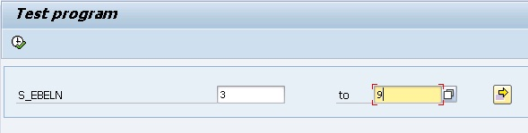](http://4.bp.blogspot.com/-Q01rCfsgXW8/UVmCp89K8_I/AAAAAAAAAeI/thAROmglOrI/s1600/1.jpg)

Primary Listing:

[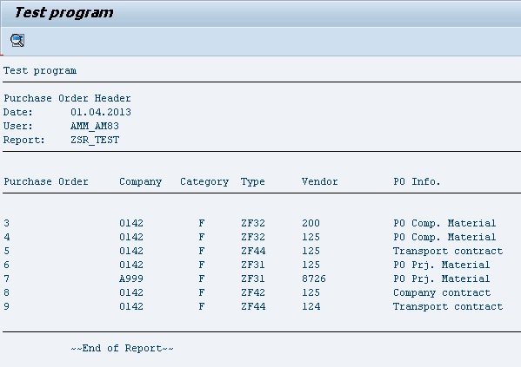](http://1.bp.blogspot.com/-0cigq9BKBsQ/UVmDR6vTUCI/AAAAAAAAAeY/m0948G5rKsU/s1600/2.jpg)

If we double click on the PO in this list then following will be generated:

[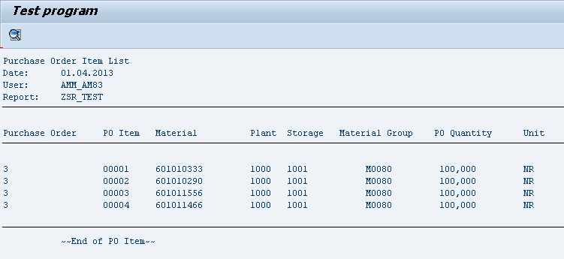](http://4.bp.blogspot.com/-wu-vl_V-590/UVmDiMVX1PI/AAAAAAAAAeg/KPdMsv91Ul4/s1600/3.jpg)