Prac 5:Conversion of decimal to hexadecimal number in a file.

code:

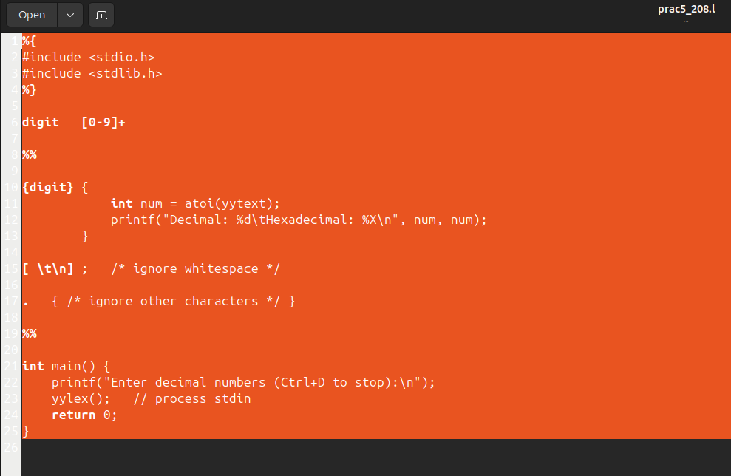OUTPUT:

