Software Requirements Specification
VaxTrace
A Smart Vaccination System for Parents
Final Year Design Project
Document Version 1.0
June 2026

Table of Contents

1. Introduction

1.1 Objective
The objective of VaxTrace is to design and develop a centralized, web-based vaccination management system that digitizes child immunization records for parents, healthcare workers, and administrators. The system automatically generates a complete vaccination schedule for each registered child based on their date of birth, in accordance with Bangladesh's National Immunization Schedule (NIS), and proactively notifies parents through SMS and email before each scheduled dose. By replacing manual, paper-based immunization tracking with an automated digital workflow, VaxTrace aims to:
- Reduce the number of missed or delayed vaccine doses among children.
- Give parents real-time, self-service visibility into their child's immunization history and upcoming doses.
- Give healthcare workers a fast, reliable interface for registering children and recording administered vaccines.
- Give administrators centralized oversight of vaccine inventory, coverage rates, and missed-dose statistics.
- Demonstrate, as a Final Year Design Project, a practical full-stack implementation of an automated, rule-driven scheduling and notification system.

1.2 Scope
VaxTrace is a scalable, web-based platform for centralized vaccination record management, built as a single full-stack application using the Next.js App Router with JavaScript for both the user interface and the backend API, with MongoDB as the persistent data store. Three role-based user classes — parents/guardians, healthcare workers, and administrators — access the system through dedicated dashboards served by the same application. The system's scope covers child registration, automated schedule generation from date of birth, vaccination record updates, multi-channel reminder notifications, vaccine inventory monitoring, and administrative reporting.
The current scope is limited to a single-country deployment aligned with Bangladesh's NIS and is intended primarily as a working prototype for academic evaluation; broader integrations (national databases, a dedicated mobile app, multilingual support) are addressed separately as future enhancements in Section 9.

1.3 Definitions and Acronyms
Field | Description
NIS | National Immunization Schedule (Bangladesh)
EPI | Expanded Programme on Immunization
API | Application Programming Interface
JWT | JSON Web Token
RBAC | Role-Based Access Control
SMTP | Simple Mail Transfer Protocol
DOB | Date of Birth
UI | User Interface
SRS | Software Requirements Specification
CRUD | Create, Read, Update, Delete

2. Overall Description

2.1 Product Perspective
VaxTrace is a new, self-contained product rather than an extension of an existing system. It is built as a single Next.js application in which frontend pages and backend API routes are served from the same codebase. At a high level, the system consists of role-based web interfaces for parents, healthcare workers, and administrators; Next.js API routes (/api/*) that handle business logic and data access; NextAuth for session management combined with a JWT and RBAC middleware layer for role-based access control; scheduled cron jobs that check vaccination due dates and trigger reminders; a notification layer that dispatches reminders through an email service (Nodemailer) and an SMS gateway API; and a centralized MongoDB Atlas database.

2.2 User Classes and Characteristics
- Parent / Guardian (Web User): Views their child's vaccination history and upcoming schedule, and receives SMS and email reminders ahead of due dates. Assumed to have basic web/smartphone literacy.
- Healthcare Worker (Web User): Registers children, records administered vaccines, and updates vaccination status. Assumed to have routine clinical data-entry experience.
- Administrator (Web User): Manages user accounts and permissions, monitors vaccine inventory, and generates reports and statistical analyses. Assumed to be the most technically proficient user class.

2.3 Operating Environment
- Client: modern web browsers (Chrome, Firefox, Edge, Safari) on desktop or mobile devices.
- Application server: Node.js runtime running Next.js (App Router, JavaScript) for both frontend and backend.
- Database: MongoDB (Atlas or self-hosted).
- Notification gateways: third-party SMS API and SMTP-based email service.
- Deployment: cloud hosting (e.g., Vercel) or a local server environment with HTTPS enabled.

2.4 Constraints
- Each child's vaccination schedule must be automatically generated from the date of birth, following Bangladesh's National Immunization Schedule.
- Sensitive child and guardian data must be protected through proper authentication and role-based access control.
- SMS and email reminder delivery depends on third-party gateway availability and may be simulated within the prototype.
- The system must operate within the academic project (Final Year Design Project) timeline and resource constraints.

3. System Requirements
This section defines the minimum hardware and software requirements needed to develop, deploy, and run VaxTrace.

3.1 Hardware Requirements
Component | Minimum Requirement | Recommended
Application server (cloud or local) | 1 vCPU, 2 GB RAM, 10 GB storage | 2 vCPU, 4 GB RAM, SSD storage
Database server (MongoDB Atlas tier or self-hosted) | Shared cluster (M0) or 2 GB RAM | Dedicated cluster, 4 GB+ RAM
Developer workstation | Dual-core CPU, 8 GB RAM | Quad-core CPU, 16 GB RAM, SSD
Client device | Any smartphone, tablet, or PC with a modern browser | Smartphone or laptop with stable internet access
Network connectivity | Stable internet connection (for cloud deployment and SMS/email gateways) | Broadband / 4G or better

3.2 Software Requirements
Layer | Technology / Tool | Purpose
Frontend & Backend | Next.js (App Router, JavaScript) | Unified full-stack framework serving UI pages and /api/* routes
Database | MongoDB / MongoDB Atlas | Persistent storage for users, children, vaccines, records, schedules, notifications, inventory
Authentication | NextAuth, JWT, RBAC middleware | Session management and role-based access control
Notifications | Nodemailer (SMTP), SMS Gateway API | Automated email and SMS reminders for upcoming doses
Scheduling | Cron jobs (Node.js scheduler / Vercel Cron) | Periodic checks for upcoming vaccination due dates
Hosting / Deployment | Vercel or Node.js server with HTTPS | Production deployment of the application
Version Control | Git and GitHub | Source code management and collaboration
Development Environment | Visual Studio Code, Node.js runtime, npm | Local development and dependency management
Password Security | bcrypt | Hashing of user passwords before storage

4. Functional Requirements
ID | Requirement
FR-1 | The system shall authenticate users using NextAuth with JWT-based sessions, enforced by an RBAC middleware layer for parents, healthcare workers, and administrators.
FR-2 | Healthcare workers shall register a new child with details such as name, date of birth, gender, and guardian contact information.
FR-3 | The system shall prevent duplicate child registration based on identifying details such as guardian contact and date of birth.
FR-4 | The system shall automatically generate a complete vaccination schedule for each child based on date of birth, following Bangladesh's National Immunization Schedule.
FR-5 | Healthcare workers shall update vaccination records after a dose is administered, including date administered, vaccine name, and dose number.
FR-6 | The system shall automatically calculate and update the next due date immediately after a vaccination record is updated.
FR-7 | Parents/guardians shall access a dashboard to view their child's complete vaccination history and upcoming scheduled doses.
FR-8 | A scheduled cron job shall check upcoming vaccination due dates and automatically trigger SMS and email reminders to parents before each scheduled date.
FR-9 | Administrators shall manage user accounts and role-based permissions for healthcare workers and parents.
FR-10 | Administrators shall monitor vaccine inventory, including stock levels and batch/expiry tracking.
FR-11 | The system shall generate reports and statistical analyses, including immunization coverage rates and missed-dose tracking, for administrators.
FR-12 | The system shall maintain audit logs of all vaccination record updates.

5. Non-Functional Requirements
- Security: Passwords hashed (e.g., bcrypt), JWT-based authentication, role-based access control, and HTTPS for all communication.
- Performance: Average response time of under 3 seconds under normal load.
- Availability: Target uptime of 99% (prototype simulation).
- Scalability: Architecture should support a growing number of registered children, guardians, and healthcare facilities.
- Reliability: Regular MongoDB backups, structured error handling, and retry logic for failed SMS/email delivery attempts.
- Usability: A simple, intuitive interface suitable for parents and healthcare workers with varying levels of technical familiarity.

6. System Architecture Description

6.1 Architecture Overview
VaxTrace is implemented as a single Next.js application using the App Router for both the user interface and the backend API routes. Parents, healthcare workers, and administrators all interact with the same Next.js frontend, which communicates with the Next.js backend through RESTful API routes under /api/*. The backend is supported by three core components: NextAuth for session management, a JWT + RBAC middleware layer that enforces role-based access control on every request, and scheduled cron jobs that check for upcoming vaccination due dates. When a reminder is due, the cron job triggers the notification layer, which dispatches messages through an email service (Nodemailer) and an SMS gateway API. All application data — including users, children, vaccines, vaccination records, schedules, notifications, and inventories — is persisted in MongoDB Atlas.
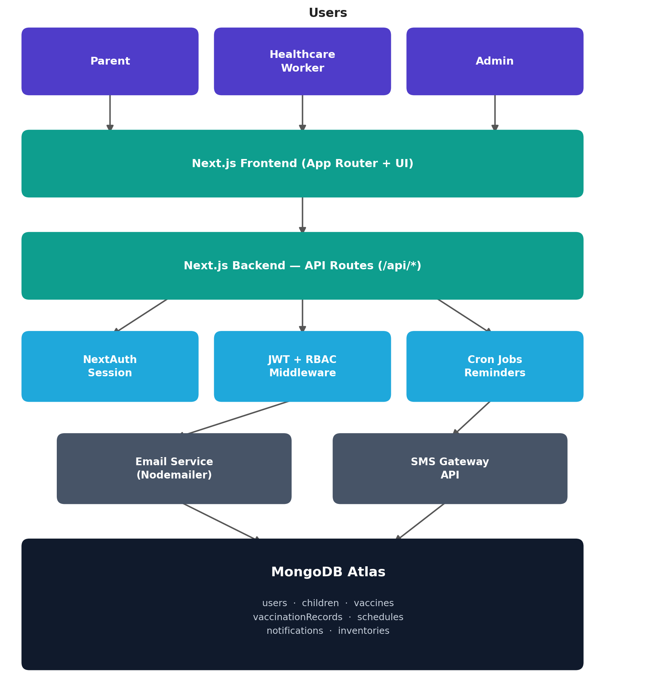
Figure 1: VaxTrace System Architecture

6.2 Component Description
- Next.js Frontend: Renders role-specific dashboards and forms for parents, healthcare workers, and administrators using the App Router.
- Next.js Backend (API Routes): Exposes RESTful endpoints under /api/* that implement business logic, validation, and data access.
- NextAuth Session: Manages login sessions and issues JWTs on successful authentication.
- JWT + RBAC Middleware: Validates tokens and enforces role-based permissions on every protected request.
- Cron Jobs (Reminders): Run on a schedule to identify vaccinations due within a configurable window and queue reminder notifications.
- Notification Layer: Dispatches due reminders through Nodemailer (email) and a third-party SMS gateway API.
- MongoDB Atlas: Centralized data store holding the users, children, vaccines, vaccinationRecords, schedules, notifications, and inventories collections.

7. System Workflow
The diagram below illustrates the end-to-end workflow of VaxTrace, from user login through child registration, automatic schedule generation, reminder delivery via the cron job, and final report generation.
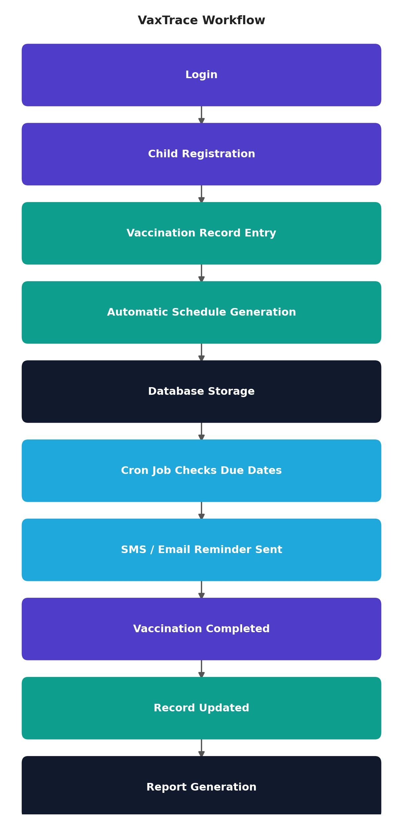
Figure 2: VaxTrace Vaccination Workflow

8. Expected Outcomes
Upon completion, VaxTrace is expected to deliver the following outcomes:
- A fully functional, role-based web application covering child registration, automated NIS-based scheduling, vaccination record updates, and reminder notifications.
- A measurable reduction in missed or delayed vaccine doses through proactive, automated SMS and email reminders sent ahead of each due date.
- A centralized, digital alternative to paper-based immunization records that improves data accuracy, auditability, and accessibility for parents and healthcare workers.
- A self-service parent dashboard that increases visibility into each child's vaccination history and upcoming schedule without requiring a clinic visit.
- An administrative reporting capability that surfaces immunization coverage rates and missed-dose statistics to support data-driven decision-making.
- Real-time vaccine inventory monitoring, including stock levels and batch/expiry tracking, to reduce stock-outs and wastage at healthcare facilities.
- A secure system, with hashed passwords, JWT-based authentication, role-based access control, and HTTPS, that protects sensitive child and guardian data.
- A working prototype suitable for demonstration and evaluation as a Final Year Design Project, with an architecture that can be extended toward the future enhancements identified in Section 9.

9. Future Enhancements
- Integration with the national Birth Registration / EPI database for automated child verification.
- A dedicated mobile application for parents (Android/iOS).
- Full bilingual support (Bangla and English) across the interface and notifications.
- Vaccine coverage-gap and outbreak-risk analysis using AI-driven analytics.
- A telemedicine / teleconsultation module for post-vaccination queries.
- Integration with national health information systems to enable nationwide deployment.

10. Conclusion
VaxTrace aims to provide a centralized, easy-to-use web platform for managing child immunization records in line with Bangladesh's National Immunization Schedule. By combining a single Next.js application with automated scheduling and multi-channel reminders backed by MongoDB, the project demonstrates a practical approach to reducing missed vaccinations and improving record-keeping for parents, healthcare workers, and administrators alike.

11. References
- Next.js Documentation. Vercel. Available at: https://nextjs.org/docs
- MongoDB Documentation. MongoDB, Inc. Available at: https://www.mongodb.com/docs/
- NextAuth.js Documentation. Available at: https://next-auth.js.org/
- JSON Web Tokens (JWT) Introduction. Available at: https://jwt.io/introduction
- Nodemailer Documentation. Available at: https://nodemailer.com/about/
- World Health Organization. Expanded Programme on Immunization (EPI). Available at: https://www.who.int/teams/immunization-vaccines-and-biologicals
- Directorate General of Health Services (DGHS), Bangladesh. National Immunization Schedule, EPI Bangladesh.
- IEEE Std 830-1998. IEEE Recommended Practice for Software Requirements Specifications. Institute of Electrical and Electronics Engineers.
- MongoDB Atlas Documentation. Available at: https://www.mongodb.com/docs/atlas/

