## Image composition

We are discussed work on using the Homographynet work and the Spatial Transformer network towards achieving our goal of effectively splicing the donor image ROI into the recipient image in previous reports. In this report we continue discussing our development of the network architecture and this training regime and hyper-parameter optimization.

With a focus on visual category of people in images we explore the ability of our spatial transform network to compute an effective homography for ‘glasses’ onto ‘human faces’. We have worked with face images in the past so the CelebA dataset makes sense as a training set. We focus on the cropped and aligned subset of faces from CelebA. This constraint of pose obviously will be a problem with unconstrained face images in the wild during testing, however, it will allow us to build the network to handle (a) Scale; (b) Rotation; (c) and Translation parameters. We will augment the network with pose variation to extend the network to train on (d) Shear and (e) Projective parameters. Results use the following sample of human face and glasses. The glasses image is manually segmented. With development of image segmentation the donor image will be algorithmicaly acquired from donor images in the wild.

  
Figure 1: Recipient image of croped and aligned human face

  
Figure 4: Donor image of glasses, manually segmented.

Some preliminary results from our work on splicing 'glasses' onto 'faces':

The first image is 'input', both face and the glasses are displayed with the glasses at their 'initial' position, scale, and rotation. The second image is the 'output', the glasses have been warped onto their 'correct' position onto the face.



I've used my face, which is not part of the celebA dataset. It is also not equivalent to the cropped+aligned+centered faces that are used in the training of the GAN. Actually, this divergence in the test sample (my face) from the entire corpus of training images is reflected in some results where the glasses are bizarrely warped.

The failure of such a scenario:



In this failure case, the discriminator (part of GAN) seems to show is limitations. Since, its trained for celebA cropped and aligned faces, it can happen that a 'variation' in the input data falls in the 'dark zone' of the parameter space. In other words, the discriminator has never seen sufficient training data for this space and essentially makes a 'guess', an extrapolation. Such extrapolation can lead to divergence in the feedback to the affine transform parameters (scale, rotation, translation). Hence, the glasses are erroneously warped.

## Faces in the wild

We extended our approach to function with faces in the wild, i.e. unconstrained faces in terms of number of faces in the recipient image and their pose. Naturally this requires detection of face(s) in the recipient image. We incorporated Multi-Task Cascaded Convolutional Networks (MTCNN) towards this task. Our aim was to extract a bounding-box of the faces such that the face is correlated to the cropped and aligned faces of CelebA dataset used in training the spatial transform GAN. Obviously, the faces in the will not be aligned and this will be an issue we will progressively resolve.

### Face detection

Face detection and alignment in unconstrained environment are challenging due to various poses, illuminations and occlusions. Recent studies show that deep learning approaches can achieve impressive performance on these two tasks.

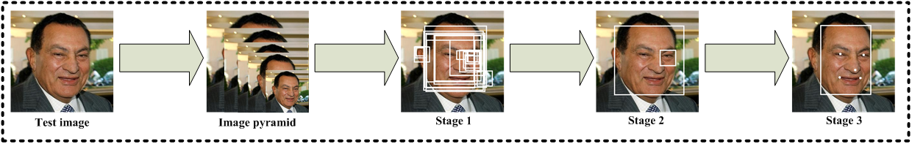  
Figure 2: Bounding box estimation of human faces using MTCNN

The MTCNN is a deep cascaded multi-task framework which exploits the inherent correlation between detection and alignment to boost up their performance. In particular, it leverages a cascaded architecture with three stages of carefully designed deep convolutional networks to predict face and landmark location in a coarse-to-fine manner. The results of the network depend on consistent facial landmarks and the consequent bounding box is a subset of the actual face. For the moment we simply extend the bounding box proportionally to human facial dimensions, assuming that detected faces are reasonably oriented, i.e. the person in generally upright in the image.

### Glasses on Faces

In our sample images we typically have multiple people, each with different orientations. We detect the face and utilize the cropped image with our spatial transformer GAN to splice the glasses onto the face. The resulting face with glasses is reinserted into the test recipient image. Some results using multiple faces and multiple glasses are shown below:

