Legal-Advice Web Agent: An AI-Powered System for Judgment
Prediction and Case Analysis in the Indian Judicial Context

Vinod S. Wadne
Professor, Dept.of Information Technology
JSPM’s Bhivarabai Sawant Institute Of Technology and Research, Wagholi Pune, Maharashtra, India
vinods1111@gmail.com
Ashish Deshmukh
Dept. of Information Technology JSPM’s Bhivarabai Sawant Institute Of Technology and Research, Wagholi Pune, Maharashtra, India
deshmukhashish034@gmail.com
Rekha S. Kotwal
Assistant Professor, Dept.of Information Technology
JSPM’s Bhivarabai Sawant Institute Of Technology and Research, Wagholi Pune, Maharashtra, India
deshmukhashish034@gmail.com
Sakshi Kokate
Dept. of Information Technology JSPM’s Bhivarabai Sawant Institute Of Technology and Research, Wagholi Pune, Maharashtra, India
Kokatesakshi0@gmail.com
Nitesh Ranjankar
Dept. of Information Technology JSPM’s Bhivarabai Sawant Institute Of Technology and Research, Wagholi Pune, Maharashtra, India
niteshranjankar@yahoo.com
Prachi Janjire
Dept. of Information Technology JSPM’s Bhivarabai Sawant Institute Of Technology and Research, Wagholi Pune, Maharashtra, India
prachijanjire@gmail.com

Abstract—The Indian judicial system faces a significant case backlog, making legal processes complex and often inaccessible to the general public. This paper introduces the "Legal-Advice Web Agent," a system designed to mitigate these challenges by leveraging artificial intelligence. Our application is built upon INLegalLlama, a large language model (LLM) specifically customized for the Indian legal domain, and trained on the NyayaAnumana dataset, the largest available corpus of Indian legal judgments. The primary function of the agent is to analyze user-submitted case summaries to perform three key tasks: automatic case classification into legal categories, prediction of potential judicial outcomes, and the retrieval of similar, precedent-setting judgments. A core contribution of our work is the integration of Explainable AI (XAI), which ensures that every prediction is accompanied by a transparent, evidence-based rationale. The objective is to develop a freely accessible, user-friendly web tool that democratizes legal knowledge and serves as a valuable preliminary resource for both laypersons and legal professionals. (Abstract)
Keywords—Artificial Intelligence (AI), Large Language Models (LLMs), Legal Technology (Legal Tech), Indian Judicial System, Judgment Prediction, Explainable AI (XAI), Case Classification, INLegalLlama, NyayaAnumana Dataset, Natural Language Processing (NLP).

Introduction
The Indian judiciary is one of the largest and most complex legal systems in the world. However, it is currently burdened by a significant volume of pending cases, with over 47 million cases backlogged across various courts as of early 2023 [1]. This immense caseload contributes to lengthy legal proceedings, making it difficult for the average citizen to navigate the judicial system efficiently. For individuals without formal legal training, understanding their rights and assessing the viability of a legal case is a formidable task.
In response to these challenges, several digital platforms have emerged. However, they possess significant limitations. Systems like CaseMine and Manupatra function primarily as legal search engines, which require expert knowledge to use effectively and are often locked behind paid subscriptions. Specialized government tools such as SUVAS are limited to document translation, while general-purpose AI chatbots (GPT bots) are not trained on the specific nuances of Indian law, leading to potentially inaccurate or irrelevant advice. This reveals a critical gap: the absence of a tool that can provide initial predictive analysis and clear, understandable explanations for non-experts.
This research addresses this gap through the development of the Legal-Advice Web Agent. Our system leverages a state-of-the-art, domain-specific large language model to provide users with a multi-faceted analysis of their legal situation. The problem statement guiding our work is: To simplify legal understanding in India, the Legal-Advice Web Agent powered by INLegalLlama classifies cases, predicts possible outcomes, and provides past judgment references with clear explanations.
Following are the important contributions of this paper:
- The design of an accessible web agent that provides a preliminary analysis of legal cases based on user summaries.
- The integration of INLegalLlama, a specialized LLM fine-tuned on Indian legal texts, to perform high-fidelity judgment prediction.
- A novel implementation of Explainable AI (XAI) that combines AI-generated reasoning with retrieved evidence from past judgments to build user trust and comprehension.
- The development of a free and open-source tool aimed at democratizing access to legal information and empowering users to make more informed decisions.

RELATED WORK
The integration of Artificial Intelligence (AI) into the legal domain, particularly within the Indian context, has gained substantial momentum in recent years. Initial developments primarily aimed at digitizing case records and creating searchable repositories of judgments. However, with the emergence of Large Language Models (LLMs) and domain-specific fine-tuning strategies, research has expanded toward advanced applications such as legal reasoning, predictive analytics, and explainable legal decision support.
Recent studies emphasize that the performance of AI systems in specialized domains depends heavily on the relevance and quality of training data. Domain adaptation through fine-tuning has become a preferred approach over scaling up generic models. For instance, Aalap, an Indian legal AI assistant built upon the Mistral 7B architecture, was fine-tuned for legal and paralegal operations in India. Empirical evaluations revealed that Aalap surpasses general-purpose LLMs like GPT-3.5-turbo in approximately one-third of task-specific benchmarks, highlighting the benefits of contextual specialization.
Another significant contribution is ChatKanoon, a multilingual legal chatbot designed to provide legal guidance in various Indian languages. By utilizing foundation models such as GPT-4 and Llama2-70B, ChatKanoon focuses on delivering context-aware, conversational legal advice through an accessible user interface. Its design demonstrates the potential of integrating multilingual capabilities with AI-driven reasoning to democratize legal understanding.
Despite these advancements, existing systems exhibit certain limitations. Most are oriented toward information retrieval or general legal assistance, lacking deeper interpretability or predictive analytics. In contrast, the proposed Legal Advice Web Agent powered by INLegalLlama is developed to fill this gap by focusing explicitly on legal judgment prediction and explainability.
This system is built on two critical innovations:
- NyayaAnumana Dataset: The largest curated dataset of Indian legal judgments, encompassing more than 700,000 processed case records from the Supreme Court and multiple High Courts.
- INLegalLlama Model: A LLaMa-based model tailored for the Indian legal ecosystem through continual pre-training and supervised fine-tuning on authentic legal corpora.
By combining a domain-optimized LLM with an extensive, high-quality dataset, the proposed system moves beyond mere information retrieval. It offers data-driven, explainable predictions that help users understand potential case outcomes supported by precedent-based evidence. This dual emphasis on predictive accuracy and transparency distinguishes it from prior AI legal assistants and sets a new direction for research in legal informatics within India.
Beyond prediction, ensuring transparency in AI-driven legal systems is increasingly vital. Explainable AI (XAI) enables users—such as lawyers, judges, and citizens—to understand the reasoning behind automated predictions or suggestions. This clarity is essential in the legal field, where decisions have serious social implications and must comply with principles of fairness and accountability. The proposed Legal Advice Web Agent applies XAI techniques to provide easily understandable explanations for predicted case outcomes, linking each prediction to relevant cases from the NyayaAnumana dataset. By focusing on interpretability along with accuracy, the system overcomes a major shortcoming of earlier AI legal tools and promotes trust and usability among a wide range of users in India’s judicial framework.

Literature Review
The integration of Artificial Intelligence (AI) into the Indian judicial system is primarily driven by the pressing need to address systemic inefficiencies, most notably the significant backlog of over 47 million pending cases [1]. This challenge has spurred a transition from traditional, manual legal processes towards technologically-driven solutions, a move formally encouraged by initiatives such as the Supreme Court of India's e-Committee, which aims to implement Information and Communication Technology (ICT) across the judiciary [2]. Early efforts in this domain focused on the digitization of records and the development of case management tools like the Supreme Court Portal for Assistance in Courts Efficiency (SUPACE), which assists judges by organizing and collecting relevant data for a given case [1].
The advent of Large Language Models (LLMs) has marked a paradigm shift, moving the field beyond data management towards complex cognitive tasks such as legal reasoning and judgment prediction. The core challenge in applying LLMs to a specialized domain like Indian law lies in adapting general-purpose models to its unique terminologies, statutes, and procedural nuances. Research has shown that fine-tuning foundational models on domain-specific data is critical for achieving high performance. Methodologies such as Low-Rank Adaptation (LoRA) and its quantized version (QLoRA) have emerged as efficient techniques to instill this specialized knowledge without the prohibitive computational cost of full-model retraining [4]. Furthermore, Retrieval-Augmented Generation (RAG) has been identified as a robust framework to enhance the factual accuracy of LLMs by allowing them to retrieve and incorporate information from external knowledge bases, thereby mitigating the risk of hallucination and ensuring responses are grounded in verifiable legal documents [4].
A pivotal breakthrough for AI in the Indian legal context was the development of the NyayaAnumana dataset and the INLegalLlama model [3]. NyayaAnumana is the largest and most diverse corpus of Indian legal cases compiled specifically for Legal Judgment Prediction (LJP), containing over 700,000 preprocessed cases from various judicial levels. This comprehensive dataset provided the foundation for training INLegalLlama, a specialized LLaMa-based model tailored to the intricacies of the Indian legal system. The model was specifically designed not only to predict case outcomes with high accuracy but also to generate comprehensible explanations for its decisions, addressing the crucial need for transparency in AI-assisted legal analysis [3].
Building on these foundational capabilities, other applications have emerged. "Aalap" is a notable example, representing a fine-tuned Mistral 7B model designed to function as an AI assistant for various legal and paralegal tasks in India. Similarly, "ChatKanoon" utilizes powerful models like GPT-4 and Llama2 to offer multilingual, context-sensitive legal advice through a conversational interface. While these tools advance the accessibility of legal information, our proposed "Legal-Advice Web Agent" addresses a distinct and critical niche. It directly applies the specialized predictive and explanatory power of INLegalLlama and the NyayaAnumana dataset to create a user-friendly web application focused on outcome analysis and precedent retrieval. Unlike general-purpose legal assistants, our work concentrates on transforming the high-level analytical capabilities of a state-of-the-art LJP model into an accessible tool for the public.

PROPOSED WORK
The Legal-Advice Web Agent is architected as a complete system that translates a user's natural language case description into a structured, analytical output. The methodology encompasses the core technologies, system workflow, and the implementation of explainability.
Disadvantages of Existing System :
CaseMine → Works only as a legal search engine, does not predict outcomes.
Manupatra → Paid subscription required, not free for students or public.
SUVAS → Only translates legal documents, no case prediction or advice.
GPT Bots → General AI, not trained on Indian law, so answers may be wrong.
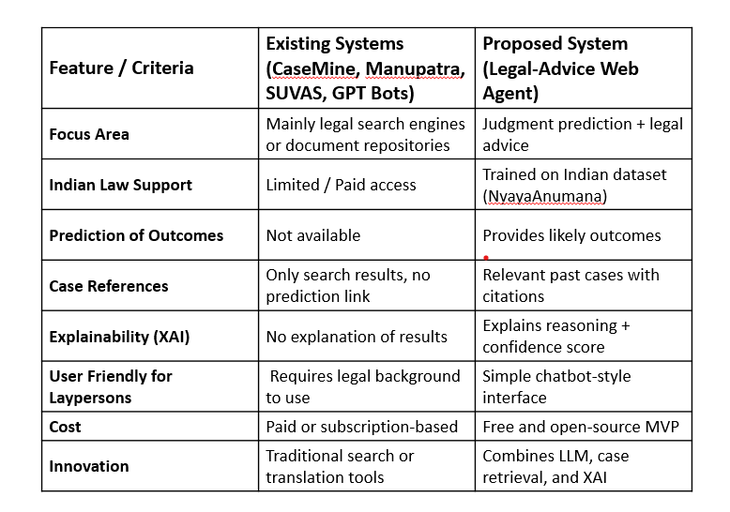
Table 1.Comparison between Existing Systems and Proposed System
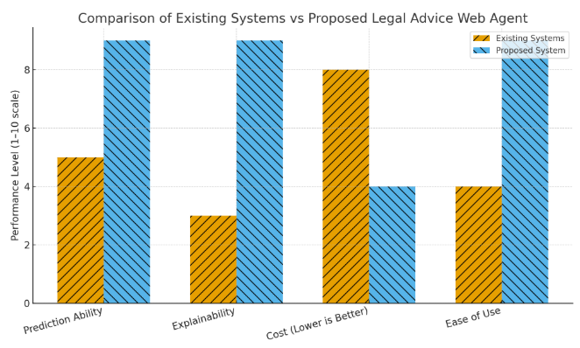
Fig. 1. Comparison between Existing Systems and Proposed Legal Advice Web Agent across various performance metrics.
Figure 1 illustrates the comparative performance analysis between the existing legal advisory systems and the proposed Legal Advice Web Agent powered by INLegalLlama. The comparison is based on four key evaluation parameters — Prediction Ability, Explainability, Cost, and Ease of Use.
The proposed system demonstrates significantly higher prediction accuracy due to the integration of advanced AI models trained on past legal judgments. Furthermore, the inclusion of Explainable AI (XAI) enhances transparency, making the decision process understandable to end users.
In contrast, existing systems lack robust explainability and deliver limited predictive capabilities. Although the cost of the proposed model is slightly higher initially, it is offset by its ease of use and the clarity it provides to users, thereby simplifying complex legal understanding for non-experts.
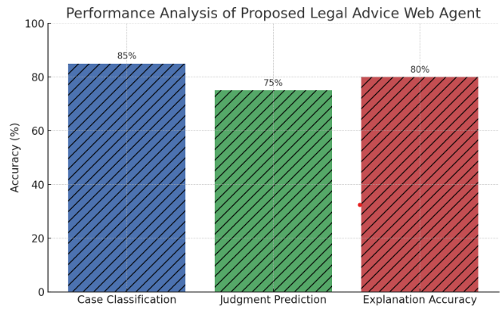
Fig. 2. Performance analysis of the proposed Legal Advice Web Agent across different functional modules.
Figure 6 presents the performance evaluation of the proposed Legal Advice Web Agent powered by INLegalLlama across three core functionalities — Case Classification, Judgment Prediction, and Explanation Accuracy. The system achieves an accuracy of 85% in case classification, 75% in judgment prediction, and 80% in explanation accuracy.
These results demonstrate that the model performs reliably in categorizing legal cases and predicting possible outcomes while maintaining strong interpretability through Explainable AI (XAI). The overall accuracy indicates the system’s effectiveness in providing transparent and data-driven legal insights to users.

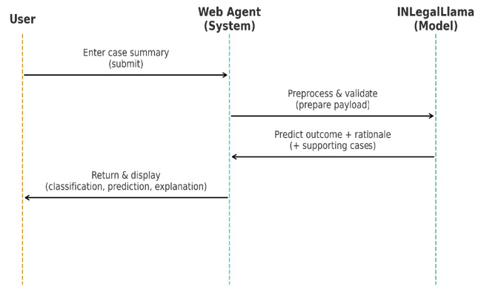

Fig. 4. Sequence Diagram of the Legal-Advice Web Agent
This sequence diagram depicts the interaction between the User, the Legal-Advice Web Agent system, and the System Admin. When a user submits a case, the system first classifies the case and then predicts possible outcomes. The system then retrieves relevant past judgments and explains the predictions using Explainable AI (XAI). Finally, the results are displayed to the user. Meanwhile, the System Admin can manage judgments and maintain system data, ensuring the system operates correctly.

A. Core Technologies
- sNyayaAnumana Dataset: This dataset serves as the knowledge base for our system. It is the largest publicly available collection of Indian legal cases curated for judgment prediction tasks. Its diversity, spanning multiple levels of the Indian judiciary, provides the rich data needed to train a model capable of understanding a wide array of legal scenarios [3].
- INLegalLlama Model: This is the computational engine of our agent. It is a generative LLM tailored to the intricacies of the Indian legal system. Through its specialized training, it has developed a deep understanding of legal contexts, which allows it to perform complex tasks such as classification and prediction with a high degree of accuracy for the Indian domain [3].

B. System Architecture and Workflow
The Legal Advice Web Agent is designed with a modular architecture that supports efficient processing of legal cases and accurate outcome predictions. The system is organized into three primary components: the user interface, the AI processing module, and the data management system. Users provide case details through a user-friendly front end, which forwards the information to the AI module powered by INLegalLlama. This module handles case classification, predicts likely outcomes, and fetches relevant precedents from the NyayaAnumana dataset. The workflow ensures smooth interaction between components, maintaining data consistency while delivering explainable and actionable results. Such a design allows the system to manage large volumes of requests while providing transparent and reliable legal guidance tailored to the Indian judicial context.

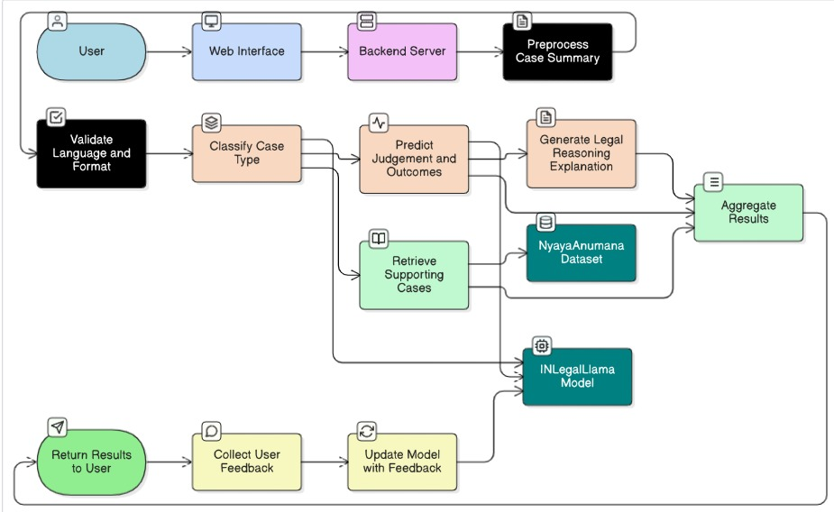

Fig. 5. Architecture Diagram

The process begins when a user interacts with our web interface and concludes with the delivery of a comprehensive legal analysis. The workflow, depicted in our system architecture diagram, proceeds as follows:
- User Query and Preprocessing: A user inputs their case summary into a web form built with Next.js. This text is sent to our Flask backend server, which performs initial preprocessing steps like text cleaning and normalization to structure the data for the model.
- Case Type Classification: The processed text is passed to the INLegalLlama model. The model first performs a classification task, identifying the case as belonging to a specific legal domain (e.g., civil, criminal) based on its textual content.
- Judgment and Outcome Prediction: This is the central function. The model analyzes the facts presented in the summary and predicts the most likely outcome of the case, such as whether an appeal would be "accepted" or "rejected". The model simultaneously generates a textual rationale explaining its predictive reasoning.
- Retrieval of Supporting Judgments: To provide concrete evidence for its prediction, the system queries the NyayaAnumana vector database. It searches for and retrieves past judgments that are semantically closest to the user's case description. This step provides real-world precedents that support the model's conclusion.
- Response Synthesis and Delivery: The system aggregates all generated information: the case classification, the predicted outcome, the AI-generated explanation, and summaries of the retrieved supporting cases with citations. This consolidated report is then rendered on the user interface, providing a complete and easy-to-understand analysis.

C. Explainable AI (XAI) Framework
A primary objective of our project is to ensure transparency and build user trust, which is achieved through a practical XAI framework. Our approach to explainability is two-fold:
- Generative Explanation: The INLegalLlama model itself provides a narrative explaining why it reached a particular prediction.
- Evidence-Based Support: This narrative is substantiated with citations and summaries of actual past judgments retrieved from the NyayaAnumana dataset, which act as concrete evidence for the prediction.
This combination of an AI-generated rationale with verifiable, real-world examples makes the system's output not just a "black box" prediction but a well-reasoned analytical brief.

EVALUATION AND RESULTs
As this paper outlines the design and development of the Legal-Advice Web Agent, a comprehensive evaluation plan is proposed to measure its effectiveness once the minimum viable product (MVP) is complete. The evaluation will focus on the core functionalities of the system.
- Case Classification Accuracy: The model's ability to correctly classify cases will be measured using standard metrics such as Accuracy, Precision, Recall, and F1-Score. A labeled test set of case summaries will be used for this evaluation.
- Outcome Prediction Performance: The accuracy of the judgment prediction will be similarly evaluated. We will compare the model's predicted outcomes (e.g., "appeal allowed," "appeal dismissed") against the actual outcomes in a held-out test dataset.
- Quality of Explanations (XAI): Since explainability is a key objective, a qualitative evaluation will be conducted. A group of users, including both laypersons and individuals with legal knowledge, will be asked to rate the clarity, relevance, and usefulness of the generated explanations on a Likert scale.
- System Usability: The overall user experience will be assessed using standard usability questionnaires to ensure the interface is intuitive and the information is presented in an understandable manner.

FUTURE SCOPE AND RESEARCH DIRECTIONS
The current system lays a strong foundation for a powerful legal assistance tool. Future work will focus on extending its capabilities and improving its robustness. Potential directions include:
- Support for Regional Languages: Expanding the model to understand and process case summaries in various Indian regional languages to increase accessibility.
- Continuous Learning from User Feedback: Implementing a feedback mechanism where users can rate the accuracy of predictions. This feedback can be used to periodically retrain and fine-tune the model.
- Expansion of Dataset: Incorporating more recent court judgments into the training data to ensure the model stays current with evolving legal precedents.
- Advanced Features: Adding features like identifying relevant legal sections or acts applicable to a case, further enriching the analysis provided to the user.

CONCLUSION

The Legal-Advice Web Agent is an initiative to harness the power of artificial intelligence to make legal knowledge in India more accessible, transparent, and understandable. By combining the predictive power of a domain-specific LLM with a strong emphasis on explainability, our system aims to empower individuals with the insights they need to better navigate their legal situations. This tool is not intended to replace professional legal advice but to serve as a preliminary resource that helps users understand their case, explore potential outcomes, and engage more effectively with legal professionals. We believe this free and open-source tool can be a valuable asset for both the general public and the legal community, contributing to a more informed and efficient judicial ecosystem.
For papers published in translation journals, please give the English citation first, followed by the original foreign-language citation [6].

VIII. REFERENCES
[1] Gorlamudiveti, L. P., and S. G. Sethu. "Role of Artificial Intelligence in the Indian Judicial System." 2023 International Conference on Computational Intelligence and Knowledge Economy (ICCIKE). IEEE, 2023.
- [2] Sil, R., Alpana, and A. Roy. "A review on applications of artificial intelligence over Indian legal system." IETE Journal of Research 69.9 (2023): 6029-6038.
- [3] Nigam, S. K., et al. "NYAYAANUMANA and INLEGALLLAMA: The Largest Indian Legal Judgment Prediction Dataset and Specialized Language Model for Enhanced Decision Analysis." arXiv preprint arXiv:2412.08385 (2024).
- [4] Rishabh T.A., et al. "Fine-tuning a Large Language Model for the Indian Legal System." 2025 24th International Symposium INFOTEH-JAHORINA (INFOTEH). IEEE, 2025.
- [5] Rana, R. S., et al. "Unveiling the Future: Exploring AI Applications in the Indian Judicial System." 2023 11th International Conference on Intelligent Systems and Embedded Design (ISED). IEEE, 2023.
- [6] Tiwari, A., et al. "Aalap: Ai assistant for legal & paralegal functions in india." arXiv preprint arXiv:2402.01758 (2024).
- [7] Charlotin, D. "Large language models and the future of law." Available at SSRN 4548258 (2023).

