db.CSE.insertOne({
title: "Post Title 1",
body: "Body of post.",
category: "News",
likes: 1,
tags: ["news", "events"],
date: Date()
})
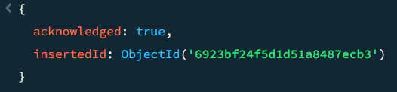
db.CSE.find()
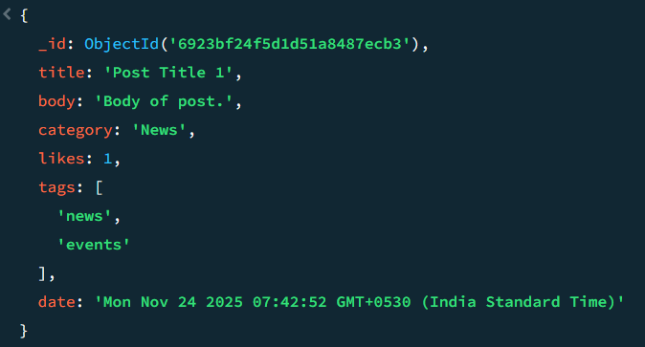
db.posts.insertMany([
{
title: "Post Title 2",
body: "Body of post.",
category: "Event",
likes: 2,
tags: ["news", "events"],
date: Date()
},
{
title: "Post Title 3",
body: "Body of post.",
category: "Technology",
likes: 3,
tags: ["news", "events"],
date: Date()
},
{
title: "Post Title 4",
body: "Body of post.",
category: "Event",
likes: 4,
tags: ["news", "events"],
date: Date()
}
])
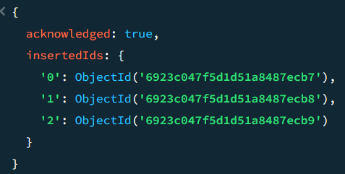

db.CSE.find({likes:4})
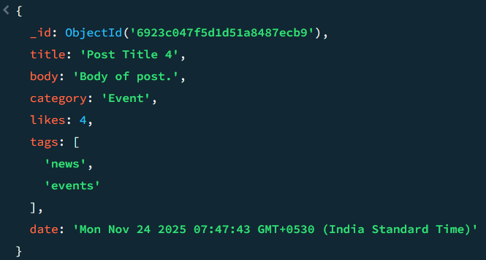

db.CSE.find({likes:4}, {title: 1, date: 1})
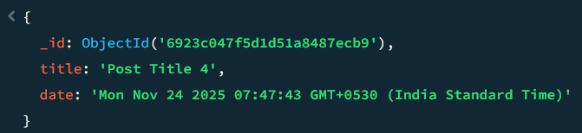

db.CSE.find({}, {title: 1, date: 1})
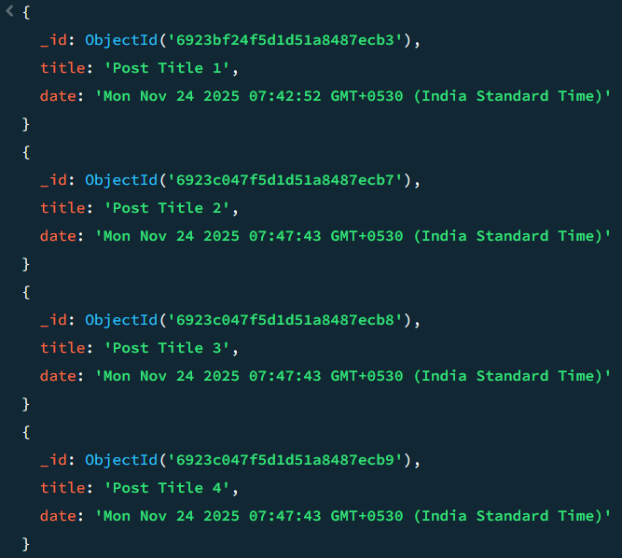

db.CSE.find({}, {_id: 0, title: 1, date: 1})
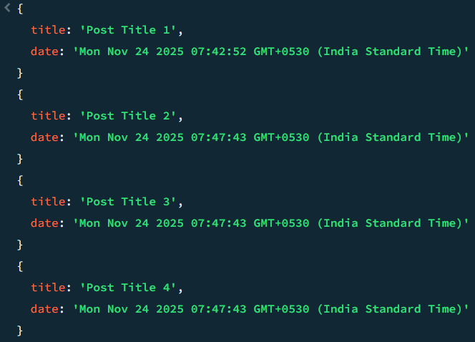
db.CSE.updateOne( { title: "Post Title 1" }, { $set: { likes: 20 } } )
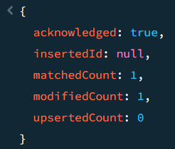

db.posts.updateOne(
{ title: "Post Title 5" },
{
$set:
{
title: "Post Title 5",
body: "Body of post.",
category: "Event",
likes: 5,
tags: ["news", "events"],
date: Date()
}
},
{ upsert: true }
)
