(for array based)
db.products.insertMany([
{ "_id" : 1, "name" : "xPhone", "price" : 799, "releaseDate" : ISODate("2011-05-14T00:00:00Z"), "spec" : { "ram" : 4, "screen" : 6.5, "cpu" : 2.66 }, "color" : [ "white", "black" ], "storage" : [ 64, 128, 256 ] },
{ "_id" : 2, "name" : "xTablet", "price" : 899, "releaseDate" : ISODate("2011-09-01T00:00:00Z"), "spec" : { "ram" : 16, "screen" : 9.5, "cpu" : 3.66 }, "color" : [ "white", "black", "purple" ], "storage" : [ 128, 256, 512 ] },
{ "_id" : 3, "name" : "SmartTablet", "price" : 899, "releaseDate" : ISODate("2015-01-14T00:00:00Z"), "spec" : { "ram" : 12, "screen" : 9.7, "cpu" : 3.66 }, "color" : [ "blue" ], "storage" : [ 16, 64, 128 ] },
{ "_id" : 4, "name" : "SmartPad", "price" : 699, "releaseDate" : ISODate("2020-05-14T00:00:00Z"), "spec" : { "ram" : 8, "screen" : 9.7, "cpu" : 1.66 }, "color" : [ "white", "orange", "gold", "gray" ], "storage" : [ 128, 256, 1024 ] },
{ "_id" : 5, "name" : "SmartPhone", "price" : 599, "releaseDate" : ISODate("2022-09-14T00:00:00Z"), "spec" : { "ram" : 4, "screen" : 9.7, "cpu" : 1.66 }, "color" : [ "white", "orange", "gold", "gray" ], "storage" : [ 128, 256 ] },
{ "_id" : 6, "name" : "xWidget", "spec" : { "ram" : 64, "screen" : 9.7, "cpu" : 3.66 }, "color" : [ "black" ], "storage" : [ 1024 ] }
])
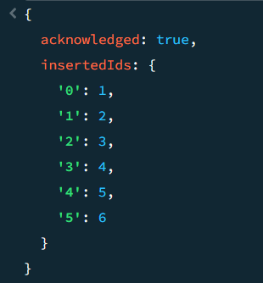
db.products.find({
color: {
$size: 2
}
}, {
name: 1,
color: 1
})
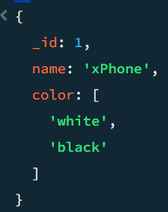

(for $all)
db.products.insertMany([
{ "_id" : 1, "name" : "xPhone", "price" : 799, "releaseDate" : ISODate("2011-05-14T00:00:00Z"), "spec" : { "ram" : 4, "screen" : 6.5, "cpu" : 2.66 }, "color" : [ "white", "black" ], "storage" : [ 64, 128, 256 ] },
{ "_id" : 2, "name" : "xTablet", "price" : 899, "releaseDate" : ISODate("2011-09-01T00:00:00Z"), "spec" : { "ram" : 16, "screen" : 9.5, "cpu" : 3.66 }, "color" : [ "white", "black", "purple" ], "storage" : [ 128, 256, 512 ] },
{ "_id" : 3, "name" : "SmartTablet", "price" : 899, "releaseDate" : ISODate("2015-01-14T00:00:00Z"), "spec" : { "ram" : 12, "screen" : 9.7, "cpu" : 3.66 }, "color" : [ "blue" ], "storage" : [ 16, 64, 128 ] },
{ "_id" : 4, "name" : "SmartPad", "price" : 699, "releaseDate" : ISODate("2020-05-14T00:00:00Z"), "spec" : { "ram" : 8, "screen" : 9.7, "cpu" : 1.66 }, "color" : [ "white", "orange", "gold", "gray" ], "storage" : [ 128, 256, 1024 ] },
{ "_id" : 5, "name" : "SmartPhone", "price" : 599, "releaseDate" : ISODate("2022-09-14T00:00:00Z"), "spec" : { "ram" : 4, "screen" : 9.7, "cpu" : 1.66 }, "color" : [ "white", "orange", "gold", "gray" ], "storage" : [ 128, 256 ] }
])
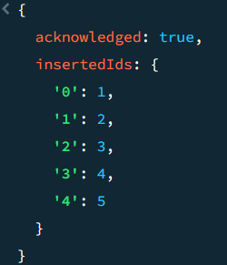
db.products.find({
color: {
$all: ["black", "white"]
}
}, {
name: 1,
color: 1
})
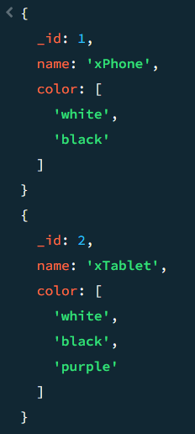

(for $elematch)
db.products.insertMany([
{ "_id" : 1, "name" : "xPhone", "price" : 799, "releaseDate" : ISODate("2011-05-14T00:00:00Z"), "spec" : { "ram" : 4, "screen" : 6.5, "cpu" : 2.66 }, "color" : [ "white", "black" ], "storage" : [ 64, 128, 256 ] },
{ "_id" : 2, "name" : "xTablet", "price" : 899, "releaseDate" : ISODate("2011-09-01T00:00:00Z"), "spec" : { "ram" : 16, "screen" : 9.5, "cpu" : 3.66 }, "color" : [ "white", "black", "purple" ], "storage" : [ 128, 256, 512 ] },
{ "_id" : 3, "name" : "SmartTablet", "price" : 899, "releaseDate" : ISODate("2015-01-14T00:00:00Z"), "spec" : { "ram" : 12, "screen" : 9.7, "cpu" : 3.66 }, "color" : [ "blue" ], "storage" : [ 16, 64, 128 ] },
{ "_id" : 4, "name" : "SmartPad", "price" : 699, "releaseDate" : ISODate("2020-05-14T00:00:00Z"), "spec" : { "ram" : 8, "screen" : 9.7, "cpu" : 1.66 }, "color" : [ "white", "orange", "gold", "gray" ], "storage" : [ 128, 256, 1024 ] },
{ "_id" : 5, "name" : "SmartPhone", "price" : 599, "releaseDate" : ISODate("2022-09-14T00:00:00Z"), "spec" : { "ram" : 4, "screen" : 9.7, "cpu" : 1.66 }, "color" : [ "white", "orange", "gold", "gray" ], "storage" : [ 128, 256 ] }
])
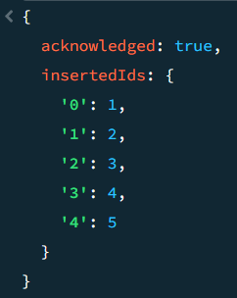
db.products.find({
storage: {
$elemMatch: {
$lt: 128
}
}
}, {
name: 1,
storage: 1
})
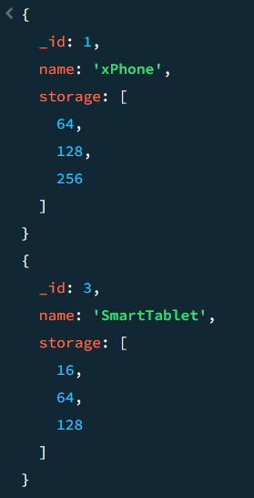

(For $sorting)
db.products.insertMany([
{ "_id" : 1, "name" : "xPhone", "price" : 799, "releaseDate" : ISODate("2011-05-14T00:00:00Z"), "spec" : { "ram" : 4, "screen" : 6.5, "cpu" : 2.66 }, "color" : [ "white", "black" ], "storage" : [ 64, 128, 256 ] },
{ "_id" : 2, "name" : "xTablet", "price" : 899, "releaseDate" : ISODate("2011-09-01T00:00:00Z"), "spec" : { "ram" : 16, "screen" : 9.5, "cpu" : 3.66 }, "color" : [ "white", "black", "purple" ], "storage" : [ 128, 256, 512 ] },
{ "_id" : 3, "name" : "SmartTablet", "price" : 899, "releaseDate" : ISODate("2015-01-14T00:00:00Z"), "spec" : { "ram" : 12, "screen" : 9.7, "cpu" : 3.66 }, "color" : [ "blue" ], "storage" : [ 16, 64, 128 ] },
{ "_id" : 4, "name" : "SmartPad", "price" : 699, "releaseDate" : ISODate("2020-05-14T00:00:00Z"), "spec" : { "ram" : 8, "screen" : 9.7, "cpu" : 1.66 }, "color" : [ "white", "orange", "gold", "gray" ], "storage" : [ 128, 256, 1024 ] },
{ "_id" : 5, "name" : "SmartPhone", "price" : 599, "releaseDate" : ISODate("2022-09-14T00:00:00Z"), "spec" : { "ram" : 4, "screen" : 9.7, "cpu" : 1.66 }, "color" : [ "white", "orange", "gold", "gray" ], "storage" : [ 128, 256 ] },
{ "_id" : 6, "name" : "xWidget", "spec" : { "ram" : 64, "screen" : 9.7, "cpu" : 3.66 }, "color" : [ "black" ], "storage" : [ 1024 ] },
{ "_id" : 7, "name" : "xReader", "price" : null, "spec" : { "ram" : 64, "screen" : 6.7, "cpu" : 3.66 }, "color" : [ "black", "white" ], "storage" : [ 128 ] }
])
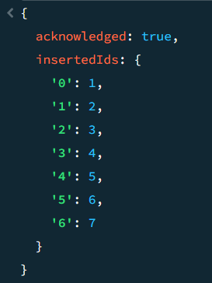
db.products.find({
'price': {
$exists: 1
}
}, {
name: 1,
price: 1
}).sort({
price: 1,
name: 1
})
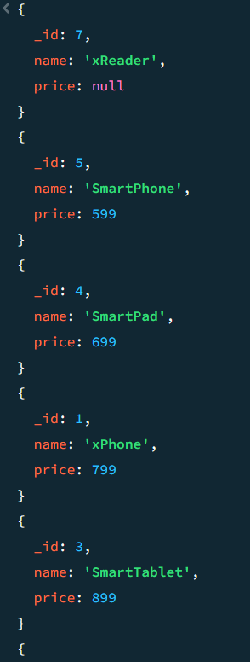
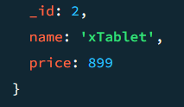
db.products.find({
'price': {
$exists: 1
}
}, {
name: 1,
price: 1
}).sort({
price: 1,
name: -1
})
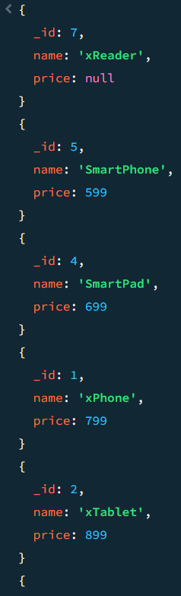
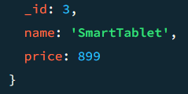
db.products.find({
'releaseDate': {
$exists: 1
}
}, {
name: 1,
releaseDate: 1
}).sort({
releaseDate: 1
})
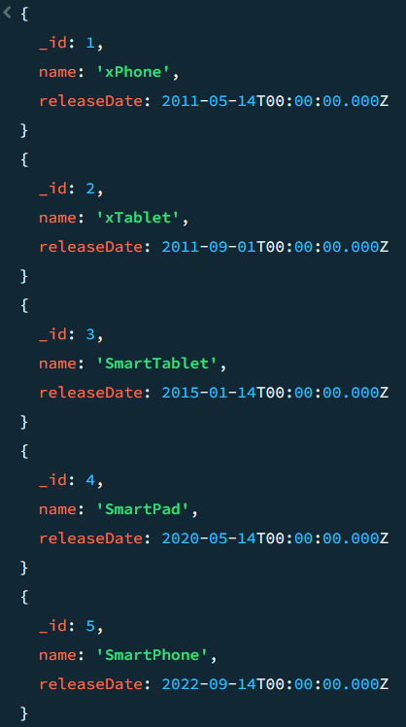

db.products.find({}, {
name: 1,
spec: 1
}).sort({
"spec.ram": 1
});
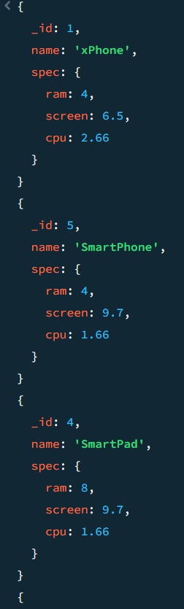
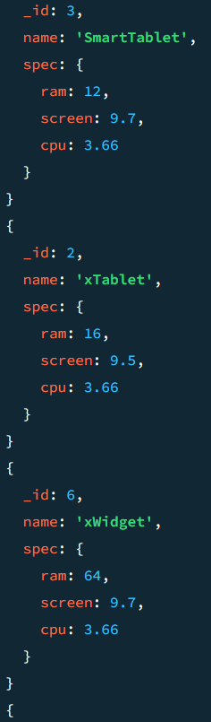
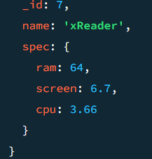
($limit)
db.products.insertMany([
{ "_id" : 1, "name" : "xPhone", "price" : 799, "releaseDate" : ISODate("2011-05-14T00:00:00Z"), "spec" : { "ram" : 4, "screen" : 6.5, "cpu" : 2.66 }, "color" : [ "white", "black" ], "storage" : [ 64, 128, 256 ] },
{ "_id" : 2, "name" : "xTablet", "price" : 899, "releaseDate" : ISODate("2011-09-01T00:00:00Z"), "spec" : { "ram" : 16, "screen" : 9.5, "cpu" : 3.66 }, "color" : [ "white", "black", "purple" ], "storage" : [ 128, 256, 512 ] },
{ "_id" : 3, "name" : "SmartTablet", "price" : 899, "releaseDate" : ISODate("2015-01-14T00:00:00Z"), "spec" : { "ram" : 12, "screen" : 9.7, "cpu" : 3.66 }, "color" : [ "blue" ], "storage" : [ 16, 64, 128 ] },
{ "_id" : 4, "name" : "SmartPad", "price" : 699, "releaseDate" : ISODate("2020-05-14T00:00:00Z"), "spec" : { "ram" : 8, "screen" : 9.7, "cpu" : 1.66 }, "color" : [ "white", "orange", "gold", "gray" ], "storage" : [ 128, 256, 1024 ] },
{ "_id" : 5, "name" : "SmartPhone", "price" : 599, "releaseDate" : ISODate("2022-09-14T00:00:00Z"), "spec" : { "ram" : 4, "screen" : 9.7, "cpu" : 1.66 }, "color" : [ "white", "orange", "gold", "gray" ], "storage" : [ 128, 256 ] },
{ "_id" : 6, "name" : "xWidget", "spec" : { "ram" : 64, "screen" : 9.7, "cpu" : 3.66 }, "color" : [ "black" ], "storage" : [ 1024 ] },
{ "_id" : 7, "name" : "xReader", "price" : null, "spec" : { "ram" : 64, "screen" : 6.7, "cpu" : 3.66 }, "color" : [ "black", "white" ], "storage" : [ 128 ] }
])
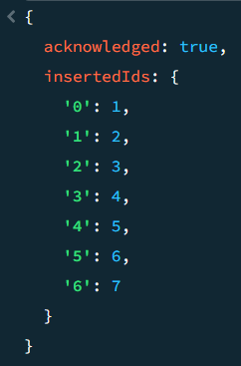
db.products.find({}, {
name: 1,
price: 1
}).sort({
price: -1
}).limit(1);
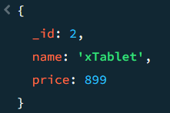
db.products.find({}, {
name: 1,
price: 1
}).sort({
price: -1,
name: 1
}).limit(2);
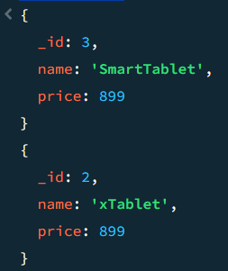
db.products.find({}, {
name: 1,
price: 1
}).sort({
price: -1,
name: 1
}).skip(2).limit(2);
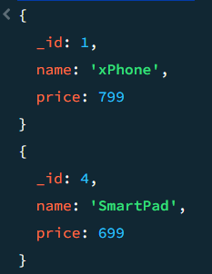

(for $inc)
db.products.insertMany([
{ "_id" : 1, "name" : "xPhone", "price" : 799, "releaseDate": ISODate("2011-05-14"), "spec" : { "ram" : 4, "screen" : 6.5, "cpu" : 2.66 },"color":["white","black"],"storage":[64,128,256]},
{ "_id" : 2, "name" : "xTablet", "price" : 899, "releaseDate": ISODate("2011-09-01") , "spec" : { "ram" : 16, "screen" : 9.5, "cpu" : 3.66 },"color":["white","black","purple"],"storage":[128,256,512]},
{ "_id" : 3, "name" : "SmartTablet", "price" : 899, "releaseDate": ISODate("2015-01-14"), "spec" : { "ram" : 12, "screen" : 9.7, "cpu" : 3.66 },"color":["blue"],"storage":[16,64,128]},
{ "_id" : 4, "name" : "SmartPad", "price" : 699, "releaseDate": ISODate("2020-05-14"),"spec" : { "ram" : 8, "screen" : 9.7, "cpu" : 1.66 },"color":["white","orange","gold","gray"],"storage":[128,256,1024]},
{ "_id" : 5, "name" : "SmartPhone", "price" : 599,"releaseDate": ISODate("2022-09-14"), "spec" : { "ram" : 4, "screen" : 5.7, "cpu" : 1.66 },"color":["white","orange","gold","gray"],"storage":[128,256]}
])
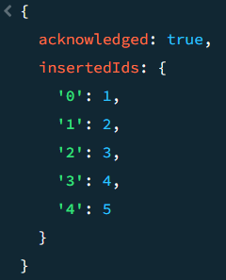
db.products.updateOne({
_id: 1
}, {
$inc: {
price: -150
}
})
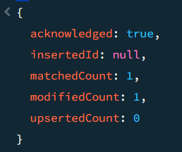
db.products.updateOne({
_id: 1
}, {
$inc: {
price: 50,
"spec.ram": 4
}
})
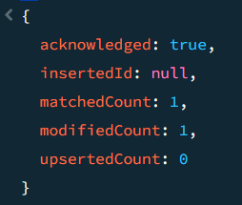

(For Min with update)
db.products.insertMany([
{ "_id" : 1, "name" : "xPhone", "price" : 799, "releaseDate": ISODate("2011-05-14"), "spec" : { "ram" : 4, "screen" : 6.5, "cpu" : 2.66 },"color":["white","black"],"storage":[64,128,256]},
{ "_id" : 2, "name" : "xTablet", "price" : 899, "releaseDate": ISODate("2011-09-01") , "spec" : { "ram" : 16, "screen" : 9.5, "cpu" : 3.66 },"color":["white","black","purple"],"storage":[128,256,512]},
{ "_id" : 3, "name" : "SmartTablet", "price" : 899, "releaseDate": ISODate("2015-01-14"), "spec" : { "ram" : 12, "screen" : 9.7, "cpu" : 3.66 },"color":["blue"],"storage":[16,64,128]},
{ "_id" : 4, "name" : "SmartPad", "price" : 699, "releaseDate": ISODate("2020-05-14"),"spec" : { "ram" : 8, "screen" : 9.7, "cpu" : 1.66 },"color":["white","orange","gold","gray"],"storage":[128,256,1024]},
{ "_id" : 5, "name" : "SmartPhone", "price" : 599,"releaseDate": ISODate("2022-09-14"), "spec" : { "ram" : 4, "screen" : 5.7, "cpu" : 1.66 },"color":["white","orange","gold","gray"],"storage":[128,256]}
])
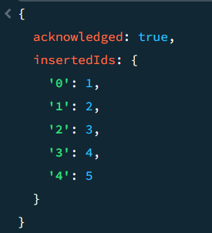

db.products.updateOne({
_id: 5
}, {
$min: {
price: 699
}
})
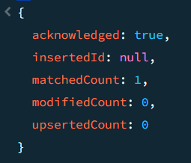
db.products.updateOne({ _id: 5}, {$mul: {price: 1.1}})
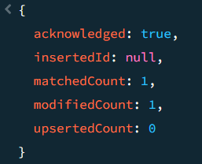
db.products.updateOne({
_id: 1
}, {
$mul: {
"storage.0": 2,
"storage.1": 2,
"storage.2": 2
}
})
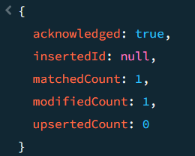
db.products.updateOne({
_id: 1
}, {
$unset: {
price: ""
}
})
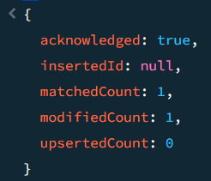
db.products.updateMany({}, {
$unset: {
"spec.ram": ""
}
})
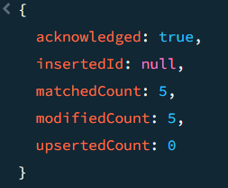
db.products.updateMany({}, {
$unset: {
releaseDate: "",
spec: ""
}
})
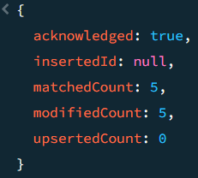

(for $rename)
db.products.insertMany([
{ "_id" : 1, "nmea" : "xPhone", "price" : 799, "releaseDate": ISODate("2011-05-14"), "spec" : { "ram" : 4, "screen" : 6.5, "cpu" : 2.66 },"color":["white","black"],"storage":[64,128,256]},
{ "_id" : 2, "nmea" : "xTablet", "price" : 899, "releaseDate": ISODate("2011-09-01") , "spec" : { "ram" : 16, "screen" : 9.5, "cpu" : 3.66 },"color":["white","black","purple"],"storage":[128,256,512]},
{ "_id" : 3, "nmea" : "SmartTablet", "price" : 899, "releaseDate": ISODate("2015-01-14"), "spec" : { "ram" : 12, "screen" : 9.7, "cpu" : 3.66 },"color":["blue"],"storage":[16,64,128]},
{ "_id" : 4, "nmea" : "SmartPad", "price" : 699, "releaseDate": ISODate("2020-05-14"),"spec" : { "ram" : 8, "screen" : 9.7, "cpu" : 1.66 },"color":["white","orange","gold","gray"],"storage":[128,256,1024]},
{ "_id" : 5, "nmea" : "SmartPhone", "price" : 599,"releaseDate": ISODate("2022-09-14"), "spec" : { "ram" : 4, "screen" : 5.7, "cpu" : 1.66 },"color":["white","orange","gold","gray"],"storage":[128,256]}
])
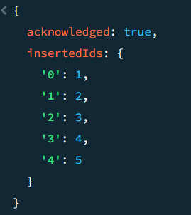
db.products.updateMany({}, {
$rename: {
nmea: "name"
}
})
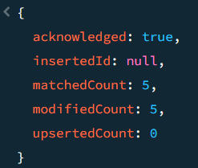
db.products.updateMany({}, {
$rename:{
"spec.screen": "spec.screenSize"
}
})
