db.products.insertMany([
{ "_id" : 1, "nmea" : "xPhone", "price" : 799, "releaseDate": ISODate("2011-05-14"), "spec" : { "ram" : 4, "screen" : 6.5, "cpu" : 2.66 },"color":["white","black"],"storage":[64,128,256]},
{ "_id" : 2, "nmea" : "xTablet", "price" : 899, "releaseDate": ISODate("2011-09-01") , "spec" : { "ram" : 16, "screen" : 9.5, "cpu" : 3.66 },"color":["white","black","purple"],"storage":[128,256,512]},
{ "_id" : 3, "nmea" : "SmartTablet", "price" : 899, "releaseDate": ISODate("2015-01-14"), "spec" : { "ram" : 12, "screen" : 9.7, "cpu" : 3.66 },"color":["blue"],"storage":[16,64,128]},
{ "_id" : 4, "nmea" : "SmartPad", "price" : 699, "releaseDate": ISODate("2020-05-14"),"spec" : { "ram" : 8, "screen" : 9.7, "cpu" : 1.66 },"color":["white","orange","gold","gray"],"storage":[128,256,1024]},
{ "_id" : 5, "nmea" : "SmartPhone", "price" : 599,"releaseDate": ISODate("2022-09-14"), "spec" : { "ram" : 4, "screen" : 5.7, "cpu" : 1.66 },"color":["white","orange","gold","gray"],"storage":[128,256]}
])
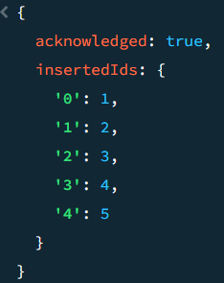
db.products.updateMany(
{ _id: 6},
{$set: {price: 999}},
{upsert: true}
)
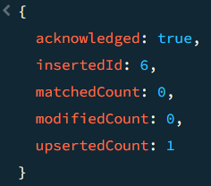

(for aggre)
db.sales.insertMany([
{ "_id" : 1, "item" : "Americanos", "price" : 5, "size": "Short", "quantity" : 22, "date" : ISODate("2022-01-15T08:00:00Z") },
{ "_id" : 2, "item" : "Cappuccino", "price" : 6, "size": "Short","quantity" : 12, "date" : ISODate("2022-01-16T09:00:00Z") },
{ "_id" : 3, "item" : "Lattes", "price" : 15, "size": "Grande","quantity" : 25, "date" : ISODate("2022-01-16T09:05:00Z") },
{ "_id" : 4, "item" : "Mochas", "price" : 25,"size": "Tall", "quantity" : 11, "date" : ISODate("2022-02-17T08:00:00Z") },
{ "_id" : 5, "item" : "Americanos", "price" : 10, "size": "Grande","quantity" : 12, "date" : ISODate("2022-02-18T21:06:00Z") },
{ "_id" : 6, "item" : "Cappuccino", "price" : 7, "size": "Tall","quantity" : 20, "date" : ISODate("2022-02-20T10:07:00Z") },
{ "_id" : 7, "item" : "Lattes", "price" : 25,"size": "Tall", "quantity" : 30, "date" : ISODate("2022-02-21T10:08:00Z") },
{ "_id" : 8, "item" : "Americanos", "price" : 10, "size": "Grande","quantity" : 21, "date" : ISODate("2022-02-22T14:09:00Z") },
{ "_id" : 9, "item" : "Cappuccino", "price" : 10, "size": "Grande","quantity" : 17, "date" : ISODate("2022-02-23T14:09:00Z") },
{ "_id" : 10, "item" : "Americanos", "price" : 8, "size": "Tall","quantity" : 15, "date" : ISODate("2022-02-25T14:09:00Z")}
]);
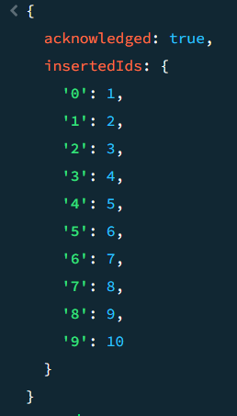
db.sales.aggregate([
{
$match: { item: "Americanos" }
},
{
$group: {
_id: "$size",
totalQty: {$sum: "$quantity"}
}
},
{
$sort: { totalQty : -1}
}
]);
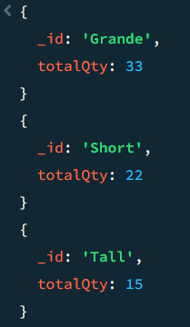
db.sales.aggregate([
{
$group: {
_id: '$item',
averageQty: {$avg: '$quantity'},
},
},
]);
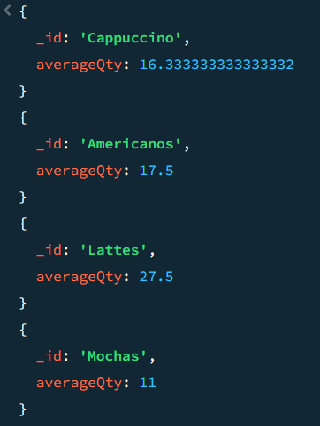

db.sales.aggregate([
{
$group: {
_id: '$item',
averageAmount: { $avg: { $multiply: ['$quantity', '$price'] } },
},
},
{ $match: { averageAmount: { $gt: 150 } } },
{ $sort: { averageAmount: 1 } },
]);
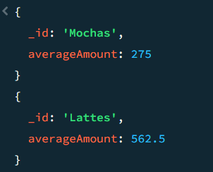

db.sales.insertMany([
{ "_id" : 1, "item" : "Americanos", "price" : 5, "size": "Short", "quantity" : 22, "date" : ISODate("2022-01-15T08:00:00Z") },
{ "_id" : 2, "item" : "Cappuccino", "price" : 6, "size": "Short","quantity" : 12, "date" : ISODate("2022-01-16T09:00:00Z") },
{ "_id" : 3, "item" : "Lattes", "price" : 15, "size": "Grande","quantity" : 25, "date" : ISODate("2022-01-16T09:05:00Z") },
{ "_id" : 4, "item" : "Mochas", "price" : 25,"size": "Tall", "quantity" : 11, "date" : ISODate("2022-02-17T08:00:00Z") },
{ "_id" : 5, "item" : "Americanos", "price" : 10, "size": "Grande","quantity" : 12, "date" : ISODate("2022-02-18T21:06:00Z") },
{ "_id" : 6, "item" : "Cappuccino", "price" : 7, "size": "Tall","quantity" : 20, "date" : ISODate("2022-02-20T10:07:00Z") },
{ "_id" : 7, "item" : "Lattes", "price" : 25,"size": "Tall", "quantity" : 30, "date" : ISODate("2022-02-21T10:08:00Z") },
{ "_id" : 8, "item" : "Americanos", "price" : 10, "size": "Grande","quantity" : 21, "date" : ISODate("2022-02-22T14:09:00Z") },
{ "_id" : 9, "item" : "Cappuccino", "price" : 10, "size": "Grande","quantity" : 17, "date" : ISODate("2022-02-23T14:09:00Z") },
{ "_id" : 10, "item" : "Americanos", "price" : 8, "size": "Tall","quantity" : 15, "date" : ISODate("2022-02-25T14:09:00Z")}
]);
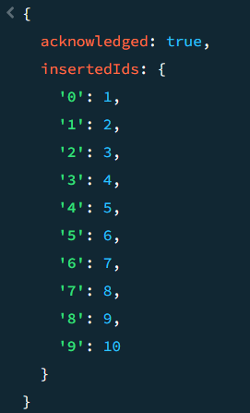
db.sales.aggregate([
{
$group: {
_id: '$item',
itemCount: {$count: {} },
},
},
])
