BRACT’s

Vishwakarma Institute of Information Technology, Kondhwa(BK), Pune-48

Department of Computer Engineering



Group No:

Group Members:

Database Management System Project

On

ZOO MANAGEMENT SYSTEM

SY BTech Computer Engineering Academic Year: 2023-24

|  |  |  |  |
| --- | --- | --- | --- |
| **Sr. No.** | **GrNo.** | **RollNo.** | **Name of Student** |
| 1 | 22210064 | 222027 | Sakshi Hedke |
| 2 | 22210487 | 222033 | Ashis Khenat |
| 3 | 22320128 | 222084 | Jayesh Jadhav |
| 4 | 22211510 | 222047 | Omkar Patil |
| 5 | 22210007 | 222031 | Juilee Talekar |

Faculty Mentor: **Mr. Y. K. Sharma**

**Index**

|  |  |  |
| --- | --- | --- |
| **Serial No.** | **Topic** | **Page No.** |
| 1. | Title Page | 1 |
| 2. | Index Page | 2 |
| 3. | Abstract & Objectives of Project | 3 |
| 4. | Introduction (Including Literature Survey & Project Architecture) | 4-5 |
| 5. | Software Requirement (Front End, Back End & Software used for Connectivity) | 6 |
| 6. | E-R Diagram | 7-8 |
| 7. | Screen Snapshots of Project | 9 |
| 8. | Project Cost Estimation | 10 |
| 9. | Conclusion | 10 |
| 10. | Future Aspects of Project | 11 |
| 11. | References | 12 |

**ABSTRACT & OBJECTIVES OF THE PROJECT**

This project represents a comprehensive Zoo Management System leveraging Tkinter for GUI development, MySQL for database management, and Pillow for proficient image handling. It offers a versatile platform featuring a sophisticated login interface, empowering users to either register or access their accounts as administrators or regular users. Administrators enjoy privileged access to a dedicated zoo management interface, enabling them to oversee diverse operational facets such as animal care, staff management, inventory supervision, and financial administration. Meanwhile, regular users are facilitated with seamless access to a user-friendly ticket booking system, enhancing their overall experience. Noteworthy aspects of the project include the adept utilization of Tkinter widgets to create an intuitive interface, robust database connectivity to ensure data integrity and security, and meticulous error handling mechanisms to guarantee a smooth and reliable user journey. Through this endeavor, the project exemplifies best practices in software development, encapsulating the essence of modern technological solutions for efficient zoo management.

**INTRODUCTION**

In the modern era of zoological management, the convergence of technology and traditional practices is paramount for enhancing efficiency and visitor experience. This project introduces a robust Zoo Management System that integrates cutting edge technologies such as Tkinter for graphical user interface (GUI) development, MySQL for database management, and Pillow for image processing. By amalgamating these technologies, the system provides a seamless and intuitive platform for administrators and visitors alike.The system comprises three distinct modules: the User Window or Ticket Window, the Admin Login or Management System Login Page, and the Ticket Booking Page. The User Window/Ticket Window module facilitates visitors in booking tickets for their zoo visit, enabling them to select the date of visit and the number of tickets required. Utilizing Tkinter widgets and dynamic database connectivity, visitors can efficiently manage their ticket bookings, enhancing their overall experience.On the other hand, the Admin Login/Management System Login Page module caters to the administrative personnel responsible for overseeing various aspects of zoo operations. With secure authentication mechanisms, administrators can access the comprehensive zoo management interface, enabling them to manage animal information, staff schedules, and financial transactions with ease. Furthermore, the Ticket Booking Page module empowers users to print their tickets seamlessly. Leveraging Pillow for image handling and report lab for PDF generation, users can generate and download their tickets in a convenient format, enhancing the efficiency of the ticketing process. Overall, this project exemplifies the fusion of innovative technologies with traditional zoo management practices, culminating in a sophisticated and user-friendly Zoo Management System that elevates the standards of operational efficiency and visitor satisfaction.

**LITERATURE SURVEY**

[1] The existing manual entry ticketing system at Anna Zoological Park lacks secure data storage and efficient management of visitor and animal information, leading to potential errors and drawbacks. To address this, a comprehensive Zoo Information Management System (ZIMS) was developed with modules for animal data entry, update, and ticketing. ZIMS ensures secure user authentication, streamlined data handling, and reporting capabilities, enhancing operational efficiency and accuracy at the zoo.

[2] Anuj Kumar's paper introduces a Zoo Management System designed to enhance operational efficiency, animal welfare, and visitor experience. It integrates modules for data management, animal monitoring, and visitor engagement, empowering administrators to streamline operations and personalize visitor interactions. Leveraging IoT sensors, data analytics, and augmented reality, the system offers real-time insights for informed decision-making, ensuring the well-being of animals and increasing visitor satisfaction.

Administrative functionalities include tracking ticket sales, managing animal details, updating ticket prices, and generating customized tickets for Indian and foreign visitors. Additionally, the system facilitates search functionalities and provides comprehensive reports on ticket generation trends.

**SOFTWARE REQUIREMENTS**

Visual Studio Code: Visual Studio Code, a versatile code editor, is tailored for crafting and troubleshooting contemporary web and cloud-based applications with enhanced efficiency.

MySQL Workbench: MySQL Workbench serves as an extensive visual toolkit catering to database architects, developers, and DBAs, facilitating the design, development, and administration of MySQL databases with ease.

Python : The frontend of our application was developed using python .Tkinter is the backbone of frontend. MySQL : The backend of Zoo Management System has been implemented using MySQL.

Front-end Python GUI:

Python: The core requirement for developing the front-end GUI using Python.

GUI Library/Framework: Choose a suitable GUI library or framework for building the user interface. Some popular options for Python GUI development include Tkinter (built-in with Python. Install the chosen library/framework using Python's package manager (pip).

IDE or Text Editor: We need an Integrated Development Environment (IDE) or a text editor to write and edit Python code. Some popular choices include PyCharm, Visual Studio Code, Atom, Sublime Text, and IDLE (built-in with Python).

Backend - MySQL:

MySQL Database Server.

MySQL Client: You'll need a MySQL client to interact with the MySQL database server. MySQL Workbench is a popular choice for managing MySQL databases and executing SQL queries. Alternatively, you can use command-line tools like MySQL Shell or MySQL Command-Line Client.

MySQL Connector/Python: To connect your Python application to the MySQL database, we need the MySQL Connector/Python library.

Software Used for Connectivity:

MySQL Connector/Python: As mentioned earlier, MySQL Connector/Python is used to establish a connection between your Python application and the MySQL database server. It provides an interface for executing SQL queries and retrieving data from the database.

**SCHEMA**

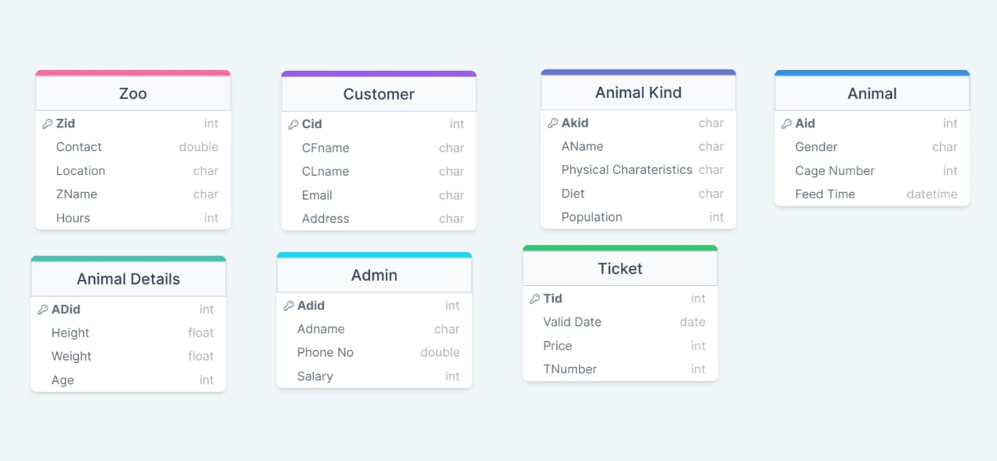

**E-RDIAGRAM**

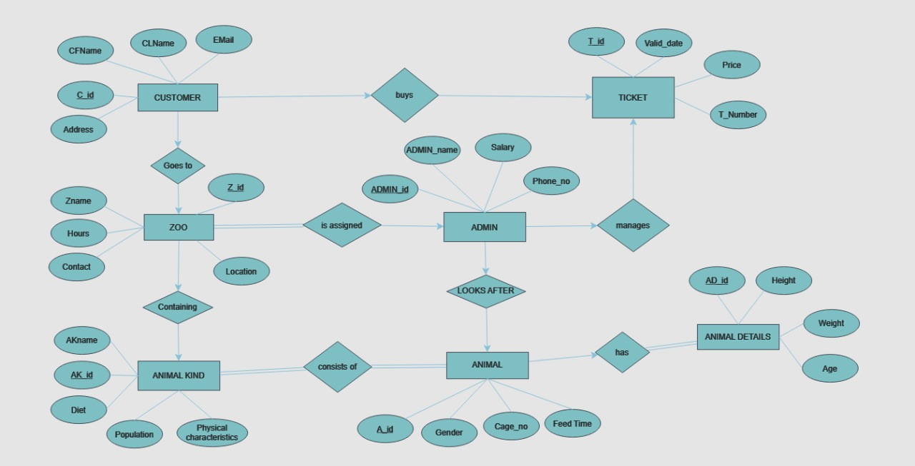

**SCREEN SNAPSHOTS OF THE PROJECT**

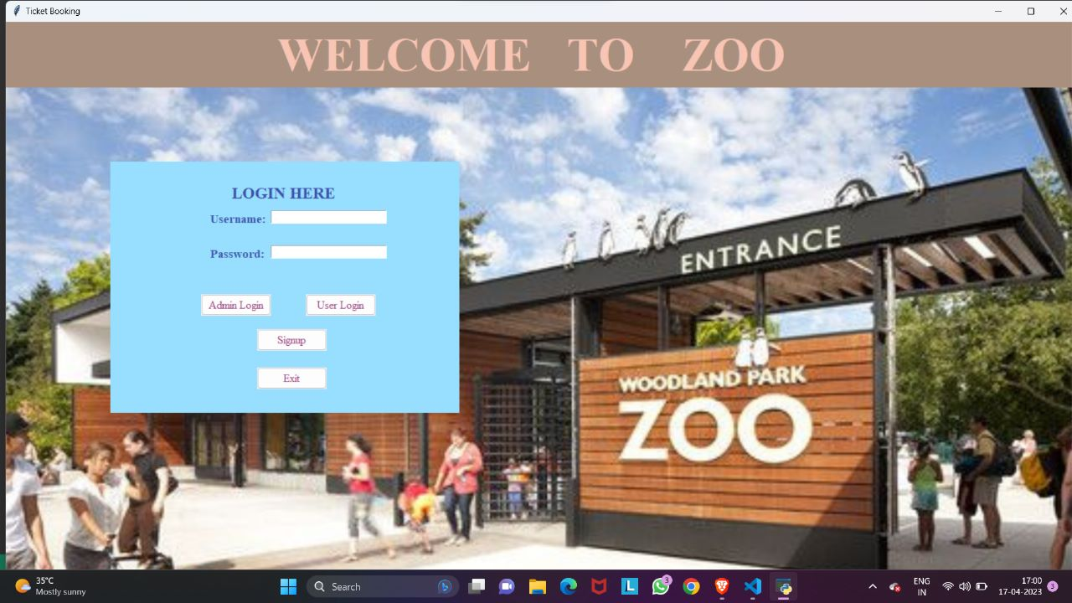

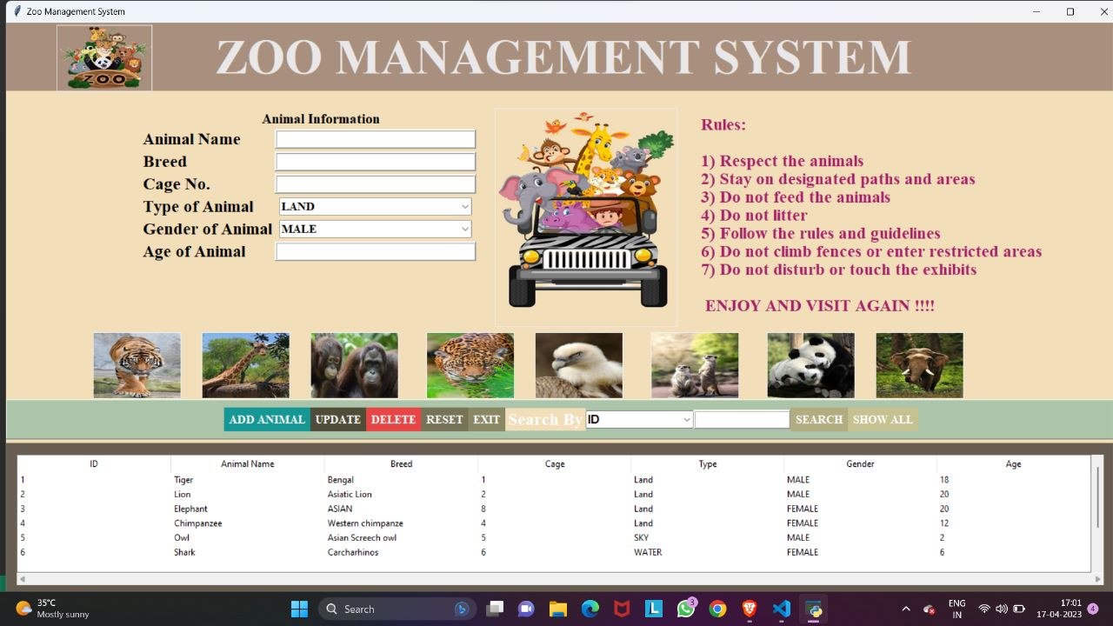

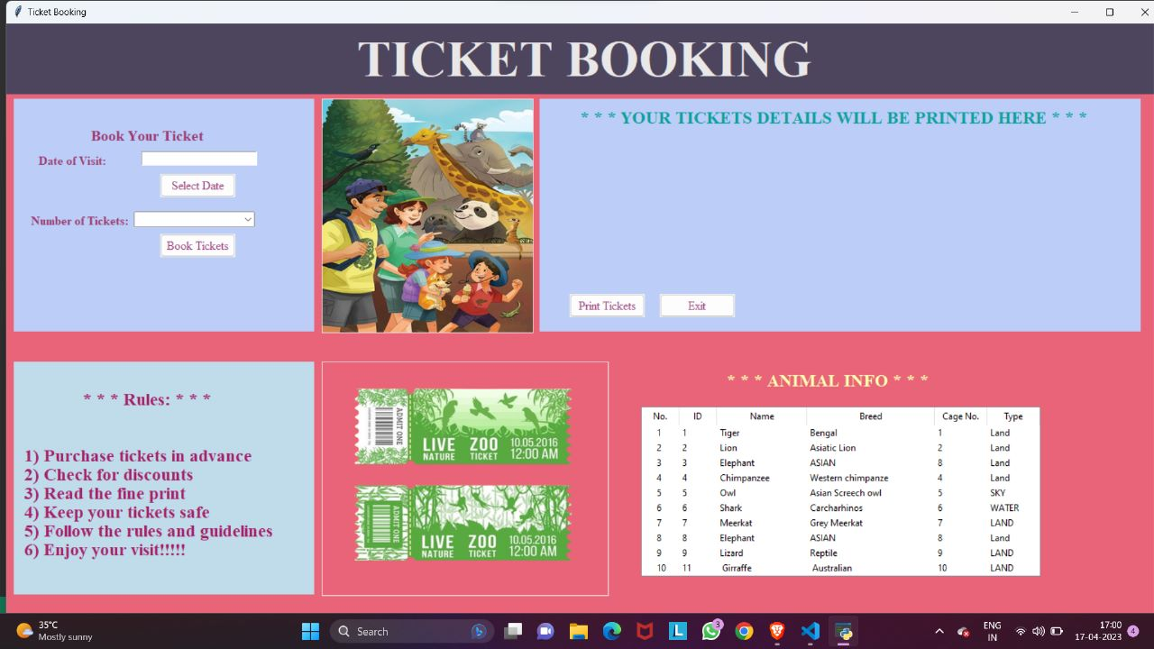

**PROJECT COST ESTIMATION**

Our project is software-based, which means that the cost estimation is effectively zero in terms of direct financial expenditure. However, it's crucial to recognize that despite the absence of monetary expenses, the development process involves significant effort, time, and expertise from skilled professionals. Therefore, while the project may not incur direct financial costs, its creation requires substantial human resources and intellectual capital.

**CONCLUSION**

This research paper presents a sophisticated Zoo Management System developed using Python technologies, offering a seamless platform for efficient zoo management and enhanced visitor experience. By integrating Tkinter, MySQL, and Pillow, the system exemplifies the fusion of innovative technologies with traditional zoo management practices. Through its intuitive interface, robust database connectivity, and efficient ticket booking system, the project sets a new standard for modern zoo management solutions. This project exemplifies best practices in software development, showcasing the potential of technology to streamline operations and enhance experiences in the field of zoo management.

**FUTURE ASPECTS OF THE PROJECT**

The future scope of a Zoo Management System is broad and promising, with potential advancements and enhancements in various aspects. Here are some potential areas of future development:

1)Integration of IoT and Sensor Technologies: Implementing Internet of Things (IoT) devices and sensor technologies can revolutionize zoo management by providing real-time data on animal behavior, environmental conditions, and visitor traffic. This data can be used for better decision-making, animal welfare monitoring, and enhancing visitor experiences.

2) AI and Machine Learning Applications: Integration of Artificial Intelligence (AI) and Machine Learning (ML) algorithms can automate tasks such as animal health monitoring, predictive maintenance of zoo facilities, and personalized visitor recommendations based on their preferences and behavior.

3) Augmented and Virtual Reality Experiences: Future zoo management systems could offer immersive augmented reality (AR) and virtual reality (VR) experiences for visitors, allowing them to interact with virtual animals, explore habitats, and learn about conservation efforts in engaging ways.

4) Sustainability and Conservation Initiatives: Future zoo management systems are likely to focus more on sustainability and conservation efforts, including eco friendly infrastructure, renewable energy sources, and educational programs aimed at promoting environmental awareness and conservation practices among visitors.

5) Collaborative Research and Conservation Projects: Zoo management systems can facilitate collaboration among zoos, wildlife conservation organizations, and research institutions for joint research projects, breeding programs, and conservation initiatives aimed at protecting endangered species and preserving biodiversity.

**REFERENCES**

1]**https://www.researchgate.net/publication/309459820_Zoo_Information_Management_Syste m_ZIMS_for_Anna_Zoological_Park_Chennai_India**

2] **Zoo Management System Project in PHP | Zoo Management System Project (phpgurukul.com)**