1) Enlist some commands of DDL, DML, and DCL.
Answer: Data Definition Language (DDL) commands:
CREATE to create a new table or database.
ALTER for alteration.
TRUNCATE to delete data from the table.
DROP to drop a table.
RENAME to rename a table.

Data Manipulation Language (DML) commands:
INSERT to insert a new row.
UPDATE to update an existing row.
DELETE to delete a row.
MERGE for merging two rows or two tables.

Data Control Language (DCL) commands:
COMMIT to permanently save.
ROLLBACK to undo the change.
SAVEPOINT to save temporarily.

2) How many SQL statements are used? Define them.
Answer: SQL statements are basically divided into three categories, DDL, DML, and DCL.
They can be defined as:
Data Definition Language (DDL) e.g., CREATE, ALTER, DROP, TRUNCATE, RENAME, etc. All these commands are used for updating the data that’s why they are known as Data Definition Language.
Data Manipulation Language (DML) e.g., SELECT, UPDATE, INSERT, DELETE, etc. These commands are used for the manipulation of already updated data that's why they are the part of Data Manipulation Language.
DATA Control Language (DCL) e.g., GRANT and REVOKE. These commands are used for giving and removing the user access on the database. So, they are the part of Data Control Language.
Transaction Control Language (TCL) e.g., COMMIT, ROLLBACK, and SAVEPOINT. These are the commands used for managing transactions in the database. TCL is used for managing the changes made by DML.

3) Explain Normalization and De-Normalization.
Answer:
Normalization is the process of removing redundant data from the database by splitting the table in a well-defined manner in order to maintain data integrity. This process saves much of the storage space.
De-normalization is the process of adding up redundant data on the table in order to speed up the complex queries and thus achieve better performance.

4) Define the relationship between ‘View’ and ‘Data Independence’.
Answer: View is a virtual table that does not have its data on its own rather the data is defined from one or more underlying base tables.
Views account for logical data independence as the growth and restructuring of base tables are not reflected in views.

5) What are the advantages and disadvantages of views in the database?
Answer: Advantages of Views:
As there is no physical location where the data in the view is stored, it generates output without wasting resources.
Data access is restricted as it does not allow commands like insertion, updation , and deletion.
Disadvantages of Views:
The view becomes irrelevant if we drop a table related to that view.
Much memory space is occupied when the view is created for large tables.

6) What do you understand by the E-R model?
Answer: E-R model is an Entity-Relationship model which defines the conceptual view of the database. This model is used to define the data elements and relationship for a specified system.
The E-R model basically shows the real-world entities and their association/relations. Entities here represent the set of attributes in the database.

7) Define Entity, Entity type, and Entity set.
Answer:
Entity can be anything, be it a place, class or object which has an independent existence in the real world.
Entity Type represents a set of entities that have similar attributes.
Entity Set in the database represents a collection of entities having a particular entity type.

8) Define a Weak Entity set.
Answer: Weak Entity set is the one whose primary key comprises its partial key as well as the primary key of its parent entity. This is the case because the entity set may not have sufficient attributes to form a primary key.

9) Explain the terms ‘Attribute’ and ‘Relations’
Answer:
Attribute is described as the properties or characteristics of an entity. For Example, Employee ID, Employee Name, Age, etc., can be attributes of the entity Employee.
Relation is a two-dimensional table containing a number of rows and columns where every row represents a record of the relation. Here, rows are also known as ‘Tuples’ and columns are known as ‘Attributes’.

10) What is Data Warehousing?
Answer: The storage as well as access to data, that is being derived from the transactions and other sources, from a central location in order to perform the analysis is called Data Warehousing.

11) What do you understand by Join?
Answer: Join is the process of deriving the relationship between different tables by combining columns from one or more tables having common values in each. When a table joins with itself, it is known as Self Join.

12) Differentiate between ‘Cluster’ and ‘Non-cluster’ index.
Answer: Clustered index alters the table and re-order the way in which the records are stored in the table. Data retrieval is made faster by using the clustered index.
A Non-clustered index does alter the records that are stored in the table but creates a completely different object within the table.

13) Explain the Primary Key and Composite Key.
Answer: Primary Key is that column of the table whose every row data is uniquely identified. Every row in the table must have a primary key and no two rows can have the same primary key. Primary key value can never be null nor can it be modified or updated.
Composite Key is a form of the candidate key where a set of columns will uniquely identify every row in the table.

14) What do you understand by the Unique key and foreign key?
Answer: A Unique key is the same as the primary key whose every row data is uniquely identified with a difference of null value i.e. Unique key allows one value as a NULL value.
A foreign key is one table which can be related to the primary key of another table. Relationship needs to be created between two tables by referencing foreign key with the primary key of another table.

15) Differentiate between ‘DELETE’, ‘TRUNCATE’ and ‘DROP’ commands.
Answer: After the execution of ‘DELETE’ operation, COMMIT and ROLLBACK statements can be performed to retrieve the lost data.
After the execution of ‘TRUNCATE’ operation, COMMIT, and ROLLBACK statements cannot be performed to retrieve the lost data.
‘DROP’ command is used to drop the table or key like the primary key/foreign key.

16) Define Stored procedures.
Answer: A Stored procedure is a collection of pre-compiled SQL Queries, which when executed denotes a program taking input, process and gives the output.

17) Define Join types.

Answer: Given below are the types of Join, which are explained with respect to the tables as an Example.

employee table:

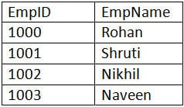

employee_info table:

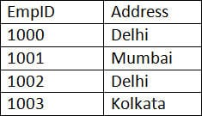

a) Inner JOIN: Inner JOIN is also known as a simple JOIN. This SQL query returns results from both the tables having a common value in rows.

SQL Query:
SELECT * from employee, employee_info WHERE employee.EmpID = employee_info.EmpID ;

Result:
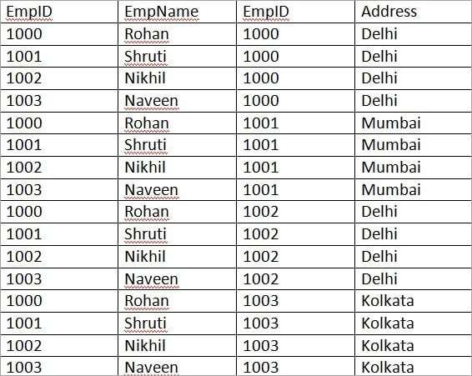

b) Natural JOIN: This is a type of Inner JOIN that returns results from both the tables having the same data values in the columns of both the tables to be joined.

SQL Query:
SELECT * from employee NATURAL JOIN employee_info;

Result:
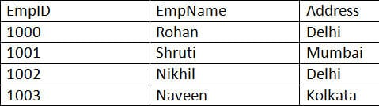

c) Cross JOIN: Cross JOIN returns the result as all the records where each row from the first table is combined with each row of the second table.

SQL Query:
SELECT * from employee CROSS JOIN employee_info;

Result:
Let us do some modification in the above tables to understand Right JOIN, Left JOIN, and Full JOIN.

employee table:
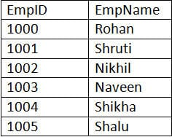

employee_info table:
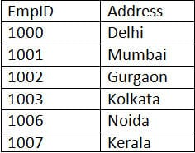

a) Right JOIN: Right JOIN is also known as Right Outer JOIN. This returns all the rows as a result from the right table even if the JOIN condition does not match any records in the left table.

SQL Query:
SELECT * from employee RIGHT OUTER JOIN employee_info on (employee.EmpID = employee_info.EmpID);

Result:
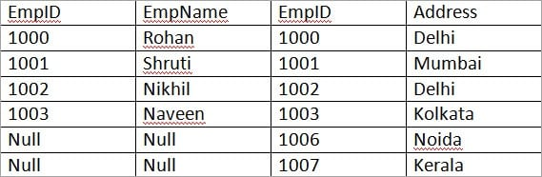

b) Left JOIN: Left JOIN is also known as Left Outer JOIN. This returns all the rows as a result of the left table even if the JOIN condition does not match any records in the right table. This is exactly the opposite of Right JOIN.

SQL Query:
SELECT * from employee LEFT OUTER JOIN employee_info on (employee.EmpID = employee_info.EmpID);

Result:
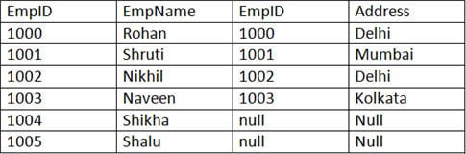

c) Outer/Full JOIN: Full JOIN return results in combining the result of both the Left JOIN and Right JOIN.

SQL Query:
SELECT * from employee FULL OUTER JOIN employee_info on (employee.EmpID = employee_info.EmpID);

Result:
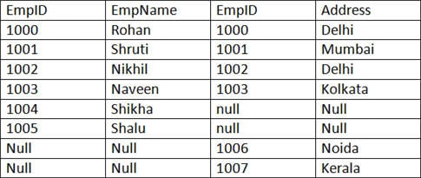

18) What is RDBMS?
RDBMS stands for Relational Database Management System. RDBMS store the data into the collection of tables, which is related by common fields between the columns of the table. It also provides relational operators to manipulate the data stored into the tables.

19) What is an Index?
An index is performance tuning method of allowing faster retrieval of records from the table. An index creates an entry for each value and it will be faster to retrieve data.
There are three types of indexes -.
Unique Index.
This indexing does not allow the field to have duplicate values if the column is unique indexed. Unique index can be applied automatically when primary key is defined.
Clustered Index.
This type of index reorders the physical order of the table and search based on the key values. Each table can have only one clustered index.
NonClustered Index.
NonClustered Index does not alter the physical order of the table and maintains logical order of data. Each table can have 999 nonclustered indexes.

20) What is a query?
A DB query is a code written in order to get the information back from the database. Query can be designed in such a way that it matched with our expectation of the result set. Simply, a question to the Database.

22) What is subquery?
A subquery is a query within another query. The outer query is called as main query, and inner query is called subquery. SubQuery is always executed first, and the result of subquery is passed on to the main query.

22) What are the types of subquery?
There are two types of subquery – Correlated and Non-Correlated.
A correlated subquery cannot be considered as independent query, but it can refer the column in a table listed in the FROM the list of the main query. A Non-Correlated sub query can be considered as independent query and the output of subquery are substituted in the main query.
23) What is a constraint?
Constraint can be used to specify the limit on the data type of table. Constraint can be specified while creating or altering the table statement. Sample of constraint are.
NOT NULL.
CHECK.
DEFAULT.
UNIQUE.
PRIMARY KEY.
FOREIGN KEY.

24) What is collation?
Collation is defined as set of rules that determine how character data can be sorted and compared. This can be used to compare A and, other language characters and also depends on the width of the characters.
ASCII value can be used to compare these character data.

25) What are all different types of collation sensitivity?
Following are different types of collation sensitivity -.
Case Sensitivity – A and a and B and b.
Accent Sensitivity.
Kana Sensitivity – Japanese Kana characters.
Width Sensitivity – Single byte character and double byte character.

26) What is CLAUSE?
SQL clause is defined to limit the result set by providing condition to the query. This usually filters some rows from the whole set of records.
Example – Query that has WHERE condition
Query that has HAVING condition.

27) What is an ALIAS command?
ALIAS name can be given to a table or column. This alias name can be referred in WHERE clause to identify the table or column.
Example-.
Select st.StudentID, Ex.Result from student st, Exam as Ex where st.studentID = Ex. StudentID
Here, st refers to alias name for student table and Ex refers to alias name for exam table.

28) What is Union, minus and Interact commands?
UNION operator is used to combine the results of two tables, and it eliminates duplicate rows from the tables.
MINUS operator is used to return rows from the first query but not from the second query. Matching records of first and second query and other rows from the first query will be displayed as a result set.
INTERSECT operator is used to return rows returned by both the queries.

29) Which operator is used in query for pattern matching?
LIKE operator is used for pattern matching, and it can be used as -.
% – Matches zero or more characters.
_(Underscore) – Matching exactly one character.
Example -.
Select * from Student where studentname like 'a%'
Select * from Student where studentname like 'ami_'

30) What is the command used to fetch first 5 characters of the string?
There are many ways to fetch first 5 characters of the string -.
Select SUBSTRING(StudentName,1,5) as studentname from student
Select LEFT(Studentname,5) as studentname from student

31) What is the E-R model?
E-R model is a short name for the Entity-Relationship model. This model is based on the real world. It contains necessary objects (known as entities) and the relationship among these objects. Here the primary objects are the entity, attribute of that entity, relationship set, an attribute of that relationship set can be mapped in the form of E-R diagram.

In E-R diagram, entities are represented by rectangles, relationships are represented by diamonds, attributes are the characteristics of entities and represented by ellipses, and data flow is represented through a straight line.

32) Explain ACID properties
ACID properties are some basic rules, which has to be satisfied by every transaction to preserve the integrity. These properties and rules are:
ATOMICITY: Atomicity is more generally known as ?all or nothing rule.' Which implies all are considered as one unit, and they either run to completion or not executed at all.
CONSISTENCY: This property refers to the uniformity of the data. Consistency implies that the database is consistent before and after the transaction.
ISOLATION: This property states that the number of the transaction can be executed concurrently without leading to the inconsistency of the database state.
DURABILITY: This property ensures that once the transaction is committed it will be stored in the non-volatile memory and system crash can also not affect it anymore.

33) What is the difference between a DELETE command and TRUNCATE command?
DELETE command: DELETE command is used to delete rows from a table based on the condition that we provide in a WHERE clause.
DELETE command delete only those rows which are specified with the WHERE clause.
DELETE command can be rolled back.
DELETE command maintain a log, that's why it is slow.
DELETE use row lock while performing DELETE function.

TRUNCATE command: TRUNCATE command is used to remove all rows (complete data) from a table. It is similar to the DELETE command with no WHERE clause.
The TRUNCATE command removes all the rows from the table.
The TRUNCATE command cannot be rolled back.
The TRUNCATE command doesn't maintain a log. That's why it is fast.
TRUNCATE use table log while performing the TRUNCATE function.

