The fundamental concepts underlying Artificial Neural Networks (ANNs) are analogous to the functioning of neural networks in the human brain. ANNs consist of a number of interconnected processing elements called neurodes, analogs to neurons in the brain (Maier and Dandy, 1996). Each neurode combines a number of inputs and produces an output, which is transmitted to many different locations, including other neurodes. The difference between the various types of ANNs usually comes from the many different ways to arrange the neurodes (architecture) and the many ways to determine the weights and functions for inputs and neurodes (training) (Caudill and Butler, 1992a).
Figure 4.1 shows a typical artificial neural network architecture. Inputs to the ANN are usually binary, either "0 and 1" or "-1 and +1." The connections between the input layer and the middle or hidden layer contain weights, which are usually determined through training the system. The middle layer neurodes take the weighted inputs and sums them. To make a single value output from each neurode, the sum is used in an equation called a transfer function to create an output value. A typical transfer function is the sigmoid function, which varies from 0 to 1 for a range of inputs (Caudill and Butler, 1992a). The connections between the middle and output layer also have weights, and the output layer neurodes contain transfer functions. Finally, the output layer produces a set of values. These values might put a particular input into an output category or class, or the values may be combined or scaled to produce a numeric value (Caudill and Butler, 1992a). Maier and Dandy (1996) give a more detailed description of the architecture of ANNs.
ANNs are powerful tools, because architecture and training procedures allow a great deal of flexibility to model many types of systems. When there is a large data set of input and outputs available for some system, a supervised training procedure can be used to create an ANN. Some of the more popular supervised ANNs are the Forward-Backward Propagation network, Hopfield network, and the bidirectional associative memory network (Caudill and Butler, 1992a). For a system with highly complex input data, there are unsupervised ANNs which can help with pattern recognition and data compression. Some of the more popular unsupervised ANNs include Kohonen networks and resonance networks (Caudill and Butler, 1992b). In addition, there are many types of hybrid and higher-order networks that take portions of several networks and combine them into a single system.
ANNs are beginning to have an impact on water resource and hydrologic modeling. According to Maier and Dandy (1997), ANNs were first introduced to the water resource community by Daniell (1991), who used ANNs to predict monthly water consumption and to estimate flood occurrence. Since then, ANNs have been used for a variety of water resource applications. These include time-series prediction for rainfall forecasting (French, 1992), reservoir inflow time series (Raman and Sunilkumar, 1995), rainfall-runoff processes (Hsu, 1995 and Shamseldin, 1997), and river salinity (Maier and Dandy, 1996). ANNs also have been used for representing soil and water processes including soil moisture (Altenford, 1992), groundwater cleanup strategies (Ranjithan, 1993), water table fluctuations (Shukla, 1996; Yang, 1996a), pesticide movement in soils (Yang, 1996b), drainage pattern determination from a Digital Elevation Model (Kao, 1996), and water table management (Yang , 1998). In addition, they have been applied to irrigation systems (McClendon , 1996), a greenhouse management expert system (Seginer, 1996), and a water quality management system (ChingGung and ChihSheng, 1998).
As an emerging field of modeling, many of the methods and techniques used in ANNs are not standardized and vary between texts and software applications. Caudill and Butler (1992a) suggest the use of a trial and error approach for determining parameters and network architecture for a given problem. ANNs also tend to be very problem specific (Maier and Dandy, 1996). Still, some general guidelines emerge from the literature. Usually the larger the number of neurodes in the hidden layer or layers the better the predictive ability of the network (Caudill and Butler, 1992a). Training data sets will produce better networks when they are larger and contain the extremes of possible values. ANNs will almost never perfectly predict all values, so a reasonable error must be used for training and testing of networks (Caudill and Butler, 1992a). The key to a good network is the training data.
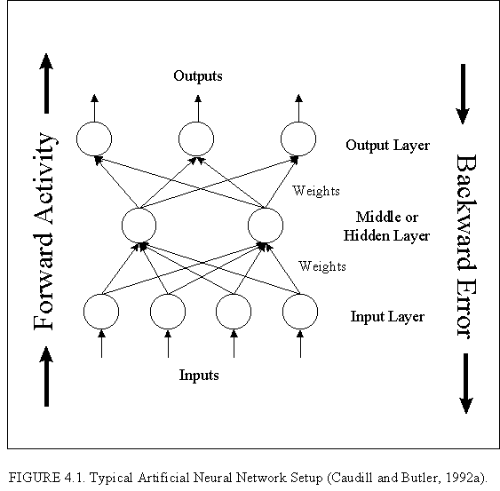
Figure 4.1 : Typical Artificial Neural Network Setup

