Artificial Neural Networks attempt to replicate the human brain’s functionality on a much smaller scale. It is a similar structure which is composed of neurons which are connected via dendrites. The human brain contains approximately 1011 neurons whilst each neuron would have 104 inputs. For this system, a range of inputs would be determined and a value would be inputted for each. The system can be configured to have many outputs. It can consist of many layers; each layer is composed of a certain number of neurons. For example, a simple system would consist of an input layer, hidden layer and output layer. All neurons from the input layer are connected to the hidden layer, from which all are connected to the output layer. This is known as a Feed Forward Multilayer NN or Multilayer Perceptron. Figure 2.3 shows this implementation. [ A ] Before the inputs pass to the hidden layer, they are weighted. The weights are the most important aspect as they define the behaviour of the ANN. The value of the weights can be determined by training or evolving the ANN with genetic algorithms.
Artificial neural networks are parallel computational models, comprised of densely interconnected adaptive processing units. These networks are fine-grained parallel implementations of nonlinear static or dynamic systems. A very important feature of these networks is their adaptive nature where "learning by example" replaces "programming" in solving problems. This feature makes such computational models very appealing in application domains where one has little or incomplete understanding of the problem to be solved, but where training data is available. Another key feature is the intrinsic parallel architecture which allows for fast computation of solutions when these networks are implemented on parallel digital computers or, ultimately, when implemented in customized hardware.
Artificial neural networks are viable computational models for a wide variety of problems. These incude pattern classification, speech synthesis and recognition, adaptive interfaces between humans and complex physical systems, function approximation, image compression, associative memory, clustering, forecasting and prediction, combinatorial optimization, nonlinear system modeling, and control. These networks are "neural" in the sense that they may have been inspired by neuroscience, but not necessarily because they are faithful models of biological neural or cognitive phenomena. In fact, the majority of the networks covered in this book are more closely related to traditional mathematical and/or statistical models such as non-parametric pattern classifiers, clustering algorithms, nonlinear filters, and statistical regression models than they do with neurobiological models.
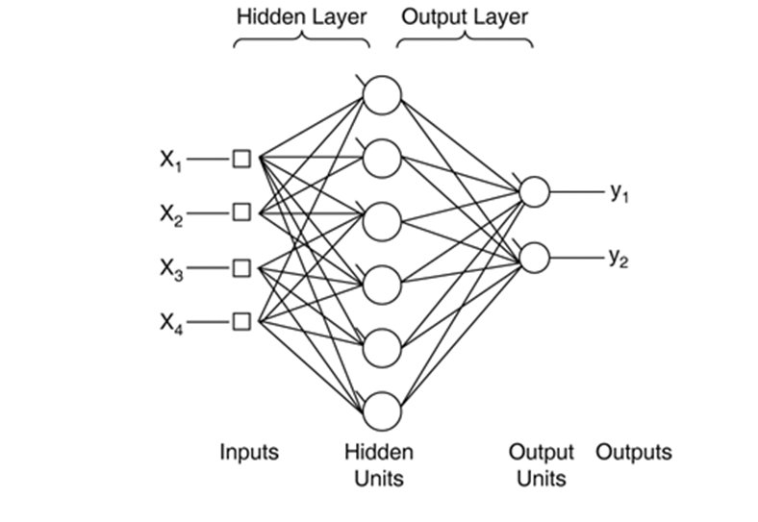
FIGURE 2.3 : MULTILAYER PERCEPTRON NEURAL NETWOR

