How can we use Twin Research To Identify the effects of

Sun Ageing and Sun Damage

The Twin Research and Genetic Epidemiology Unit at St Thomas’ Hospital, London is renowned for have the most widely studied database of twins in the world. It has nearly 10,000 adult twin volunteers on its books and has studied everything from obesity and back pain to sense of humour.

The unit has recently focused on the mysteries of the skin and what makes one individual so different from another, in terms of factors such as skin ageing and our response to sunlight. Twins are the ideal natural experiment to separate the effects of nature and nurture. By comparing the similarity of groups of identical twins (who share all their genes) and non-identical twins (who share half) the proportion of any trait or characteristic that is due to genes can be worked out.

Already the Twin Unit under the guidance of Consultant Dermatologist Dr Veronique Bataille has made some remarkable discoveries into the role of genes on the skin.

A key research area has been understanding factors which affect ageing of the skin. For the purpose of our day with Dr Bataille, we have focused in particular on the effects of sun exposure. The twins have answered a detailed questionnaire about their sun exposure and use of sunbeds. They also had a full skin examination performed by trained research nurses.

TWIN RESEARCH HELPS TO CLEARLY IDENTIFY THE LEVEL OF DAMAGE SUN EXPOSURE CAUSES TO THE SKIN, BY COMPARING GENETICALLY IDENTICAL INDIVIDUALS, ONE OF WHOM HAS BEEN MORE EXPOSED TO THE SUN.

Identical twins, who have very different sun exposure histories, show different features developing from sun exposure. Sun exposed skin is thicker and has different ultrasound features from skin protected by the sun. It also shows marked differences skin 'properties' - confirming the role of ultraviolet light in skin ageing having accounted for genetic differences. The twin skin programme looks for example at the role of sunlight and sunbeds in accelerating wrinkles and moles.

The twin skin programme is now looking at the role of sunlight and sunbeds in accelerating skin ageing, wrinkles and moles – in other words - how our genes interact with our environment to produce changes in our skin with age. The reasons for all of us having such different genes that control the way our skin behaves is slowly becoming clearer.

Understanding the way our skin ages may also give vital clues to why other parts of our body ages, such as the joints and bones, these age at different speeds and may also be the clue to longevity.

SUMMARY OF RESEARCH FINDINGS ILLUSTRATED AT THE WORKSHOP

The tests carried out measure skin thickness on the face, inner and outer arm (using skin ultrasound), the amount of sebum produced on the forehead (sebutape test), and also the amount of skin peeling off after applying a sticky tape (desquame test).

The correlations between identical twins were very high in terms of skin thickness showing that genes are important: the correlation for sun exposed sites in identical twins was 0.8 compared to 0.2 in non identical twins.

The following graph shows how similar skin thickness is for twins who share 100% of their genes (identical twins) compared to individuals who only share 50% of their genes (non-identical twins)

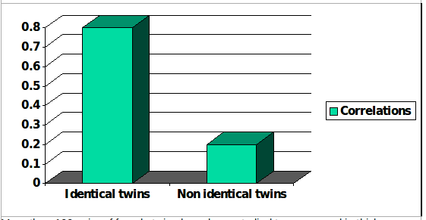
Figure 1: Correlations in skin thickness at sun exposed sites in identical and non-identical twins.
More than 100 pairs of female twins have been studied to compare skin thickness between sun exposed and non-exposed skin. The skin thickness on sun-exposed site (outer forearm) was greater than non-sun exposed site (inner upper arm): 1.18 mm compared to 0,82 mm respectively. Skin thickness on the forehead the most sun-exposed site was the greatest: 1.6 mm. This represents the disorganisation of the elastic fibres caused by sun damage.

Figure 2: Skin thickness in mm at different body sites

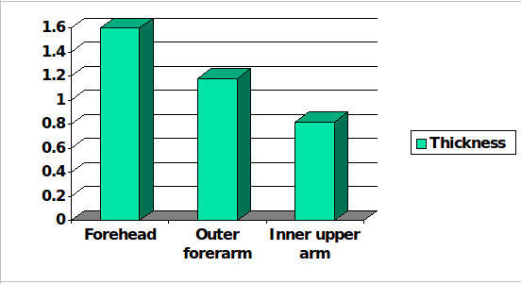

The Twin Unit is still looking for volunteers (both identical and non-identical twins) to help with its studies. All twins have a health check and full expenses.

