THE NILE RIVER

The Nile is the longest river in the world, stretching north for approximately 4,000 miles from East Africa to the Mediterranean. Studies have shown that the River (Iteru, meaning, simply, River, as the Egyptians called it) gradually changed its location and size over millions of years. The Nile flows from the mountains in the south to the Mediterranean in the north. Egyptians traveling to other lands would comment on the "wrong" flow of other rivers. For example, a text of Tuthmosis-I in nubia describes the great Euphrates river as the "inverted water that goes downstream in going upstream."
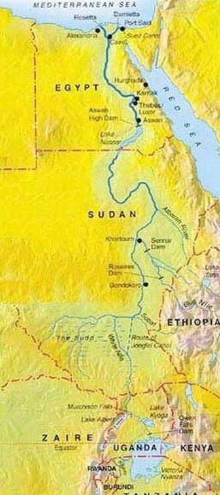
Figure 1: Three rivers flowed into the Nile from the south and thus served as its sources: the Blue Nile, the White Nile and the Arbara. Within the southern section between Aswan and Khartoum, land which was called Nubia, the River passes through formations of hard igneous rock, resulting in a series of rapids, or cataracts, which form a natural boundary to the south. Between the first and second cataracts lay Lower Nubia, and between the second and sixth cataracts lay upper Nubia.
Along most of its length through Egypt, the Nile has scoured a deep, wide gorge in the desert plateau. At Aswan North of the first cataract the Nile is deeper and its surface smoother. Downstream from Aswan the Nile flows northerly to Armant before taking a sharp bend, called the Qena. From Armant to Hu, the River extends about 180 kilometers and divides the narrow southern valley from the wider northern valley.
Southern Egypt, thus being upstream, is called Upper Egypt, and northern Egypt, being downstream and the Delta, is called Lower Egypt. In addition to the Valley and the Delta, the Nile also divided Egypt into the Eastern and Western Deserts.

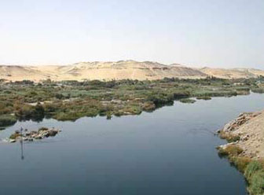
Figure 2: The Nile Valley is a canyon running 660 miles long with a floodplain occupying 4,250 square miles. The Delta spans some 8,500 square miles and is fringed in its coastal regions by lagoons, wetlands, lakes and sand dunes.
The Delta represented 63 percent of the inhabited area of Egypt, extending about 200 kilometers from south to north and roughly 400 kilometers from east to west. While today the Nile flows through the Delta in only two principal branches, the Damietta and the Rosetta, in ancient times there were three principal channels, known as the water of Pre, the water of Ptah and the water of Amun. In classical or Graeco-Roman times, these were called the Pelusiac, the Sebennytic, and the Canopic branches. There were additionally subsidiary branches or artificially cut channels.
The most dominant features of the Delta as the sandy mounds of clay and silt that appear as islands rising 1-12 meters above the surrounding area. Since these mounds would not be submerged by the inundation, they were ideal sites for Predynastic and Early Dynastic settlements, and indeed evidence of human habitation have been found. Perhaps these mounds rising above the water table inspired the ancient belief of creation as having begun on a mound of earth that emerged from the primordial waters of Nun (Pyramid Text 600).
There were several major oases of the Western desert, which comprised about 2/3 of Egypt: the Fayoum, where during the Middle Kingdomperiod the capital of all Egypt was situated, and which increasingly became one of the most densely populated and agriculturally productive area in Egypt, the Bahriya, where many sarcophagi of the Graeco-Roman period have been found, the so-called Golden Mummies, Kharga and Dakhla, which were known for their excellent wines, and Siwa, whose Oracle of Amun was consulted by Alexander the Great to demonstrate that he was the true successor to the kingship of Egypt.
The Eastern Desert was exploited in Pharaonic times for its rich minerals. The mere mention of the name of the Nile evokes for modern man images of Pyramids, great temples, fantastic tales of mummies, and wondrous treasures. But the Nile represents life itself to the people of Egypt, ancient and modern. In fact, for thousands of years, the River has made life possible for hundreds of thousands of people and animals, and has shaped the culture we today are only beginning to truly understand.
The River filled all areas of life with symbolism. In religion, for example, the creator sun-god Ra(Re) was believed to be ferried across the sky daily in a boat (compare that to the Greeks and Romans whose non-creator sun-god rode across the sky in a chariot driven by fiery horses, and Hymns to Hapy (Hapi), the deity personifying the Nile, praise his bounty and offerings were left to him, and the creation myths, as mentioned earlier, revolve around the primordial mound rising from the floodwaters surrounding it; in ritual where Nile creatures such as the hippopotamus, whose shape the goddess Tawaret took, or the crocodile, called Sobek, or Heket (Heqet), the frog, deities deemed powerful in the processes of childbirth and fertility, were revered, in writing, where floral signs such as the lotus and papyrus figured prominently, in architecture, where the very structure of temples emulated the mounds of the Nile and its waves, from the bottom to the top of capital columns and the trim on walls, and in travel, where models of boats have been found dating from the fifth millennium BCE.
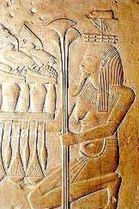
Figure 3: The god Hapy was earlier mentioned as being the personification of the floods and ensuing fertility. Two Hymns to the Nile, one probably composed in the Middle Kingdom, the second written later in the Ramesside period, praise Hapy and the river for its renewed life for Egypt.
"Hail to you Hapy, Sprung from earth, Come to nourish Egypt…Food provider, bounty maker, Who creates all that is good!…Conqueror of the Two Lands, He fills the stores, Makes bulge the barns, Gives bounty to the poor." (from the Middle Kingdom hymn as translated by Lichtheim)
From the earliest times, the waters of the Nile, swollen by monsoon rains in Ethiopia, flooded over the surrounding valley every year between June and September of the modern calendar. A nilometer was used to measure the height of the Nile in ancient times. It usually consisted of a series of steps against which the increasing height of the Inundation, as well as the general level of the river, could be measured. Records of the maximum height were kept. Surviving nilometers exist connected with the temples at Philae, on the Nubian Egyptian border, Edfu, Esna, Kom Ombo, and Dendera, as well as the best-known nilometer on the island of Elephantine at Aswan.
The ancient Egyptian calendar, made up of twelve months of 30 days each, was divided into three seasons, based upon the cycles of the Nile. The three seasons were: akhet, Inundation, peret, the growing season, and shemu, the drought or harvest season. During the season of the Inundation, layers of fertile soil were annually deposited on the flood-plain. Chemical analysis has shown how fertile the Nile mud is. It contains about 0.1 percent of combined nitrogen, 0.2 percent of phosphorus anhydrides and 0.6 percent of potassium.
Since most of the Egyptian people worked as farmers, when the Nile was at its highest and they could not plant, they were drafted by corvee into labor projects such as building Pyramids, repairing temples and other monuments and working on the king’s tomb.
Herodotus, the great Greek philosopher, wrote of the Nile: "the river rises of itself, waters the fields, and then sinks back again; thereupon each man sows his field and waits for the harvest." The great historian also called Egypt the gift of the Nile. This description would lead the casual reader to imagine Egypt as being a great paradise where the people simply sat and waited for the sowing and harvesting to need be done. But the ancient Egyptians knew better. Too high a flood from their river, and villages would be destroyed; too low a flood, and the land would turn to dust and bring famine. Indeed, one flood in five was either too low or too high.
The rock inscription called the Famine Stela, dated in its present form from the Ptolemaic period, recounts an incident, (whether real or fictitious is not currently known for certain), from the period of King Djoser of the 3rd Dynasty. The King writes to a governor in the south, describing himself as disheartened over the country’s seven-year famine. The King learns from a priest of Imhotep that if gifts are given to the temple of Khnum, the creator-god of the region, who it was believed had control over the Nile and its flooding, then the famine would be ended.
Many modern travelers to Egypt today take a Nile cruise as part of their package. And why not? For to see the land as its people do, one must journey on the river. A felucca is often the water vehicle of choice.
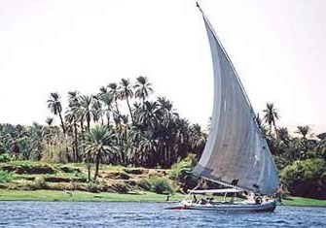
Figure 4: A typical Felucca on the Nile
The Nile flowed from south to north at an average speed of about four knots during inundation season. The water level was on average about 25-33 feet deep and navigation was fast. That made a river voyage from Thebes (modern Luxor) north to Memphis (near modern Cairo) lasting approximately two weeks. During the dryer season when the water level was lower, and speed slower, the same trip would last about two months. At the great bend near Qena, the Nile would flow from west to east and then back from east to west, slowing down travel. No sailing was done at night because of the danger of running aground on one of the many sandbank and low islands.
When one cruises on the Nile, one might pass by the ancient and significant sites of Karnak itself, Luxor, on the other side of the river from Karnak,Dendera, with its grand temple to the goddess Hathor, Abydos, with its marvelous temple built by Seti I as well as being the site of Earlier Dynastic tombs, Esna, with its temple to the potter and creator-god Khnum, lord of the region who was credited as having the power over the river and its richness, Edfu, with its temple to Horus, Kom Ombo, with its double temple to Sobek and a form of Horus called Haroeris, and Aswan itself, with its mighty modern dam. Truly, the Nile is the Heart of the ancient and modern land of Egypt.

