RESUME
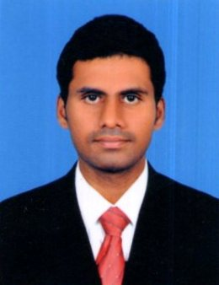

B.RIYASKHAN

Mobile No : +91 9944210186

Email Id : riyazbabu23@gmail.com

CAREER OBJECTIVE:

To enhance my working capabilities, professional sills, business efficiencies and to serve my organization in best possible way with sheer determination and commitment.

ACADEMIC QUALIFICATION:

Course | Institute | Board /University | Year of Completion
MBA | Sona School of Management, Salem | Anna University | 2018
BBA | KSR College of Arts and Science | Periyar Unviersity | 2016
HSC | Little Flower Hr. Sec. School, Salem | State Board | 2013
SSLC | Little Flower Hr. Sec. School, Salem | State Board | 2011

AREA OF INTEREST:

- Marketing
- Recruitment
- CRM
- BD
- Team Management

WORK EXPERIENCE

- YES BANK –SENIOR RELATIONSHIP OFFICER (CASA)
I have started my carrier in YES BANK as a relationship officer in Retail Liability (CASA). From April 2019-May 2021.

- ASCENTZ TECHNOLOGIES – BUSSINESS DEVELOPMENT EXECUTIVE
I have started my job in ASCENTZ TECHNOLOGIES as a Business Development
Executive. (B2B) sales. From February 2018 – February 2019.

INTERNSHIP TRAINING

- Worked as a Intern Recruiter in Hinduja Global Solutions, Bangalore.
- A study on salaried employees behavior towards savings and investments in AAVIN Diary , Salem.
- A study on customer’s behavior of motorcycle purchase in Chitra Motors, Coimbatore.
- A study on strategy using in managerial departments in Salem Steel Plane, Salem.

INPLANT TRAINING:

- Done the In plant visit and training of the period of 45 days training in Salem Steel
Plant.

PERSONAL ATTRIBUTES :

- Adaptable to different kinds of situations
- Willingness and ability to stretch
- Assertive, Confident and a good team work

PERSONAL DETAILS :

Name : B.RIYASKHAN
Father’s Name : Mr U. Babu
Date of Birth : 23.06.1996
Gender : Male
Marital Status : married
Nationality : Indian
Languages known : English, Tamil, Urdu & Hindi
Mobile No : 99442 10186

DECLARATION :

I hereby declare that all the above given particulars are true to the best of my knowledge and belief.
Thanking you

Place : Salem Yours faithfully
Date :
[B.RIYASKHAN]

