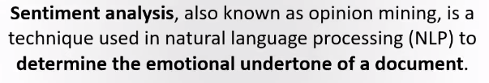

* Also knows as opinion mining
* Technique used in Natural Language Processing to determine the emotional undertone of any document.
* Tools for sentiment analysis assist businesses in extracting information from unstructured, unorganized language found in online sources like emails, blog posts, support tickets, web chats, forums and comments.
* Sentiment analysis can extract the subject, opinion holder and polarity or the degree of positivity or negativity from the text and identify sentiment.

**Types of Sentiment analysis.**

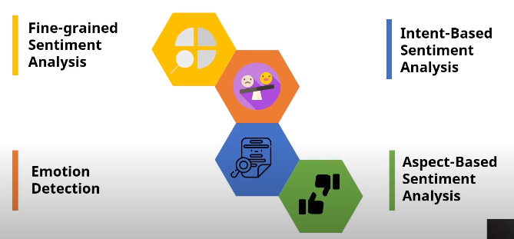

**Applications of sentiment analysis.**

