**TAILORED CAREER PREDICTION BASED ON EMOTIONAL AND PERSONALITY TRAITS**

Minor project report submitted in partial fulfilment of the requirement for the degree of Bachelor of Technology

in

# Computer Science and Engineering

By

## Sanya Jain(221030048)

Aashi Gupta(221030140)

Ashish Agarwal(221030420)

**UNDER THE SUPERVISION OF**

Dr. Ramesh Narwal

Assistant Professor

Department of CSE & IT



Department of Computer Science & Engineering and Information Technology

Jaypee University of Information Technology, Waknaghat, 173234, Himachal Pradesh, INDIA

**TABLE OF CONTENT**

| **Title** | **Page No.** |
| --- | --- |
| **Declaration** | **iii** |
| **Certificate** | **iv** |
| **Acknowledgement** | **v** |
| **Abstract** | **vi** |
| **Chapter-1 (Introduction)** | **1-3** |
| **Chapter-2 (Feasibility Study, Requirements Analysis and Design** | **4-9** |
| **Chapter-3 (Implementation)** | **10–19** |
| **Chapter-4 (Results)** | **20-24** |
| **References** | **25** |

**DECLARATION**

I hereby declare that this project has been done by me under the supervision of **Dr. Ramesh Narwal, Assistant Professor**, Department of CSE & IT, Jaypee University of Information Technology. I also declare that neither this project nor any part of this project has been submitted elsewhere for award of any degree or diploma.

**Supervised by:**

**Dr. Ramesh Narwal**

Assistant Professor

Department of Computer Science & Engineering and Information Technology

Jaypee University of Information Technology

**Submitted by:**

**Sanya Jain(221030048)**

**Aashi Gupta(221030140)**

**Ashish Agarwal(221030420)**

Computer Science & Engineering Department

Jaypee University of Information Technology

**CERTIFICATE**

This is to certify that the work which is being presented in the project report titled “**TAILORED CAREER PREDICTION BASED ON EMOTIONAL AND PERSONALITY TRAITS**” in partial fulfilment of the requirements for the award of the degree of B.Tech in Computer Science And Engineering and submitted to the Department of Computer Science And Engineering, Jaypee University of Information Technology, Waknaghat is an authentic record of work carried out by “**Sanya Jain(221030048), Aashi Gupta(221030140), Ashish Agarwal(221030420)**” during the period from January 2025 to May 2025 under the supervision of **Dr. Ramesh Narwal, Assistant Professor**, Department of Computer Science and Engineering, Jaypee University of Information Technology, Waknaghat.

**Sanya Jain(221030048)**

**Aashi Gupta(221030140)**

**Ashish Agarwal(221030420)**

The above statement made is correct to the best of my knowledge.

**Dr. Ramesh Narwal**

**Assistant Professor**

**Computer Science & Engineering and Information Technology**

**Jaypee University of Information Technology, Waknaghat, Solan**

**ACKNOWLEDGEMENT**

Firstly, I express my heartiest thanks and gratefulness to almighty God for His divine blessing makes it possible for us to complete the project work successfully.

I am really grateful and wish my profound indebtedness to Supervisor **Dr. Ramesh Narwal, Assistant Professor**, Department of CSE Jaypee University of Information Technology,Wakhnaghat. Deep Knowledge & keen interest of my supervisor in the field of “Machine Learning” to carry out this project. Her endless patience, scholarly guidance, continual encouragement, constant and energetic supervision, constructive criticism, valuable advice, reading many inferior drafts and correcting them at all stages have made it possible to complete this project.

I would like to express my heartiest gratitude to Dr. Ramesh Narwal, Assistant Professor**,** Department of CSE, for his kind help to finish my project.

I would also generously welcome each one of those individuals who have helped me straightforwardly or in a roundabout way in making this project a win. In this unique situation, I might want to thank the various staff individuals, both educating and non-instructing, which have developed their convenient help and facilitated my undertaking.

Finally, I must acknowledge with due respect the constant support and patience of my parents.

**Sanya Jain(221030048)**

**Aashi Gupta(221030140)**

**Ashish Agarwal(221030420)**

**ABSTRACT**

Finding the right career path is crucial for personal success and long-term satisfaction because it shapes professional growth and overall well-being. In today's competitive job market, understanding one's unique strengths and preferences has become more critical than ever. Personality profiling and emotional intelligence play an important role in this process. They offer a deeper understanding of an individual’s traits, emotions, and potential.

To overcome the limitations and shortcomings of self-reported career assessments, our project developes an innovative career prediction system which takes advantage of the combination of video interviews, machine learning algorithms and affective computing techniques to perform a profile prediction on the emotional and personality characteristics of a particular individual. In line with the Big Five Personality Model, personality traits are classified individually, and matching is performed between them and career profiles that satisfy the individual.

Aside from this, this platform is also set to transform career counseling in the educational sector and both in the enterprise. Schools and universities could start implementing it as part of their career guidance programs to let students get started on the right path to success earlier in their lives. Companies would then use it as a talent acquisition tool as well as for employee development so that they can better align their people’s roles and achieve maximum employee satisfaction. Both the psychology-based model and AI-powered analysis in the platform can help harness the human potential of individuals in a more professional way. With more and more industries shifting the way we all work, data-driven career decisions will be crucial part of anyone’s life in the future to make career decisions more objective and unbiased. They will also be more successful for people in all sorts of fields.

**Chapter 01: INTRODUCTION**

**1.1 Introduction**

The right career is critical to one’s long term success and happiness. Traditionally, self-assessment approaches are flawed due to their reliance on subjective factors. In this paper, we introduce an AI-powered career recommendation system that incorporates a combination of video analytic techniques, machine learning, and affective computing that combines skill sets and interests with emotions and behavioral clues, in addition to traits related to personality profile (which are then modeled based on the scientifically validated Big Five Personality Model).

While traditional career counselors were dominated by testing, AI’s revolutionary technology proactively analyzes answers from users in real time and reduces potential bias while exploring much deeper insights into an individual’s personality and aptitude. From college students looking to determine their path or professionals who are seeking a change, our AI identifies intelligent, highly predictive career recommendations that help our users make informed decisions.

**1.2 Objective**

* Develop an AI-based career prediction system using video analysis.
* Implement effective computing for emotional assessment.
* Use Big Five Personality Traits for personality classification.
* Improve the accuracy of career recommendations.
* Provide data-driven career guidance.

**1.3 Motivation**

There’s currently a substantial crisis in career mismatch. According to studies, “over 80% of workers claim that they feel stuck in careers that don’t align with their skillset and interests. ” Companies feel trapped in jobs because employees know they have low performance. A 65% rate of people not being productive at work is considered too low. The traditional approach to career guidance depends on self-report surveys, which are biased by personality traits and prone to errors due to personal biases. As demand for personalized career counseling increases — particularly in today’s dynamic job market — there is an obvious lack of solutions with advanced technologies. Psychological research has firmly demonstrated that personality traits are highly influential in career success, leading to the need for career assessments based on scientifically validated frameworks such as the Big Five Personality Model. However, an AI-driven solution to this problem exists today. Our solution provides objective career recommendations based on video analysis, machine learning, and emotion recognition technology. Using this data-driven approach, a user will be able to make better-informed decisions for their future career while meeting changing workforce demands.

**1.4 Language Used**

* **Python**

1. **Libraries:** OpenCV (video processing), Librosa (audio analysis), Pandas/NumPy (data handling), Scikit-learn (ML models).
2. **Framework:** Jupyter Notebook for prototyping

**1.5 Technical Requirements ( Hardware)**

* Cloud-based execution via Google Colab
* Minimum 12GB RAM
* Python 3.8 environment
* Key libraries: OpenCV 4.1.2, scikit-learn 1.0.2, pandas 1.3.5
* Google Drive integration for video storage
* Input: MP4/AVI video files (any resolution)
* Annotation format: CSV with Big Five trait scores
* Web browser access (Chrome/Firefox recommended)
* Internet connection (>10Mbps for stable uploads)

**1.6 Deliverables/Outcomes**

* **Core System**

1. Video analysis pipeline for trait extraction
2. Trained ML models (Decision Trees/CNNs) for personality prediction

* **User Interface**

1. Jupyter Notebook interface for research use
2. Optional web dashboard (Flask/Django) for end-users

* **Documentation**

1. Technical white paper on methodology
2. User guide for counselors/end-users
3. Integration guidelines for technical implementation
4. Application examples demonstrating practical use case

* **Performance Metrics**

1. Trait prediction accuracy (F1-score)
2. Career recommendation satisfaction rate (via user surveys)
3. Processing time per interview (<5 minutes/video)

* **Ethical Considerations**

1. Privacy-preserving design
2. Data Minimization

**Chapter 02: Feasibility Study, Requirements Analysis and Design**

**2.1 Feasibility Study**

**2.1.1 Problem Definition**

Choosing the right career is something almost everyone struggles with. A lot of the time, people end up in jobs that don’t really match who they are as a person. Career guidance options do exist, but they aren’t always personal enough or they just suggest general paths based on marks or interests. That’s not always enough.So we thought—what if we could use someone’s personality to help with this? The Big Five traits (Openness, Conscientiousness, Extraversion, Agreeableness, and Neuroticism) are widely used in psychology, and they seemed like a good base. If we could get those scores and map them to career types, maybe we could help someone get a better idea of what roles they might actually enjoy or be good at.

**2.1.2 Problem Analysis**

We searched high and low for a dataset that matched people’s OCEAN scores to real job titles—and came up empty. So, of course, we rolled up our sleeves and built one:

* Dug up interview videos on YouTube where folks chat about their work.
* Snipped each clip down to just the person speaking (no background noise or music).
* Each clip was handed off to three of us; we each scribbled trait scores and jotted down what jobs seemed right.
* When our scores didn’t match, we literally talked it out until we all agreed.
* Everything went into a CSV: video link, five trait columns, and one (or more) job roles.

**2.1.3 Solution**

In the end, we needed an algorithm that could say “Hey, you might fit more than one role,” so multi‑label it was. Random Forest jumped out as a good fit because it’s basically a crowd of decision trees voting—and that felt like us three annotators coming together.

* **Inputs:** our hand‑scored OCEAN values.
* **Outputs:** the model provides a shortlist of career options aligned with each person’s trait profile.
* We trained the model on our homemade CSV and then tested it on clips it had never seen.
* To make it fun, we added a tiny Jupyter widget so you can drop in a video and get instant job ideas.
* Finally, we saved the model plus the scaler and label encoder so we don’t have to keep retraining from scratch.

**Literature Review**

| Authors | Title of Literature | Work Done | Pros | Cons |
| --- | --- | --- | --- | --- |
| Prof. Priyanka Shahane, Prutha Rinke, Taniksha Datar, Soham Badjate [1] | Student's Career Interest Prediction using Machine Learning | The paper explores ML techniques to predict students' career interests. It uses SVM, Random Forest, Decision Tree, and XG Boost, detailing data processing and algorithm application. | The study tackles a student-related problem, comparing ML algorithms with a clear methodology. | mentions decision tree limitations but lacks solutions for their implementation. |
| Kevin Johnson, Samarth Khaire, Yash Nage, Priya Kaul  [2] | Personality Prediction App Using Big-Five Traits | Developed a web application that predicts user personality based on the Big Five traits using a questionnaire and machine learning, and suggests music based on personality and mood. | Offers music suggestions based on both personality and mood. Includes user authentication and history tracking | primarily focuses on the app’s development ; it provides limited detail on the machine learning model's optimization or comparative performance. |
| Jia Xu, Weijian Tian, Guoyun Lv, Shiya Liu, and Yangyu Fan  [3] | Prediction of the Big Five Personality Traits Using Static Facial Images of College Students With Different Academic Backgrounds | Predicted college students' Big Five personality traits from static facial images using deep learning. | Utilized a large dataset of facial images and personality data | Limited discussion on the potential biases or limitations of using facial images for personality prediction. |

| Authors | Title of Literature | Work Done | Pros | Cons |
| --- | --- | --- | --- | --- |
| Yazid Bounab a , Mourad Oussalah a,∗ , Nabil Arhab a , Salah Bekhouche b  [4] | Towards job screening and personality traits estimation from video transcription | The research proposes an NLP-based BiLSTM model with attention to estimate Big-Five personality traits from video transcriptions for job screening. Trained on multiple datasets, it outperforms existing methods in accuracy and generalizability, making it valuable for automated recruitment. | High accuracy, bias reduction, strong generalization, and improved recruitment efficiency. | Lacks non-verbal cues, struggles with low-resource languages, dataset biases, and needs multimodal integration. |
| Huansheng Ning, Sahraoui Dhelim, Nyothiri Aung  [5] | PersoNet: Friend Recommendation System Based on Big 5 Traits | Developed a friend recommendation system combining Big Five personality traits with hybrid filtering to enhance accuracy.  The model leverages personality compatibility and social voting behaviors for better friend suggestions. | Improves recommendation accuracy, reduces the cold-start problem, and enhances user compatibility. | Relies on accurate personality data, increases computational complexity, and may not work well for new users. |
| David J. Holman* and David J. Hughes  [6] | Transactions between Big-5 personality traits and job characteristics across 20 years | The study examines how job characteristics influence Big-5 personality traits over 20 years, showing that workload affects personality development while job description does not. | Provides long-term insights into personality change due to workplace factors, highlighting workload impact on openness, extraversion, and agreeableness. | Limited support for personality influencing job characteristics, no evidence of reciprocal effects, and findings are constrained to two job characteristics. |

| Authors | Title of Literature | Work Done | Pros | Cons |
| --- | --- | --- | --- | --- |
| Nicole de Jong1*, Barbara Wisse1,2, José A. M. Heesink1 and Karen I. van der Zee3  [7] | Personality Traits and Career Role Enactment: Career Role Preferences as a Mediator | The paper examines personality traits as predictors of behaviors and outcomes, using a literature review, framework, data collection, and analysis. | The study links personality to career success, aiding HR and career planning with a clear methodology. | The small sample limits generalizability, the analysis is complex, and external factors are not fully considered. |
| [Ammar Hussein](https://www.researchgate.net/profile/Ammar-Hussein-4?_tp=eyJjb250ZXh0Ijp7InBhZ2UiOiJwdWJsaWNhdGlvbiIsInByZXZpb3VzUGFnZSI6bnVsbCwic3ViUGFnZSI6bnVsbH19)  [8] | Examination of Personality Traits as Predictors of Career Success | The study examines how personality traits shape career role enactment, assessing their impact on professional behavior and success through surveys and statistical analysis. | The research highlights personality's impact on careers, supporting HR and organizational studies with a structured methodology. | The small sample size limits generalizability, the analysis is complex, and external career factors are overlooked. |
| Abhishek S. Rao*, Bola Sunil Kamath, Ramya R, Shreya Chowdhury, Shreya A Pattan, Raveena Krishna Kundar [9] | Use of Artificial Neural Network in Developing a Personality Prediction Model for Career Guidance: A Boon for Career Counselors. | The paper explores personality prediction using machine learning and psychological models, analyzing data to infer traits. It involves data collection, feature extraction, model training, and evaluation. | Innovative approach with real-world applications in HR, marketing, and mental health; data-driven and based on MBTI Traits. | Privacy concerns, potential bias, accuracy limitations, and difficulty in interpreting results |

**2.2 Requirements**

Before building anything, we agreed on what the system must do (functional) and how it should behave (non‑functional). Here’s the mix of narrative and crisp points that we actually wrote down in our planning sessions.

**2.2.1 Functional Requirements**

We wanted the tool to handle our personality‑to‑career workflow start‑to‑finish, so we specified that it needs to:

* Read in the CSV of OCEAN scores plus career labels and clean out any bad rows.
* Turn each person’s job list into a format the ML model understands (multi‑label encoding).
* Fit a Random Forest (via MultiOutputClassifier) on those traits‑to‑career mappings.
* Scale the trait numbers so the model doesn’t get biased by different ranges.
* Accept new trait inputs—whether typed in or extracted from a video—and output relevant job options.
* Offer a simple “upload video → get roles” interface in Jupyter for live testing.

**2.2.2 Non-Functional Requirements**

Beyond just “does it work,” we also talked about how it needs to feel and perform under the hood. We jotted down that:

* **Scalability** matters, because we might add hundreds more videos or open it to many users.
* **Accuracy** has to stay high, so people actually trust the job suggestions.
* **Privacy and security** are critical—no leaked videos or personal data.
* **Ease of use** was non‑negotiable; anyone should figure out the upload widget in seconds.
* **Reliability** means the notebook and model shouldn’t crash or lag when you hit “Predict.”

**2.3 E-R Diagram / Data-Flow Diagram (DFD)**

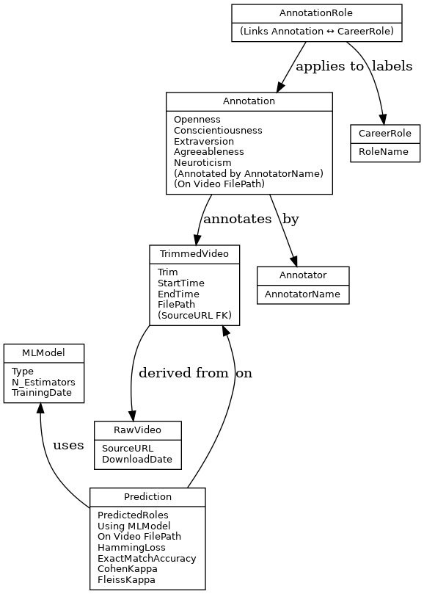

Figure 1. Entity-Relation Diagram

**Chapter 03: IMPLEMENTATION**

**3.1 Date Set Used in the Minor Project**

When we couldn’t find any off‑the‑shelf dataset matching Big Five scores to real job titles, we built our own. We gathered 409 interview clips, trimmed each one down to just the speaker, and stored its Google Drive link. Next, each team member individually reviewed every clip and scored it against the five‑factor personality framework. After that, we met to agree on one or more career titles that felt right for each person. Once every entry was aligned, we merged everything into a single CSV. We loaded that CSV into our machine‑learning workflow to train the Random Forest model and evaluate how well it predicted careers.

* **409 video entries**, each with its own Drive URL
* **Triple‑checked annotations**: all three annotators scored and then reconciled any differences
* **Independent scoring**: each clip was rated separately against our five‑factor model
* **Multiple roles** tagged when someone seemed a fit for more than one job
* **Final CSV** served as the foundation for training and testing the model

**3.2 Date Set Features**

**3.2.1 Types of Data Set**

* The dataset was made manually after watching interview videos and rating them based on personality traits.
* Each record in the dataset matches a specific person featured in one of the analyzed interview clips.
* We recorded five numerical values (the Big Five traits), and the career roles they seemed best suited for.
* Since people can fit into more than one job type, we marked multiple roles per person where needed.
* It’s a labeled dataset — we already know the input (traits) and output (careers), so it's supervised.
* Both numerical and text data are present in each row.

**3.2.2 Number of Attributes, fields, description of the data set**

The dataset we constructed has 8 key columns, each playing an important role in training and testing our machine learning model. Every row in the dataset represents a person speaking in one of the interview clips we processed. After watching the videos, we manually assessed their personality and guessed the kinds of roles they might suit. Here's a breakdown of the fields we included:

* Video_ID: This is a unique identifier for each interview video, typically pointing to its location on Google Drive.
* Openness: A numerical score between 1 and 5 reflecting how open the speaker appeared to be—based on tone, expression, and content.
* Conscientiousness: Again rated between 1 and 5, this measures signs of responsibility or organization we could infer from how they spoke.
* Extraversion: We looked at energy levels and social engagement to score this trait.
* Agreeableness: Based on how cooperative or friendly the person came across, we rated this from 1 to 5.
* Neuroticism: This score reflects any signs of emotional instability or nervousness that might be visible.
* Cluster: We added this later when we experimented with grouping similar personality types using unsupervised techniques like K-means.
* Career Role: Based on discussion content, tone, and how the person presented themselves, we noted down one or more job roles we felt might suit them (e.g., HR, Teaching, Sales Support).

This mix of numerical and categorical values helped us build a model that could learn patterns from traits and predict appropriate roles.

**3.3 Design of Problem Statement**

We wanted to see whether someone’s Big Five scores could drive realistic career suggestions. Since people often align with multiple roles, we treated prediction as a multi‑label problem and picked tools that support that setup.

* **Input data:** the five trait scores we assigned after watching each clip.
* **Algorithm:** a Random Forest wrapped in a MultiOutputClassifier so we can predict more than one career at once.
* **Prediction output:** the model returns a set of job options that align with the person’s personality mix.
* **Interactive demo:** we added a lightweight Jupyter uploader—drop in a video, run a stub trait extractor, and see your personalized job list.
* **Deployment readiness:** everything (scaler, encoder, model) is saved so new predictions can start immediately without rebuilding.

**3.4 Pseudocode**

'merged_big5_scores.csv' LOAD dataset

SELECT trait columns: neuroticism, agreeableness, extraversion, conscientiousness, and openness

USE the scaler to normalize the numbers before beginning a StandardScaler TRANSFORM trait data.

SET cluster count = 4.

KMeans should be started with four clusters.

With scaled trait data, FIT and PREDICT cluster labels are used.

Create a new column called "Cluster" in the dataframe with the expected cluster labels.

GROUP the information using "Cluster"

Determine the average trait scores for every cluster.

DISPLAY averages of traits by cluster

Use Seaborn to plot a pairplot with "Cluster"-colored trait columns.

PRESENT the story.

**ClusterToCareer():**

IF cluster == 0:

RETURN roles like "Data Analyst", "Business Analyst", "Project Manager"

IF cluster == 1:

RETURN roles like "Software Developer", "Engineer", "Technical Specialist"

IF cluster == 2:

RETURN roles like "Artist", "Researcher", "Freelancer", "Startup Roles"

IF cluster == 3:

RETURN roles like "HR", "Product Manager", "Teaching", "Customer Success"

ELSE:

RETURN "Unknown"

A new column called "Career Role" created when this function is applied to the "Cluster" value of each row.

Write the successful message after storing the changed dataframe in 'updated_data.csv'.

### **Function main_pipeline():**

### Load dataset from CSV

### Drop rows with missing Big Five or Career Role

### Convert Career Role column to list of roles

### Extract Big Five features as X

### Scale X using StandardScaler

### Convert Career Role to binary labels using MultiLabelBinarizer → y

### Divide X and Y into sets for testing and training.

### Initialize RandomForestClassifier

### Wrap in MultiOutputClassifier

### Train on training set

### Predict on test set

### Print classification report

### Save model, scaler, and label binarizer

### 

### **Function predict_career(openness, conscientiousness, extraversion, agreeableness, neuroticism):**

### Form input vector with traits

### Utilizing a scaler that has been saved

### Predict binary labels using trained classifier

### Career names can be converted from binary labels using inverse_transform.

### Return predicted career roles

### 

### **Function extract_big5_traits_from_video(video_path):**

### Simulate trait extraction from video

### Give random trait values in the range of 2 and 4.

### **Function handle_video_upload(event):**

### For each uploaded video:

### The video file should be saved local.

### Call extract_big5_traits_from_video(video_path)

### Call predict_career(traits)

### Print predicted career roles

### **Display FileUpload widget**

### Bind handle_video_upload() to widget value change

### 

**3.5 Flow graph of the Minor Project Problem**

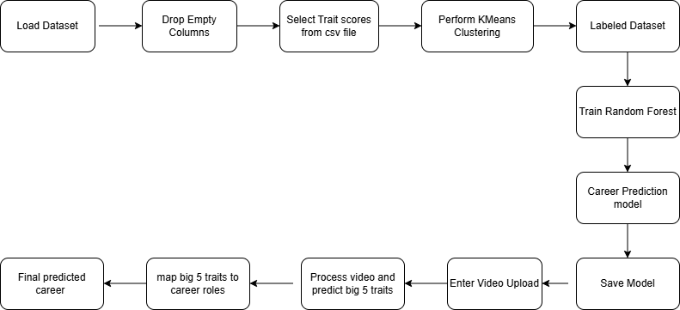

Figure 2. Flow graph

**3.6 Screenshots showing the project's different phases**

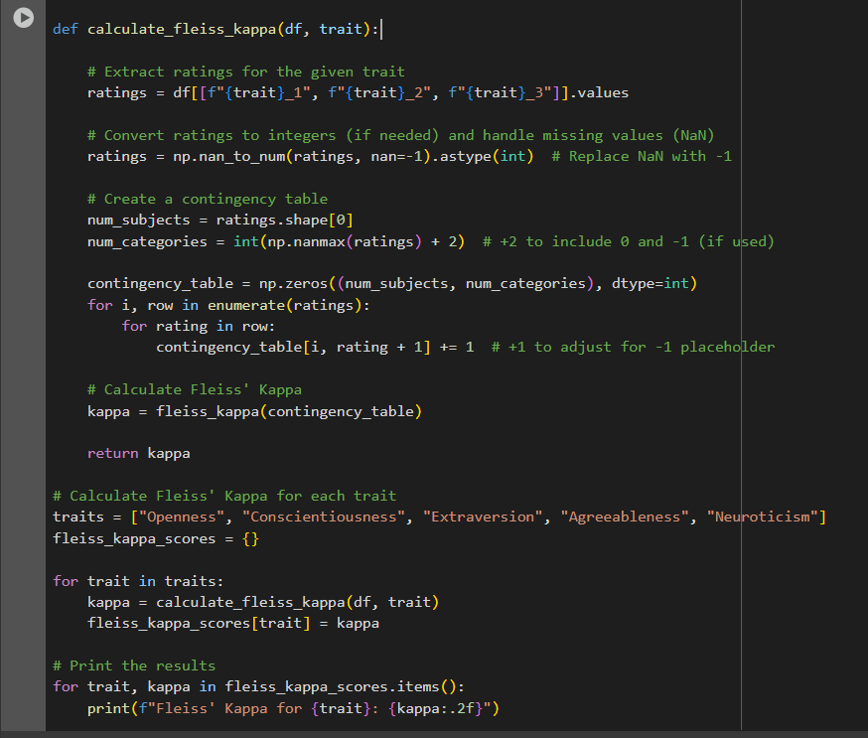

Figure 3. Function for Fleiss Kappa to validate annotations

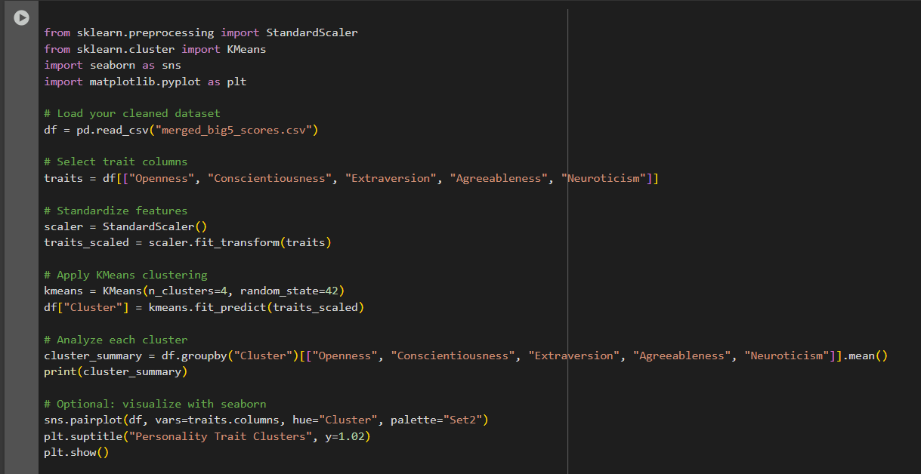

Figure 4. KMeans Clustering

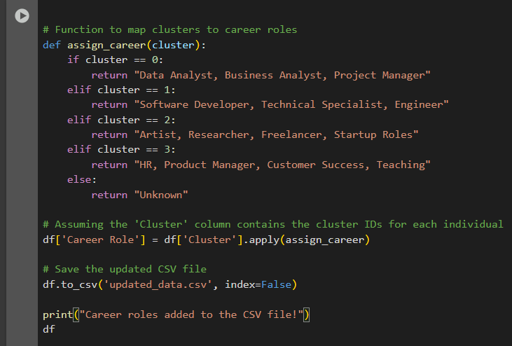

Figure 5. Map clusters to career roles

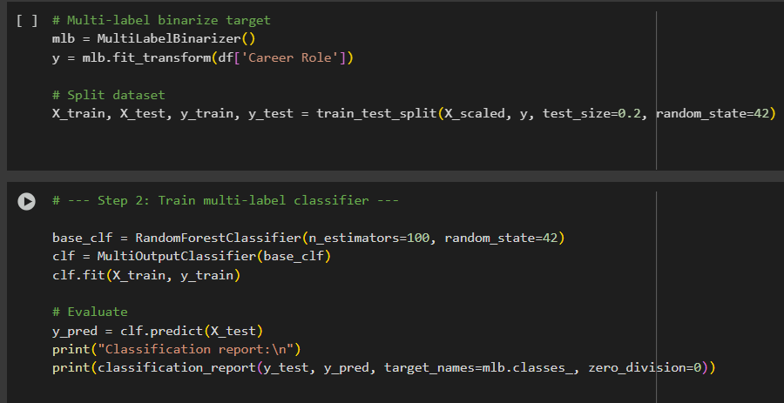

Figure 6. Random Forest Classification

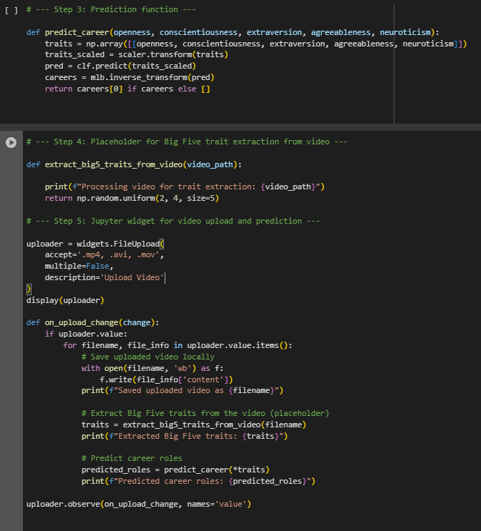

Figure 7. Model predicts career taking new videos as input

**Chapter 04: RESULTS**

**4.1 Discussion on the Results Achieved**

**4.11 Fleiss Kappa**

An inter-agreement metric called Fleiss Kappa is employed when there are more than two annotators. It can be between -1 and 1. Our estimated Fleiss Kappa is within the acceptable range of 0.21–0.40, which is fair agreement.

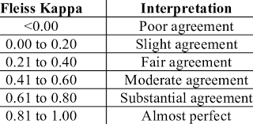

Figure 8. Fleiss Kappa Range

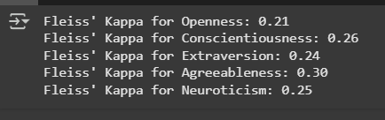

Figure 9. Fleiss Kappa score

**4.12 KMeans Clustering**

It is Unsupervised Machine Learning algorithm. It is utilized to gather comparable datapoints into clusters based on their features. It grouped the data into three clusters: Cluster 0, Cluster 1, Cluster 2, Cluster 3. Each cluster can now be mapped to the career suitable according to their scores on the basis of the Big 5 Personality Model.

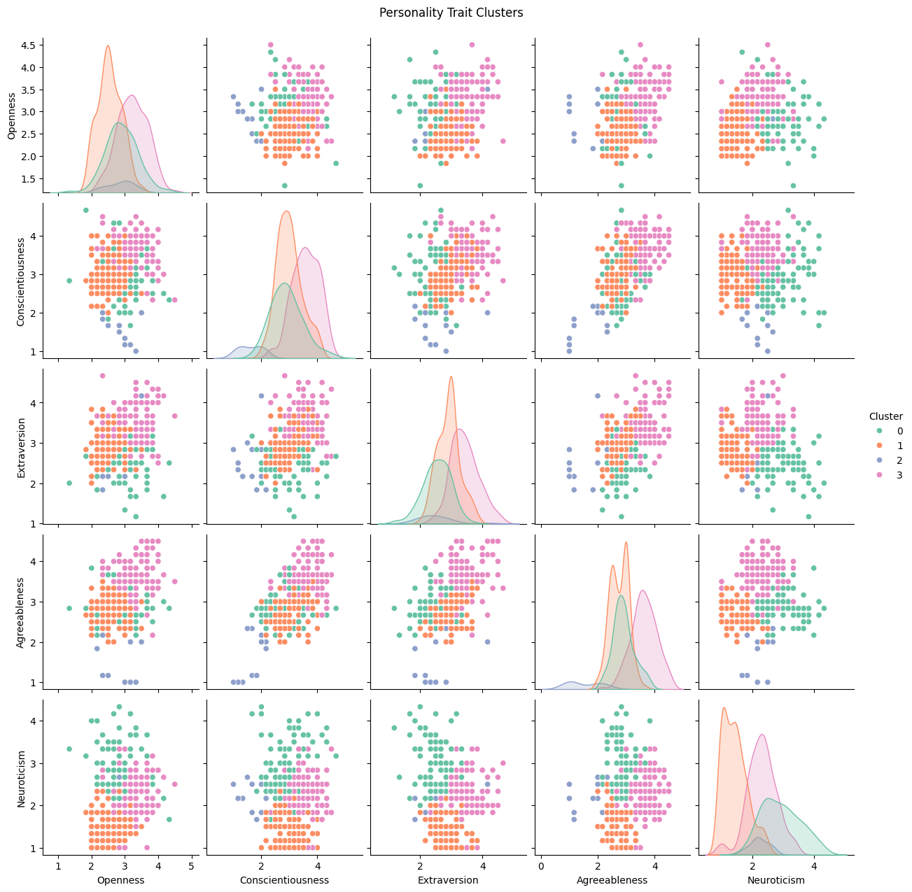

Figure 10. Clusters using KMeans Clustering Algorithm

**4.13 Random Forest Classification**

This technique uses collection of decision trees to predict output. It is used in supervised learning.

It used the labeled data obtained after the clustering. The model gives an accuracy score of 84% along with other metric measure as shown in Figure 3.

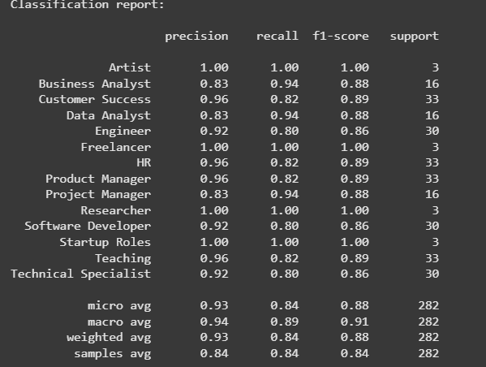

Figure 11. Random Forest Classification results

**4.14 Final Results**

Based on the Big Five Personality model (OCEAN), the model now accurately predicts each person's career.





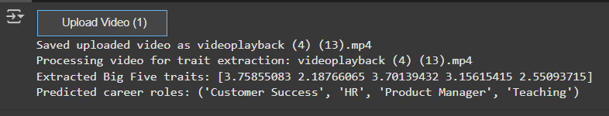

Figure 12. Career roles predicted through video input

**4.2 Application of the Minor Project**

Tailored Career Predictions based on Emotional and Personality Traits can be used for various purposes:

1. Career Recommendations: It can give personalised career advice to student and job seekers by analysing their personality.
2. Recruitment process: It can be used to automate the recruitment process and used to evaluate whether the candidate is suitable for the job role or not.
3. Mobile/Web Applications: Can be used by users to discover their careers. Upload a short video and they can receive career recommendations instantly.

**4.3 Limitation of the Minor Project**

While the project helps in various fields it has certain limitations also such as:

1. Dataset Limitations: Since we made our dataset on our own so it is very small of just 410 videos. So underrepresented career paths like Artist or Freelancer might be inaccurately predicted.
2. Multilabel Complexity: Job Roles like Product Manager and Project Manager are overlapping.The model might confuse similar roles or give generic predictions.
3. Static personality assumptions: The Big Five personality traits may shift over time or vary by context. One time prediction may not reflect person’s evolving personality or traits.

**4.4 Future Work**

The project's upcoming tasks include the following:

1. Incorporate additional user data: Data such as user’s interests, educational background, career goals will be incorporated to make better predictions.
2. Mobile/Web App Deployment: Make an app where users can upload video and get career recommendations instantly.
3. Support for Multilingual Variation: The current model may work poorly on diverse languages. To prevent this multilingual support will be added to the model

**References**

[1] Priyanka Shahane, Prutha Rinke, Taniksha Datar and Soham Badjate, "Student's Career Interest Prediction using Machine Learning," International Research Journal of Engineering and Technology (IRJET), vol. 9, no. 11, Nov. 2022, pp. 533-539.

[2] Kevin Johnson, Samarth Khaire, Yash Nage, and Priya Kaul, "Personality Prediction App Using Big-Five Traits," International Research Journal of Modernization in Engineering Technology and Science, vol. 4, no. 06, June 2022, pp. 2887-2894.

[3] Xu, J., Tian, W., Lv, G., Liu, S., & Fan, Y. (2021). Prediction of the big five personality traits using static facial images of college students with different academic backgrounds. *Ieee Access*, *9*, 76822-76832.

[4] Bounaba, Y., Oussalah, M., Arhab, N., & Bekhoucheb, S. (2024). Towards job screening and personality traits estimation from video transcriptions. *Expert Systems With Applications*, *238*, 122016.

[5] Ning, H., Dhelim, S., & Aung, N. (2019). PersoNet: Friend Recommendation System Based on Big-Five Personality Traits and Hybrid Filtering. *IEEE Transactions on Computational Social Systems*.

[6] Holman, D. J., & Hughes, D. J. (2021). Transactions between Big-5 personality traits and job characteristics across 20 years. *Journal of Occupational and Organizational Psychology*, *94*, 762-788.

[7] De Jong, Nicole, Barbara Wisse, José AM Heesink, and Karen I. Van der Zee. "Personality traits and career role enactment: Career role preferences as a mediator." *Frontiers in psychology* 10 (2019): 1720.

[8] Hussein, Ammar. "Examination of personality traits as predictors of career success." *International Journal of Academic Research in Business and Social Sciences* 7, no. 10 (2017): 556-566.

[9] Rao, Abhishek S., Bola Sunil Kamath, R. Ramya, Shreya Chowdhury, A. Shreya, and Raveena Krishna Kundar Pattan. "Use of artificial neural network in developing a personality prediction model for career guidance: A boon for career counselors." *International Journal of Control and Automation* 13, no. 4 (2020): 391-400.