Hi,

I have provide 2 folder 1. (CharacterCounterOnlyTextarea) 2.CharacterCounterMultiple

1. CharacterCounterOnlyTextarea :- In this folder i have used /create angular directive for Counter and pass the object in html text area

2.CharacterCounterMultiple :- In this folder i have used angular ng-model .ng-model update value instantly

Procsss of add addon in chrome browser
1. Open chrome browser and click menu icon appear right side in browser
2. After click this icon open menu dialogue box > click on more tools> Extension
3.Extension find Developer mode and check this.
4 After this you see Load unpacked Extension
5 click Load unpacked Extension then after populate Browser for Folder Window
6. Then select your folder which i heve give you press ok
7.Finally addon place in your browser.

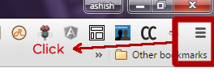
1.

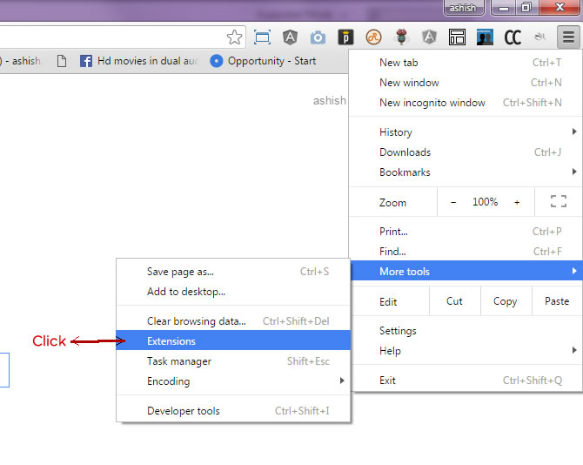
2.

3.

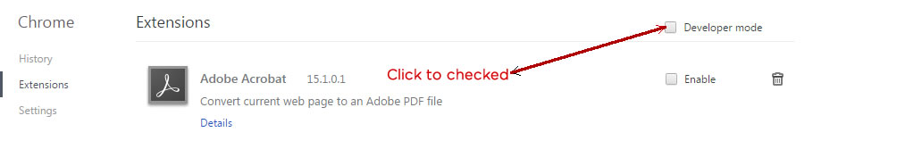

4.
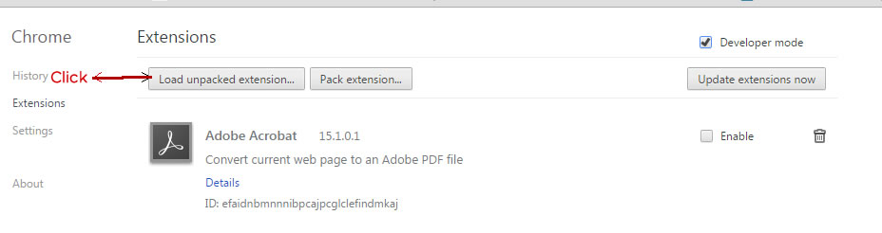

5.
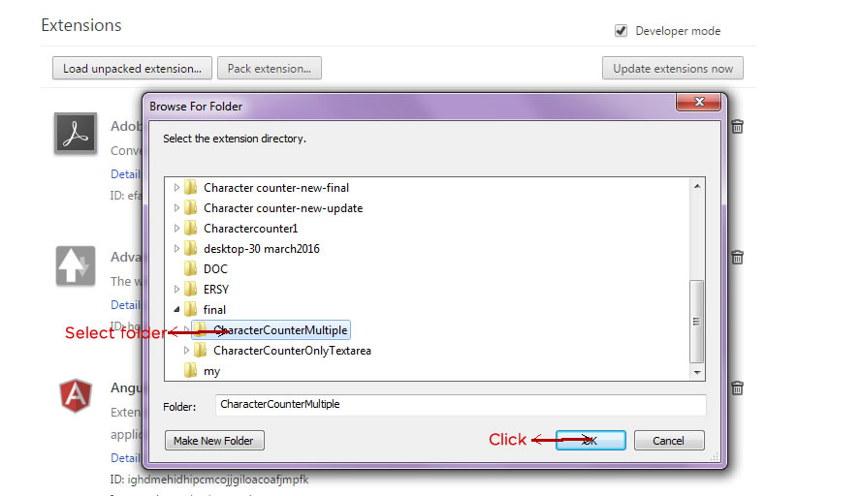

6.
